Listening:
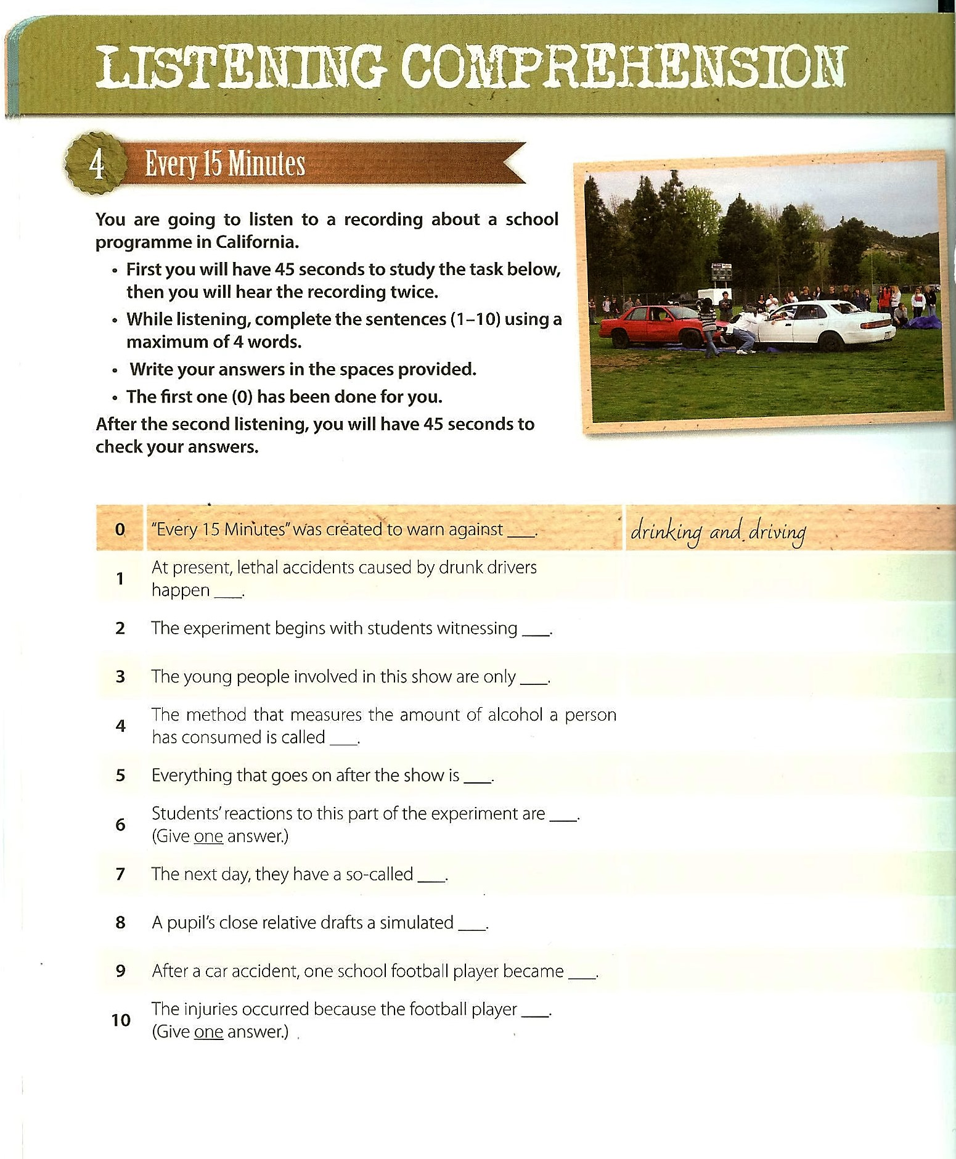
___/10 pts
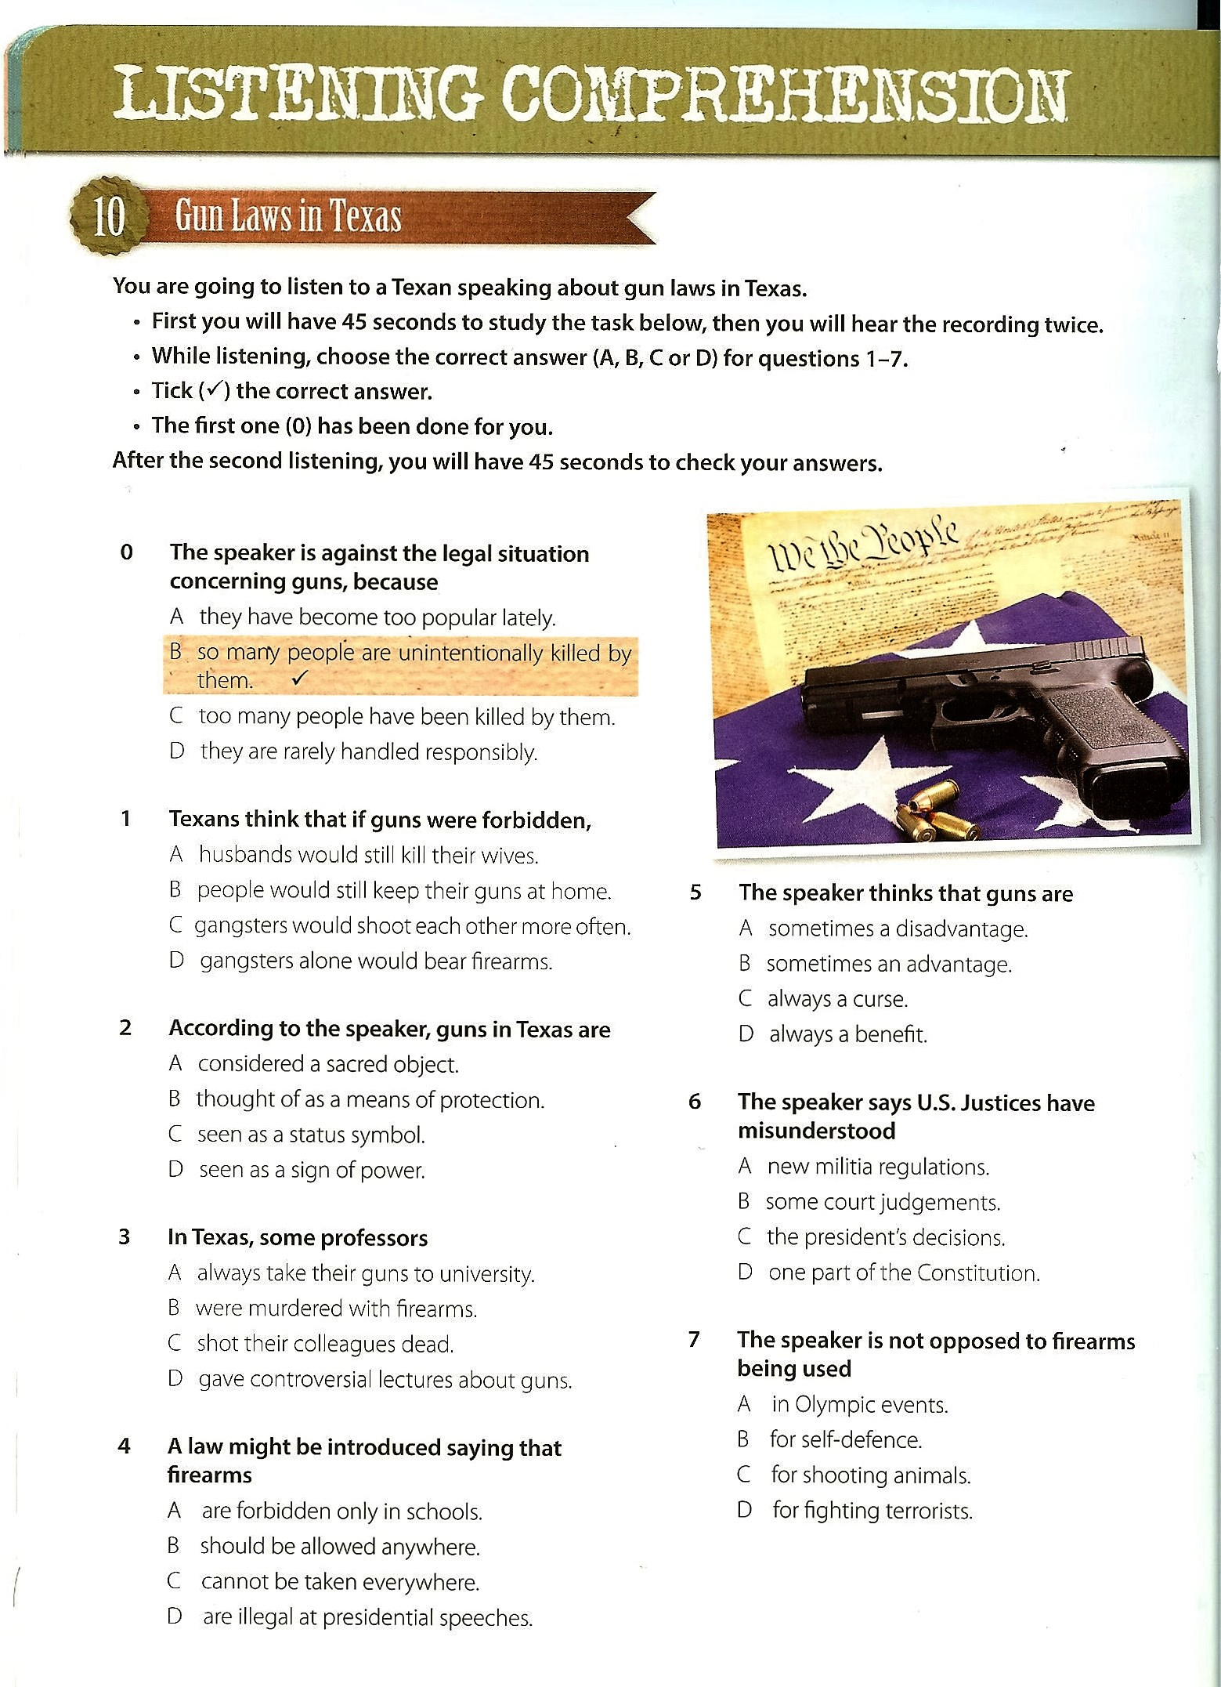
___/7 pts

Reading 1 : 7pts
Read the text, published in 2009, about a new way of marking tests. First decide whether the statements (1-7) are true (T) or false (F) and put a cross (x) in the correct box on the answer sheet. Then identify the sentence in the text which supports your decision. Write the first four words of this sentence in the space provided. There may be more than one correct answer; write down only one. The first one (0) has been done for you.

Can computers replace humans in assessment?

The owner of one of England's three major exam boards is to introduce artificial intelligence-based automated marking of English exam essays in the UK from next month. Pearson, the American-based parent company of Edexcel, is to use computers to "read" and assess essays for international English tests in a move that has fuelled speculation that GCSEs and A-levels will be next.

All three exam boards are now investing heavily in e-assessment but none has yet perfected a form of marking essays using computers – or "robots" – that it is willing to use in mainstream exams. Academics and leaders in the teaching profession said that using machines to mark papers would create a "disaster waiting to happen".

The Times Educational Supplement (TES) reports today that the Pearson Test of English Academic, an English-language exam, will launch on 26 October. It includes essay questions and will be used in 20 countries, including the UK, to rate applicants' English skills before they are admitted to university.

Computers have been programmed to scan the papers, recognise the possible right responses and tot up the marks. Pearson claims this will be more accurate than human
marking. John Bangs, head of education at the National Union of Teachers, said that computers could be useful in many areas of assessment but cautioned against their use in English exams: "I'm very concerned that it would constrain the nature of the questions being asked. You won't pick up nuances by machine and it will trigger a trend to answering narrower questions. It could be a disaster waiting to happen."

A Pearson spokesman told the TES that its system produced the accuracy of human markers while eliminating human elements such as tiredness and subjectivity.

Other exam boards said the adoption of computers to mark beyond their current use in multiple choice tests was inevitable. Tim Oates, director of research for Cambridge Assessment, which owns the exam board OCR, said: "It's extremely unlikely that automated systems will not be deployed extensively in educational assessment. The uncertainty is 'when' not 'if'. But all systems need to meet exacting quality criteria and should definitely not be adopted just to make life easier for testing organisations.

"Some approaches look like technology in search of a test, rather than assessment designed to accurately report attainment."

An Edexcel spokesperson said that the board was not planning to use automated marking
in mainstream exams such as A-levels and GCSEs. She said that previous trials of the
technology in GCSE essay questions had not been expanded.

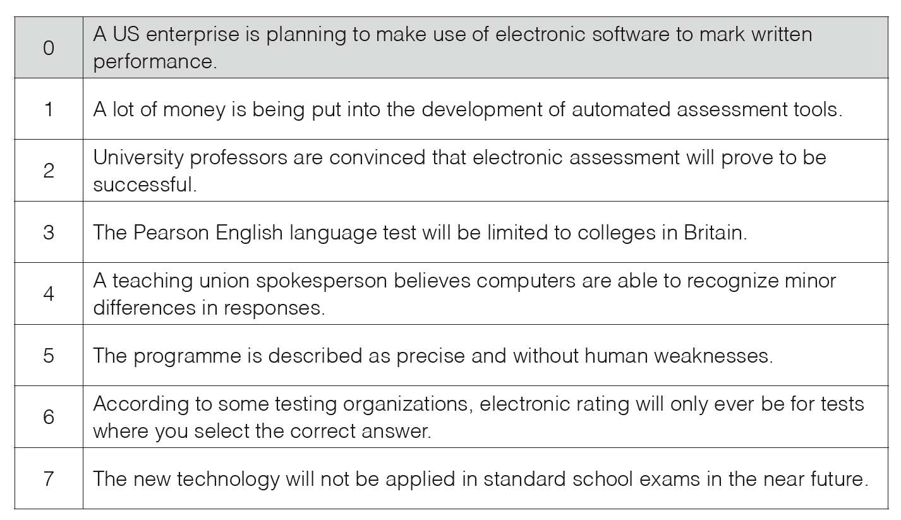
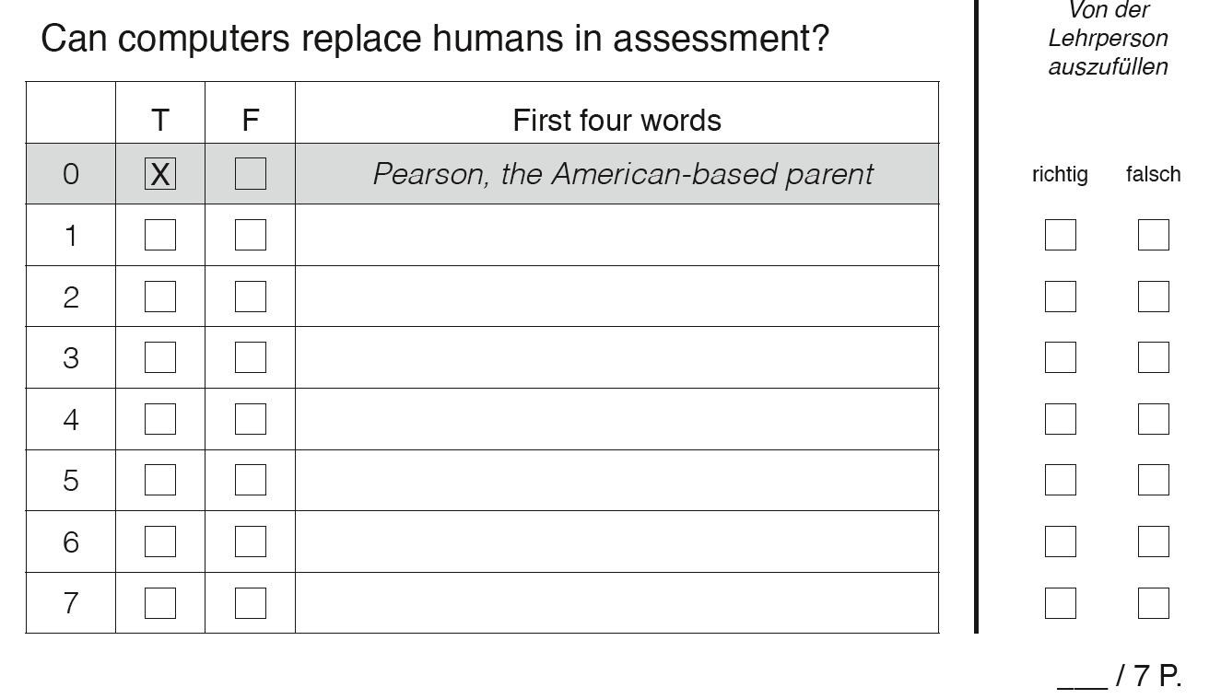

Reading 2
Read the text about animals that have been introduced into another country, then choose the correct answer (A, B, C or D) for questions 1-6. Put a cross (X) in the correct box on the answer sheet. The first one (0) has been done for you.
Invasive species 6pts
Britain is facing a surge of invaders with scientists recording 3,800 alien species, including 44 mammals, 326 birds, 1,821 flowering plants and 865 insects.
One of the worst invaders is the harlequin ladybird, a voracious predator that cannibalises other ladybirds and threatens many other insect species. It arrived in Essex in 2004 but has already reached the Orkneys. Its arrival in an area appears to herald rapid declines in native species.
Another is the ring-necked parakeet, which is spreading so fast that the government has just allowed landowners to shoot them without a licence.
Macdonald and Burnham wrote their report, The State of Britain’s Mammals, for the People’s Trust for Endangered Species. They suggest that each invasive mammal species should be considered on its merits and not persecuted just for being foreign. They write: “There comes a point where a non-native has been exerting its influence on native biodiversity for so long that a new community has emerged to which the intruder is integral so its removal would no longer rescue or restore the original natural state. At that point the intruder’s origins no longer justify killing it.”
They add: “The decision to consider a naturalised non-native species as an ecological

citizen should hinge solely on the nature of the damage it causes to native biodiversity.”
The grey squirrel would probably be among the candidates for such a reassessment.
Introduced to Britain in 1828, it has spread across most of the country, driving out the smaller red squirrel and possibly damaging wild bird populations by eating their eggs.
The researchers argue, however, that in many areas the animal is now part of Britain’s wildlife and it would be difficult to get the public support and money needed for eradication. But they say that the animals must still be heavily controlled in areas such as Scotland, where the red squirrel still survives.
Some invaders are already ecological citizens. One such is the brown hare, which was introduced to Britain by the Romans but which is so widely accepted that its recent decline has prompted the government to list it as an endangered species.
Similarly, rabbits, brought to Britain in the 11th century and now responsible for £115m of losses to farmers each year, are also seen as British. Macdonald points out that although they do damage they also maintain grasslands and provide food for predators.
Soon, such “ecological citizens” could be joined by the Chinese water deer, which is facing rapid decline in its home regions in China and Korea. In Britain, its population has surged to several thousand, accounting for 10% of the global population. “Britain has become an ark for these creatures, so conserving it might help protect the species,” Burnham said.
The American mink, by contrast, would probably fail the ecological citizenship test, because of the damage it causes to Britain’s native wildlife, especially the water vole.

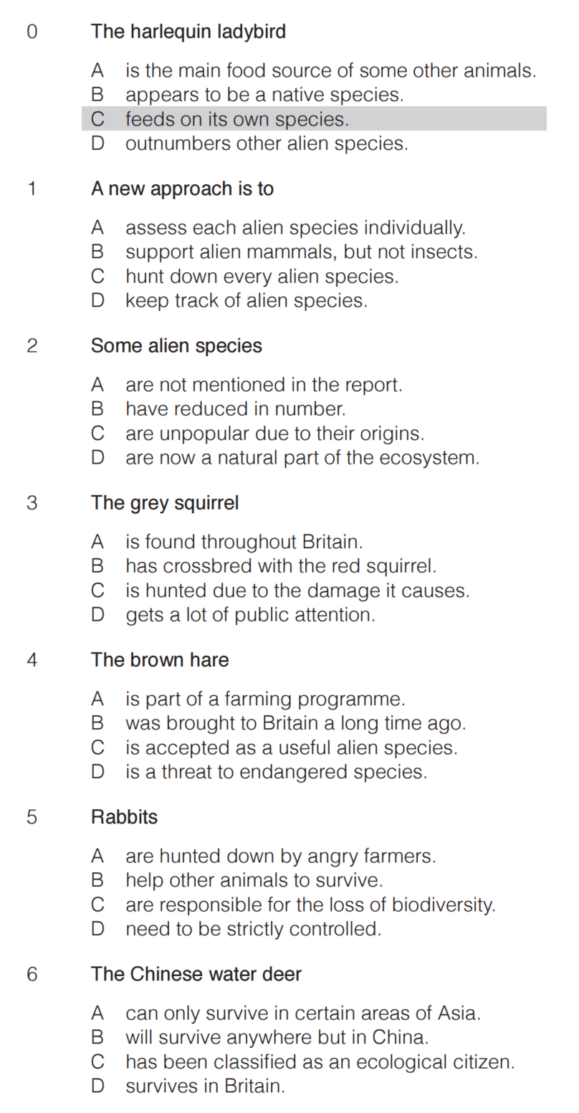

Writing: Write a report AND an e-mail according to the following instructions.

Report

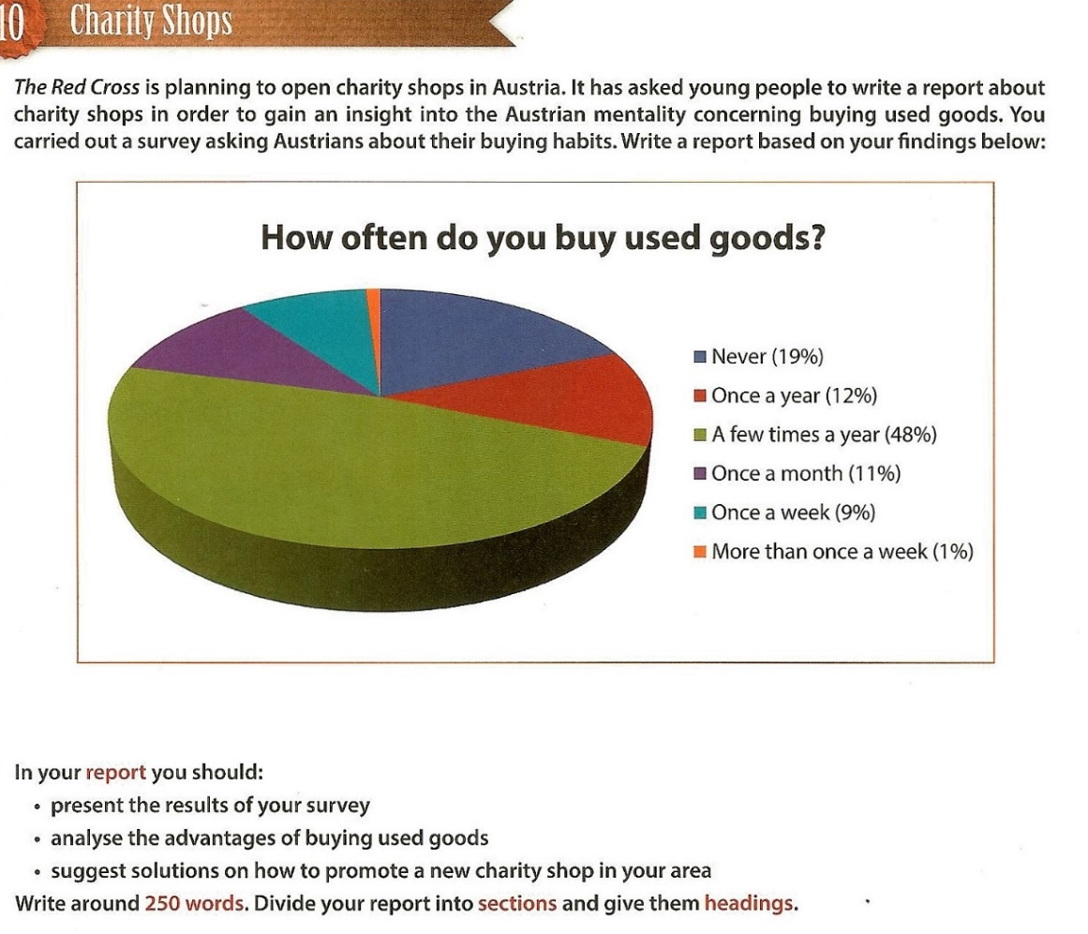 /40pts

E-mail

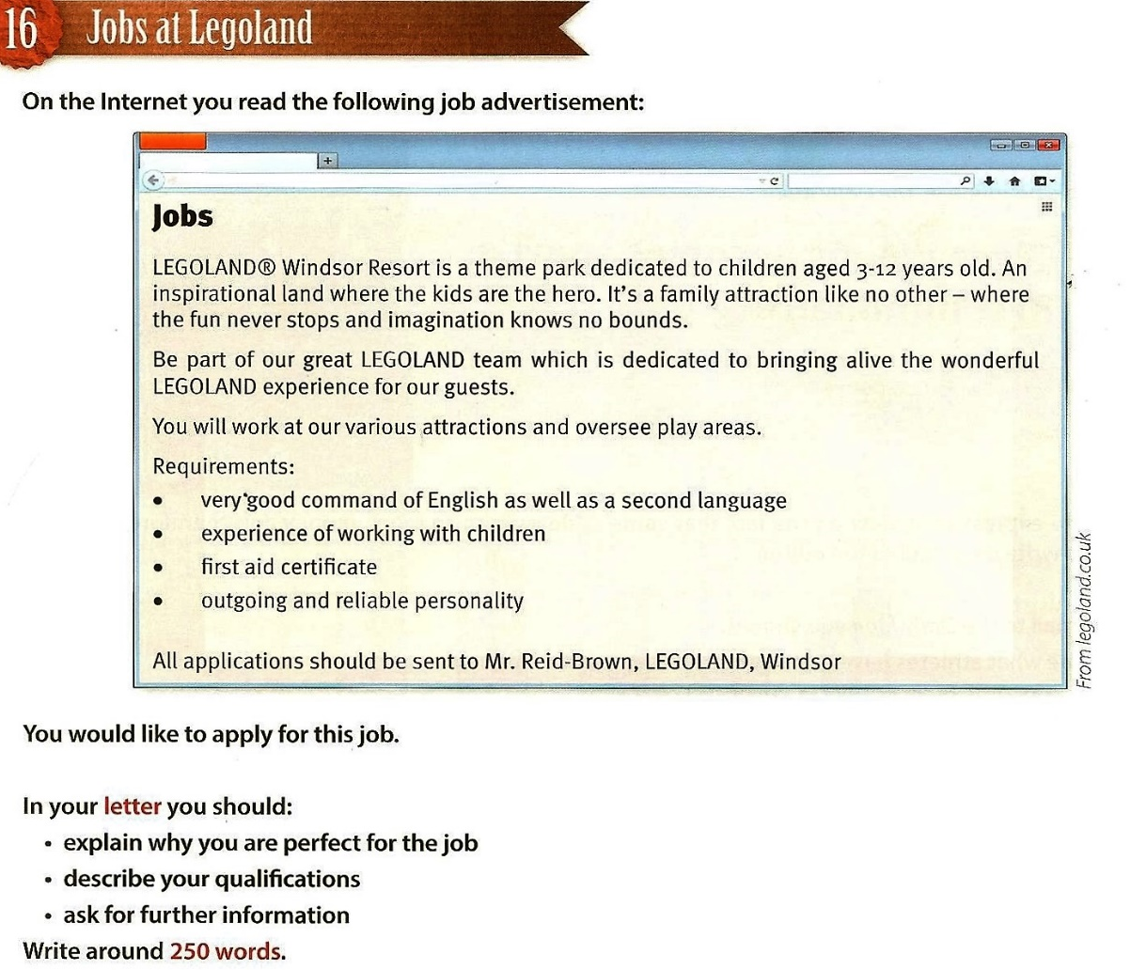/40pts

Solutions for the teacher
Listening
Every 15 Minutes (track 7+8=
0 | drinking and driving
1 | every 32 minutes
2 | a fake accident, a fake car accident, re-enactment of an accident
3 | actors, acting
4 | field sobriety test, sobriety test, medical test
5 | videotaped
6 | mixed, not sentimental, excited, laughing, laughter, joking
7 | closing ceremony, funeral
8 | last letter, farewell letter
9 | paralysed, paralised, paralized
10 | drove recklessly, didn’t wear a seatbelt, didn’t fasten his seatbelt, had no seatbels, made a poor decision

Gun Laws in Texas
0 | 1 | 2 | 3 | 4 | 5 | 6 | 7
B | D | A | B | B | C | D | C

