First English Test: 8ab Nov. 2010

- Graph
Look at the graph below and describe the development of the Dubai Gold Sales in the year 2002. Write about 150 words.

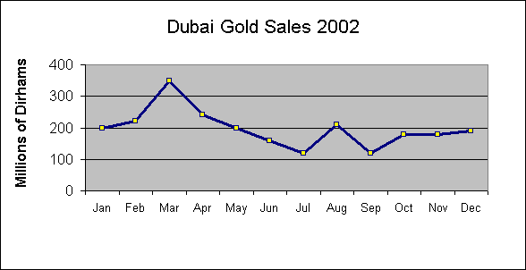
2. Opinion Paper

At the end of your career as a student you will have to decide what to do in your future life to earn a living. Read the quotations below. Then explain what you think are the most important aspects for choosing your future profession.

Write a well-structured essay of about 350 words. Don’t forget to start with a clear thesis statement and topic sentences for each paragraph. Find a fitting title.
Genius is 1% inspiration and 99% perspiration. Accordingly a genius is often merely a talented person who has done all of his or her homework.
Thomas Edison
I've always worked very, very hard, and the harder I worked, the luckier I got.
Alan Bond
I feel sorry for the person who can't get genuinely excited about his work. Not only will he never be satisfied, but he will never achieve anything worthwhile.
Walter Chrysler

Doing what you love is the cornerstone of having abundance in your life.
Wayne Dyer

The man who has done his level best, and who is conscious that he has done his best, is a success, even though the world may write him down as a failure.
BC Forbes

Do what you love. When you love your work, you become the best worker in the world.
Uri Geller

- Using the new vocabulary: group A

Use the following words in meaningful sentences and typical collocations.

inevitably:
to convey:
tedious: devastating:
bulky:
versatility:
hostile:
littered:
obedient:
habitable:

Using the new vocabulary: group B
Use the following words in meaningful sentences and typical collocations.

appliance:
obliterate:
inadequate:
obsolete:
drudgery:
misperceptions:
asset:
beneficial:
resourceful:
predisposition:

