NAME_______________________________________________________________________________________________________
8A/B English Test 3 29.03.12

WRITING
Select TWO tasks and write 250 words ( + 10%) for each task.

1. Report
You are a local coordinator for European Hop, an American organization that takes teenagers on tours of Europe. European Hop wishes to improve its service and is collecting information from local coordinators about the teenagers’ stay in the various European cities they visit.
In your report

- describe the most popular half-day programme in Graz and account for its popularity
- outline a problem with accommodation that arose with the last group
- make a recommendation for improving the European Hop programme

2. Article
Amazon.com is running a competition to promote the reading of books among teenagers. Keen young readers are invited to send in articles describing their own positive reading experiences. The winning article will appear on Amazon’s website. The prize for the winning article is a Kindle e-reader.

In your article
- describe your first childhood experiences with reading for pleasure
- explain what reading means to you personally
- assess the importance for you personally of one of your favourite books

3. Letter

Read the advertisement for Home Exchange holidays.

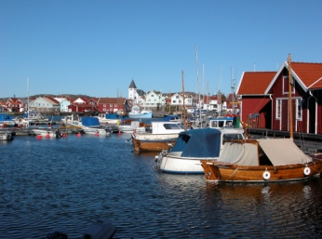

Home Exchange is a vacation alternative where you allow someone else to stay in your home while you stay in theirs. During a home exchange holiday you swap your home at a time that is convenient to both. A house swap holiday may also include an automobile exchange. Home exchanging has numerous advantages, including significant savings on hotel and car rental costs. And who doesn't prefer a spacious house to a one- room hotel? Whether for a vacation, or a longer term, a home exchange allows you to live like a local.

You and your family have just got back from a Home Exchange holiday abroad. You find that the family that was living in your house has caused some damage. Write a letter of complaint to the Home Exchange organization.

In your letter
- give details of your Home Exchange holiday
- explain exactly what damage has been caused
- say exactly how you expect Home Exchange to react

