Writing Task 1: Graph
You should spend about 20 minutes on this task.
The graph below shows the number of complaints made about noise to Environmental Health authorities in the city of Newtown between 1980 and 1996.
Summarize the information by selecting and reporting the main features, and make comparisons where relevant.

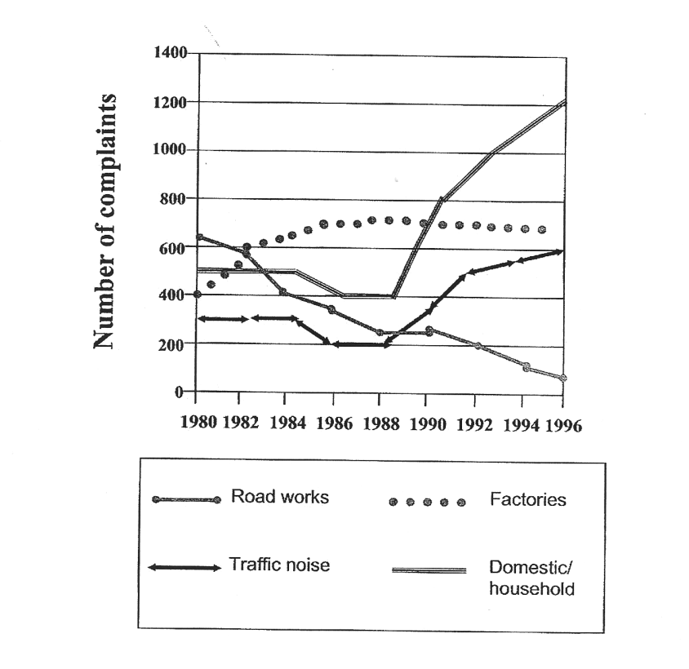

Writing Task 2: Opinion Paper

Write a well-structured essay of about 250 words.

At the end of your career as a student you will have to decide what to do in your future life to earn a living. Read the quotations below. Then explain what you think are the most important aspects for choosing your future profession.
I feel sorry for the person who can't get genuinely excited about his work. Not only will he never be satisfied, but he will never achieve anything worthwhile. Walter Chrysler
Doing what you love is the cornerstone of having abundance in your life. Wayne Dyer
The man who has done his level best, and who is conscious that he has done his best, is a success, even though the world may write him down as a failure. BC Forbes
Genius is 1% inspiration and 99% perspiration. Accordingly a genius is often merely a talented person who has done all of his or her homework. Thomas Edison

