Name_______________________________________________________
8ab English Test 3 (pö) 06.04.11

WRITING
Select TWO tasks and write 230 words ( + 10%) for each task. Dictionaries permitted.

1. Report
You are a local coordinator for European Hop, an American organization that takes teenagers on tours of Europe. Last week you were in charge of a group of 17-year-old Americans who had a stopover in Graz. In spite of the organization strictly forbidding alcohol and drugs, one of the participants got into trouble because of alcohol or drug abuse. Write a report for the organization. In your report
- explain exactly what happened
- say how you dealt with the situation
- say how such incidents might be avoided in future

2. Article
IELTS is running a writing competition. IELTS candidates are invited to write an article about their experience of taking the examination. The best articles will appear on the IELTS website to advertise the examination. You decide to take part in the competition. In your article
- explain the benefits of an IELTS qualification
- say what you gained from preparing for the exam
- describe a few aspects of the live exam situation

3. Letter

Read the advertisement for Home Exchange holidays.

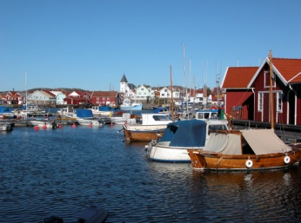

Home Exchange is a vacation alternative where you allow someone else to stay in your home while you stay in theirs. During a home exchange holiday you swap your home at a time that is convenient to both. A house swap holiday may also include an automobile exchange. Home exchanging has numerous advantages, including significant savings on hotel and car rental costs. And who doesn't prefer a spacious house to a one- room hotel? Whether for a vacation, or a longer term, a home exchange allows you to live like a local.

You and your family have just got back from a Home Exchange holiday abroad. You find that the family that was living in your house has caused some damage. Write a letter of complaint to the Home Exchange organization.

In your letter

- give details of your Home Exchange holiday
- explain exactly what damage has been caused
- say exactly how you expect Home Exchange to react

