Writing Task 1: Graph Description
You should spend about 20 minutes on this task.
The line graph below shows the percentage of tourists to England who visited four different attractions in Brighton.
Summarise the information by selecting and reporting the main features, and make comparisons where relevant.
Write at least 150 words.

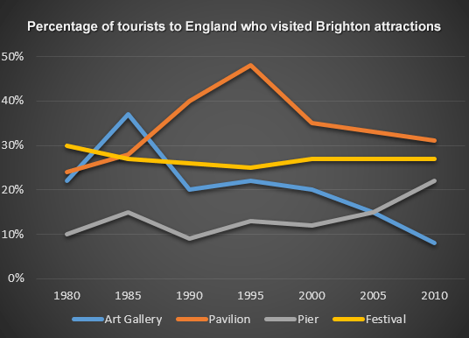
Festival
Pavillion
Art Gallery
Pier

Writing Task 2:

Essay
Graduation Ball
Graduation balls involve very time-consuming preparations criticized by many teachers. Are these balls worth the money, time and effort? The SGA (Schulgemeinschaftsausschuss) would like to find out what year 8 students think about this topic and have invited them to send in essays in which they argue for or against organizing graduation balls.
You have decided to write an essay. In your essay:
- evaluate the impact of graduation balls on school work
- analyze the effects on your class community
- discuss whether graduation balls teach a lesson for life
Give your essay a title. Write around 400 words.

