Name______________________________________________________________________
8AB English Test 2 19th January, 2011

Writing Task I
You must do this task. Write 250-300 words.
Read what the successful American inventor and businessman Thomas Edison had to say about talent and work. Then do the essay task. Do not copy whole phrases from the excerpts or task instructions to use in your essay.
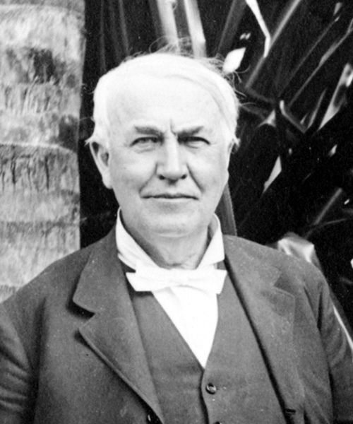
Opportunity is missed by most people because it is dressed in overalls and looks like work.
If we did all the things we are capable of doing, we would literally astound ourselves.
I never did a day's work in my life, it was all fun.
Genius is one percent inspiration, ninety-nine percent perspiration.
Glossary: astound = astonish; perspiration = sweat
Young people are always told how important it is to study hard in order to get a good job later in life and have a successful career. But what exactly is a good job? What makes a job worth doing? Why work hard at all if one can find a way of avoiding it?
Write an opinion essay in which you
- state clearly your opinion on the importance of work and career in our lives
- support your opinion with valid arguments and examples
- say what you personally aim to achieve in your future working life

