Age of Marriage in the USA

Read the text and draw the graph. Then check your drawing with the solution sheet.
28
27
26
25
24
23
22
21
20
1900 | 1920 | 1940 | 1960 | 1980 | 2000

The graph shows changes in the age of marriage in the USA over the last 100 years. Overall, although there have been big changes in the average age of m
arriage, and although the difference has narrowed, men still tend to be older than women when they make their vows.
The biggest changes were for women. At the start of the century, the average age stood at just 22, and this dropped slightly to about 21 over the next two decades. Between 1920 and 1950, the age fluctuated slightly, but in 1950, it plunged and reached just over 20 in 1960. Then a major change took place. Between 1960 and 2000 there was a sharp and continued increase in the age of marriage for women. It rose from just 20 in 1960 to 25 in 2000. This represented a gap of two years between women in men, in contrast to the gap of four years in 1900.
The trend for men to marry at a later age also increased. At the start of the period, men got married at 26. One hundred years later the age stood at 27, a slight increase of just one year. However there were big changes during the century. From 1900 to1930 the age dropped from 26 to 24. It plunged in 1940 to almost 22 and then remained stable for 20 years. From 1970 to 2000 there was a sharp increase, mirroring the rise in the women’s age of marriage. It shot up from 20.5 to 27.
In conclusion, there have been big changes in the age of marriage. However, men still get married later than women, and women tend to get married much later than in the past.
284 words!

Shorter Version: 180 words
The graph shows changes in the average age of marriage for men and women in the USA between 1900 and 2000. Overall, although both men and women are getting married later, the difference between them has decreased.
The biggest change was in the age of marriage for women. For the first 50 years it changed very little, ranging between 21 and 22 years, but by 1960 it had fallen to a low of just over 20. However, then it shot up dramatically, rising to 22 in 1980 and 25 in 2000, just two years younger than men, compared to four years in 1900.
The age of marriage for men followed a similar pattern, falling from 26 at the start of the century to a low of just over 22 between 1950 and 1970. During the last forty years, however, the age jumped sharply, reaching 27 in 2000, one year older on average than at the start of the period.
In conclusion, men still tend to be older than their partners at marriage, but the difference has fallen significantly, and both are marrying later.

Even Shorter Version: 158 words!
The graph shows changes in the ages at which Americans married over the last century. In general, men are still older than their partners, but the age of marriage for both has increased.
In 1900, men got married at 26 on average. This fell gradually to 24 in 1930 and then to a low of about 22.5 between 1950 and 1970. From 1970 to 2000, however, it shot up, reaching 27 at the turn of the century.
In contrast, women married much earlier 100 years ago. The age of marriage was just 22 and this barely changed before 1950. After a low of 20.5 in 1960, however, the age began to shoot up and by 2000 the average woman got married at 26 years of age, four years older than a century earlier, and much closer to the age for men.
In conclusion, women are getting married much later, although men still tend to be two years older.

Use two colors to highlight the verbs in the past tense and the present perfect tense.
Explain why the writers used these tenses.

Solution

Age of Marriage
The graph shows changes in the average age of marriage for men and women in the US in the last century.
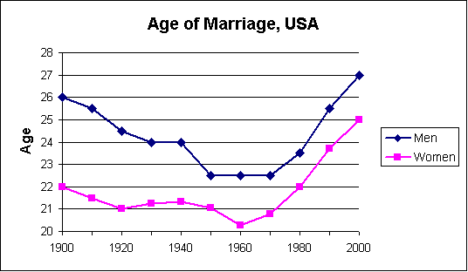
Describe the graph in two paragraphs (one for men, one for women) using simple vocabulary (rose by/rose to, climbed, increased, went up. fell slightly, dropped, decreased).
The information above comes from "The First Measured Century," a PBS website. Download the Microsoft Excel spreadsheet for this graph.

