HOW TO TALK ABOUT A VISUAL AID

Choosing the right visual aid

A flow chart is a diagram showing the progress of material through the steps (étapes) of a manufacturing process (processus) or the succession of operations in a complex activity | A pie chart displays the size (taille) of each part as a percentage of a whole (un tout). | A (vertical or horizontal) bar chart is used to compare unlike (different) items
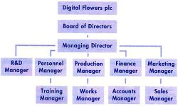 | 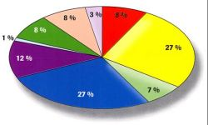 | 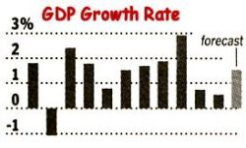
A line chart depicts changes over a period of time, showing data and trends | A table is a convenient way to show large amount of data (données, informations) in a small space | A diagram is a drawing showing arrangements and situations, such as networks (réseaux), distribution, fluctuation ...
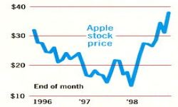 | 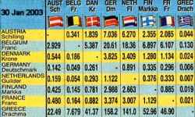 | 

Presenting a graph

Introduction | Topic | Circumstances
This graph shows ... | the results of our products ... | over 10 years.
The diagram outlines ... | rates of economic growth ... | between 1990 and 1996.
This table lists ... | the top ten agencies ... | in the industrial world.
This pie chart represents | the company's turnover ... | for this year in our sector.
This line chart depicts ... | the changes in sales ... | over the past year.
This chart breaks down (ventile) ... | the sales of each salesman ... | during the past ten weeks.

The four basic trends (tendances) are :
- upward movement :
- downward movement :
- no movement :
- change in direction : or

Indicating upward movement :
Verbs |  | Nouns
Transitive | Intransitive
(to) increase | (to) increase | (an) increase
(to) raise | (to) rise (rose, risen) | (a) raise (US), a rise (UK)
(to) push/put/step up | (to) go/be up | (an) upswing
 | (to) grow | (a) growth
(to) extend, (to) expand | (to) extend, (to) expand | (an) extension, expansion
 | (to) progress | (a) progression
 | (to) boom/soar/climb | (a) boom
 | (to) jump, (to) skyrocket | (a) jump
 | (to) reach a peak, (to) peak | (a) peak
 | (to) reach an all-time high

Indicating downward movement :
Verbs |  | Nouns
Transitive | Intransitive
(to) decrease | (to) decrease | (a) decrease
(to) cut, (to) reduce |  | (a) cut, (a) reduction
 | (to) fall (off) (fall, fell, fallen) | (a) fall
 | (to) plunge, to plummet | (a) plunge
 | (to) drop (off) | (a) drop
 | (to) go down | (a) downswing
 | (to) decline | (a) decline
 | (to) collapse | (a) collapse (dramatic fall)
 | (to) slump, (to) go bust | (a) slump
 | (to) bottom out

Indicating no movement :
Verbs |  | Nouns
Transitive | Intransitive
(to) keep ... stable | (to) remain stable
(to) hold ... constant | (to) stay constant
(to) stabilize | (to) stabilize | stability

Indicating a change of direction : or ...
Verbs |  | Nouns
Transitive | Intransitive
(to) level off | (to) level off/out, to flatten out | (a) levelling-off
 | (to) stop falling/rising | (a) change
(to) stand at | (to) remain steady
 | (to) stop falling and start rising
 | (to) stop rising and start falling

Indicating the degree or the speed of change
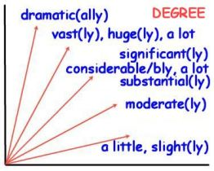
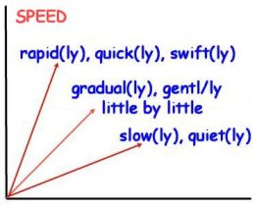

Describing the elements of a graph
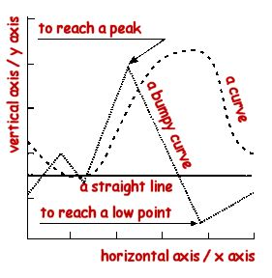
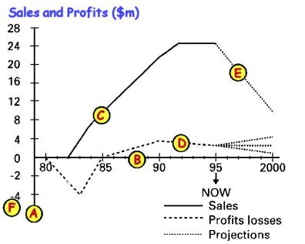

Look at the graph and write the appropriate letters in front of each definition :

: the horizontal axis ( or the x axis) : a solid line
: the vertical axis (or the y axis) : a broken line
: the scale : a dotted line

Analysing an example

The x axis of this graph shows the twelve months of the past year while our sales in millions of dollars appear on the y axis. It may be seen clearly that sales rose steadily in the first half of the year (from January to May) and reached their peak in June. Then they dropped off in July and levelled out in August. After rising sharply during September, they suffered a dramatic (spectaculaire) fall in October but then made a significant (sensible) recovery (redressement) in November. However, the year ended with a slight downturn.
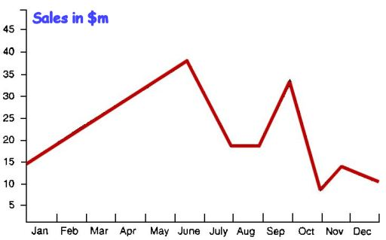

Describing graphs and trends (exercises 1)

Name : Form : Date :

1.Match each sentence below with one of the following graphs

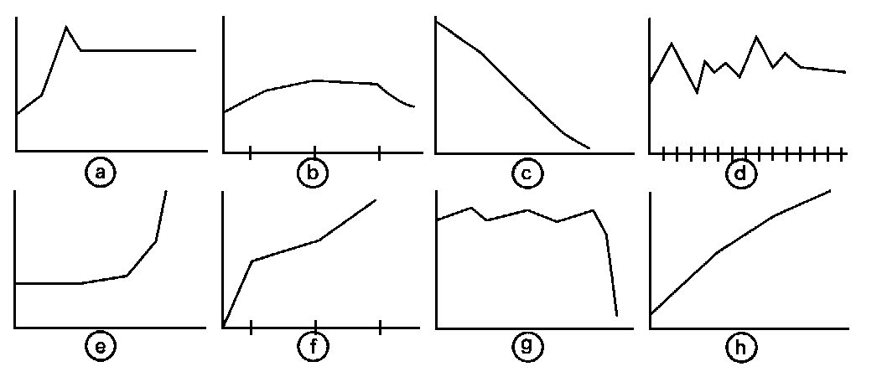
- The investment level rose suddenly.
- The sales of our products fell slightly in the final quarter.
- The Research and Development budget has stabilized over the past few years.
- At the end of the first year, sales stood at 50 per cent of the present level.
- The price reached a peak before falling a little and then maintaining the same level.
- There has been a steady increase in costs over several years.
- The sudden collapse in share prices has surprised everyone.
- The value of the shares has shown a steady decline.

2. Look at the graph below, then complete the sentences.

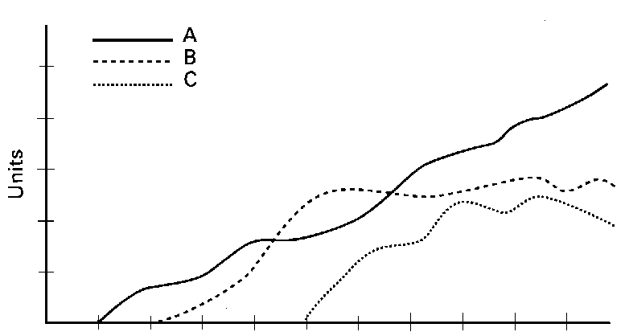

- The ............................................... compares three products : A, B and C.
- The ............. shows time over ten years while the ............. shows sales in number of units.
- As you can see, product A is represented by the ...............................................
- The performance of Product B is shown by the ..............................................
- And a …………………………………. has been used to show the results of Product C.
- Clearly, ................................... is the most successful product ....................................
- Sales of Product B .......................... in recent years while sales of Product C ......................
- On the contrary, product A has shown a ..................................................

Describing graphs and trends (exercises 2)

Name : Form : Date :

3. Read the following text and draw the corresponding graph on the right.

The graph opposite covers the years 1976 to 1995. It shows that the number of television viewing hours rose steadily and steeply during that period in the US, starting at just under 5 hours a day to reach more than 7 hours in 1995. There was a slight increase in 1982 and sharper falls in 1986 and 1991. The next decrease, in 1994, is hardly (à peine) significant. Though we do not have the latest figures, it is unlikely that the trend will have reversed.

4. Comment on the graph below using and organising the following expressions :

Sales rose / went up /
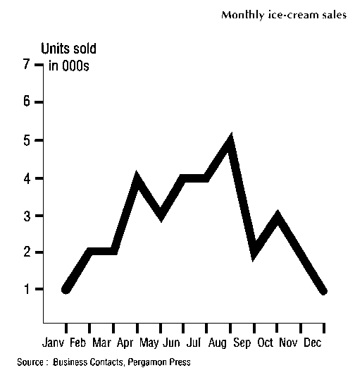
increased / climbed ...
+ adverb (slowly / steadily /
rapidly / gradually ...)
Sales stood at ...
Sales peaked / peaked out
Sales levelled out / flattened out
Sales bottomed out
This was due to ...
This was the result of ...
This caused ...
This led to ...

Avoid repetitions !

Conclude by saying whether
this graph is typical or not;
Justify your answer.

