Pie Charts: Valentine's Day Gifts
The graphs below show the types of gifts that men and women in the USA buy for each other on Valentine's Day.
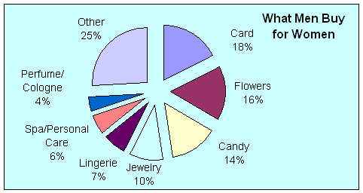
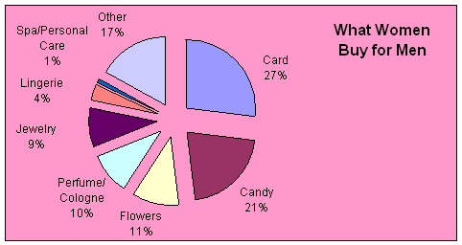
Answer the following questions:
- What are the top three gifts?
- What is the most popular gift?
- What percentage of men buy Valentine's Day cards?
- What percentage of women buy Valentine's Day cards?
- Are there any differences in the second most common gift?
- What is the second most popular gift bought by men?
- What percentage of men bought this gift for their loved one?
- What is the second most popular gift that women give men?
- What is the third most popular gift bought by men for women?

Valentine's Day Gifts
The two pie charts record the types of gifts that men and women in the US buy for each other.
There are three items which are most popular with both sexes. These are cards, flowers and candy. These three presents make nearly 50% of total male purchases, and are almost equally divided in popularity, with cards most popular by 2%, followed by flowers, and candy third.
Women spend nearly 60% on these items, but prefer cards over their second choice, candy, by a distinct margin. The third choice, flowers, accounts for about half the expenditure on candy, and nearly one third of the money spent on cards.
Apart from major, but unspecified spending on “other” – 25% for men and 17% for women - and almost identical spending on jewelry, there are no other noticeable similarities in the smaller categories. Men spend more on lingerie than on perfume for women, while women do the opposite.
In general the two sexes spend in similar ways for the most important categories, but have different spending patterns for the less standard presents.

