Graph Writing 2:

Read the following text and draw the graph.

Underground Station Passenger Numbers
The graph shows the fluctuation in the number of people at a London underground station over the course of a day.
The busiest time of the day is in the morning. There is a sharp increase between 06:00 and 08:00, with 400 people using the station at 8 o'clock. After this the numbers drop quickly to less than 200 at 10 o'clock. Between 11 am and 3 pm the number rises, with a plateau of just under 300 people using the station.
In the afternoon, numbers decline, with less than 100 using the station at 4 pm. There is then a rapid rise to a peak of 380 at 6pm. After 7 pm, numbers fall significantly, with only a slight increase again at 8pm, tailing off after 9 pm.
Overall, the graph shows that the station is most crowded in the early morning and early evening periods.

Graphs: The Vocabulary of Numbers
There are some special words for numbers, fractions and percentages.
Look at the following table which shows a number in different years (1990-1995) :
1990 | 1995
1200 | 1800
You could describe the above table using numbers, fractions or percentages:
- The number went up by 600, from 1200 to 800. (Number)
- The number went up by half, from 1200 to 1800. (Fraction)
- The figure went up by 50%, from 1200 to 1800. Percentage)
- The figure went up 150%, to 1800. (Percentage)
1992 | 1994 | 1996 | 1998
500 | 1000 | 3000 | 12000
Use “trebled,” “-fold,” and “times:”
- The number doubled between 1992 and 1994.
- The number trebled between 1994 and 1996.
- The figure quadrupled from 1996 to 1998
- There was a twofold increase between 1992 and 1994.
- The figure went up sixfold between 1992 and 1996.
- The figure in 1996 was three times the 1992 figure.
- The figure in 1998 was four times the 1996 figure.
1992 | 1994 | 1996 | 1998
1000 | 800 | 400 | 100
Use Fractions:
- Between 1992 and 1994, the figure fell by one-fifth.
- Between 1994 and 1996, the number dropped by a half.
- The figure in 1998 was one-tenth the 1992 total.

Source:
http://writefix.com

Graphs: Types of Graphs
You are likely to meet only two types of graphs in IELTS or other intermediate English tests – time and comparison graphs. (Sometimes you can get both in the same test!)
- In time graphs you have to describe changes over time.
- In comparison graphs you have to compare different items – countries, people, products, places, etc.
The vocabulary for each kind of graph is different:
- In time graphs you use time vocab to describe change: rose, fell, declined, shot up, increased, remained steady, etc.
- In comparison graphs you compare: twice as much as, more than, less than, the same amount, both X and Y have the same figure, etc.

Time Graphs
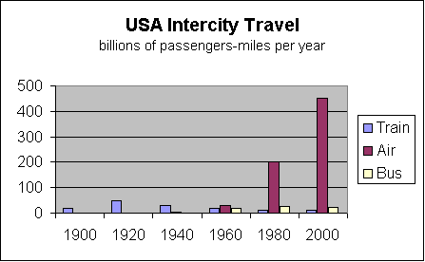
You have to compare different methods of transport used in the US over the last century – train, bus and air.
You could start with
- train (because it is the oldest method)
- by air (because it is the biggest method of public transport today.)
- However, don’t start with bus because it is very small and not the main idea
The main trend with rail transport is that it rose to a peak in the 1920s and 1930s and then declined.
The main trend with air is that it started late, in the 1960s, but it has shot up to become by far the biggest carrier of passengers.

Comparison Graphs
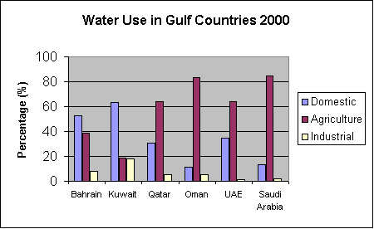
You have to compare the amount of water used for domestic, agricultural and industrial purposes.
There are two ways to write about this graph:
- by country (make groups, e.g. Saudi Arabia and Oman, which have mainly agricultural use, then Bahrain and Kuwait which have mainly domestic use, etc)
- by use (Agriculture, then Domestic, then Industrial.)
If you decide to write by describing use, you could start with Agriculture because it is the biggest user. Group together Saudi Arabia and Oman as the top users, and then group UAE and Qatar as the middle group of users, using 60% of water for agriculture. Finally mention Bahrain and Kuwait.
Your second paragraph should be about Domestic use, the use of water in the home, because it is the second biggest use. Start with Kuwait and Bahrain (grouped together) (more than 50%) and then write about Qatar and the UAE.

Source:
http://writefix.com

Writing about Graphs: Overview

Before you Begin
Underline key words. Write related words – turn nouns into verbs, verbs into nouns, adjectives into adverbs, etc. Write opposite words, similar words, synonyms, etc.
Circle and highlight the graph. Use arrows. Make notes. Circle the biggest, the smallest. stable or unchanging parts, sudden increases, etc.
Identify trends. A trend is the overall idea of the graph
- what is happening/what happened
- the main change over time
- the most noticeable thing about the graph
- the pattern over time
- the pattern for different places or groups or people.
Most IELTS graphs will have two trends, or there will be two graphs with a trend in each. You could write about the two trends in two separate paragraphs. Make sure you have identified the trends in the graph. If you don’t, you can’t get IELTS Band 6.

While you Write: Layout
Introduction
- First sentence: Describe the graph. You can use some slightly different words or word forms from those on the question paper, but be careful to give the full information. Start “The graph shows“
- Second sentence: This gives the trend or trends. You can put two trends in this sentence or only one – you could keep the other one for the conclusion. Start “Overall, …”
Paragraph 1: Trend 1
- Start with a sentence with no number. “City size increased sharply over the period.” “The most obvious trend in the graph is that women are having fewer babies.” “Oil production has increased slightly in all the countries in the graph”
- Follow this sentence with an example (sentence with number) and perhaps another example (another sentence with number). Keep alternating.
Paragraph 2: Trend 2
- Start with a sentence with no number. “City size increased sharply over the period.”
- Give an example (sentence with number) and perhaps another example (Sentence with number)

Conclusion
- Finish by repeating the main trends, or identify a second trend. Use different vocabulary.
- Don’t have any numbers in the conclusion (you could use words like “most”, “the majority” “a minority”, “a small number”).
- Don’t give an opinion.
While You Write: Some Don’ts
- Don’t describe the X and Y axis. Give the information.
- Don’t write about everything on the graph. Pick the biggest, the smallest, the main points, the main trends. Group similar things together
- Don’t write about the line or the bar: “The line went up,” “The bar went down.” Instead, write about the idea. “The number of people going to work by train increased gradually.” “Oil production shot up in 1965”
- Make sure you write about the idea. Don’t use shorthand: “Men went up.” “Women went down.” Instead, write about the real data: “The number of men at university fell dramatically,” “The percentage of female students getting a degree rose suddenly.”
- Don’t use “I feel”, “as I have written,” “as you can see,” etc. Keep it academic. In IELTS, you can give your opinions in Task 2. In Task 1 (writing about a graph or visual data) you just report what you see.
- Don’t start sentences with But, So, Also, And, For, Since, Because, Although
- Do you really need four paragraphs in IELTS Task 1? No! (You definitely need them for Task 2). But it’s good to think about four paragraphs. It will help you to organize your writing. So go ahead and write four paragraphs, or at least three (intro, body, conclusion).

Word Length and Sentence Length
Make sure you have 150 words. You should have some short sentences (about 6-10 words) and some long ones (12-18) words, but your average should be about 12 or 13 words per sentence.
A sentence without a number will usually be short. Use a mix – a sentence without a number followed by a sentence or two with a number.

Source:
http://writefix.com

Pie Charts: Valentine's Day Gifts
The graphs below show the types of gifts that men and women in the USA buy for each other on Valentine's Day.
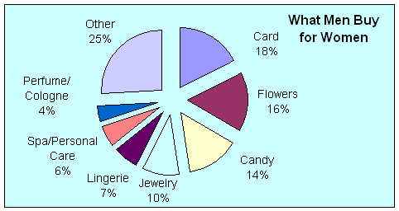
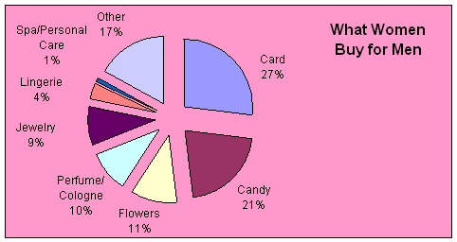
Answer the following questions:
- What are the top three gifts?
- What is the most popular gift?
- What percentage of men buy Valentine's Day cards?
- What percentage of women buy Valentine's Day cards?
- Are there any differences in the second most common gift?
- What is the second most popular gift bought by men?
- What percentage of men bought this gift for their loved one?
- What is the second most popular gift that women give men?
- What is the third most popular gift bought by men for women?
Now write a graph description based on these main ideas. Then ask your teacher for a sample text.
Source: http://www.admc.hct.ac.ae/hd1/english/graphs/pie_valentines.htm

solution :

Valentine's Day Gifts

The two pie charts record the types of gifts that men and women in the US buy for each other.
There are three items which are most popular with both sexes. These are cards, flowers and candy. These three presents make nearly 50% of total male purchases, and are almost equally divided in popularity, with cards most popular by 2%, followed by flowers, and candy third.
Women spend nearly 60% on these items, but prefer cards over their second choice, candy, by a distinct margin. The third choice, flowers, accounts for about half the expenditure on candy, and nearly one third of the money spent on cards.
Apart from major, but unspecified spending on “other” – 25% for men and 17% for women - and almost identical spending on jewelry, there are no other noticeable similarities in the smaller categories. Men spend more on lingerie than on perfume for women, while women do the opposite.
In general the two sexes spend in similar ways for the most important categories, but have different spending patterns for the less standard presents.
178 words

Go through the package again and collect lots of useful phrases. Write all the new language into your vocab book.

