Topic: Attitudes and Values
Individual Long Turn (5 minutes)

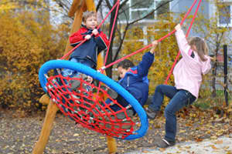
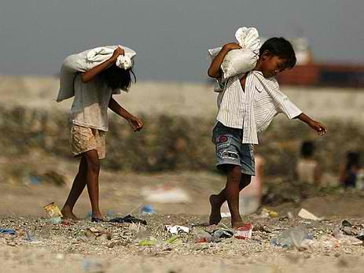

- Compare the pictures

- Give your opinion on the use of child labour in the developing world to make cheap products for the Western market

- Discuss to what extent parents should try to include their own beliefs and values in their children’s upbringing

Topic: Attitudes and Values
Individual Long Turn (5 minutes)

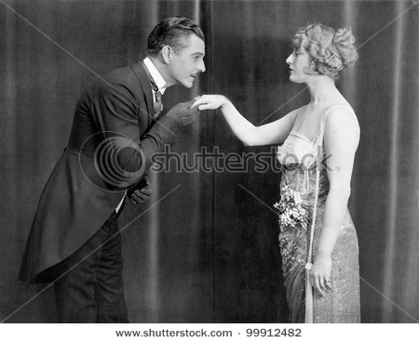


- Compare the pictures

- Discuss whether good manners are still as important today as they were in times past

- Explain how ignorance of local customs and manners can cause problems when people go abroad

Topic: Childhood and Adolescence
Individual Long Turn (5 minutes)

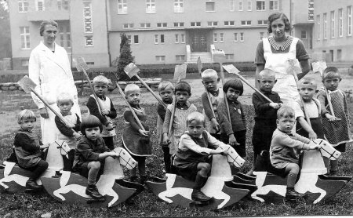
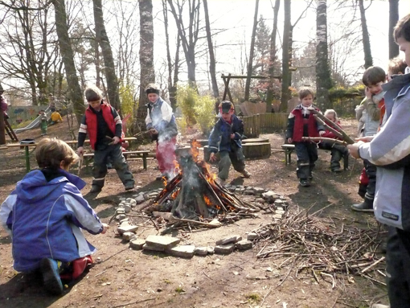

- Compare the pictures

- Discuss how much freedom children need in order to develop into well-balanced teenagers

- Suggest reasons why members of the older generation often say children today have a much easier life than they did as children

Topic: Childhood and Adolescence
Individual Long Turn (5 minutes)

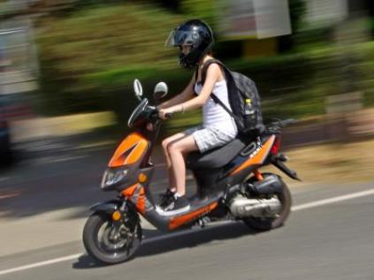

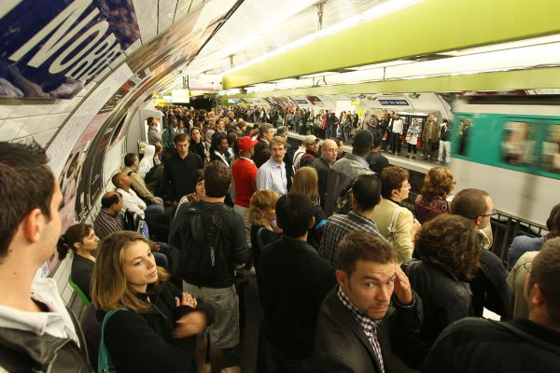

- Compare the pictures

- Analyze the benefits and drawbacks of growing up in the countryside compared with growing up in an urban environment

- Evaluate the importance of learning to drive for a young adult

Topic: Citizenship
Individual Long Turn (5 minutes)

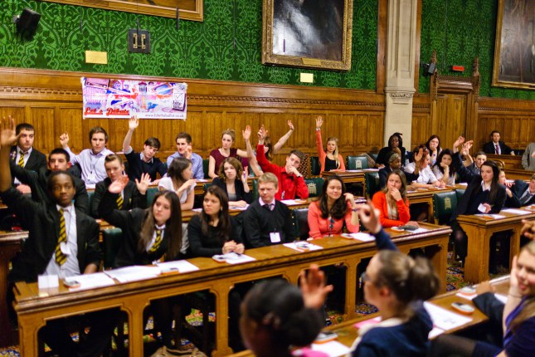
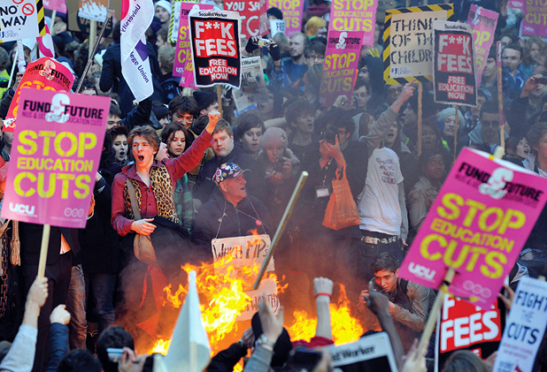

- Comment on the pictures

- Outline some possible reasons why young people are often not interested in politics nowadays

- Discuss what could be done to encourage political interest among teenagers

Topic: Citizenship
Individual Long Turn (5 minutes)

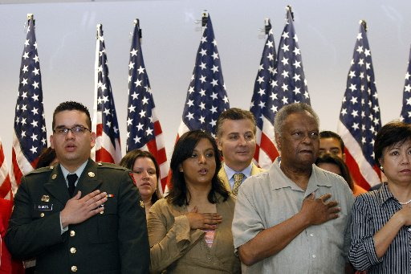



- Compare and contrast the pictures

- Comment on different ways of serving one’s country and fellow citizens

- Speculate on what patriotism means to young people nowadays

Topic: Culture and Society
Individual Long Turn (5 minutes)
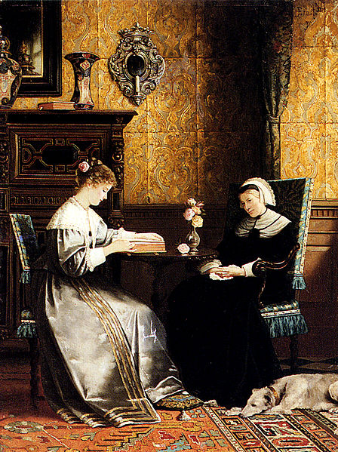
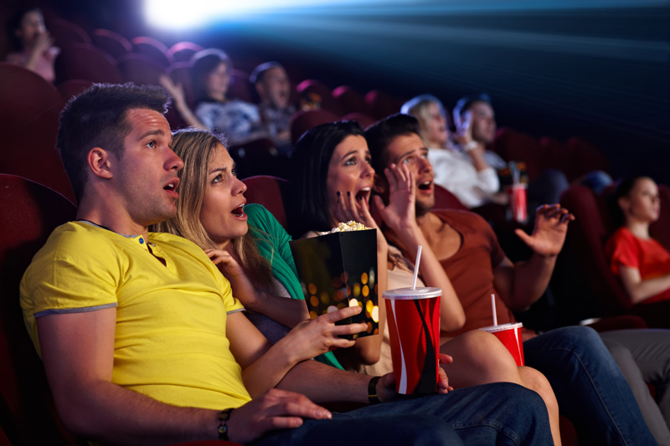

- Compare the pictures

- Explain what reading means to you personally

- Discuss the pros and cons of making a film version of a book

Topic: Culture and Society
Individual Long Turn (5 minutes)

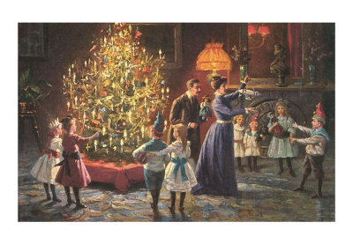


- Compare the pictures

- Give your opinion on the importance of maintaining traditions andcustoms

- Suggest how traditions and customs might change in the future

Topic: Current Trends
Individual Long Turn (5 minutes)

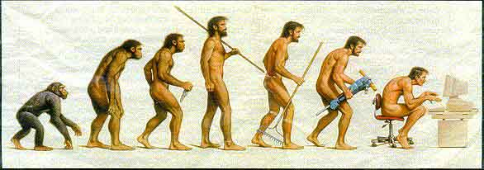



- Comment on the pictures

- Evaluate the impact of the internet and social networking on your everyday life

- Discuss whether over-use of communication technology is causing people to lose important skills

Topic: Current Trends
Individual Long Turn (5 minutes)





- Compare the pictures

- Give reasons for the current popularity of online dating

- Discuss the possible consequences of people’s increasing dependence on electronic media

Topic: Diversity in Society
Individual Long Turn (5 minutes)
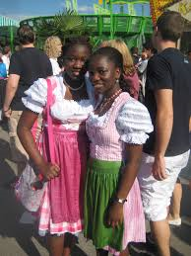
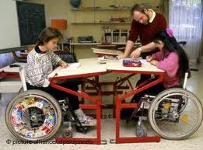
- Comment on the pictures

- Discuss what obstacles society has to overcome in order to become more diverse

- Suggest what Austrian schools could do to encourage and cultivate diversity
Topic: Diversity in Society
Individual Long Turn (5 minutes)

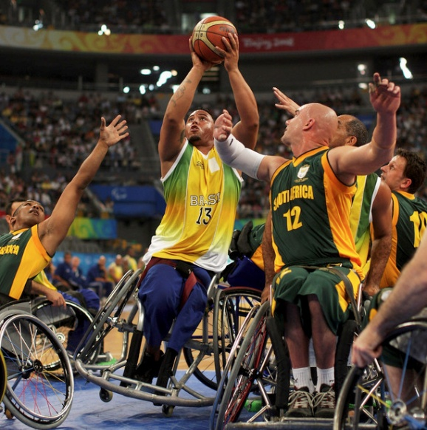
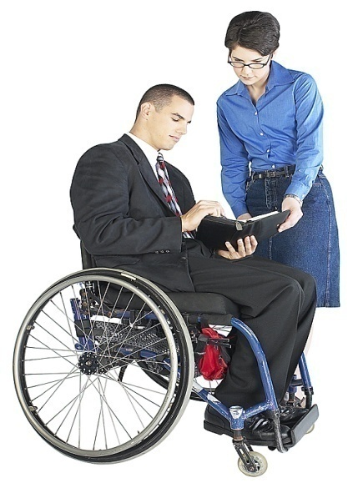

- Compare and contrast the pictures

- Evaluate the importance for our society of staging sporting events for the disabled

- Analyze the difficulties still faced by disabled people in society today

Topic: Education, Ambitions and Work
Individual Long Turn (5 minutes)

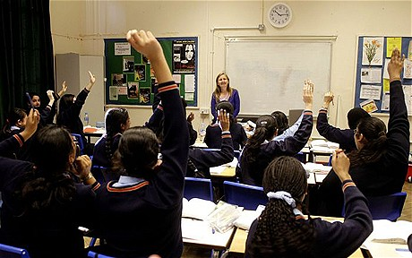
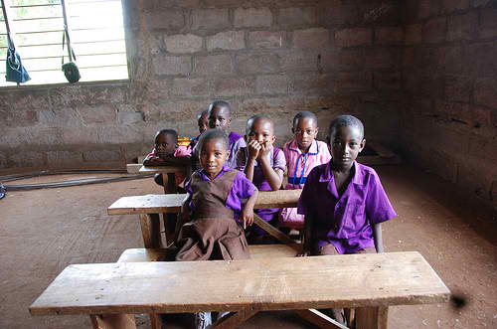

- Compare the pictures

- Explain why it is absolutely essential for all people to receive an education

- Evaluate the education you have received

Topic: Education, Ambitions and Work
Individual Long Turn (5 minutes)

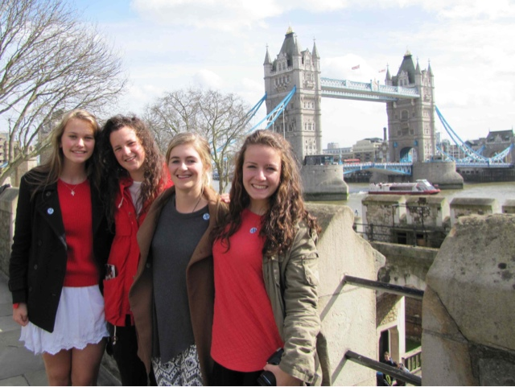

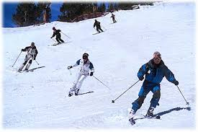

- Compare the pictures

- Discuss to what extent trips and excursions are an important part of school education

- Suggest in what ways schools and universities could improve to prepare students better for the world of work

Topic: Experiences and Emotions
Individual Long Turn (5 minutes)

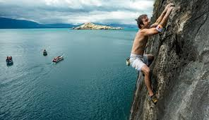

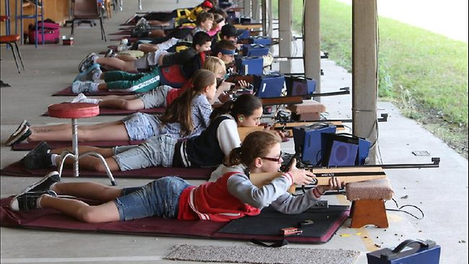

- Compare and contrast the pictures

- Explain what you personally gained from an experience that meant a lot to you

- Discuss what schools can do to introduce students not only to knowledge but also to new experiences and emotions

Topic: Experiences and Emotions
Individual Long Turn (5 minutes)


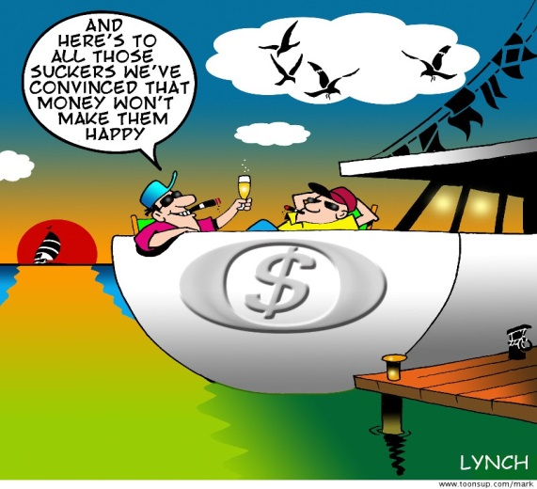

- Comment on the illustrations

- Discuss the role money plays in your life

- Give your opinion on whether it is possible to be happy without having a lot of money

Topic: Health and Nutrition
Individual Long Turn (5 minutes)

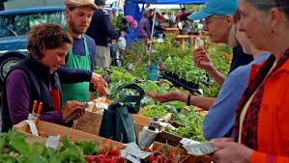

- Compare and contrast the pictures

- Suggest what could be done to make people more aware of their eating habits

- Discuss the pros and cons of buying and eating locally produced food and food from distant sources

Topic: Health and Nutrition
Individual Long Turn (5 minutes)

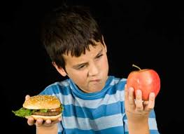

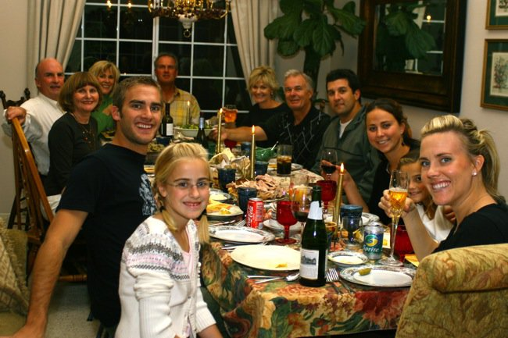

- Compare the pictures

- Describe some of the ways in which food and eating play an important role in human rituals and social life

- Discuss how lifestyle changes in the last fifty years have influenced our eating habits
Topic: Holidays and Celebrations
Individual Long Turn (5 minutes)
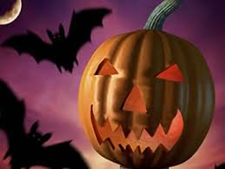
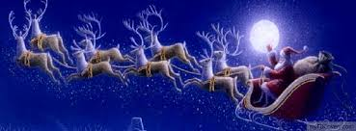

- Comment on the pictures

- Discuss how important Halloween and Christmas are in Austria or another country you have lived in

- Give your opinion on whether religious celebrations should be held at school

Topic: Holidays and Celebrations
Individual Long Turn (5 minutes)
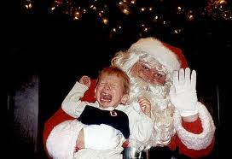



- Compare and contrast the pictures

- Give reasons why a certain celebration you personally experienced was memorable

- Discuss the importance of communal celebrations for society

Topic: Inspirational Characters
Individual Long Turn (5 minutes)

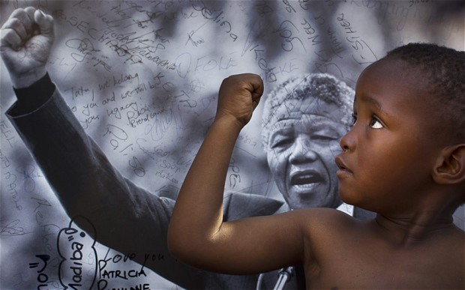

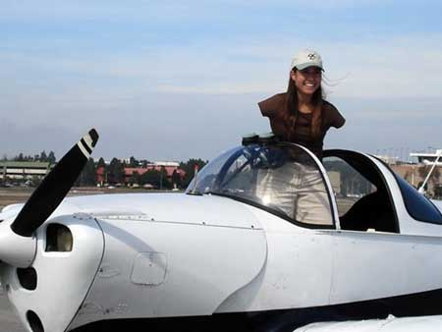

- Comment on the pictures

- Discuss the kinds of problems inspirational characters have to deal with

- Give reasons why it is important for young people to have good role models

Topic: Inspirational Characters
Individual Long Turn (5 minutes)

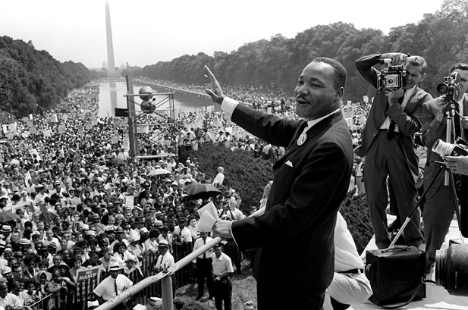

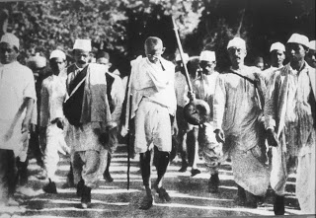

- Comment on the pictures

- Describe the qualities and characteristics that make an individual an inspiration to others

- Evaluate the importance for you personally of an individual (past or present) who has impressed you in some way

Topic: Lifestyle and Leisure
Individual Long Turn (5 minutes)

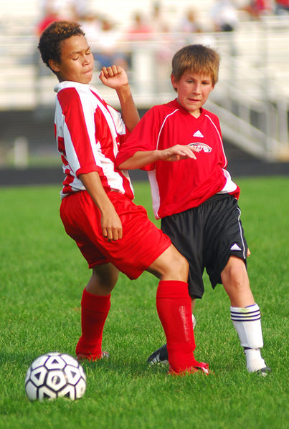

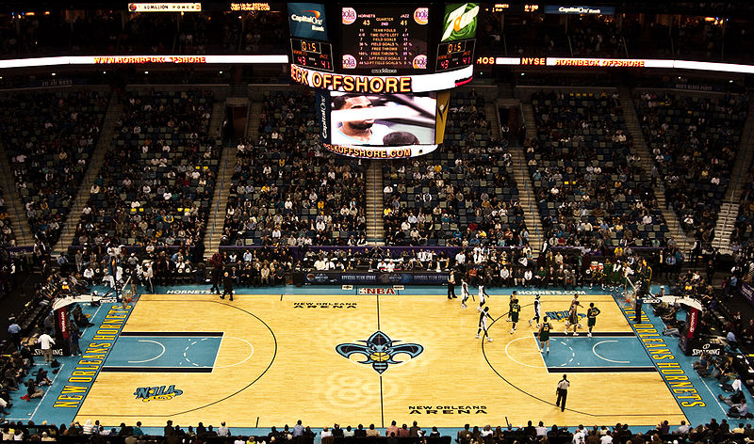

- Compare the pictures

- Explain in what ways young people can benefit from doing sport

- Discuss how the role of sport in society has changed and developed

Topic: Lifestyle and Leisure
Individual Long Turn (5 minutes)


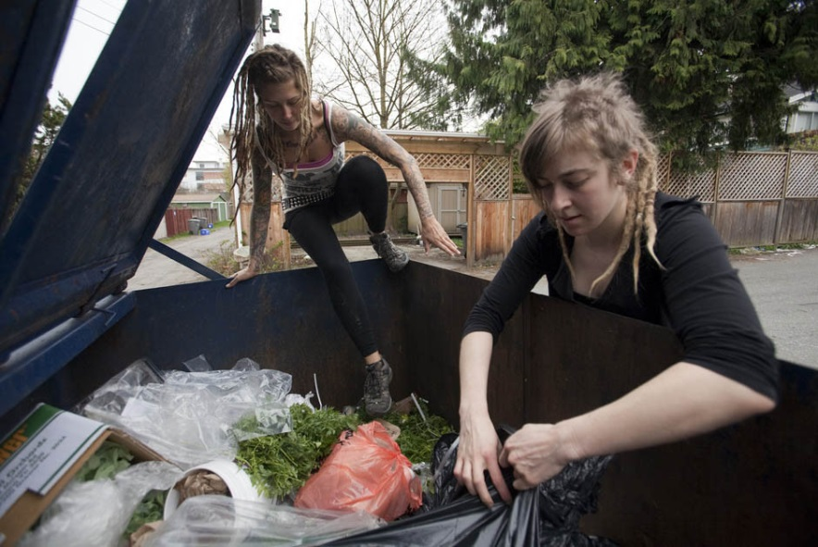

- Comment on the pictures

- Discuss the advantages and disadvantages of consumerism

- Outline how society deals with people who cannot or do not want to be part of the consumer society

Topic: Media Matters
Individual Long Turn (5 minutes)



- Compare and contrast the pictures

- Explain what it is you particularly like about the methods of communication you yourself use most often

- Discuss the disadvantages of relying heavily on technological methods of communication

Topic: Media Matters
Individual Long Turn (5 minutes)
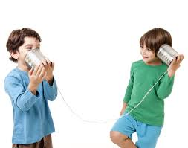
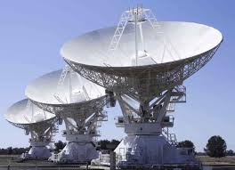

- Compare and contrast the pictures

- Compare some of the ways people communicated in the past with how we communicate today

- Discuss the advantages and disadvantages of face-to-face communication and electronic communication

Topic: Media Matters
Individual Long Turn (5 minutes)

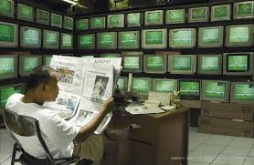
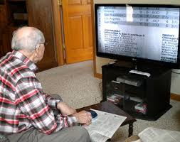

- Compare the pictures

- Evaluate the importance of keeping up with what is happening in the world

- Discuss the advantages and disadvantages of having constant access to news coverage

Topic: Media Matters
Individual Long Turn (5 minutes)

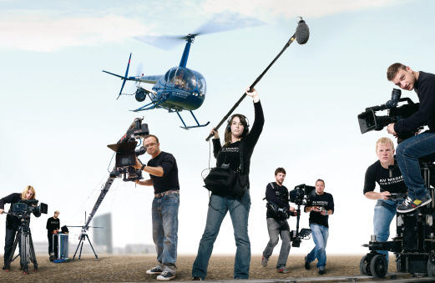

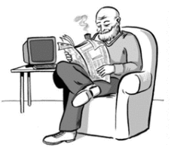

- Compare the pictures

- Outline how the new media have changed our lives in the last 20 years

- Discuss whether the rapid advancements in digital technology have created a gap between the generations

Topic: Music and Entertainment
Individual Long Turn (5 minutes)

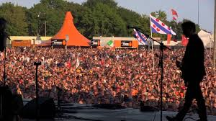
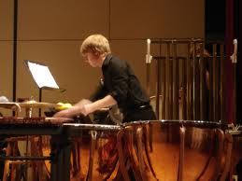

- Compare and contrast the pictures

- Comment on the differences between the various types of musical events that are on offer in Austria

- Discuss the advantages and disadvantages of attending live performances of music as opposed to listening to recorded music
Topic: Music and Entertainment
Individual Long Turn (5 minutes)



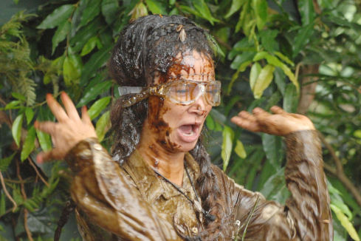

- Compare and contrast the pictures

- Evaluate reality shows as a form of entertainment

- Discuss the pros and cons for the host country of staging an international eventlike the Eurovision Song Contest
Topic: People and Relationships
Individual Long Turn (5 minutes)

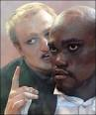

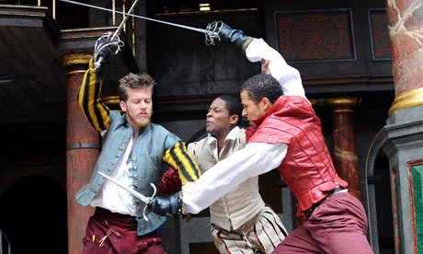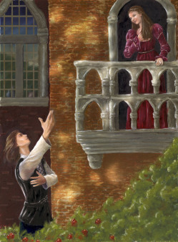

- Compare the pictures

- Explain how novels, stories and plays can give us insight into the way people think and behave and relate to each other

- Outline some human qualities and characteristics that have a positive effect on people’s relationships with each other

Topic: People and Relationships
Individual Long Turn (5 minutes)

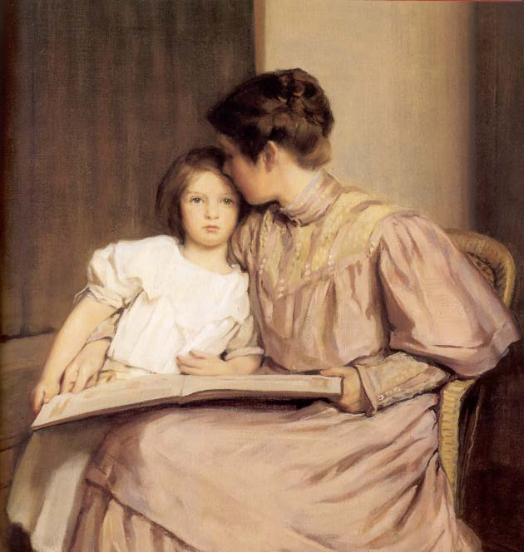
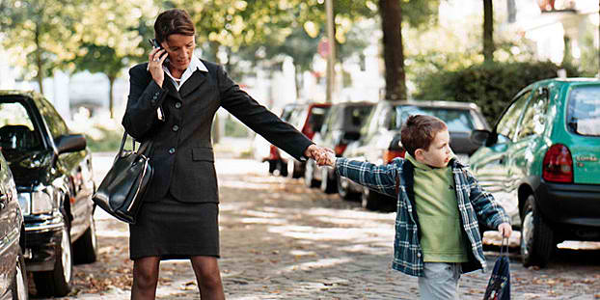

- Compare the pictures

- Explain how gender roles have changed over the last century

- Suggest how your own life might turn out in the future with regard to combining career and family

Topic: Planet Earth
Individual Long Turn (5 minutes)
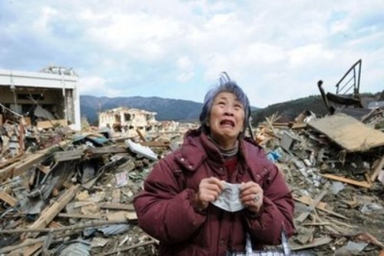
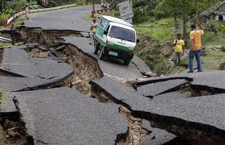
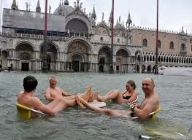

- Compare and contrast the pictures

- Outline the consequences of some of the natural disasters that happen in various parts of the world

- Explain what the negative effects of climate change might turn out to be

Topic: Planet Earth
Individual Long Turn (5 minutes)
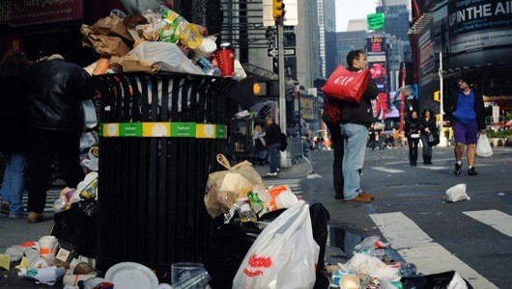
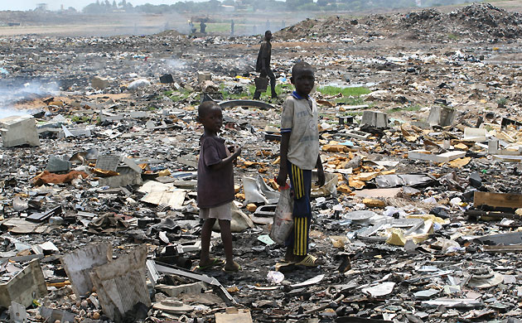

- Compare and contrast the pictures

- Analyze the problem of the waste created by the consumer society

- Explain what changes we could all make in our daily lives to help protect the environment

Topic: Reading
Individual Long Turn (5 minutes)


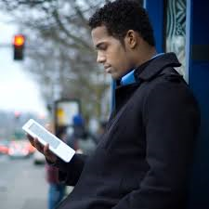

- Compare the pictures

- Explain why a certain book or short story you have read made a particular impression on you

- Discuss the various kinds of literature that people read and why

Topic: Reading
Individual Long Turn (5 minutes)



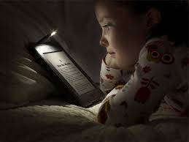

- Compare and contrast the pictures

- Give your opinion on what the most common types of reading are that people do in their daily lives nowadays

- Discuss the advantages and disadvantages of reading conventional paper books versus e-books

Topic: Science and Technology
Individual Long Turn (5 minutes)

Paro, the robot pet seal
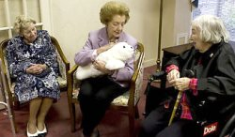
…………………………………………………………………………………………………………..……
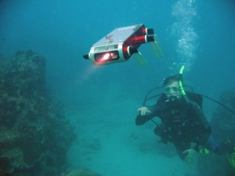

- Compare the pictures

- Outline some ways in which robots are already used and ways in which they may be used in the future

- Discuss the advantages and disadvantages of using robots instead of human teachers in the education of children
Topic: Science and Technology
Individual Long Turn (5 minutes)
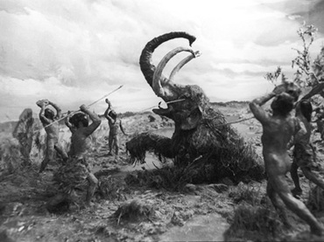
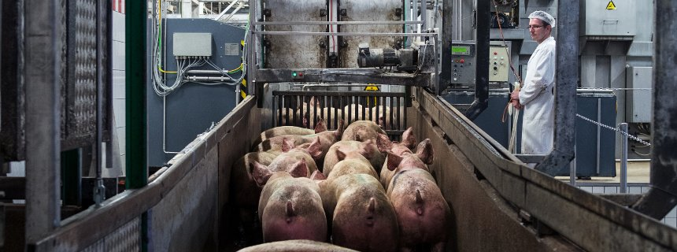

- Compare and contrast the pictures

- Outline the impact of technology on our lives over the last 200 years

- Assess how difficult it would be for you personally to do without certain technological devices

Topic: Sport and Fitness
Individual Long Turn (5 minutes)

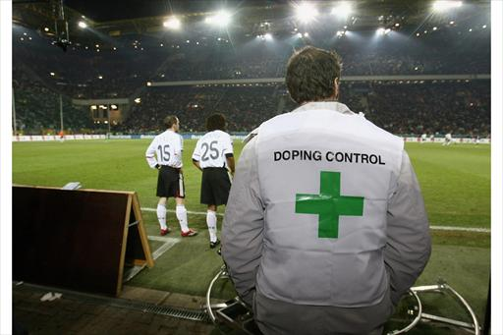
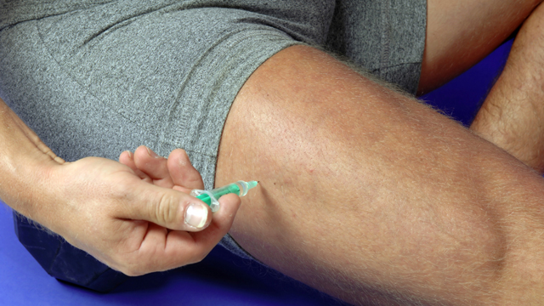

- Comment on the pictures

- Discuss why athletes still use illegal substances despite the risk to their careers and their health

- Give your opinion on the use of illegal substances in sport

Topic: Sport and Fitness
Individual Long Turn (5 minutes)

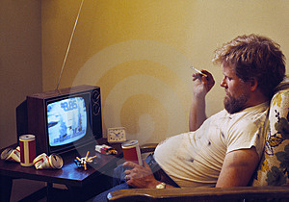

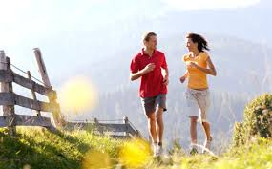

- Compare and contrast the pictures

- Speculate why children and teenagers often prefer to spend time with phones and computers than be physically active

- Discuss which types of exercise you consider to be the best for maintaining health and fitness

Topic: Sport and Fitness
Individual Long Turn (5 minutes)

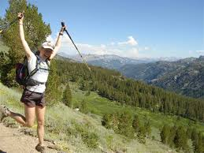



- Comment on the pictures

- Give your opinion on the role physical education and sport at school can play in helping students stay fit

- Discuss to what extent our society is obsessed with health and fitness

Topic: The English-Speaking World
Individual Long Turn (5 minutes)

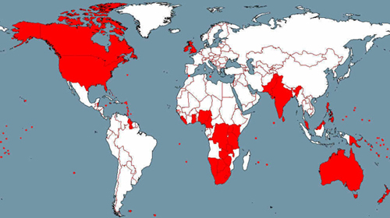

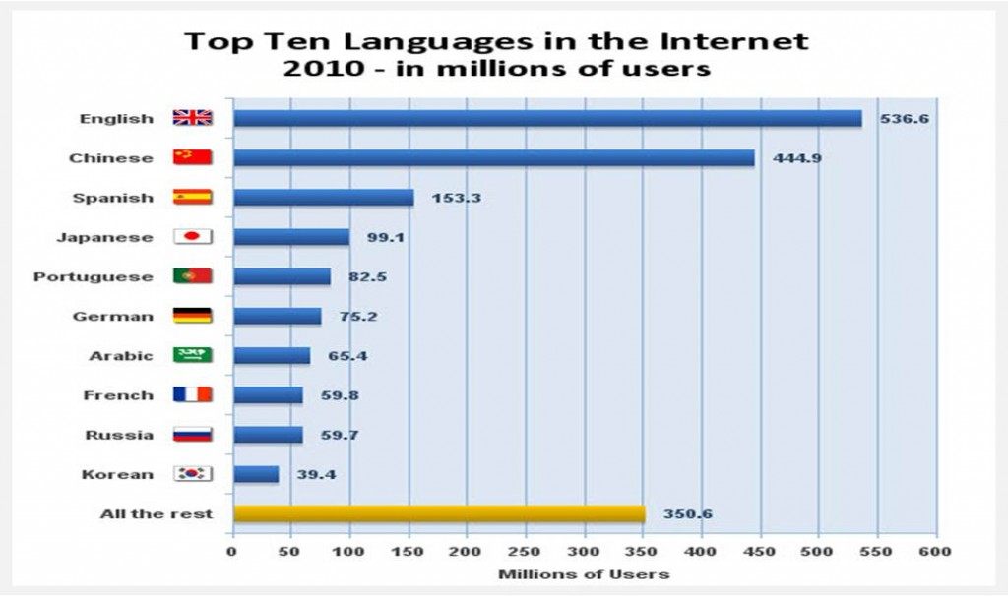

- Comment on the illustrations

- Discuss the role of the English language in the world today

- Evaluate the importance of a good knowledge of English for young Austrians

Topic: The English-Speaking World
Individual Long Turn (5 minutes)
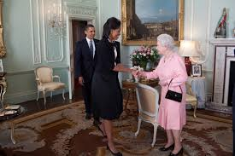

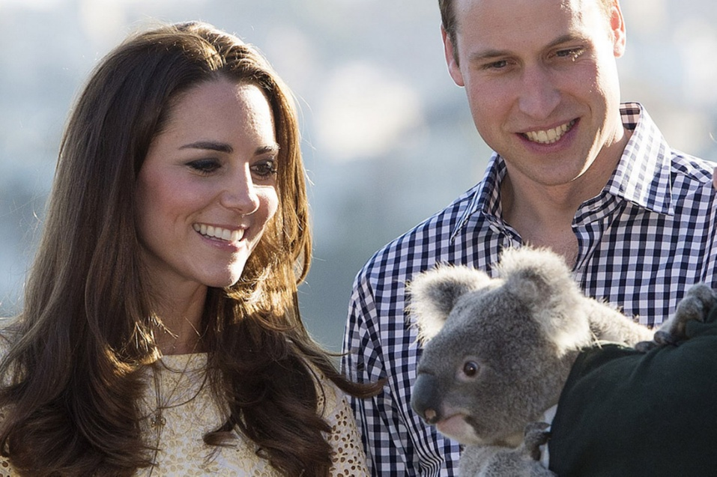

- Compare and contrast the pictures

- Evaluate the global influence of political leaders, Royalty and other celebrities from English-speaking countries

- Speculate on how British and American people view Austria and Austrians

Topic: The Individual and Society
Individual Long Turn (5 minutes)



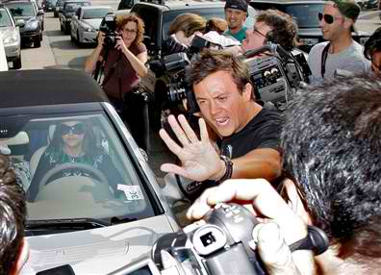

- Compare and contrast the pictures

- Speculate why so many people are interested in the lives of celebrities

- Give your opinion on whether celebrities deserve to earn the vast sums of money they do

Topic: The Individual and Society
Individual Long Turn (5 minutes)
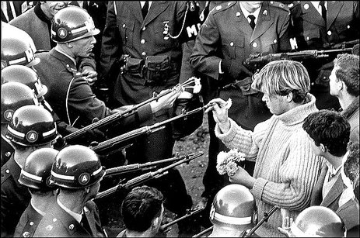
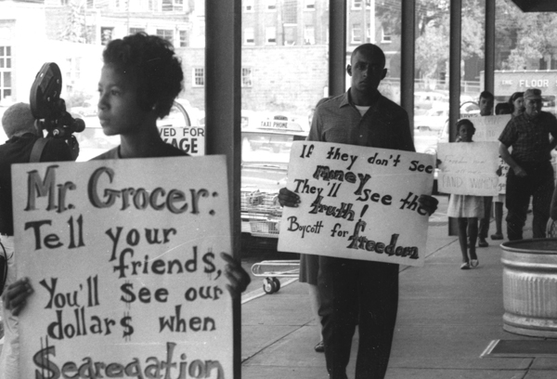

- Comment on the pictures

- Explain what makes people stand up for themselves and take action

- Discuss whether young people today are committed enough to fightfor something they believe in

Topic: Travel and Tourism
Individual Long Turn (5 minutes)

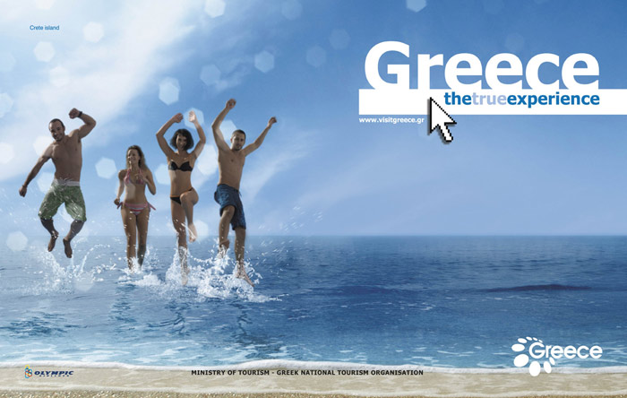

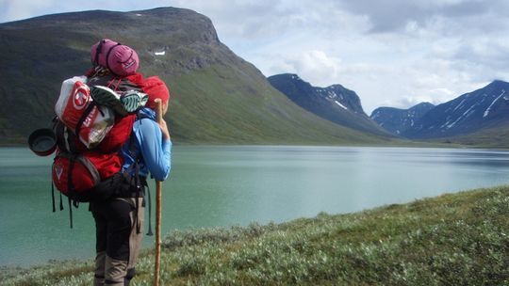

- Compare the pictures

- Evaluate the importance of travel to you personally

- Discuss the impact of tourism on the environment

Topic: Travel and Tourism
Individual Long Turn (5 minutes)

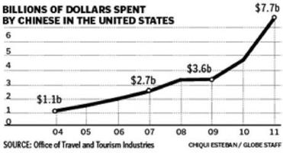
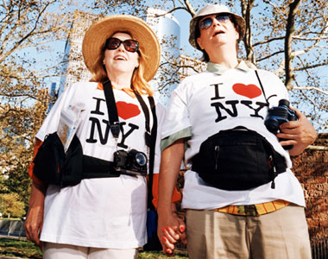

- Comment on the graph and the picture

- Discuss the impact of mass tourism on popular holiday destinations and on tourists themselves

- Elaborate on your ideal holiday

Topic: Visions of the Future
Individual Long Turn (5 minutes)

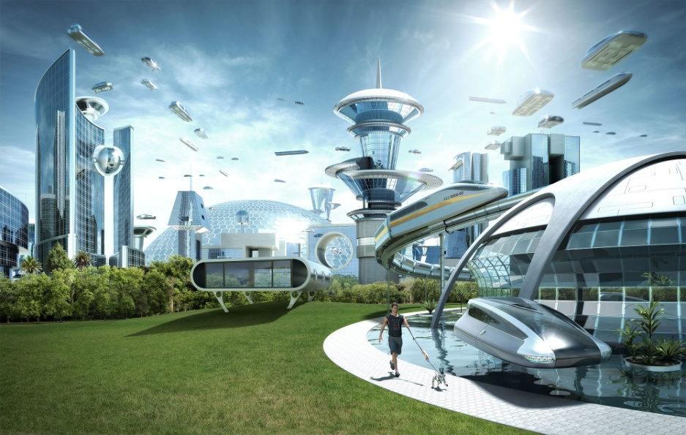


- Comment on the pictures

- Discuss the ways in which novels, stories and films tend to portray the future

- Evaluate the importance of physics, biology and chemistry as school subjects for upcoming generations of students

Topic: Visions of the Future
Individual Long Turn (5 minutes)
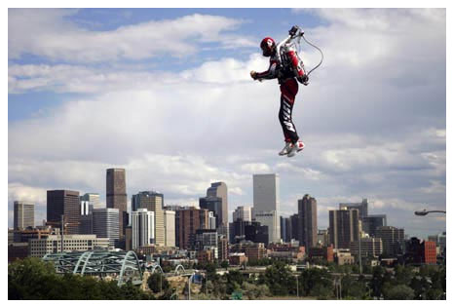

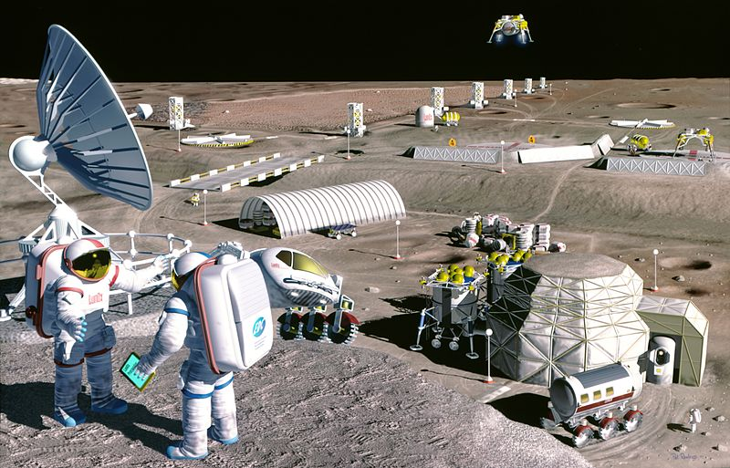

- Comment on the pictures

- Outlinethe most serious problems facing humanity in the future

- Speculate on the ideal world of tomorrow

Topic: Youth Culture
Individual Long Turn (5 minutes)

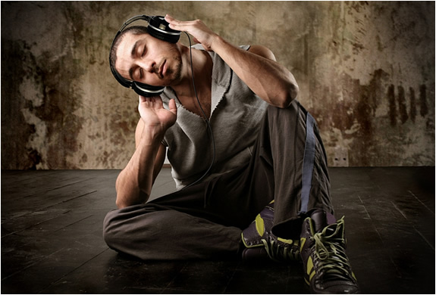

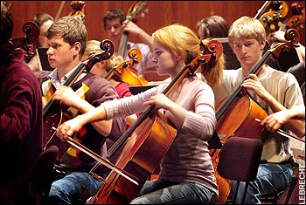

- Compare the pictures

- Elaborate on the role music plays in your life

- Discuss the differences between attending live music performances and listening to music on an mp3 player

Topic: Youth Culture
Individual Long Turn (5 minutes)

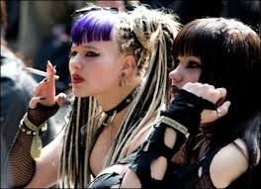
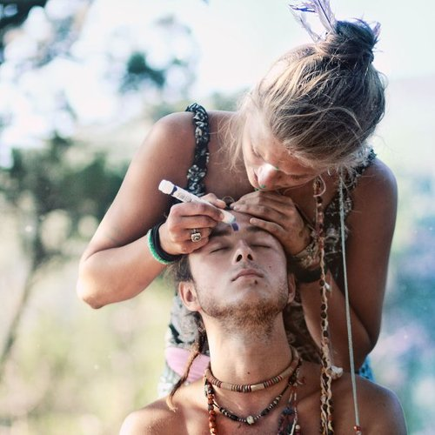

- Comment on the pictures

- Discuss the impact of peer pressure on teenagers’ choice of clothing and style

- Evaluate the influence of fashion advertising on young people

