1.1
Topic: Attitudes and Values
Individual Long Turn (5 minutes)

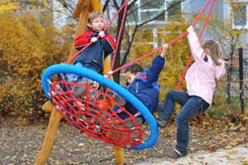
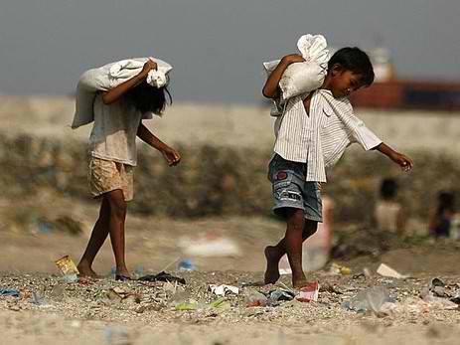
- Compare the pictures.

- Give your opinion on the use of child labor in the developing world and its connection to cheap products for the Western market.

- Discuss to what extent parents should try to include their own beliefs and values in their children’s upbringing.

1.2
Topic: Attitudes and Values
Individual Long Turn (5 minutes)
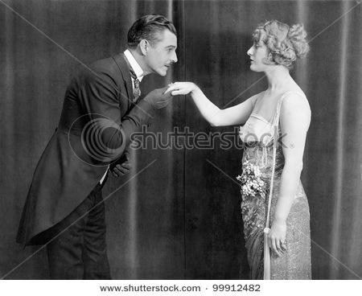


- Compare the pictures.

- Discuss whether good manners are still as important today as they were in times past.

- Explain how ignorance of local customs and manners can cause problems when people go abroad.

7.1
Topic: Childhood and Adolescence
Individual Long Turn (5 minutes)

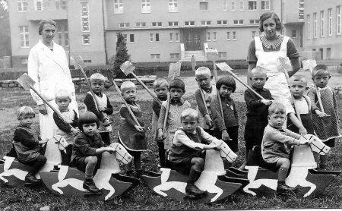
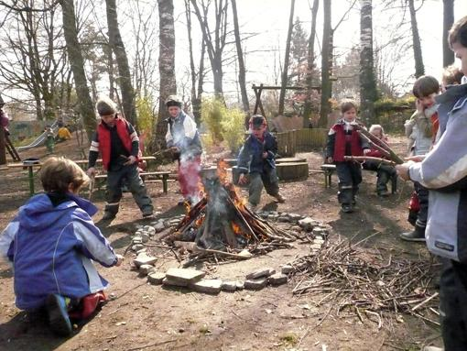

- Compare the pictures.

- Discuss how much freedom children need in order to develop into well-balanced teenagers.

- Suggest reasons why members of the older generation often say children today have a much easier life than they did as children. Do you agree?

7.2
Topic: Childhood and Adolescence
Individual Long Turn (5 minutes)

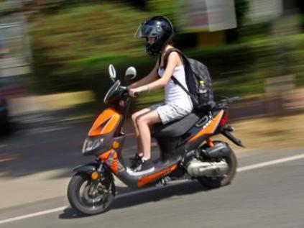

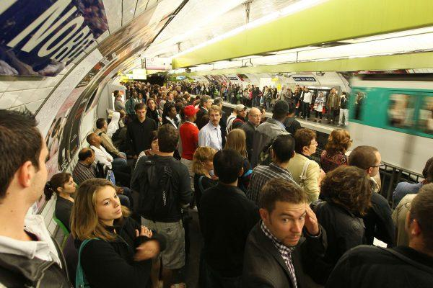

- Compare the pictures.

- Analyze the benefits and drawbacks of growing up in the countryside compared with growing up in an urban environment.

- Evaluate the importance of learning to drive for a young adult.

23.1
Topic: Citizenship
Individual Long Turn (5 minutes)

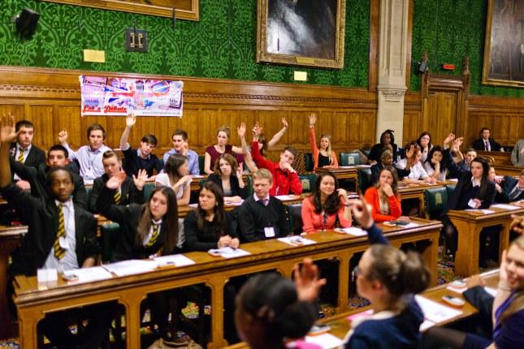
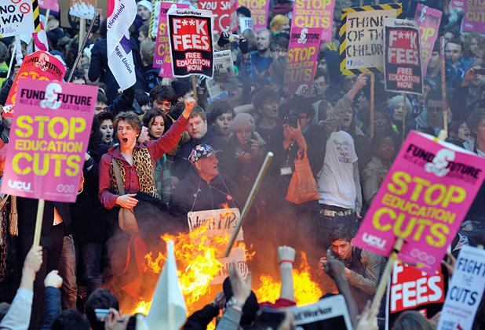

- Comment on the pictures.

- Outline some possible reasons why young people are often not interested in politics nowadays.

- Discuss what could be done to encourage political interest among teenagers.

23.2
Topic: Citizenship
Individual Long Turn (5 minutes)
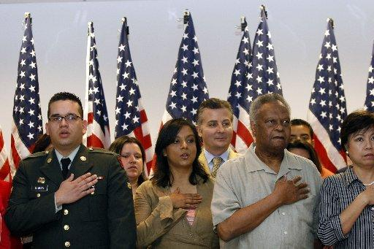



- Compare and contrast the pictures.

- Comment on different ways of serving one’s country and fellow citizens.

- Discuss what patriotism means to young people nowadays and what forms it takes.

2.1
Culture and Society
Individual Long Turn (5 minutes)
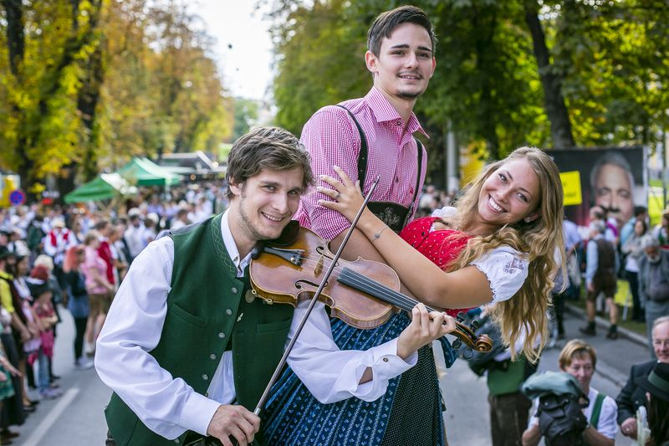
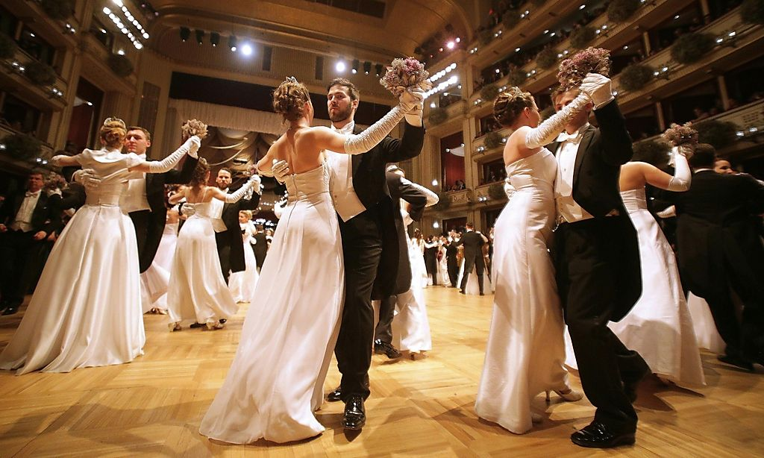
- Compare and contrast the pictures.

- Comment on what aspects are connected to the term “Austrian culture” for you and compare it to other cultures around the globe.

- Discuss whether big cultural events (like the Opernball) are necessary to reaffirm our cultural identities.

21.1
Topic: Reading
Individual Long Turn (5 minutes)
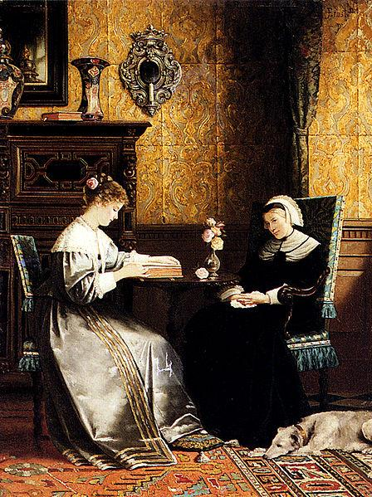
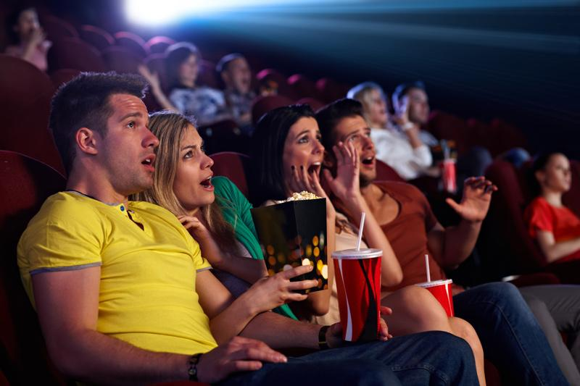

- Compare the pictures.

- Explain what reading means to you personally.

- Discuss the advantages and disadvantages of making a film version of a book.

2.2
Topic: Culture and Society
Individual Long Turn (5 minutes)

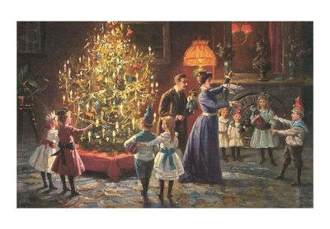


- Compare the pictures.

- Give your opinion on the importance of maintaining traditions and customs.

- Suggest how traditions and customs might change in the future.

3.1
Topic: Current Trends
Individual Long Turn (5 minutes)

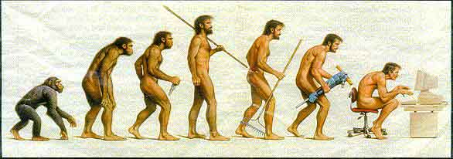



- Comment on the pictures.

- Evaluate the impact of the internet and social networking on your everyday life.

- Discuss whether over-use of communication technology is causing people to lose important skills.

3.2
Topic: Current Trends
Individual Long Turn (5 minutes)





- Compare the pictures.

- Give reasons for the current popularity of online dating.

- Discuss the possible consequences of people’s increasing dependence on electronic media.

4.1
Topic: Diversity in Society
Individual Long Turn (5 minutes)
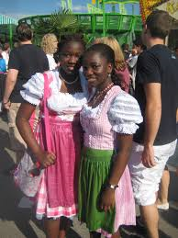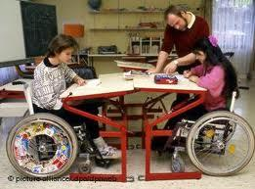

- Comment on the pictures.

- Discuss what obstacles society has to overcome in order to become more diverse.

- Suggest what Austrian schools could do to encourage and cultivate diversity.

4.2
Topic: Diversity in Society
Individual Long Turn (5 minutes)

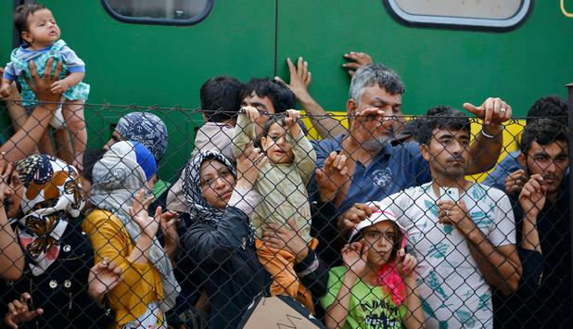

- Compare and contrast the pictures.

- Discuss the different reactions to refugees in Europe and the reasons behind them.

- Evaluate the opportunities and challenges involved in integrating refugees into our society.

5.1
Topic: Education, Ambitions and Work
Individual Long Turn (5 minutes)

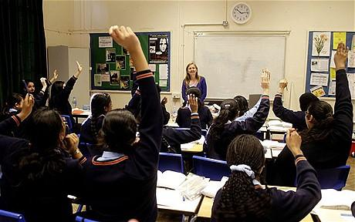
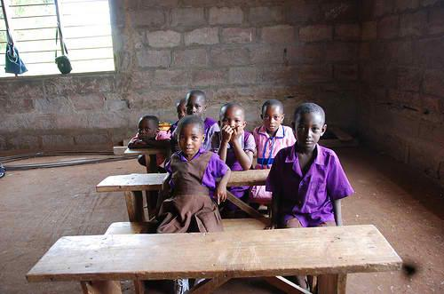

- Compare the pictures.

- Explain why it is absolutely essential for all people to receive an education.

- Evaluate the education you have received.

5.2
Topic: Education, Ambitions and Work
Individual Long Turn (5 minutes)

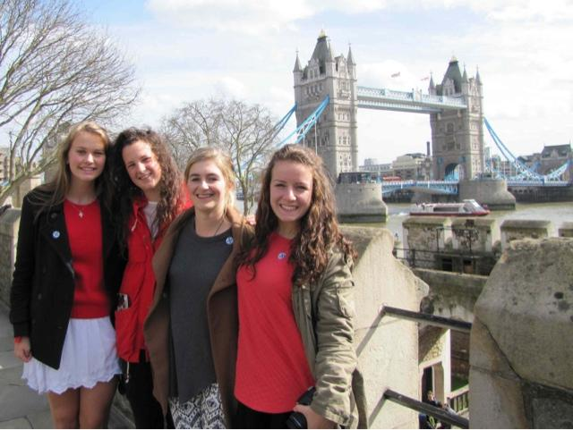
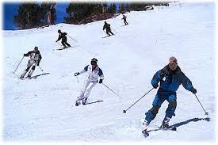

- Compare the pictures.

- Discuss to what extent trips and excursions are an important part of school education.

- Suggest in what ways schools and universities could improve to prepare students better for the world of work.

6.1
Topic: Experiences and Emotions
Individual Long Turn (5 minutes)

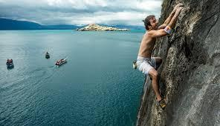

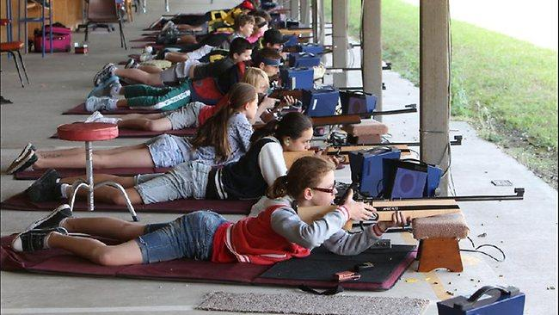

- Compare and contrast the pictures.

- Explain what you personally gained from an experience that meant a lot to you.

- Discuss what schools can do to introduce students not only to knowledge but also to new experiences and emotions.

6.2
Topic: Experiences and Emotions
Individual Long Turn (5 minutes)


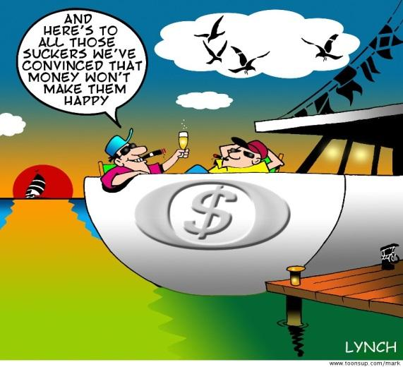

- Comment on the illustrations.

- Discuss the role money plays in your life.

- Give your opinion on whether it is possible to be happy without having a lot of money.

19.1
Topic: Health and Nutrition
Individual Long Turn (5 minutes)
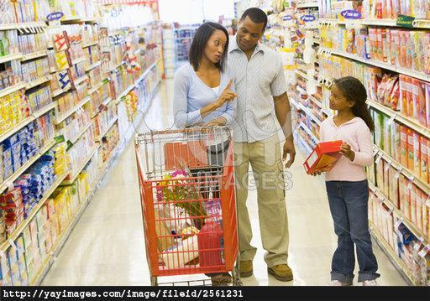
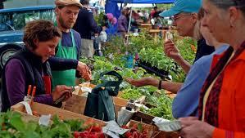

- Compare and contrast the pictures.

- Suggest what could be done to make people more aware of their eating habits.

- Discuss the advantages and disadvantages of buying and eating locally produced food and food from distant sources.

19.2
Topic: Health and Nutrition
Individual Long Turn (5 minutes)

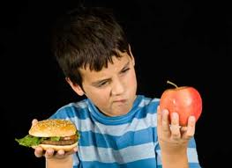

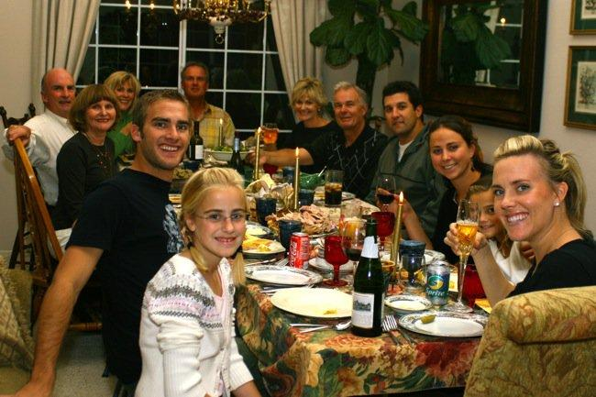
- Compare the pictures.

- Describe some of the ways in which food and eating play an important role in human rituals and social life.

- Discuss how lifestyle changes in the last fifty years have influenced our eating habits.

20.1
Topic: Holidays and Celebrations
Individual Long Turn (5 minutes)
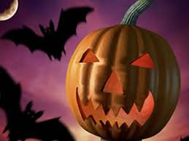
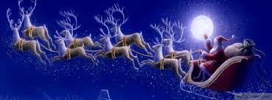

- Comment on the pictures.

- Discuss how important Halloween and Christmas are in Austria or another country you have lived in.

- Give your opinion on whether religious celebrations should be held at school.

20.2
Topic: Holidays and Celebrations
Individual Long Turn (5 minutes)
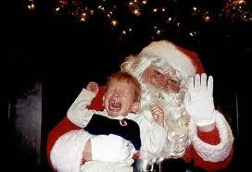

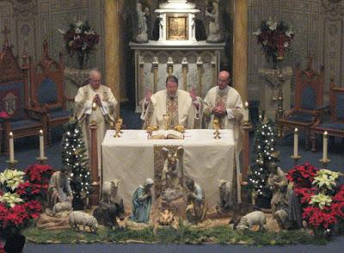

- Compare and contrast the pictures.

- Give reasons why a certain celebration you personally experienced was memorable.

- Discuss the importance of communal celebrations for society.

8.1
Topic: Inspirational Characters
Individual Long Turn (5 minutes)

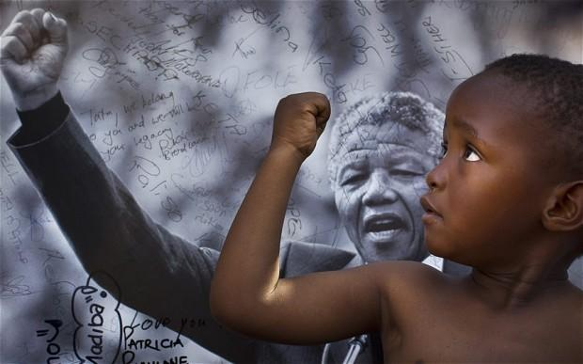

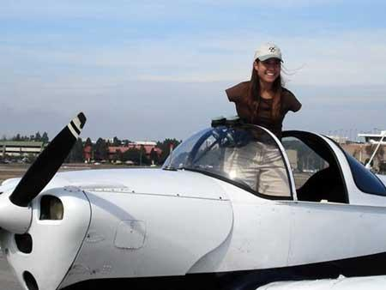

- Comment on the pictures.

- Present a few characters that you find inspiring and give reasons why you find them inspiring.

- Give reasons why it is important for young people to have good role models in their daily lives.

8.2
Topic: Inspirational Characters
Individual Long Turn (5 minutes)

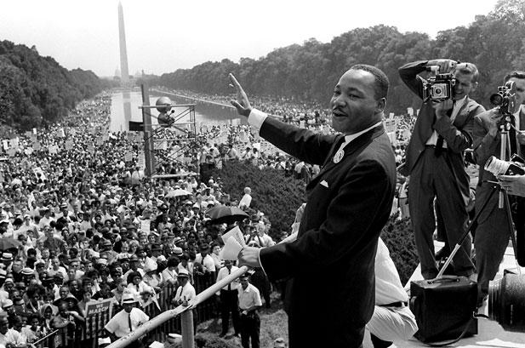

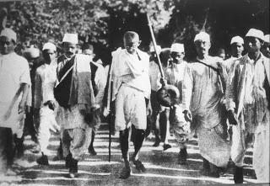

- Comment on the pictures.

- Describe the qualities and characteristics that make an individual an inspiration to others.

- Evaluate the importance for you personally of an individual (past or present) who has impressed you in some way.

9.1
Topic: Lifestyle and Leisure
Individual Long Turn (5 minutes)
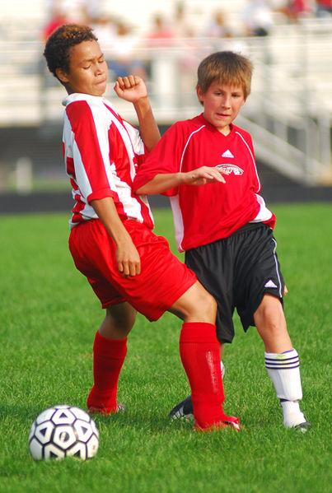
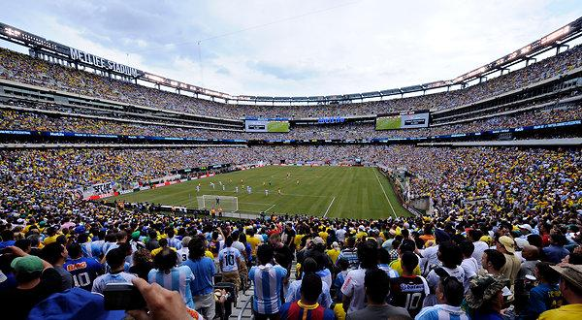
- Compare the pictures.

- Discuss how the role of sport in society has changed and developed.

- Explain in what ways young people can benefit from doing sport.

9.2
Topic: Lifestyle and Leisure
Individual Long Turn (5 minutes)


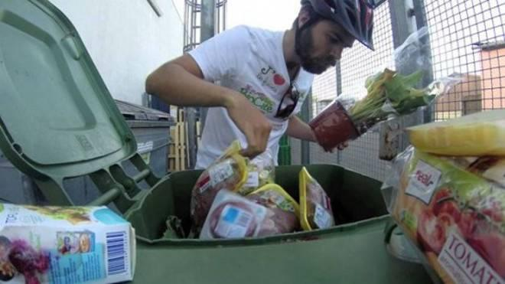
- Comment on the pictures.

- Discuss the advantages and disadvantages of consumerism.

- Outline how society deals with people who cannot or do not want to be part of the consumer society.

10.1
Topic: Media Matters
Individual Long Turn (5 minutes)



- Compare and contrast the pictures.

- Explain what it is you particularly like about the methods of communication you yourself use most often.

- Discuss the advantages and disadvantages of relying heavily on technological methods of communication.

10.2
Topic: Media Matters
Individual Long Turn (5 minutes)
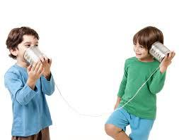
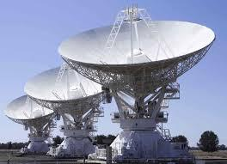

- Compare and contrast the pictures.

- Compare some of the ways people communicated in the past with how we communicate today.

- Discuss the advantages and disadvantages of face-to-face communication and electronic communication.

10.3
Topic: Media Matters
Individual Long Turn (5 minutes)

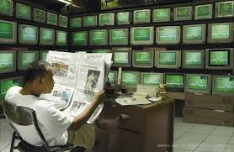
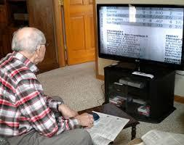

- Compare the pictures.

- Evaluate the importance of keeping up with what is happening in the world.

- Discuss the advantages and disadvantages of having constant access to news coverage.

10.4
Topic: Media Matters
Individual Long Turn (5 minutes)

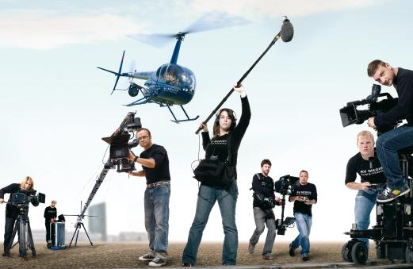

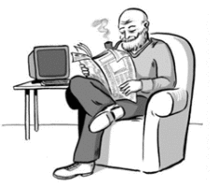

- Compare the pictures.

- Outline how the new media have changed our lives in the last 20 years.

- Discuss whether the rapid advancements in digital technology have created a gap between the generations.

24.1
Topic: Music, Art and Entertainment
Individual Long Turn (5 minutes)

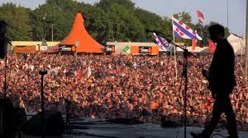
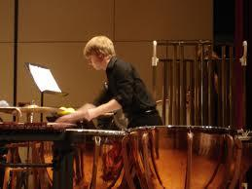

- Compare and contrast the pictures.

- Comment on the differences between the various types of musical events that are on offer in Austria.

- Discuss the advantages and disadvantages of attending live performances of music as opposed to listening to recorded music.

24.2
Topic: Music, Art and Entertainment
Individual Long Turn (5 minutes)


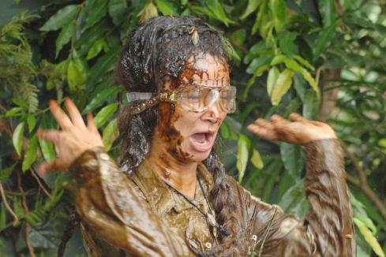

- Compare and contrast the pictures.

- Evaluate reality shows as a form of entertainment.

- Discuss the pros and cons for the host country of staging an international event like the Eurovision Song Contest.

11.1
Topic: People and Relationships
Individual Long Turn (5 minutes)
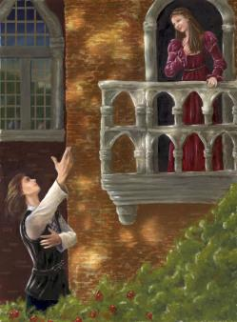
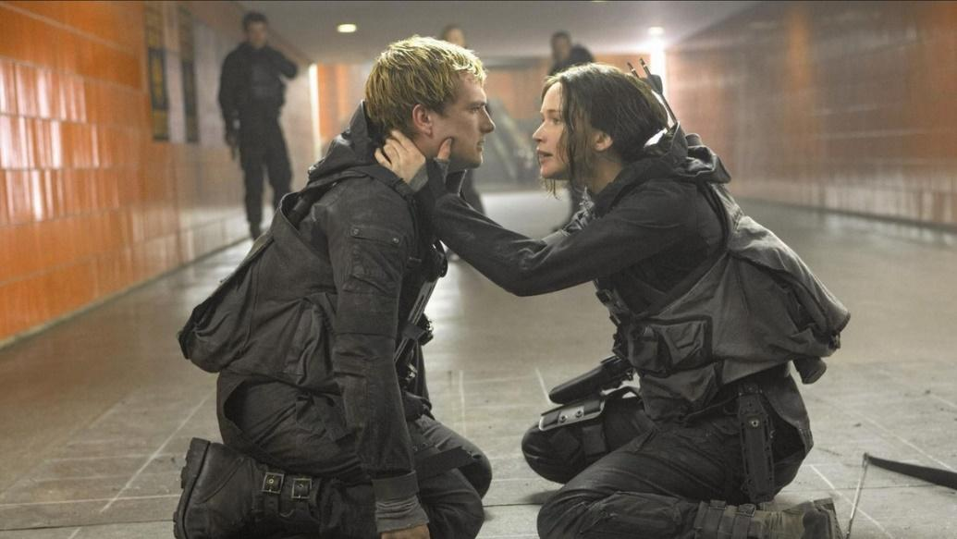

- Compare the pictures.

- Explain how novels, stories and plays can give us insight into the way people think and behave and relate to each other.

- Outline some human qualities and characteristics that have a positive effect on people’s relationships with each other.

11.2
Topic: People and Relationships
Individual Long Turn (5 minutes)

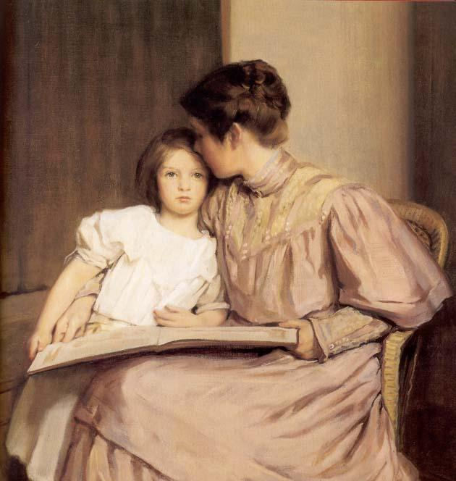
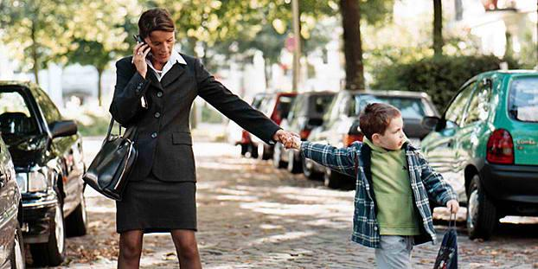
- Compare the pictures.

- Explain how gender roles have changed over the last century.

- Suggest how your own life might turn out in the future with regard to combining career and family.

12.1.
Topic: Planet Earth
Individual Long Turn (5 minutes)
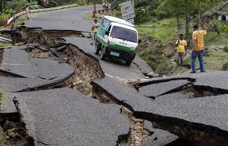
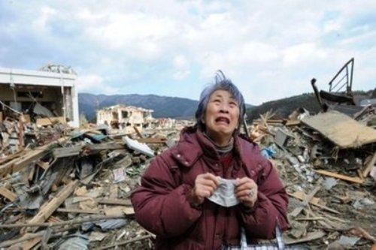

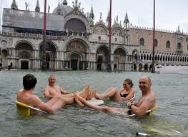

- Compare and contrast the pictures.

- Outline the consequences of climate change across the globe.

- Suggest possible steps individuals can take to keep global warming at bay.

12.2
Topic: Planet Earth
Individual Long Turn (5 minutes)
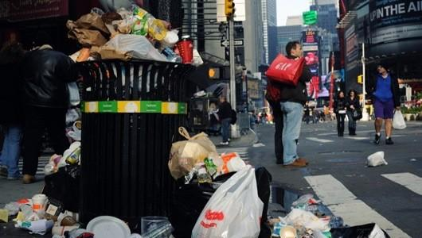
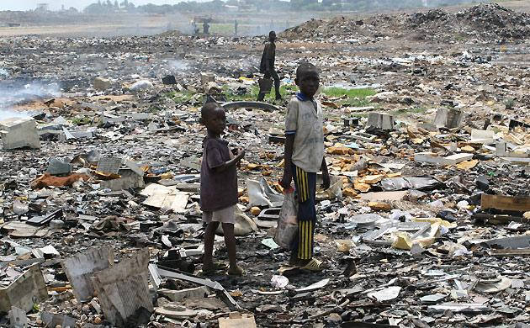

- Compare and contrast the pictures.

- Analyze the problem of the waste created by the consumer society.

- Explain what changes we could all make in our daily lives to help protect the environment.

21.2
Topic: Reading
Individual Long Turn (5 minutes)


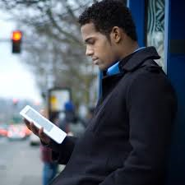

- Compare the pictures.

- Explain why a certain book or short story you have read made a particular impression on you.

- Discuss the benefits of reading for young people.

21.3
Topic: Reading
Individual Long Turn (5 minutes)



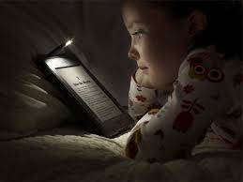

- Compare and contrast the pictures.

- Give your opinion on what the most common types of reading are that people do in their daily lives nowadays.

- Discuss the advantages and disadvantages of reading paper editions versus e-readers.

13.1
Topic: Science and Technology
Individual Long Turn (5 minutes)

Paro, the robot pet seal
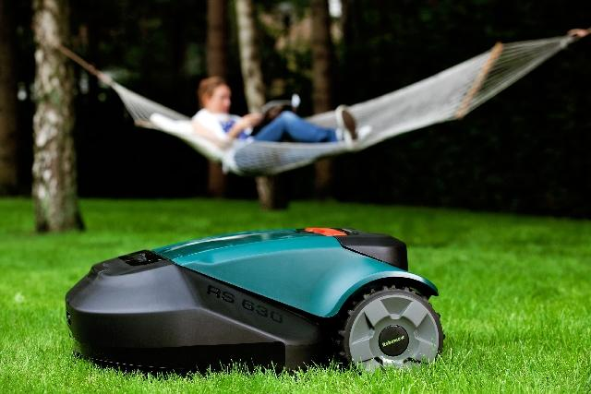
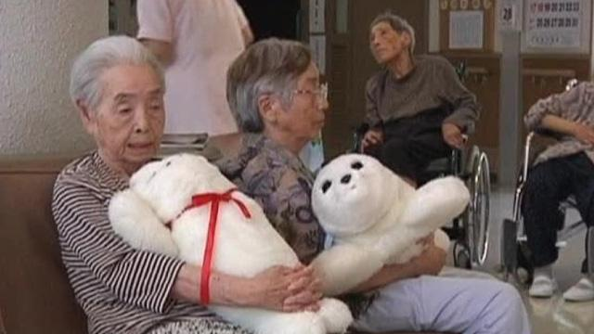

- Compare the pictures.

- Outline some ways in which robots are already used and ways in which they may be used in the future.

- Discuss the advantages and disadvantages of using new media and technology in education.

13.2
Topic: Science and Technology
Individual Long Turn (5 minutes)
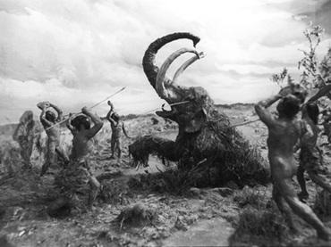
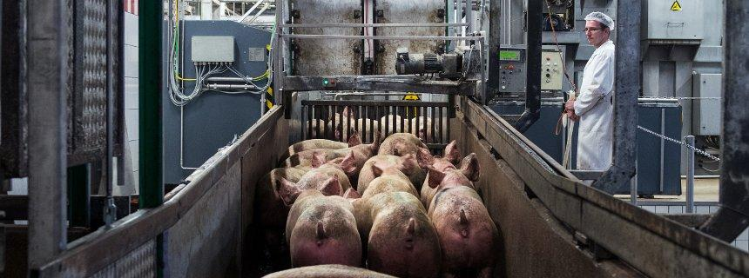

- Compare and contrast the pictures.

- Outline the impact of technology on our lives over the last 200 years.

- Assess how difficult it would be for you personally to do without certain technological devices.

22.1
Topic: Sport and Fitness
Individual Long Turn (5 minutes)

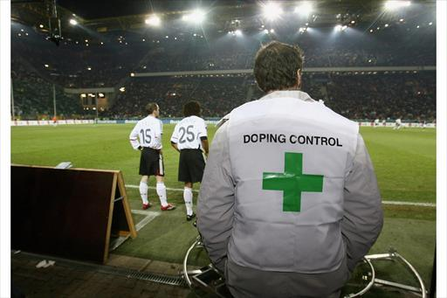
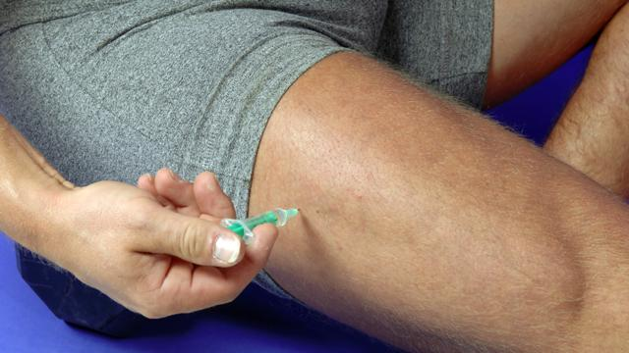

- Comment on the pictures.

- Discuss why athletes still use illegal substances despite the risk to their careers and their health.

- Give your opinion on the use of illegal substances in sport.

22.2
Topic: Sport and Fitness
Individual Long Turn (5 minutes)

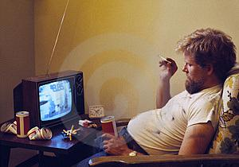

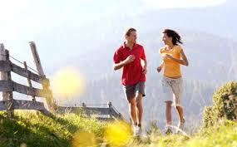

- Compare and contrast the pictures.

- Speculate why children and teenagers often prefer to spend time with phones and computers than be physically active.

- Discuss which types of exercise you consider to be the best for maintaining health and fitness.

22.3
Topic: Sport and Fitness
Individual Long Turn (5 minutes)

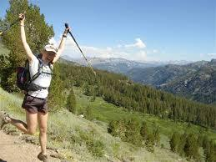



- Comment on the pictures.

- Give your opinion on the role physical education and sport at school can play in helping students stay fit.

- Discuss to what extent our society is obsessed with health and fitness.

14.1
Topic: The English-Speaking World
Individual Long Turn (5 minutes)

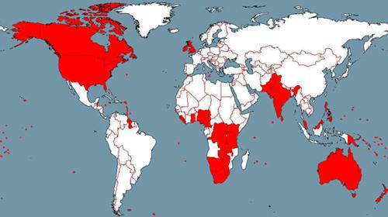

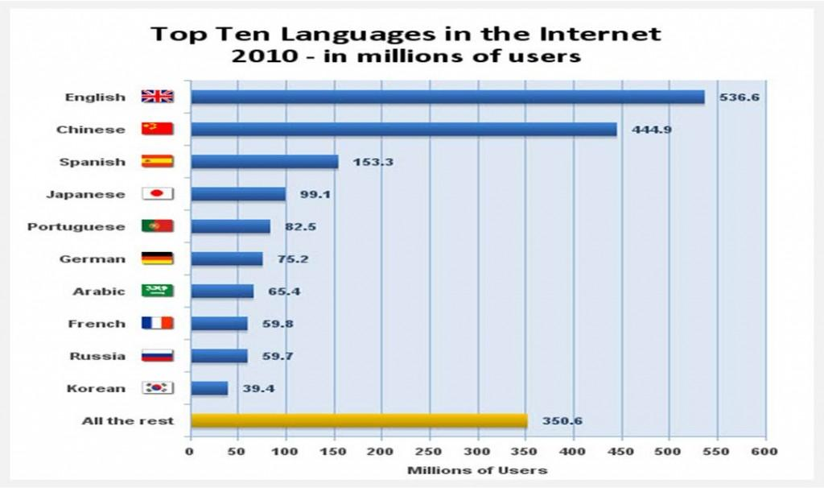

- Comment on the illustrations.

- Discuss the role of the English language in the world today.

- Evaluate the influence of American media on our society.

14.2
Topic: The English-Speaking World
Individual Long Turn (5 minutes)
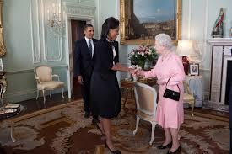
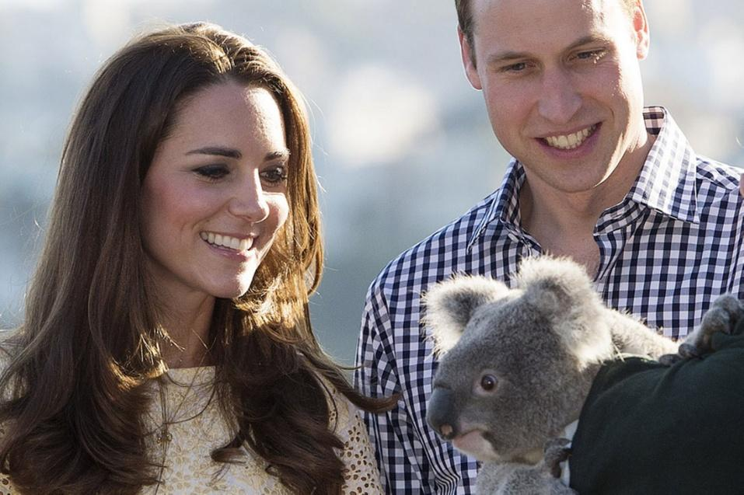

- Compare and contrast the pictures.

- Evaluate the global influence of political leaders, Royalty and other celebrities from English-speaking countries.

- Speculate on how British and American people view Austria and Austrians.

15.1
Topic: The Individual and Society
Individual Long Turn (5 minutes)



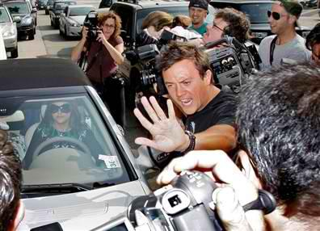

- Compare and contrast the pictures.

- Speculate why so many people are interested in the lives of celebrities.

- Give your opinion on whether celebrities deserve to earn the vast sums of money they do.

15.2
Topic: The Individual and Society
Individual Long Turn (5 minutes)
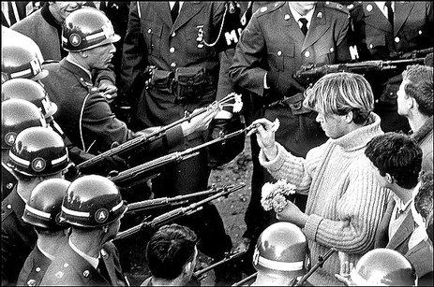
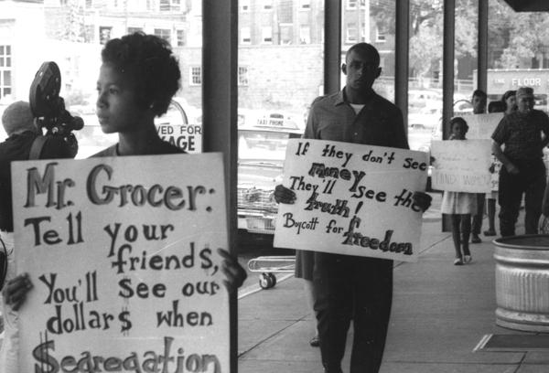

- Comment on the pictures.

- Explain what makes people stand up for a cause and take action.

- Discuss whether young people today are committed enough to fight for something they believe in.

16.1
Topic: Travel and Tourism
Individual Long Turn (5 minutes)

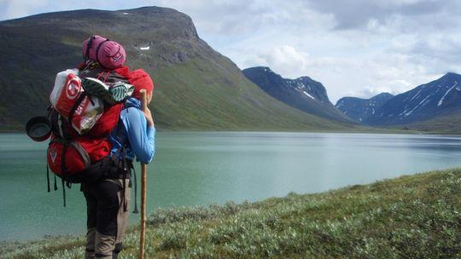

- Compare the pictures.

- Evaluate the importance of travel to you personally.

- Discuss the impact of tourism on the environment and on the local population.

16.2
Topic: Travel and Tourism
Individual Long Turn (5 minutes)
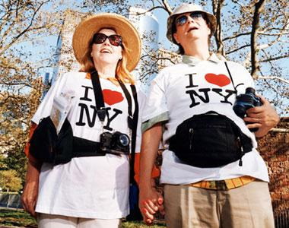

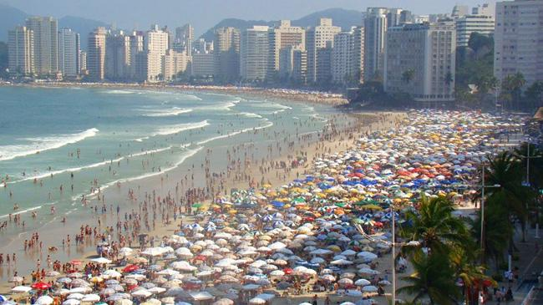

- Comment on the pictures.

- Discuss the impact of mass tourism on popular holiday destinations and on tourists themselves.

- Elaborate on your ideal holiday.

17.1
Topic: Visions of the Future
Individual Long Turn (5 minutes)

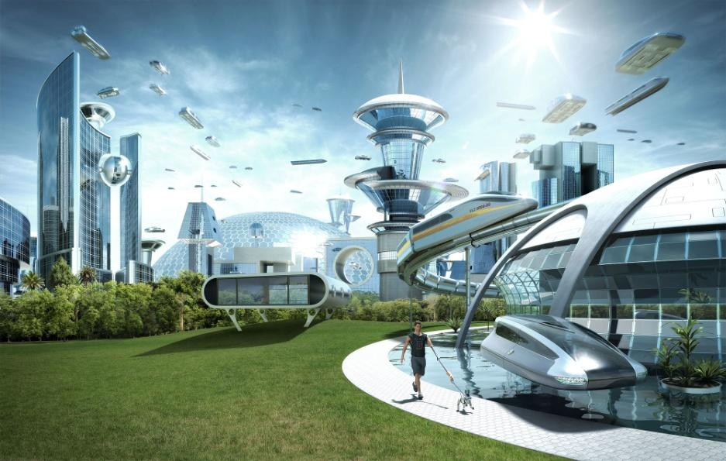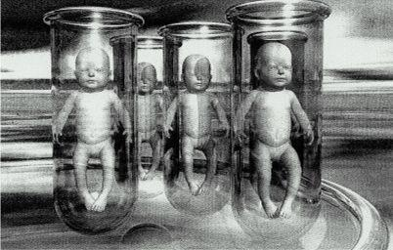

- Comment on the pictures.

- Discuss the ways in which novels, stories and films tend to portray the future.

- Evaluate to what extent some of these predictions have come true or might come true in the future.

17.2
Topic: Visions of the Future
Individual Long Turn (5 minutes)
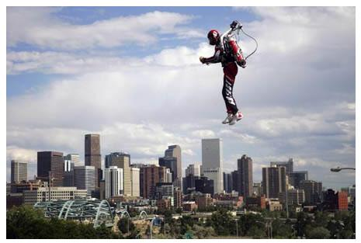

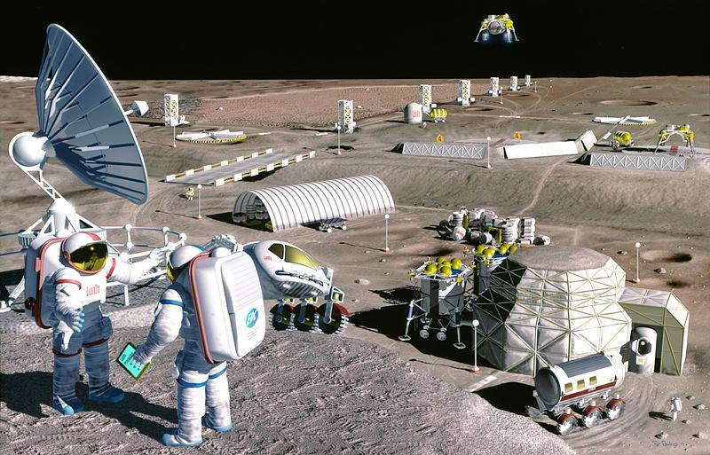

- Comment on the pictures.

- Outline the most serious problems facing humanity in the future.

- Speculate on the ideal world of tomorrow.

18.1
Topic: Youth Culture
Individual Long Turn (5 minutes)

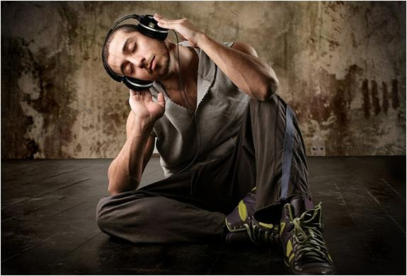

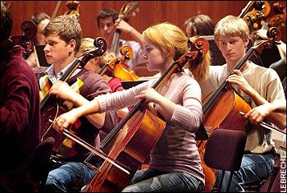

- Compare the pictures.

- Elaborate on the role music plays in your life.

- Discuss the differences between attending live music performances and listening to music on an mp3 player.

18.2
Topic: Youth Culture
Individual Long Turn (5 minutes)

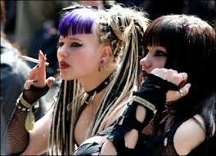
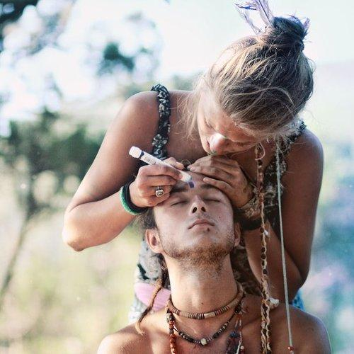

- Comment on the pictures.

- Discuss the impact of peer pressure on teenagers’ choice of clothing and style.

- Evaluate the influence of fashion advertising on young people.

