TOPIC: POLITICS
I. Individual Long Turn

  http://www.dreamstime.com/stock-image-barack-obama-stage-change-need-image27065341 [6/5/2015] |  | 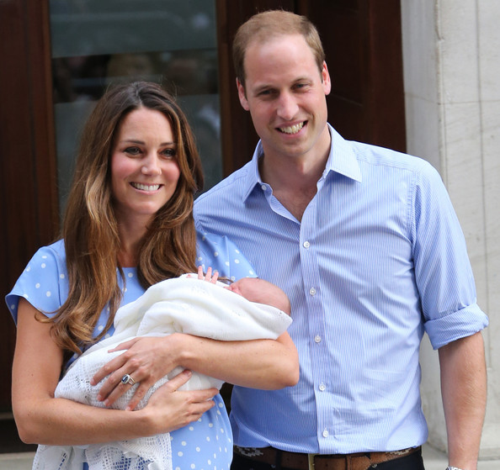  https://www.google.at/search?q=william+and+kate+baby  [9/6/2015]

- Compare and contrast the pictures.
- Speculate what makes a good politician.
- Discuss the idea that we should rather live the “European Dream” than the “American Dream”. (must have been covered in class. Detailed factual knowledge should not be expected. Social, cultural, political issues have to be accepted.)

II. Paired Activity

The EU wants to encourage young Europeans to take an active part in politics. For this purpose a workshop “Young people and politics” has been organised to find out which issues are important. In this workshop you have to give a five-minute-presentation on your thoughts on this issue. Together with your teacher, discuss each of the following aspects and agree on the three you will include in your presentation.

- background knowledge on European institutions
- gap between the rich and the poor
- environmental issues
- work and working conditions
- education

Topic: Political issues / public institutions

Individual long turn

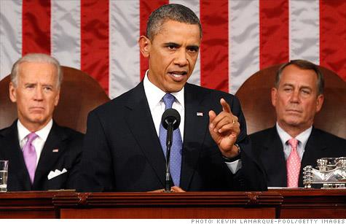
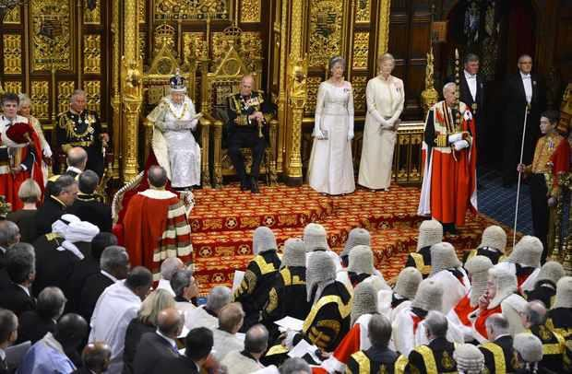

http://www.wirralnews.co.uk/wirral-news/uk-world-news/2013/05/08/queen-s-speech-immigration
-social-care-and-pensions-on-the-agenda-for-the-coalition-video-and-gallery-100252-33300593/ http://money.cnn.com/2011/09/08/news/economy/obama_stimulus_plan/

- Compare the pictures

- Illustrate the American dream

- Discuss the future of monarchy.

Paired activity

The European Youth Parliament wants to get young people interested in politics. It wants to know what schools can do to help. You have decided to present your ideas. Consider the options below and discuss which of them might be successful. Agree on three:

• inviting politicians into schools
• excursions to the parliament etc.
• school projects
• ‘Political Education’ as a school subject
• more direct democracy in schools
Themenpool XX: Landeskunde und politische Organisationen- Cultural awareness and political organizations

TASK 1: Individual long turn
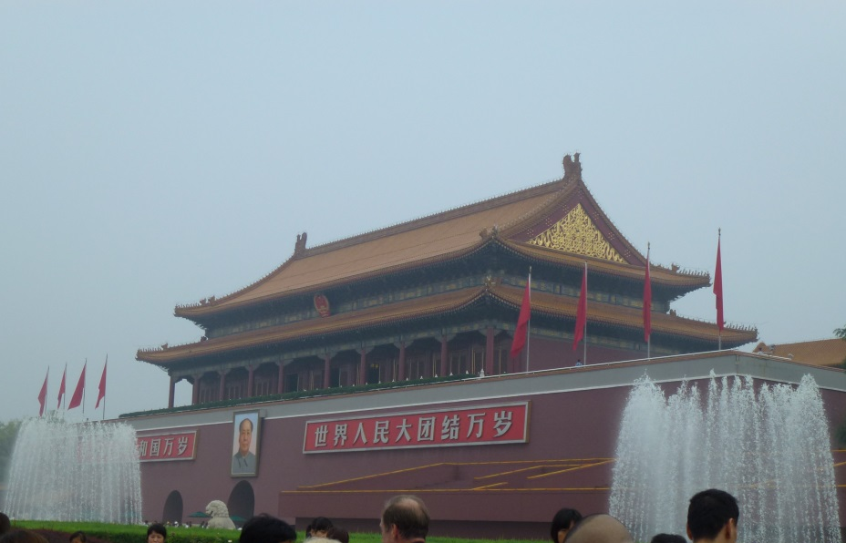
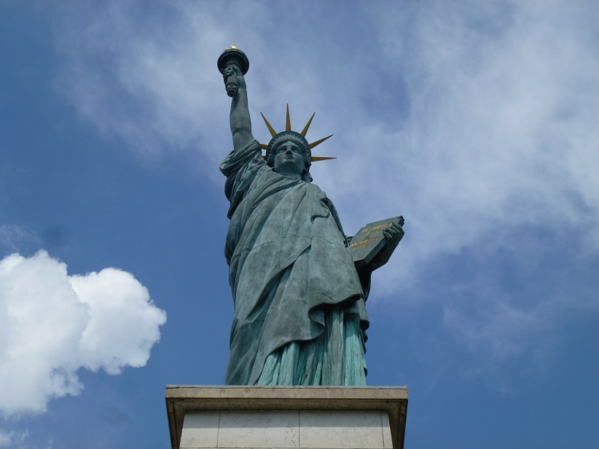
- Compare and contrast the pictures
- Explain the advantages of a democracy in contrast to a totalitarian system
- Recommend some ways how young people can influence a democratic society
Photo 1: private©ClaraDontschev
Photo 2: private©Clara Dontschev

Paired activity :

In class you have read the book The Wave by Morton Rhue. Talk with your teacher/partner about the following points, and decide in which of the following aspects the author did a very good job to convey his message.

- threats to democracy.
- relations to historic events
- civil disobedience
- conclusions that can be drawn out of that high school experiment.
- which scene you found most impressive.

