Themenbereich Rassismus & Diskriminierung/ racism and discrimination

I. Individual long turn

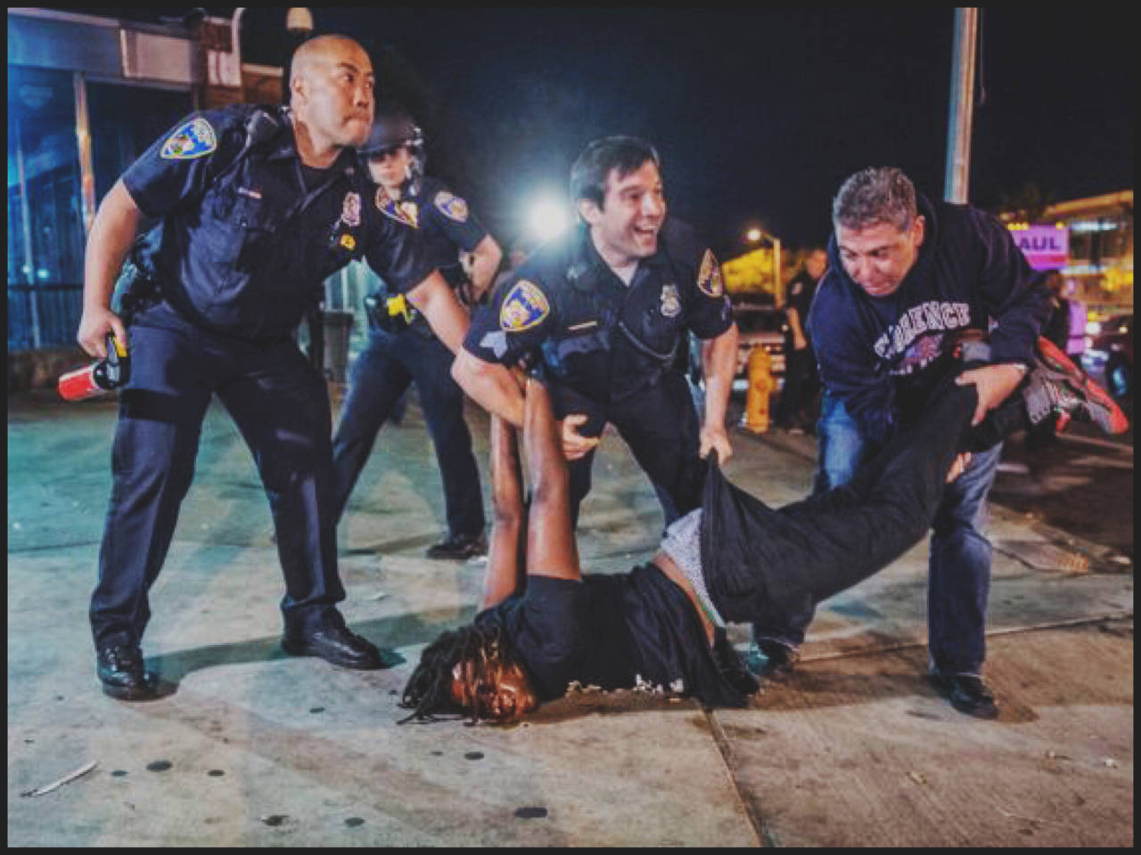

- Compare the pictures.
- Discuss different reasons to be discriminated. why people are being discriminated against.

- Evaluate the success of some efforts to reduce discrimination in our society.

Photo 1: oko-planet.su
Photo 2: www.vichealth.vic.gov.au

I. Individual long turn
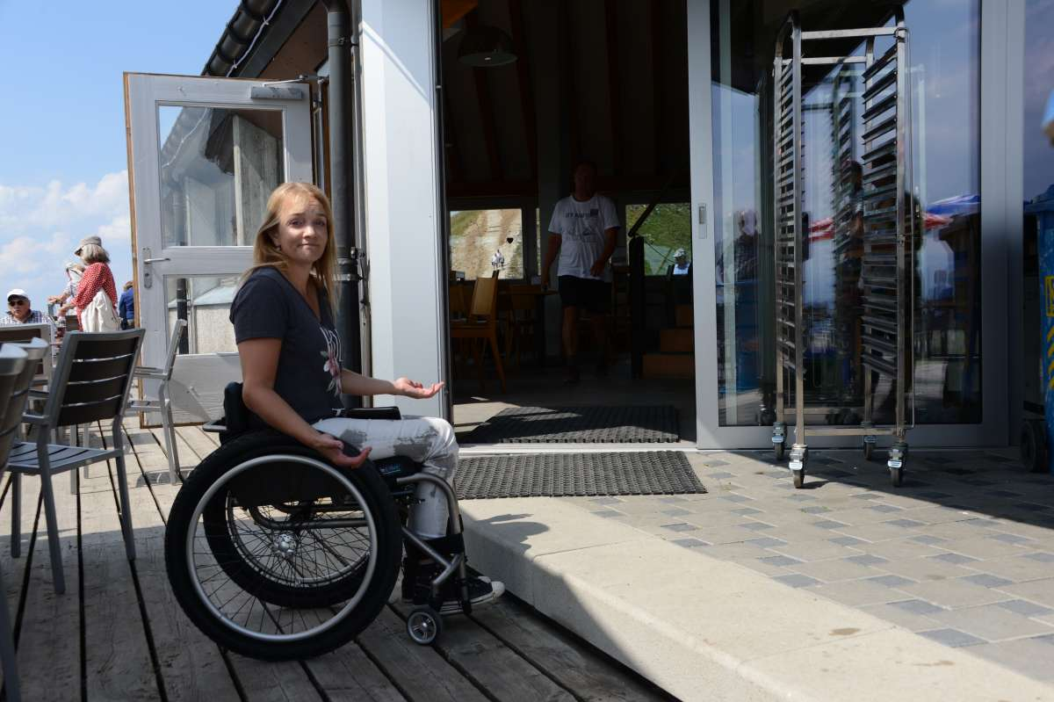


- Compare the pictures
- Discuss different sources of racism and discrimination.
- Speculate on ways of reducing racism and discrimination in today’s society.
If a book or film about this topic has been read/watched in class, it is possible to include this in the long turn, like : “Give a critical review about how … has been dealt with in the book/film”)

Photo 1: www.leblanclawandmediation.com
Photo 2: www.paraforum.ch

II. Paired activity

You and your partner have been asked to give a talk on sources of discrimination at an international youth conference.

Discuss the following theories:

- socialization
- conforming behaviour
- scapegoat theory
- comparing cultures
- fear and group closure

Agree on three theories you want to include in your talk. (theories must have been dealt with in class)

II. Paired activity

You and your partner have been asked to contribute to an article on discrimination in an international youth magazine.

Discuss the following aspects:

- signs of discrimination
- reasons for being discriminated against
- sources of prejudice
- possible solutions
- relevance of the topic today

Agree on three statements you recommend to the youth magazine to be included in the article.

