School and education

Individual Long Turn

“I believe that teachers should be in charge of the learning process of their students. They are the actual experts and should know what is best for the students. When the teacher has full control of the classroom and its activities, the classroom remains orderly, the students are quiet and don’t have to worry that they will miss an important topic.”

- Comment on the statement
- Describe your own preferred learning style and its effect on your performance
- Analyse to what extent teachers can influence the students’ attitudes and interests

School and education

Individual long turn

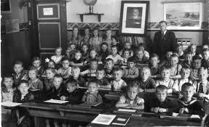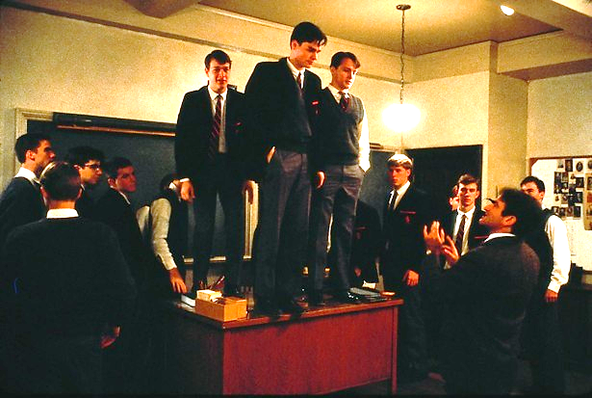

- Compare and contrast these pictures.
- Discuss pros and cons of “frontal teacher centred teaching“
- Outline the methods and effects of Mr Keating’s teaching methods in “Dead Poets’ Society”.

