Science and technology

- Individual long turn

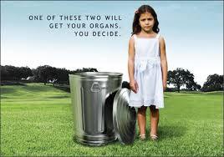

India's Black Market Organ Scandal
Police say doctors paid as little as $1000 for the kidneys and then sold them for as much as $37,500. (TIME, Feb. 2008)

- Compare and contrast the pictures with the text.
- Judge how far medical science can go to save someone’s life.
- Evaluate the benefits of medical science for our lives.

- Paired activity

In class you have dealt with scientific and technical developments.
As you are very much interested in this topic, you start a discussion with your teacher.
Discuss the following points, and decide which development will happen most likely in the future:
- exploration of Mars as a new habitat
- increase of GM food
- increase of CCTV in all places
- spreading of designer food
- cloning animals

