Topic: Utopia

Individual long turn

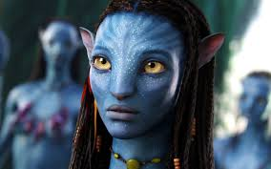


- Compare the pictures.
- Speculate why especially teenagers are interested in stories about alternative realities
- Discuss the likeliness of an alternative world.

Paired activity

Utopias and dystopias have always fascinated writers and filmmakers. With your partner you speak about a film or a book that presents a different world. Comment on

- how the political situation is depicted
- a character
- the ruler/ ruling social class and how they control the inhabitants
- how one’s feelings are controlled
- your ideal world

