Topic „TOURISM and TRAVELLING“

Task for Individual Long Turn
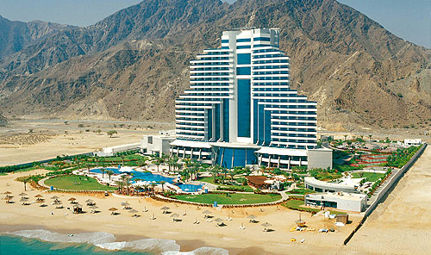
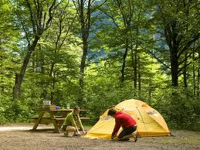

Compare and contrast the pictures.
- Describe the different types of holiday including typical target groups, activities and facilities
- Compare the two types of holiday concerning sustainability and environmental footprint
- Explain what makes a perfect holiday for you personally

