Topic: Travel and Tourism

Task for Individual Long Turn : (5 minutes)
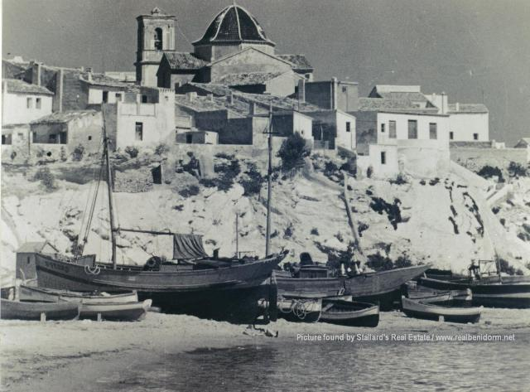  Benidorm, 1930 | 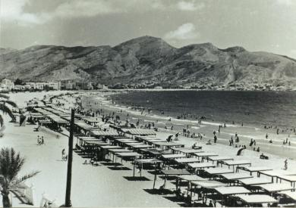  Benidorm, 1950
1http://www.realbenidorm.net/images/Benidorm_old_town_c1930.jpg | 2http://www.realbenidorm.net/images/benidorm-1950s.jpg
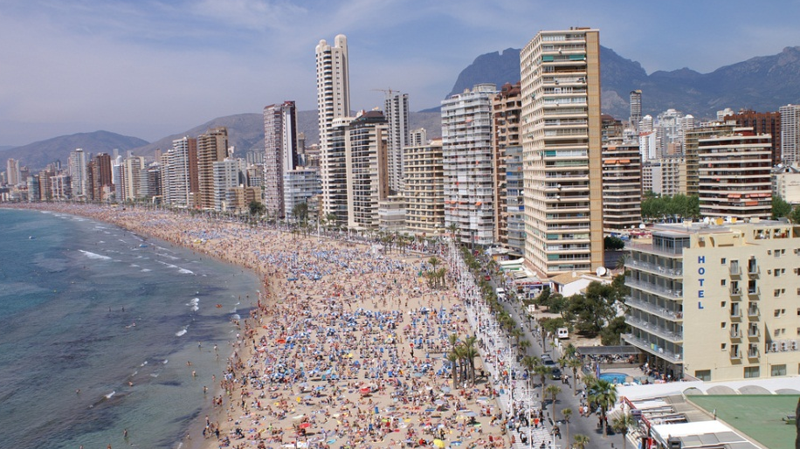
Benidorm, now
3http://www.inmobiliarianunez.com/en/to-rent/holiday/property/3060-benidorm-apartment-in-the-most-modern-building

Compare and contrast the pictures of the Spanish resort, Benidorm.
- Describe the development of the resort over the decades and speculate what a holiday in Benidorm might have been like in the 1950s, what is it like now.
- Discuss possible effects of the development of tourism on the local population and economy of a resort.
- Compare the effects on the environment at the different stages of development.

