Topic „TOURISM and TRAVELLING“
Task for Paired Activity
You and your partner have a won a holiday for two in a competition. Discuss the holidays on offer and speculate about things you might be able to do there. Together with your partner rank the offers according to your preferences.
Five nights in Las Vegas |  | 1
Five nights in Paris |  | 2
Two-week hike along St. Jacob’s Trail in Spain | 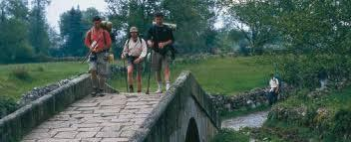 | 3
One week with “Summer Splash” in Turkey |  | 4
One week sailing in Greece | 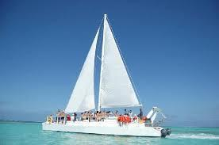 | 5
Picture sources:
1. http://www.haymoreendodontics.com/wp-content/uploads/2013/05/Las-Vegas-Dentist.jpg
2. http://www.deluxedrivers.com/wp-content/uploads/2013/03/paris-city-lights.jpg
3. http://www.spain.info/export/sites/spaininfo/comun/carrusel-recursos/Galicia/peregrinos_laboreiro_t1500154a.jpg_369272544.jpg
4. https://encrypted-tbn0.gstatic.com/images?q=tbn:ANd9GcQIGP40_5LRWJuA9Y63UZnD1YYQY3iwkRyU1cV_DV67lFvoE3Qm
5. http://media-cdn.tripadvisor.com/media/photo-s/02/59/f4/b1/sunnyday-sailing-cruise.jpg

