Must Reads of Contemporary English and American Literature

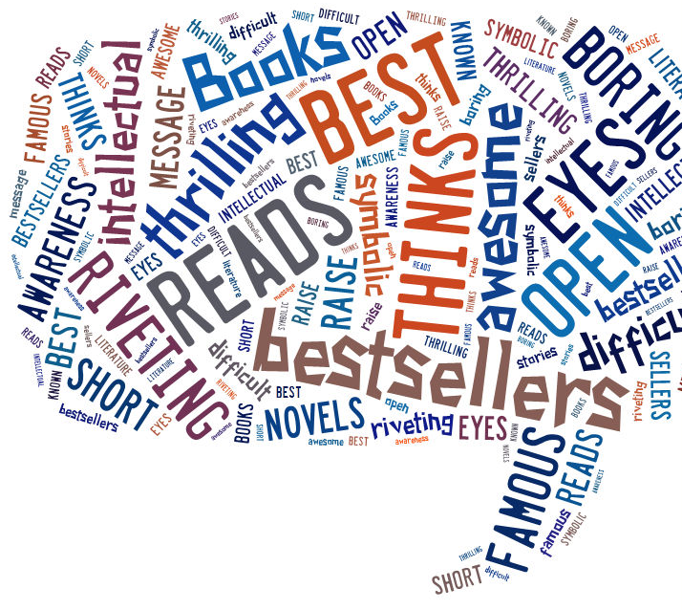

My List of Must-Reads

In the elective course you have read and discussed a number of famous and popular novels and short stories that appear on lists of Must-Reads on the Internet.
Which of the novels and stories that you have read do YOU consider Must-Reads?
What makes them so exceptionally good or interesting?
Explain the criteria you have used to come to your decisions.

Must-Reads and Bestsellers
Speculate about possible differences between must-reads and bestsellers. What criteria would you use to define these two categories?
Choose two to three examples from your reading and explain in what way your examples fit into these categories. Think of all the books you have read – not only the books for the elective course.
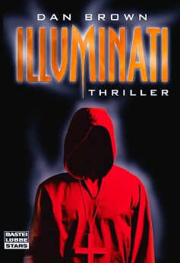
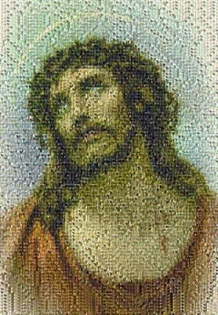
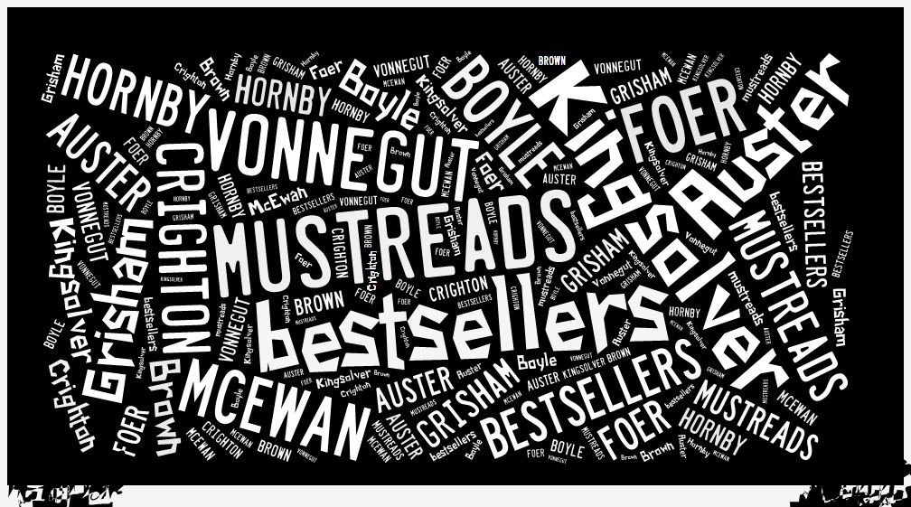
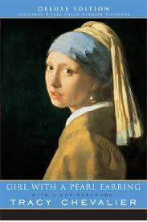
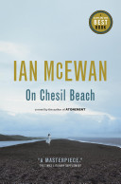
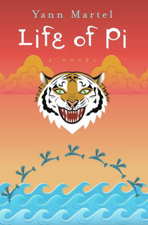

Nick Hornby
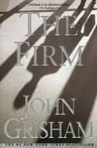
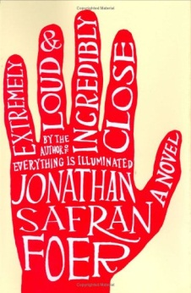
“Nipple Jesus”
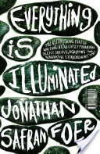
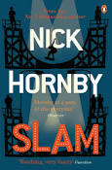
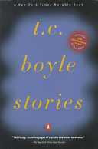
T.C. Boyle, “Top of the Food Chain”
Or “Modern Love”

