Topic „TOURISM and TRAVELLING“

Task for Paired Acticity

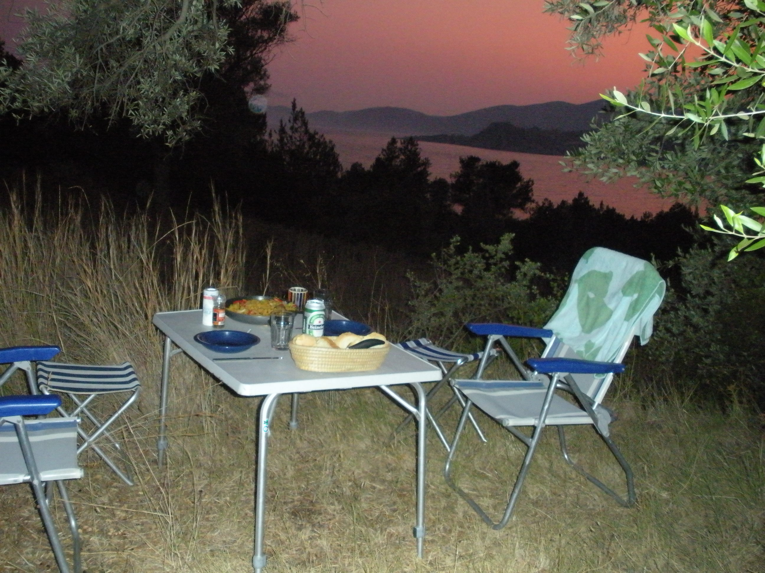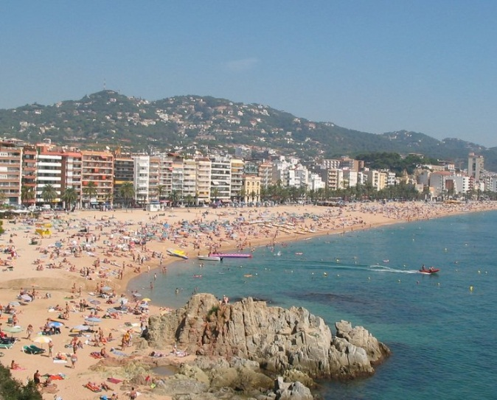

The two pictures represent two opportunities of holidays you are offered for this summer:
Camping in Greece or flying to Spain to stay in a holiday apartment.
Discuss the advantages and disadvantages of these two holidays. Consider the following aspects:
- getting there
- accommodation
- facilities and activities offered
- cost
- attractiveness
Come to a decision where you want to go together.

