  - Englisch
Themenbereich: Schule und Bildung – Education (B2)
- Individual long turn
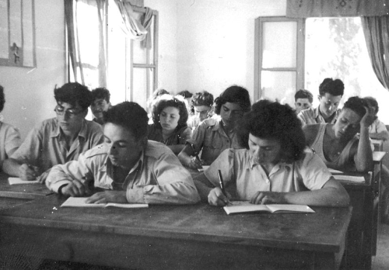 |  | 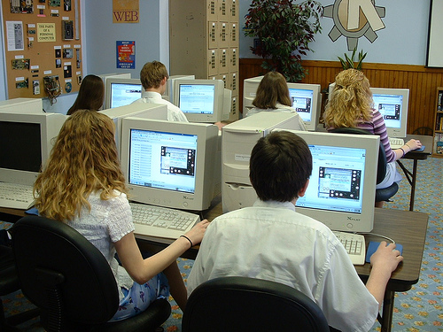

- Compare and contrast the pictures.
- Discuss how modern technology has influenced learning and teaching.
- Suggest improvements to the Austrian school system.

- Paired activity

The British Embassy wants to find out how young Austrians best learn about British tradition and culture. Your school has decided to present students’ ideas. Discuss the following options:
- British literature
- British films
- staying with an English host family
- holiday in London
- discussions with an English assistant

Decide which ideas you would recommend. Agree on three.

Photo 1: http://commons.wikimedia.org/wiki/File:PikiWiki_Israel_8508_Gan-Shmuel_-_students_in_the_class_in_1951.jpg

Photo 2 : http://upload.wikimedia.org/wikipedia/commons/c/c4/Computer_lab.jpg

Themenbereich Transport und Tourismus –Transport and Tourism (B2)
- Individual long turn
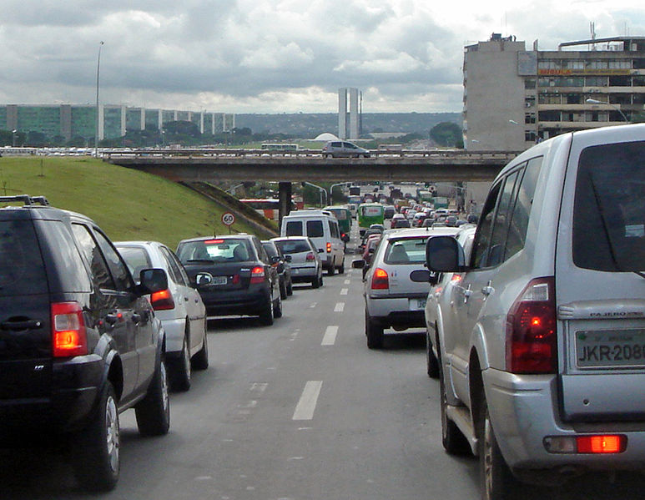
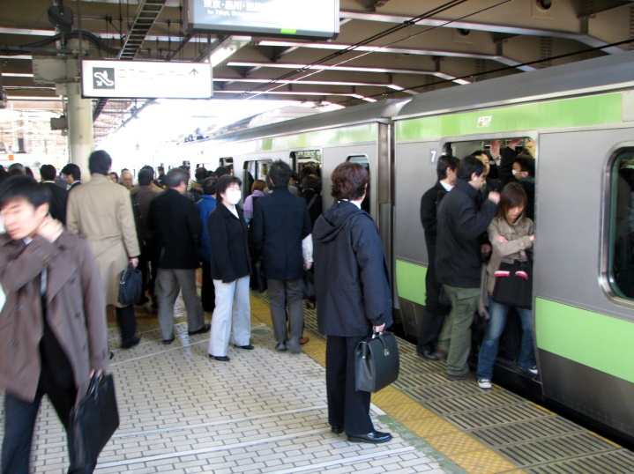

- Compare and contrast the pictures.
- Evaluate the public transport system in your area.
- Present your ideas on what traffic could be like in the future.

- Paired activity

Your school is looking for a British partner school for a student exchange programme. You have to prepare a presentation to promote your area as a desirable destination. Discuss the following ideas:
- tourist attractions
- your school’s characteristics
- leisure and sports facilities
- art and culture
- shopping facilities

Decide which ideas you would include in a presentation. Agree on three.
Photo 1: http://upload.wikimedia.org/wikipedia/commons/e/ec/Traffic_Congestion_Brasilia.jpg
Photo 2: http://upload.wikimedia.org/wikipedia/commons/f/ff/Rush_hour_at_Ueno_03.JPG

