CORE TOPIC: Culture and Society, Past and Present

Individual Long Turn

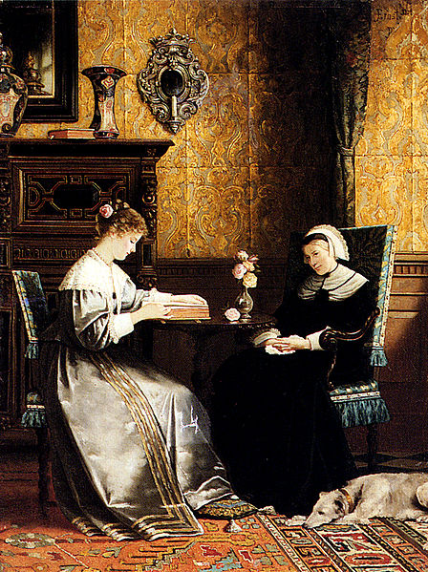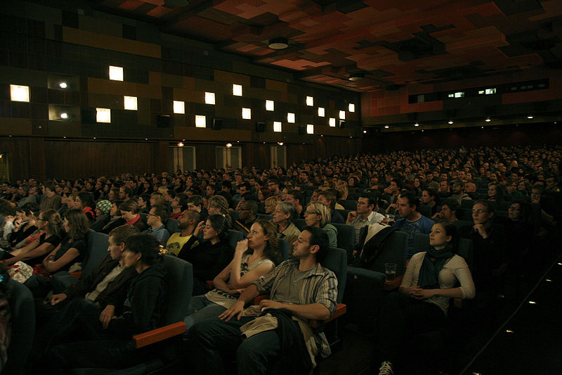

- Compare the pictures
- Explain what reading means to you personally
- Discuss the pros and cons of making a film version of a book

http://commons.wikimedia.org/wiki/File:Ernst_Rudolph_Reading_A_Book.jpg?uselang=de-at
http://commons.wikimedia.org/wiki/File:Vis_gartenbaukino3.jpg

CORE TOPIC: Culture and Society, Past and Present

Paired Activity
Your English teacher has asked the class what they think is most important about studying literature from English-speaking countries at school. Discuss the following points with your partner and decide which to include in your feedback to your teacher:
- improving language skills
- learning about other cultures
- reading famous classics
- watching film versions of literature
- personal choice of reading

Come to a decision with your partner on which three points you would recommend your teacher to take into consideration.

CORE TOPIC: Lifestyle and Leisure

Individual Long Turn

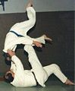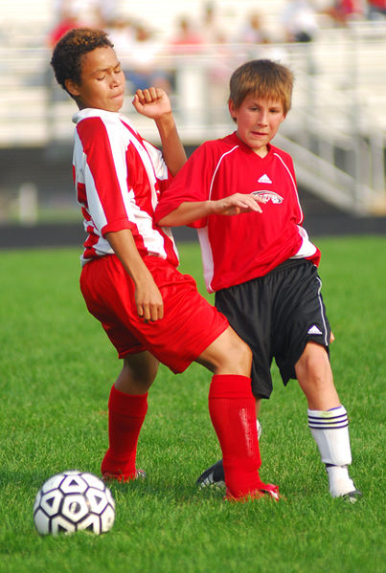
(Better pics required here)

- Comment on the pictures
- Discuss how young people can benefit from doing sport
- Explain how the role of sport in society has changed and developed

http://commons.wikimedia.org/wiki/Sport#Combat_sports
http://commons.wikimedia.org/wiki/File:Children_soccer_elbow.jpg?uselang=de-at

CORE TOPIC: Lifestyle and Leisure

Paired Activity
You are part of the team planning a school project to encourage students to do more sport. You have to decide which aspects of doing sport the project should concentrate on. Discuss the relevance of the following aspects:

- availability in your area
- attractiveness
- benefits for health
- safety
- cost

Come to a decision with your partner on which three aspects to focus on when choosing sporting activities for the project.

