Fabian Sageder | 3 | 18.6.2013 (Nachmittag) | 
Mag. Kerstin Stanzel | ENGLISCH | 8b

Kernfrage 1: American Dream/being Successful



The following pictures show symbols of liberty!

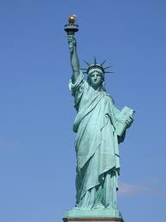

Use the pictures to discuss:
- the concept/idea of the American Dream
- the history of the American Dream
- what is meant by the phrase “From rags to riches”.
- factors of success
- what influences your career (family, friends …)

Kernfrage 2: Richard III

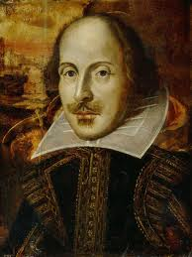
Firstly, our discussion will focus on:

- biographical information of William Shakespeare
- his plays in general

Let´s then focus on his play Richard III:
- plot
- main themes
- turning point of the play
- Richard´s character
Florian Reichl | 9 | 18.6.2013 (Nachmittag)
Mag. Kerstin Stanzel | ENGLISCH | 8b

Kernfrage 1: Rosa Parks

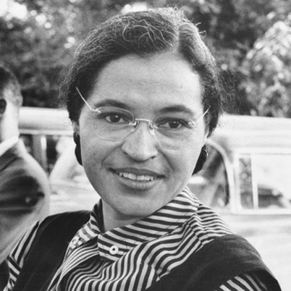
- What does the title of the picture suggest?

- What happened on Dec. 1, 1955 and what did she achieve with her act?

- What do you know about the Montgomery segregation laws?

- Talk about other highlights of the Civil Rights Movement.

Rosa Parks- The Torchbearer

Kernfrage 2: Newspapers
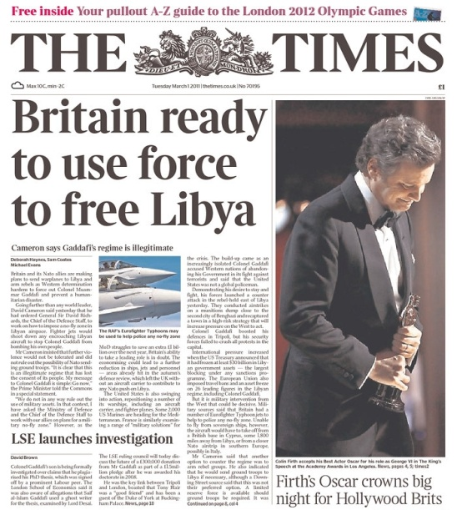
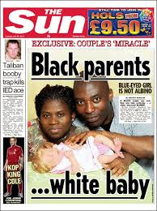

- Comment on the newspapers shown above. Refer to the main differences between tabloids and broadsheets concerning: language, subject matter, readership and layout.
- Mention other tabloids and broadsheets.
- Talk about your newspaper- reading habits.

Lena Leitner | 17 | 18.6.2013 (Nachmittag)
Mag. Kerstin Stanzel | ENGLISCH | 8b

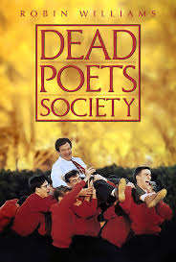
Kernfrage 1: Dead Poets Society

Firstly, provide some information on
- plot
- main characters
- interesting facts

Let´s then focus on:
- the role of prep schools in America, Europe and in the film
- John Keating´s teaching methods compared to other teachers

Kernfrage 2: Elizabethan Theatre

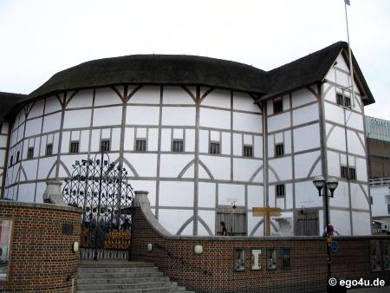
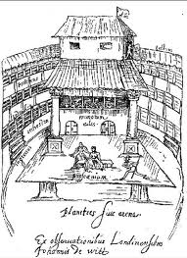

- Give some general information about Elizabethan England.
- What did the Elizabethan theatre look like?
- How were plays written and performed during that time?
- Name main differences to the theatre in our time.

Florian Kindermann | 3 | 19.6.2013 (Vormittag)
Mag. Kerstin Stanzel | ENGLISCH | 8b

Kernfrage 1: Travelling and Tourism/eco- friendly Tourism
Discuss the following aspects:

- What´s the idea of the “Lonely Planet” guide books?
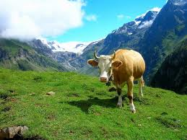
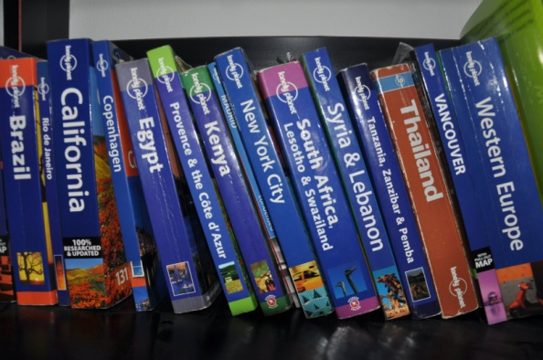

- Talk about effect of tourism on the environment
- Name do´s and don’ts for eco-friendly tourists.
- What are your travel habits?

Kernfrage 2: Prejudices




- What is racism?
- Give examples of racism in our society.
- What can be done to fight racism?
- What types of prejudice are ubiquitous in society?
- Have you ever come across prejudice of any kind?

Georg Hemetsberger | 6 | 19.6.2013 (Vormittag)
Mag. Kerstin Stanzel | ENGLISCH | 8b

Kernfrage 1: Advertising
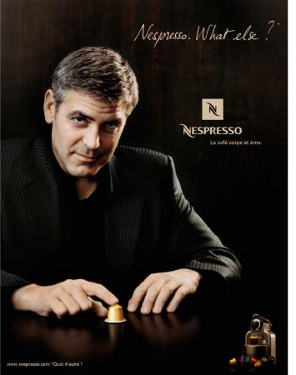
- Comment on one of the following statements:

- Having a good product is not as important as having an eye-catching logo and a memorable slogan or a catchy jingle.
- Advertising is designed to convince us to buy things we don’t need.
- Advertising gives consumers power and control.

- List different types of advertising. Then present one ad that had an impact on your life.

- Discuss the importance of as well as the reasons for advertising in today’s society.

Kernfrage 2: Mental Illness

Mental Illness

Mental illness or mental disorder is a condition that affects thoughts, feelings or behaviors of someone who is strong enough to make social integration problematic, or cause personal suffering.

Like other ailments and disorders, mental illness is also a type of disorder that is happening mostly around the brain. That’s why it is called as the mental or the mind disorder.

However, most scientists and experts believe that mental illness isn’t all about the brain and its activity; it includes all aspects of the body – including the overall body system and the way our body reacts to chemical process within the body.

Understanding the Basic Mental Illness
It is rather hard to really understand the mental illness definition since the definition of mental illness can be broad and vast.
In the core term, mental illness is a type of psychological anomaly or disturbance that is mostly reflected in the behavior and not a part of the normal or common development of a person’s culture.
This type of mental illness can be related to disability or distress. The mental disorder can be reflected in the combination of a person’s action, feeling, thought, or perception. Most experts believe that such disorder affects the certain part of the brain – and also the nervous system – that is often related to social context and behavior.
Although the understanding and the recognition to such mental condition have changed and evolved in the course of time and within different cultures, there are still different variations in the classification, assessment, and also the definition of the ailment itself. More likely, experts will use the standard guidance, but they also have to be careful on a certain conditions and cases.
(mentalillnessdefinition.com)

Let´s take the definition above to talk about mental illness. In our conversation let´s focus on:
- Different types of mental illness
- Treatment of mental illness
- Mental hospitals then and now.
Klaus Leidenmühler | 10 | 19.6.2013 (Vormittag)
Mag. Kerstin Stanzel | ENGLISCH | 8b

Kernfrage 1: Environment

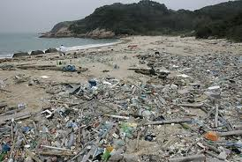
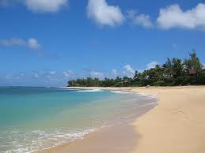

- Our children will live in a worse environment than we do. To what extent do you agree with this statement.
- Discuss the wide range of environmental problems we have to face today and in the future.
- What can you do in order make our world a better place to live in?

Kernfrage 2: Music
Let us first talk about music in general:
- What does music mean to you? How important is it to teens?
- What is your favourite band/singer and why do you like them so much?
Another study finds music piracy 'does not displace digital sales'
A report from the Institute for Prospective Technological Studies, part of the European Commission's Joint Research Centre, has found that "digital music piracy does not displace legal music purchases in digital format", and that "there is unlikely to be much harm done on digital music revenues".
The study specifically looks at the impact of online streaming and downloads -- both legal and illegal -- on digital music sales rather than sales of physical media such as CDs.
A total of 16,000 Europeans from five countries (Spain, France, Germany, Italy and the UK) had their browsing habits examined, and perhaps the most striking finding was that "the majority of the music that is consumed illegally by the individuals in [the] sample would not have been purchased if illegal downloading websites were not available".
That gets to the core of the discussion over music piracy and its effect on sales -- whether people are skipping out on paying for music they love and downloading it instead, or if they're actually adding free listening on top of their existing buying habits. The results of the study show that there's a statistically significant effect on digital music sales that correlates to music piracy. Users who pirate are more likely to also buy music, and those who don't buy much music also don't pirate as much.
The study said: "Illegal music consumption could also, in theory, stimulate legal music consumption. Since music is an experience good, ﬁle sharing can allow consumers to sample specific songs or albums which can inform them on what to buy. Similarly, the sampling of a speciﬁc song may stimulate individual demand for other songs by the same artist."
(wired.co,uk)

- Where do you get your music from?

Then let´s take the extract as a starting point to talk about music piracy:
- What are arguments in favour of/ against illegal downloading?
- How do you feel about piracy- do you consider it as a crime?
David Glasner | 14 | 19.6.2013 (Vormittag)
Mag. Kerstin Stanzel | ENGLISCH | 8b

Kernfrage 1: Harold and Maude

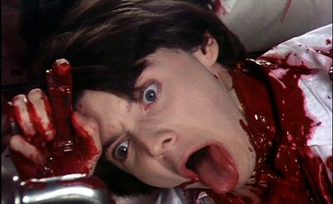
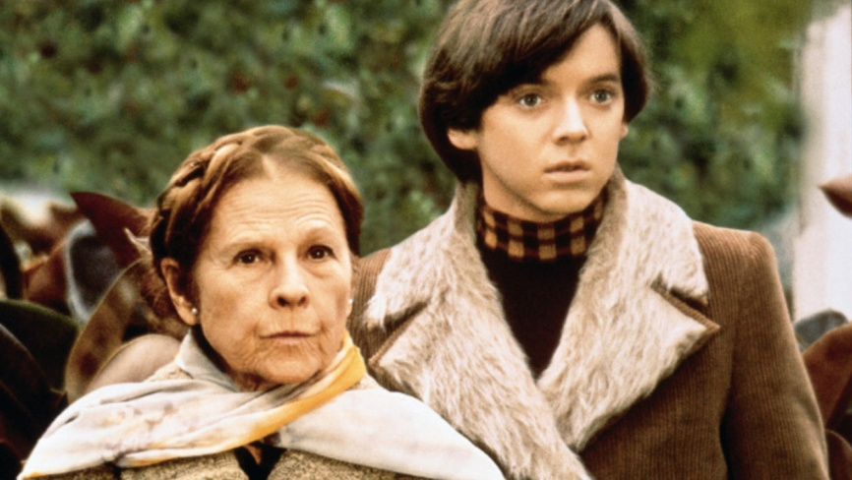
For our discussion on the film Harold and Maude provide information on
- plot
- characters
- themes/topics
- the role of Cat Stevens
- your personal response

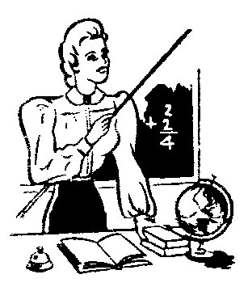
Kernfrage 2: School

- Which qualities are necessary in order to motivate and teach students well?
- How important is discipline in school? Are there rules in school you would like to see changed?
- Can you imagine working as a teacher in the future? Why/Why not? Give reasons.

Constantin Latzelsberger | 9 | 19.6.2013 (Nachmittag)
Mag. Kerstin Stanzel | ENGLISCH | 8b

Kernfrage 1: Gap Year/Voluntary Work


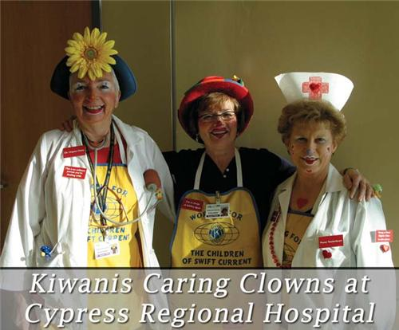

Discuss the following points:
- Reasons for doing a voluntary work.
- Advantages and disadvantages of voluntary work
- Tips to volunteers
- Which of the jobs shown would you do? Why?
Kernfrage 2: Newspapers

- Comment on the newspapers shown above. Refer to the main differences between tabloids and broadsheets.
- Mention other tabloids and broadsheets.
- Talk about your newspaper- reading habits.
Florian Berger | 12 | 19.6.2013 (Nachmittag)
Mag. Kerstin Stanzel | ENGLISCH | 8b

Kernfrage 1: Home sweet home

The question of whether to leave home or to stay even into one’s 20s and 30s occupies young adults a lot. The decision for a certain option depends on various factors. However, quite a number of young people use as their motto the following saying:

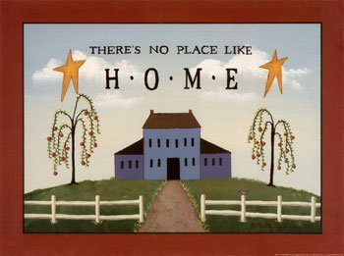
“There’s no place like home...“

- Do you agree with this statement?
- Give reasons for and against leaving home.
- Explain different styles of parenting
- What´s the situation in Austria compared to other countries?

Kernfrage 2: Martin Luther King
Read this extract of “I have a dream” and use it as a basis to talk about the points below.
“I have a dream that one day this nation will rise up, and live out the true meaning of its creed: ‘We hold these truths to be self-evident: that all men are created equal.’
I have a dream that one day on the red hills of Georgia the sons of former slaves and the sons of former slave owners will be able to sit down together at a table of brotherhood.
I have a dream that one day even the state of Mississippi, a state sweltering with the heat of injustice and sweltering with the heat of oppression, will be transformed into an oasis of freedom and justice.
I have a dream that my four little children will one day live in a nation where they will not be judged by the color of their skin but by the content of their character.
I have a dream today.”

- What are the main intentions of Martin Luther King, Jr? What does he want to achieve?
- What does he envisage?
- In his speech he also refers to Abraham Lincoln and his Emancipation Proclamation. Why?
- Name stylistic devices he uses in his speech.
Florian Dollhäubl | 15 | 19.6.2013 (Nachmittag)
Mag. Kerstin Stanzel | ENGLISCH | 8b

Kernfrage 1: Environment

The following pictures show different environmental problems:
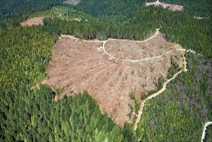
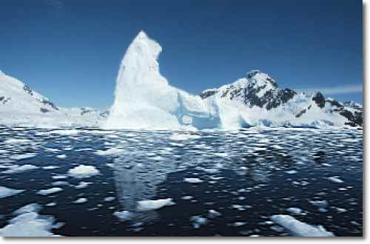
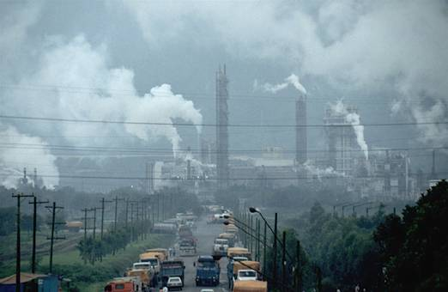

Use the pictures to discuss:
- the different environmental problems shown
- effects of environmental problems on human/ animals/ nature
- strategies to fight environmental problems
- your approach to the environment

Kernfrage 2: Controversial Advertising
Oliviero Toscani, fashion photographer for “Benetton”, once claimed:
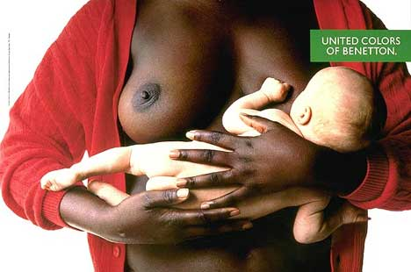
"Sure, you want to get people's attention. This is communication. "But I still can't understand why people are shocked by something that obviously exists. It's like in a family that always avoids talking about its real problems."

- Use the quote above to talk about controversial advertising.

- What is the AIDA formula? Discuss this formula. Then choose one ad and explain how the AIDA concept applies to it.

- What do you think about limiting or even banning certain ads?

- Which ads and/or commercials do you like and why?

Joshua Fried | 3 | 20.6.2013 (Vormittag)
Mag. Kerstin Stanzel | ENGLISCH | 8b

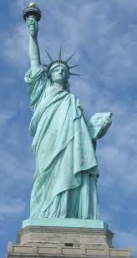
Kernfrage 1: American Dream

- Look at the photograph. What´s its significance?

- What were immigrants dreaming about this “promised land” when they came to the US?

- What is the modern American Dream?

- Can the modern American Dream come true? What is your view?

Kernfrage 2: Gap Year

Discuss the following points:
- different forms of a gap year

- reasons for taking a gap year
- benefits and disadvantages
- your opinion

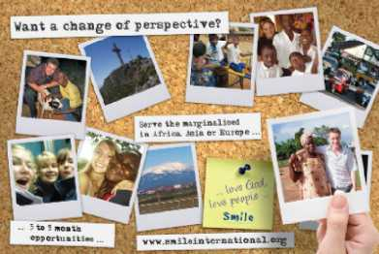

Lisa Klammer | 6 | 20.6.2013 (Vormittag)
Mag. Kerstin Stanzel | ENGLISCH | 8b

Kernfrage 1: The Curious incident of the dog in the Night Time

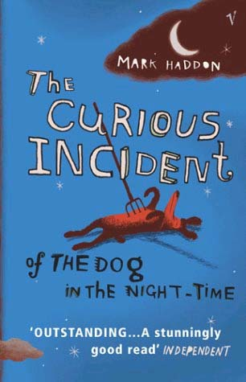
Firstly, provide us with some background information on:
- the Asperger´s Syndrome

Let´s then focus on the book:
- plot
- main characters
- personal response

Kernfrage 2: Hostels

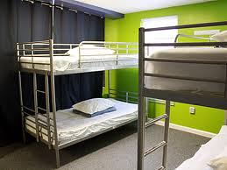
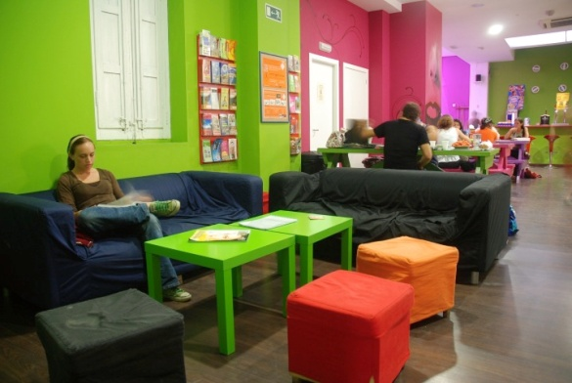
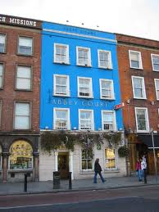

Be prepared to talk about:
- Hostels in general (what are hostels; their mission; their idea; who can use them etc.)
- What does a hostel normally look like?
- Positive and negative aspects of staying at a hostel.
- Your opinion

Gerald Wendling | 10 | 20.6.2013 (Vormittag)
Mag. Kerstin Stanzel | ENGLISCH | 8b

Kernfrage 1: Advertising/ Brands
The following pictures show different global brands:





With the help of the pictures discuss:

- the term brand and what a brand consist of
- general principles of brand- building
- advertising techniques for brands
- influence of brands on you

Kernfrage 2: Civil Rights Movement
Read the text below!

‘Old South’ and ‘New South’

There’s long been a “New South”, epitomised by the gleaming skyscrapers of Atlanta, Georgia, the emergence of a thriving black middle class, and sprawling suburbs and malls that could be Anywhere USA.
But the South remains the most distinctive part of America. It is perhaps the most patriotic region of an intensely patriotic country, with the strongest military tradition.
(abridged)
From: World and Press 2011

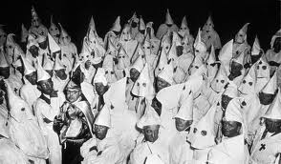
- What role did the South play during slavery?
- Right after the abolition of slavery the Ku Klux Klan was founded. What is it and what were the major aims of this group at that time?
- Under what conditions are such groups most successful?
- Have the emergence of a black middle class and a black president put an end to discrimination?

Christoph Palmetshofer | 14 | 20.6.2013 (Vormittag)
Mag. Kerstin Stanzel | ENGLISCH | 8b


Kernfrage 1: Teacher´s Dead

Prepare the following:
- plot
- main characters
- main themes and topics of the novel
- personal comment on the book

Kernfrage 2: Travelling and Tourism/eco- friendly Tourism
Discuss the following aspects:

- Why do people travel?
- Name different forms of travelling.
- What´s the idea of the “Lonely Planet” guide books?

- Talk about effect of tourism on the environment
- Name do´s and don’ts for eco-friendly tourists.
- What are your travel habits?

Michael Prieschl | 2 | 20.6.2013 (Nachmittag)
Mag. Kerstin Stanzel | ENGLISCH | 8b

Kernfrage 1: US Politics
- Explain the political system of the US.
- What are the two political parties and what are their aims?
- Talk about different phases of the presidential elections and refer to the previous elections in November 2012.

Refer to the pictures where appropriate.

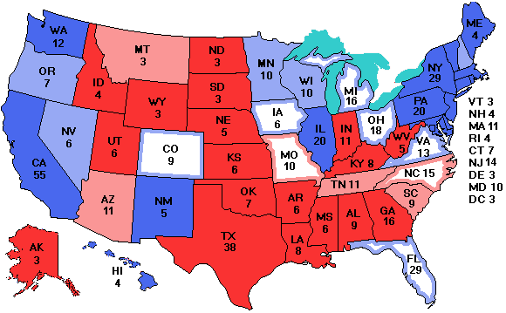

Kernfrage 2:
The following pictures show different famous people!

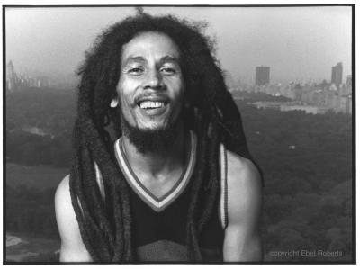
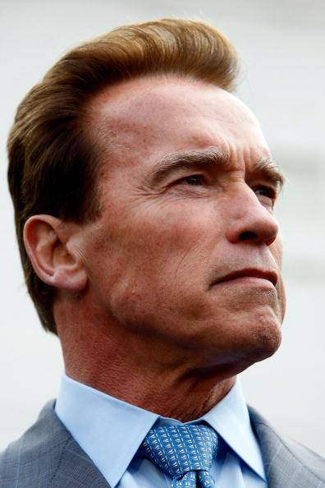

Use the pictures to discuss:
1. what they have in common
2. reasons for emigrating in general
3. people’s reaction(s) to immigrants
4. any country you would like to emigrate/ why?
Michael Traxler | 6 | 20.6.2013 (Nachmittag)
Mag. Kerstin Stanzel | ENGLISCH | 8b

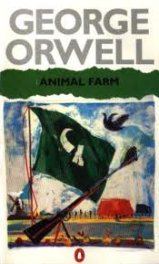
Kernfrage 1: Animal Farm

- Briefly summarize the main plot of Animal Farm.
- What are the seven commandments? How do these change in the course of the story?
- Compare the major events of Orwell’s story to real-life events during the Russian Revolution.
- Give a personal comment on the book.

Kernfrage 2: Controversial Advertising
Oliviero Toscani, fashion photographer for “Benetton”, once claimed:
"Sure, you want to get people's attention. This is communication. "But I still can't understand why people are shocked by something that obviously exists. It's like in a family that always avoids talking about its real problems."

- Use the quote above to talk about controversial advertising?

- What is the AIDA formula? Discuss this formula. Then choose one ad and explain how the AIDA concept applies to it.

- What do you think about limiting or even banning certain ads?

- Which ads and/or commercials do you like and why?

Stefan Kartusch | 16 | 20.6.2013 (Nachmittag)
Mag. Kerstin Stanzel | ENGLISCH | 8b

Kernfrage 1: Travelling and Tourism

The following pictures show different kinds of travelling!

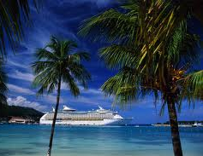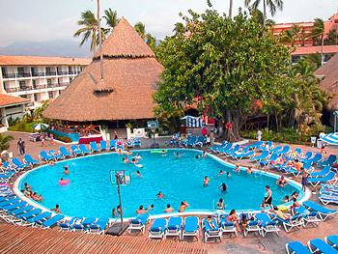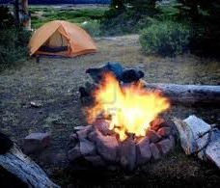
Use the pictures to discuss:

- different kinds of travelling
- the reason(s) for the increase of tourism
- benefits/ problems of world tourism
- what kind of travelling you prefer

Kernfrage 2: Environment/Waste

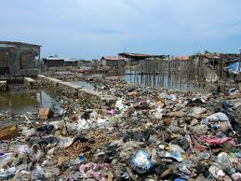
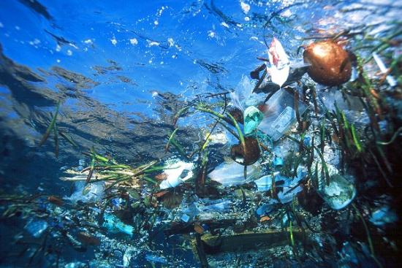
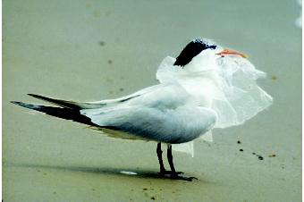
Let us take the pictures as an impulse to talk about waste.

- When do we create waste?
- What´s are positive and negative aspects of plastic?
- What can you do to avoid making waste?

