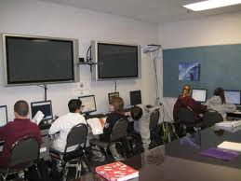
THEMA 9: School
Individual long turn:

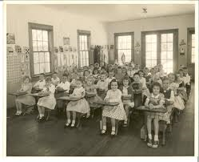

- Compare and contrast the pictures.
- Discuss how school has changed during the last decades.
- Evaluate how the use of computers helps students.
- Suggest improvements to the Austrian school system.

9. Schule und Arbeitswelt

LEARNING LANGUAGES


Sprachreisen Paris



You spend a week in a foreign speaking family and language school.

- Evaluate your experiences in your host family and the language school
- Comment on the language lessons
- Compare various ways of language learning
- Discuss the importance of learning foreign languages

Schools:
  

- Compare different types of school in different countries
- Make suggestions about possible changes to make school a happier place
- Talk about discipline at school
- Talk about your school days. What was good or bad about them?

The Wave and the American Educational System

“Strength through Discipline”

Ben Ross talks about discipline and power in his history class. Why does Ben Ross start the experiment in the book The Wave? What was the outcome of the experiment?
What is your opinion on discipline and school rules?
Do you think that discipline would help to improve standards of learning at school?
Ben Ross teaches at an American high school. What is different to an Austrian “Gymnasium“? Go on to talk about the American educational system.

