Themenkreis: Fashion
Individual long turn
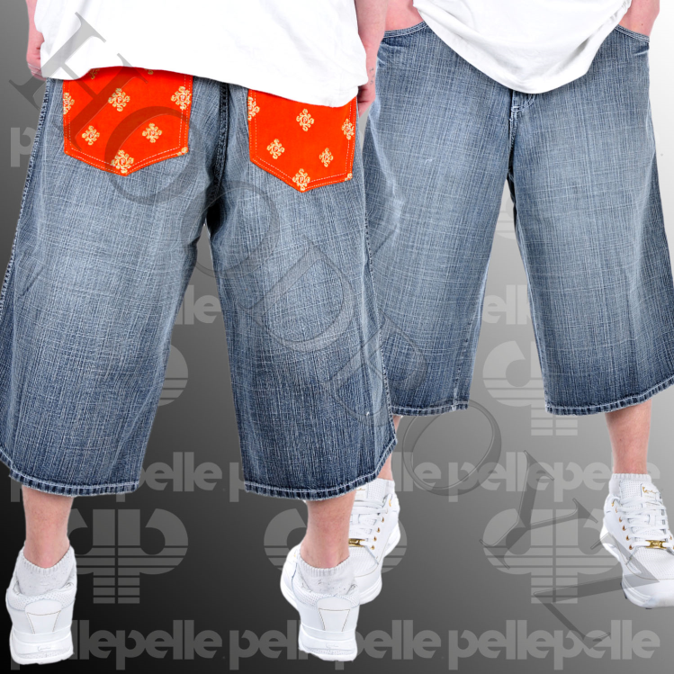
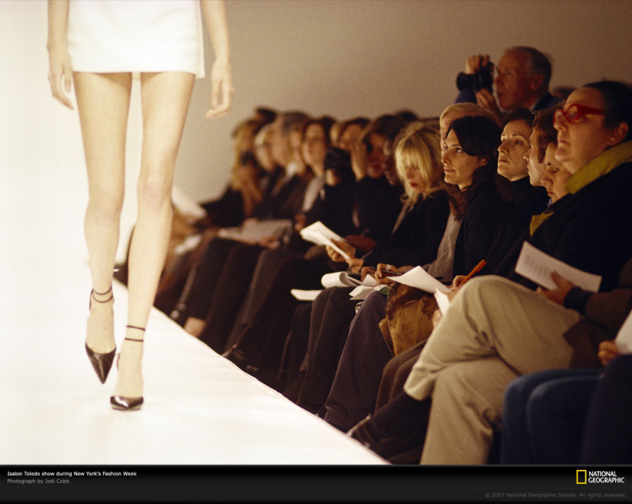

- Compare and contrast the pictures
- Give reasons why the job of a fashion model is (is not) attractive
- Speculate on what makes people buy designer clothes
- Comment on the different attitudes of boys and girls concerning fashion

paired activity

- Dialogue

Convince your friend to change his/her unhealthy lifestyle.

- Talk about the importance of sports. – What about joining a fitness club together?
- Would you recommend vegetarian food? Why / Why not?
- Point out the role of social networks in connection with unhealthy food.
- Discuss health risks.
- Try to reach agreement on a healthy lifestyle.

Themenbereich 5: Health
Extreme sports





- Provide a definition of “extreme sports” and give examples of what is actually considered an extreme sport referring also to the pictures above.
- What is this hype that surrounds these kinds of activities about? What have advertising, PR and consumer products got to do with it?
- What is your opinion on extreme sports? Would you say those who take up risky sports should be held responsible for possible consequences?

- provided you with the essential skills to achieve your goals?

- Monologue

- Analyse your lifestyle whether it is healthy or not. – What do you do – what should you do?
- Discuss vegetarianism. Are you for or against it?
- Did “Supersize Me“ inspire or scare you?
- Comment on the influence of the media.

