Themenbereich „MEDIA”
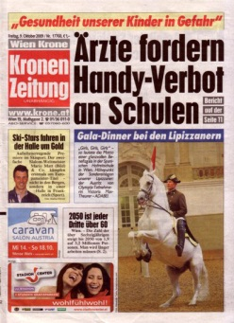
Task for Individual Long Turn




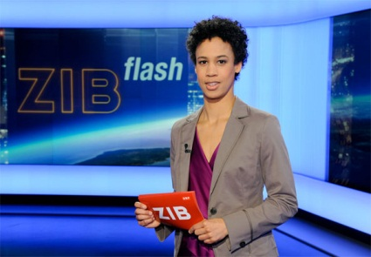
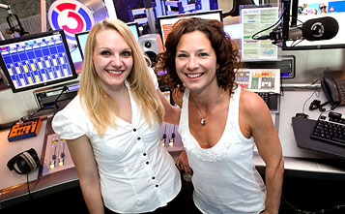

- Contrast the various ways of getting informed.
- Point out what characteristics each of them has?
- Which way do you prefer?
- Explain why you prefer it to others.


Task for Paired Acticity
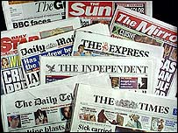

either or!
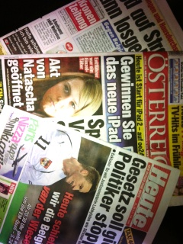
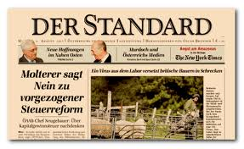

- As students you share a flat in the town where are studying. You have decided to subscribe to a daily newspaper.
- Discuss the various papers you know (you may either refer to British papers or to Austrian papers)
- Discuss what you can expect of the various sorts of Daily papers
- Decide on one that you actually want to subscribe to.

