Themenbereich „TOURISM and TRAVELLING“

Task for Individual Long Turn

These two pictures represent two very different holiday experiences you had.

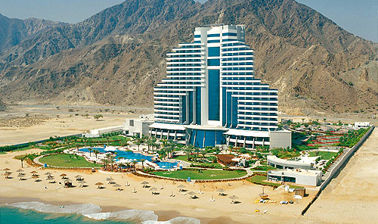
- compare them
- talk about the way you spent them
- with whom you spent them and
- what you liked/disliked about them

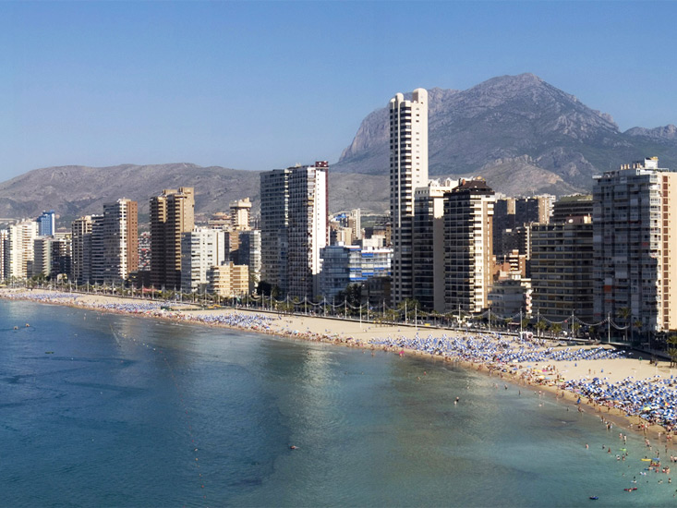
Task for Paired Acticity
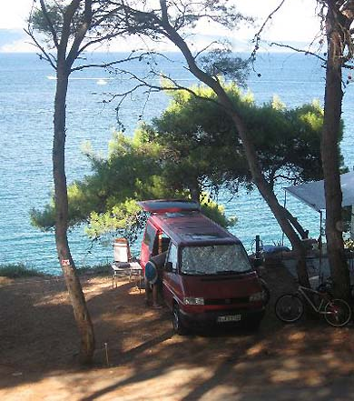

The two pictures represent two opportunities of holidays you are offered:
- Travelling and camping in a van near Austria or flying to Spain to stay in a holiday apartment
- As you want to go together you must make a decision
- Consider the advantages and disadvantages of these two ways

