Themenbereich „TOURISM and TRAVELLING“
I. Task for Individual Long Turn
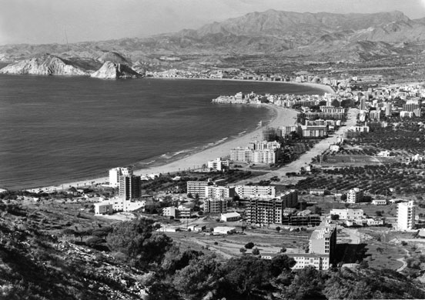

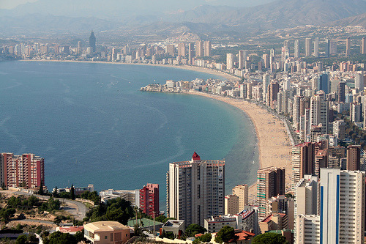

Contrast these two pictures of the Spanish seaside resort Benidorm:
- Point out the differences and similarities
- Speculate when they were taken and what must have changed between these two views
- What may a holiday in Benidorm been like then and what is it probably like now
- How did the people arrive there then and how do they now?
- Would any of the picture appeal to you so that you would like to spend a holiday there?

Task for Paired Acticity
You have won a holiday for two persons and here is the list of destinations you can choose from.
- Decide where you want to go together
- considering the things you may expect to see,
- wondering about what the different programmes and locations might offer to you
- and considering the different durations of the stays.
Classical Spain | 6 nights
Pompeii, Capri and the Bay of Naples | 7 nights
Hidden Portugal | 7 nights
Lake Garda | 7 nights
Paris by Eurostar | 3 nights
Heart of the Silk Road |  |  | 10 nights
Dubrovnik, the Dalmatian Coast & Montenegro |  |  | 7 nights
Seven Cities of Italy Tour |  |  | 7 nights
Venice, Verona & Lake Garda |  |  | 7 nights
Barcelona & the highlights of Catalonia |  |  | 6 nights

