Themenbereich „TRAFFIC and TRANSPORT”
Task for Individual Long Turn
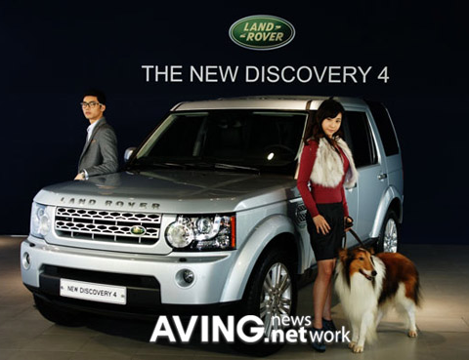

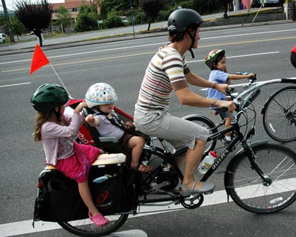

Compare these two pictures
- Analyse what they say about people’s mobility
- Point out further alternatives
- and discuss their advantages and disadvantages
in terms of money, convenience and environment

Task for Paired Acticity


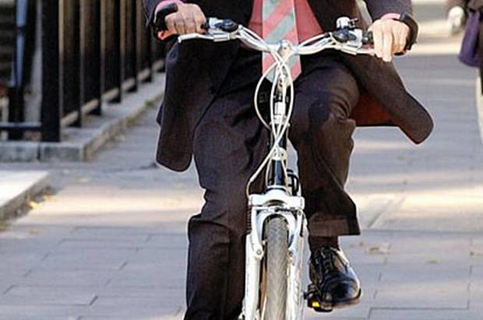

Seeing these pictures a discussion has started in your family if it was possible to give up your family car.

- As members of the family you discuss your points of view in terms of money, convenience and environment.
- You also consider alternatives
- You should finally arrive at a conclusion if you actually wanted to give up the family car.

