Themenbereich „UTOPIAS-DYSTOPIAS”
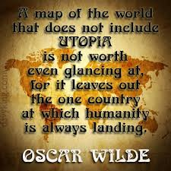
Task for Individual Long Turn
- Interpret what Oscar Wilde might have meant in this quotation.
- Point out your own ideas of an ideal world considering the difficulties in achieving it.
- Give examples of other utopias you might have read about.
- Speculate why it is so difficult to “create” an ideal world.

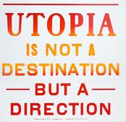
Task for Paired Acticity

UTOPIA A:
§ 1 All men are completely equal. All citizens are responsible for each other.
§ 2 Nobody is allowed to own more than
he needs for himself.
§ 3 Political leaders are found by drawing lots so everybody must be prepared to carry political responsibility
UTOPIA B:
§ 1 Everybody is responsible for himself.
§ 2 If you work hard you will be successful and become wealthy.
§ 3 Those who have achieved most are qualified to be political leaders.

- Point out the characteristics of each of these utopias.
- Find out what you like/dislike most?
- Try to agree on the one that seems to be more idealistic than the other.
- Try to agree which of the two seems more realistic.
- Finally work out basic rules that should be elementary in each state

