Topic: Utopia

Individual long turn

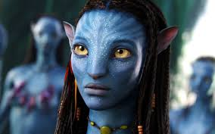


- Compare the pictures.
- Analyse why people are so fascinated by alternative realities.
- Speculate why teenagers are specially interested in stories of that kind.

Paired activity

Utopias and dystopias have always fascinated writers and filmmakers. With your partner you speak about a film or a book that presents a different world. Comment on

- how the political situation is depicted
- a character
- the ruler/ ruling social class and how they control the inhabitants
- how one’s feelings are controlled
- your ideal world

Topic: Literature/Ireland

Individual long turn

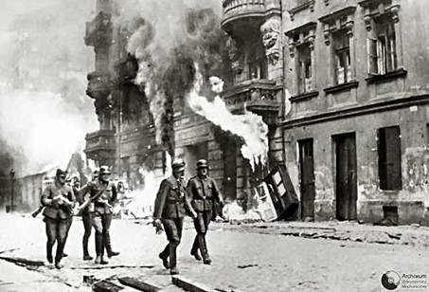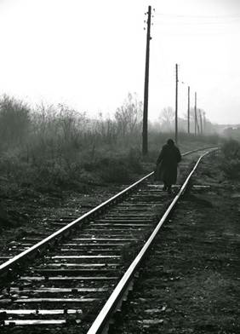
Picture sources:
http://www.scientificoatripalda.it/vociedechi/Quarta/Pagine%20web/quartaastarcalledhenry.html

- Compare the pictures.
- Explain the historic background of the scenes in the context of the Irish Revolution.
- Assess the quality of Irish-ness in Roddy Doyle’s novels.

Topic: Language trip to Ireland

A (Irish eating and drinking habits)
- Individual long turn (monologue)

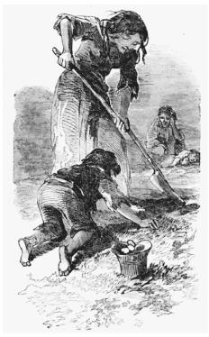

http://entertainment.ie/festival/news/Show-your-appreciation-for-spuds-on-National-Potato-Day/206640.htm

http://ic.galegroup.com/ic/whic/ReferenceDetailsPage/ReferenceDetailsWindow?zid=6fe091b111ab9a923e33bb75edf2560f&action=2&catId=&documentId=GALE%7CCX3434700334&userGroupName=pl2660&jsid=e76c11af19e3e51cb1fd4f5308a872e5

- Compare and contrast the pictures.

- Outline the historical background to the scene depicted in the first picture.

- According to your own experience assess the importance of the potato in the
Irish cuisine.

- Paired activity (dialogue)
You were asked to prepare a presentation on Irish food for next year’s group that goes to Ireland. Discuss how (you are going to present the following content points:
- typical Irish dishes and drinks
- places in Dublin to go to for food
- prices
- daily routine regarding meals
- how students taking part in a language trip are provided with food.

Doesn’t mean to ask facts and figures, but what impact the potato famine hat on the population etc..Wrong facts must not lower the mark.
Allows to incoporate personal experience, content, knowledge which leads to more advanced language) Topic: Landeskunde Individual long turn: 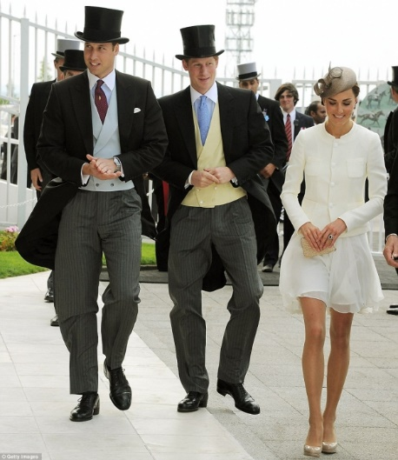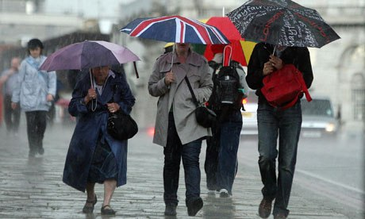 ( https://sophiechekruga.wordpress.com) (www.hercampus.com) - Compare the pictures - Illustrate some common clichés about British people - Speculate about worries British citizens in Austria might have about Brexit Paired activity: Together with your English teacher you are planning a school trip to Ireland for Year 6. This year’s trip will shorter, therefore only three activities can offered. Evaluate the following headlines of the leaflet based on your experience. Since you have been on a school trip to Ireland yourself, your teacher asks you for advice. - Hike the cliff walk - Learn about Dublin with professional guides - Walking Ulysses – follow the characters of the book - Visit Docklands and Google – Contemporary Dublin - Explore Irish History in a museum Topic: Politics I. Individual Long Turn (5 min.) 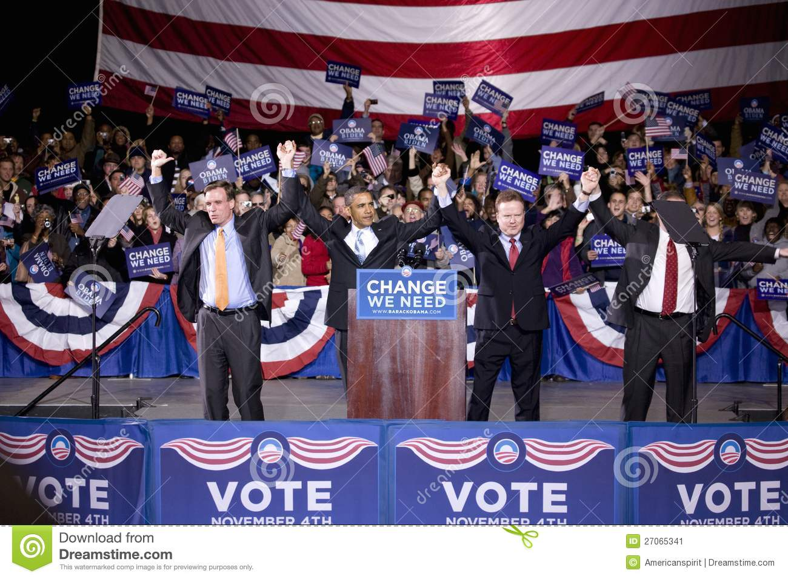 http://www.dreamstime.com/stock-image-barack-obama-stage-change-need-image27065341 [6/5/2015] 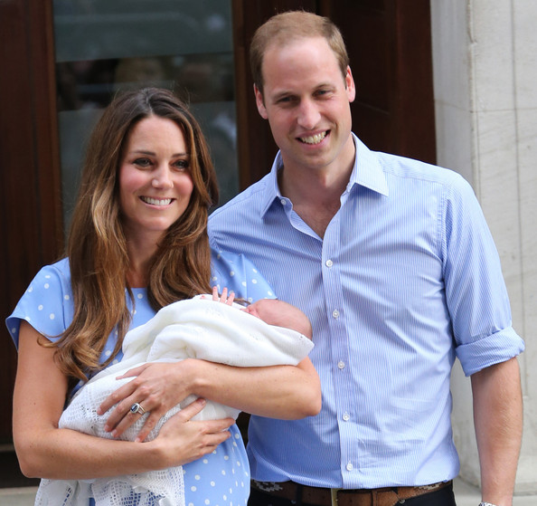 https://www.google.at/search?q=william+and+kate+baby [9/6/2015] - Compare and contrast the pictures. - Speculate what makes a good politician. - Discuss the idea that we should rather live the “European Dream” than the “American Dream”. (must have been covered in class. Detailed factual knowledge should not be expected. Social, cultural, political issues have to be accepted. ) II. Paired Activity (10 min.) (T) The EU wants to encourage young Europeans to take an active part in politics. For this purpose a workshop “Young people and politics” has been organised to find out which issues are important. In this workshop you have to give a five-minutes presentation on your thoughts on this issue. Together with your teacher, discuss each of the following aspects and agree on the three you will include in your presentation. - background knowledge on European institutions - gap between the rich and the poor - environmental issues - work and working conditions - education Topic: Landeskunde Individual long turn 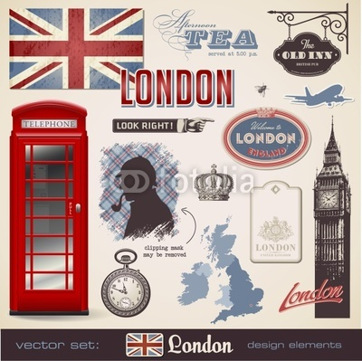 - Compare and contrast the pictures above. - Analyse the differences between the two countries/cities. - Evaluate the importance of both countries to you. Topic 7: Villains in literature and film https://shrineodreams.wordpress.com/2011/10/02/ http://www.telegraph.co.uk/history/10484835/Author-claims-to-have-solved-Jack-the-Ripper-mystery.html the-first-crime-noir-novel/ - Compare the picture and the newspaper clipping. - Discuss the portrayal of villains in literature and film. - Recommend a book/ short story or a film featuring an evil character. Paired activity Top villains from literature and film You are organising a quiz evening with friends. You and your partner are preparing questions on villains from literature and film. In your preparation you discuss the following characters and agree on the three most interesting ones: - Lord Voldemort (Harry Potter) - President Snow (The Hunger Games) - Sauron (Lord of the Rings) - Roald Dahl's female characters (e.g. Mrs Foster – The Way Up To Heaven) - your own choice This is a suitable tasks for topics in literature and films! Topic 7: Art and Culture – the Myth of Shakespeare Individual long turn - Compare the two pictures. - Explain which of these performances you would like to visit. - Suggest reasons why Shakespeare’s plays have been on stages around the world for four hundred years.

