The Other Side of the Story

Kate Chopin
The Awakening

“But when she was there beside the sea, absolutely alone, she cast the unpleasant, pricking garments from her, and for the first time in her life she stood naked in the open air, at the mercy of the sun, the breeze that beat upon her, and the waves that invited her.
How strange and awful it seemed to stand naked under the sky! How delicious! She felt like some new-born creature ,opening its eyes in a familiar world that it had never known.”
(p. 175)

The above passage appears close to the end of Kate Chopin’s famous novel The Awakening. Explain its meaning and symbolism.
Why is Edna alone and naked? What do the pricking garments stand for?
Is this new freedom only positive?
Will she be able to enjoy it?
Other Side of the Story

Virginia Woolf

A Room of One's Own

"...I could not help thinking as I looked at the works of Shakespeare on the shelf, ...; it would have been impossible, completely and entirely, for any woman to have written the plays of Shakespeare in the age of Shakespeare. Let me imagine, since facts are so hard to come by, what would have happened had Shakespeare had a wonderfully gifted sister, called Judith, let us say. Shakespeare himself went, very probably – his mother was an heiress- to the grammar school, where he may have learnt Latin – Ovide, Virgil and Horace – and the elements of grammar and logic. He was, it is well known, a wild boy who poached rabbits, perhaps shot a deer, and had, rather sooner that he should have done, to marry a woman in the neighborhood, who bore him a child rather quicker than was right. That escapade sent him to seek his fortune in London. He had, it seemed, a taste for the theatre; he began by holding horses at the stage door. Very soon he got work in the theatre, became a successful actor, and live d at the hub of the universe, meeting everybody, knowing everybody, practicing his art on the boards, exercising his wits in the street, and even getting access to the palace of the queen. Meanwhile his extraordinarily gifted sister, let us suppose....."

Continue this imaginary biography of Shakespeare's sister. What would her fate have been?

Thinking of the literature you have read, what has changed since Shakespeare's time? Give examples from the heroines of women's literature.
List some of the limitations that these women have encountered. Which strategies have they developed to overcome them?

The Other Side of the Story

"The Storm"
by Kate Chopin

The following passages have been taken from Kate Chopin's story. They describe the changes of weather in the course of the story.
Explain the symbolism of this setting. What is Kate Chopin saying about women, marriage and passion?

I
The leaves were so still that even Bibi thought it was going to rain. Bobinôt, who was accustomed to converse on terms of perfect equality with his little son, called the child's attention to certain sombre clouds that were rolling with sinister intention from the west, accompanied by a sullen, threatening roar...

II
Calixta, at home, felt no uneasiness for their safety. She sat at a side window sewing furiously on a sewing machine. She was greatly occupied and did not notice the approaching storm. But she felt very warm and often stopped to mop her face on which the perspiration gathered in beads. She unfastened her white sacque at the throat. It began to grow dark, and suddenly realizing the situation she got up hurriedly and went about closing windows and doors.
...
The rain beat upon the low, shingled roof with a force and clatter that threatened to break an entrance and deluge them there. They were in the dining room—the sitting room—the general utility room.
...
"The rain was coming down in sheets obscuring the view of far-off cabins and enveloping the distant wood in a gray mist. The playing of the lightning was incessant. A bolt struck a tall chinaberry tree at the edge of the field. It filled all visible space with a blinding glare and the crash seemed to invade the very boards they stood upon.
...
The growl of the thunder was distant and passing away. The rain beat softly upon the shingles, inviting them to drowsiness and sleep.

III
The rain was over; and the sun was turning the glistening green world into a palace of gems.
...

The Other Side of the Story

A Riddle

A riddle is making the rounds that goes like this: A man and his young son were in an automobile accident. The father was killed and the son, who was critically injured, was rushed to a hospital. As attendants wheel the unconscious boy into the emergency room, the doctor on duty looked down at him and said, "My God, it's my son!"

What was the relationship of the doctor to the injured boy?

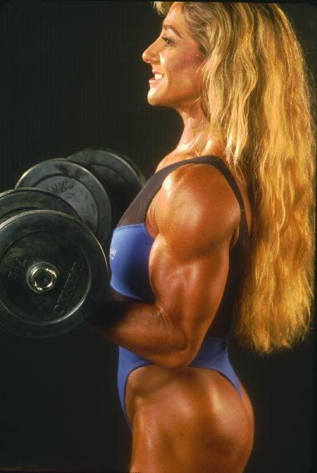

As you will certainly have noticed, the above riddle plays on stereotypes of men and women. List some of the stereotypes associated with men and women.
Then find examples from the literature you have read. How are women and men portrayed in the stories we have read in the course? Choose some fitting examples.

The Other Side of the Story

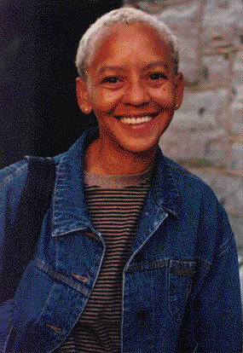
Woman
by Nikki Giovanni

she wanted to be a blade
of grass amid the fields
but he wouldn't agree
to be the dandelion

she wanted to be a robin singing
through the leaves
but he refused to be
her tree

she spun herself into a web
and looking for a place to rest
turned to him
but he stood straight
declining to be her corner

she tried to be a book
but he wouldn't read

she turned herself into a bulb
but he wouldn't let her grow

she decided to become
a woman
and though he still refused
to be a man
she decided it was all
right

Explain the meaning of this poem. How does this woman define herself?
Have you come across any women characters in literature who remind you of the speaker of this poem? Who are they?
Choose one or two fitting characters and describe their developments.
The Other Side of the Story

The Bell Jar

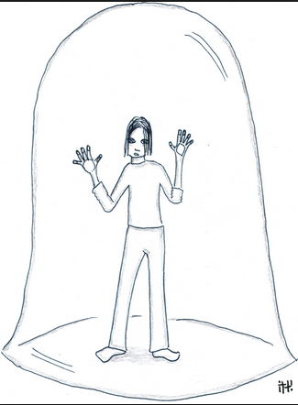

Many of the women characters in the samples we have read have felt trapped in their situations and circumstances. The Bell Jar can be seen as a symbol of this confined existence.

Name some of the women characters from literature.

- What limitations did they encounter?
- What strategies did they use to free themselves?
- Did they succeed?

