Core question

Politics and Literature
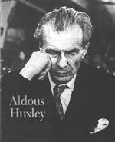
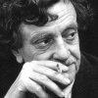

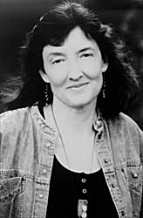
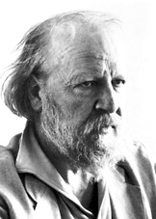
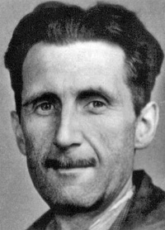

Look at the world,
We’ve warned them but…

Imagine George Orwell, Aldous Huxley, William Golding, Kurt Vonnegut and Barbara Kingsolver could meet on planet Trafalmadore and discuss politics. They would, of course, find that many of their fictitious scenarios have in the meantime come true or have been repeated throughout history and point out parallels between their characters and our leaders.

To warm up for their discussion they would do a silent round of “brainwriting”. (The silent brainstorming activity we’ve done in class. Each participant adds comments on a common sheet)

Present the writers’ statements and explain what they are referring to.

Core question

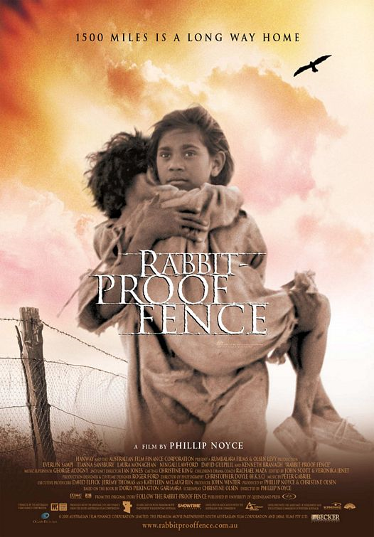
Childhood and Adolescence

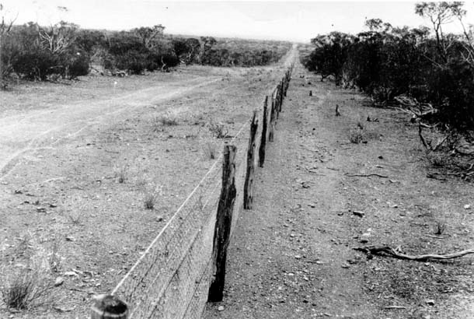

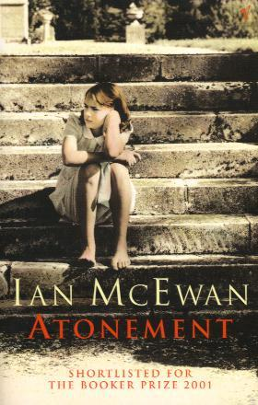
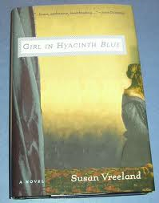

Several books on your reading list describe children and teenagers growing up in difficult circumstances or experiencing difficult situations.

Choose two interesting characters and describe the circumstances and problems they were faced with.


core question

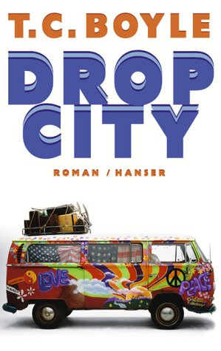
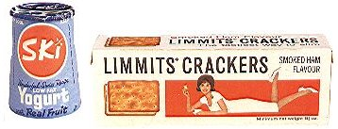
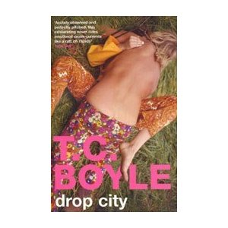
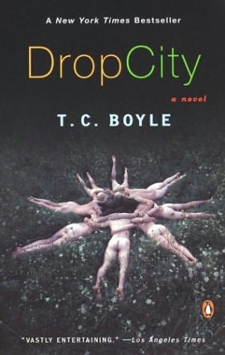

Look at the pictures. In what way do they reflect the lifestyle, values and political ideas of the Sixties?

How does the novel Drop City describe this time? Do the Hippies’ dreams of unlimited freedom come true?

core question

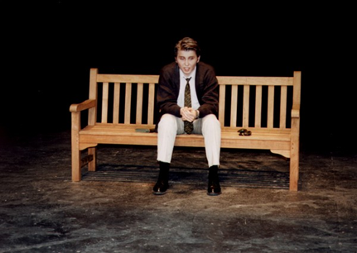
Life in a Big City

"Now I'll let you in on what happened at the zoo; but first, I should tell you why I went to the zoo. I went to the zoo to find out more about the way people exist with animals, and the way animals exist with each other, and with people too. It probably wasn't a fair test, what with everyone separated by bars from everyone else, the animals for the most part from each other, and always the people from the animals. But, if it's a zoo, that's the way it is."

“The first thing I did when I got off at Penn Station, I went into this phone booth. I felt like giving somebody a buzz […] but as soon as I was inside, I couldn't think of anybody to call up. My brother D.B. was in Hollywood. My kid sister Phoebe […] was out. Then I thought of giving Jane Gallagher's mother a buzz […]. Then I thought of calling this girl […] Sally Hayes. […] I thought of calling […] Carl Luce. […] So I ended up not calling anybody. I came out of the booth, after about twenty minutes or so. “(9.1)

Compare the two characters’ experiences in New York.
What are the authors saying about life in the big city?

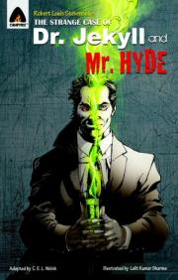
core question

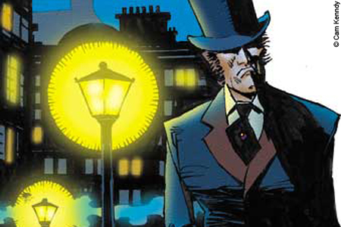

The two sides of Edinburgh

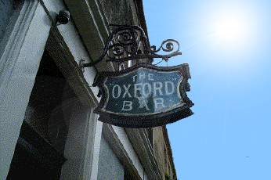

“Maybe Rebus will be in the back bar”
Reviewed 4 October 2010
Excellent small bar just near Charlotte Square in Edinburgh. Make the effort to find it, particularly if you are an Ian Rankin/Rebus fan. This is the bar mentioned regularly in the Rebus novels and Ian Rankin the author lives nearby and frequents the Ox. You may possibly see him at the bar.

The "Ox", or Oxford Bar, is a pub on Young Street where the dish of the day is as unchanged as the cracked lino and smoke-stained walls. It is also the refuge of choice for Rebus after a hard night on the tiles and a place where Rankin still drinks and does much of his research. The fact that it actually exists, along with the other bars, shops and monuments featured in the books, makes Rebus - and Rankin - fascinating companions for visitors wanting to explore both the celebrated and the darker sides of the city.

You have read Ian Rankin’s descriptions of Edinburgh and you been to Edinburgh yourself. Compare the two views of the city. Describe some of the “celebrated and darker sides of the city” that you have seen or read about.


core question

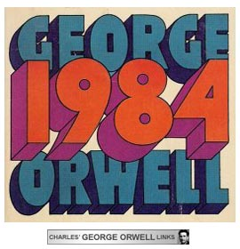
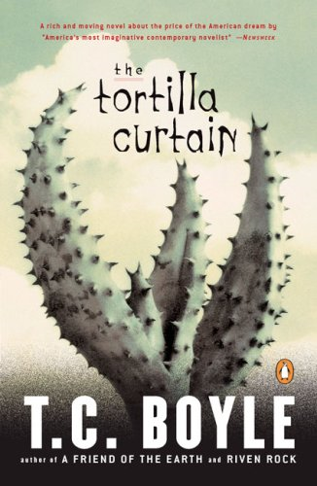
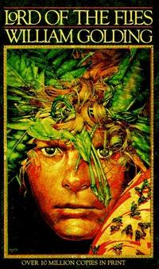

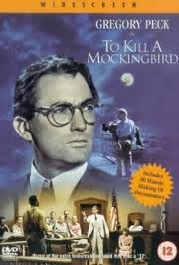

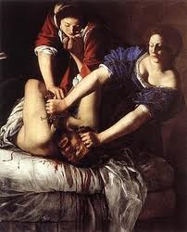
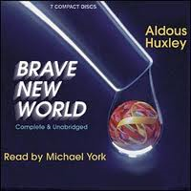

The Passion of Artemisia

You have read several novels that describe and criticize social or political systems in different places and at different times.
If each of the writers had chosen to write a newspaper article instead of the novel, what titles might they have chosen to express the same main ideas?

Briefly present your choice of titles and explain the authors’ main points of criticism.
(Choose at least 4 of the 6 books.)


core question

The American Dream

What do these pictures say about different aspects of the American Dream?
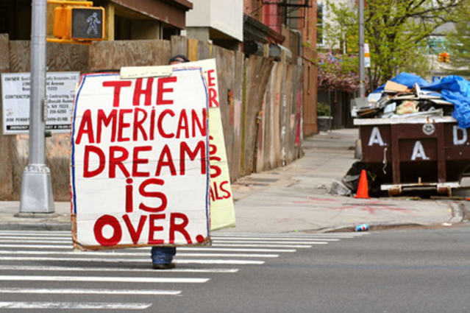

Give examples from your reading and your personal experience.

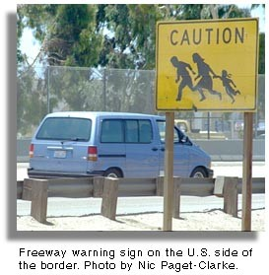

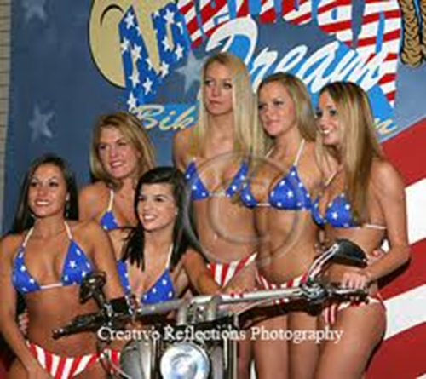

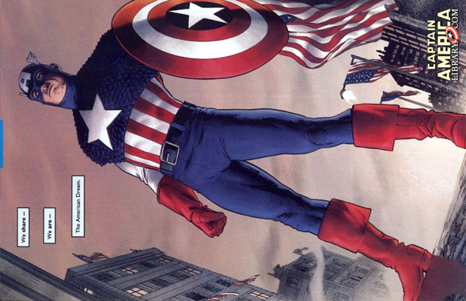
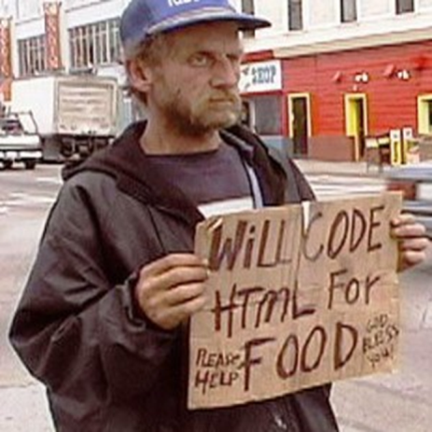

Core question

The Picture of Dorian Gray

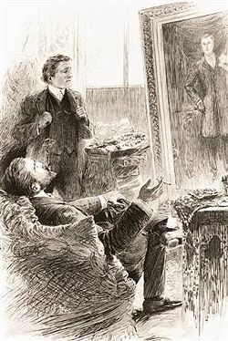

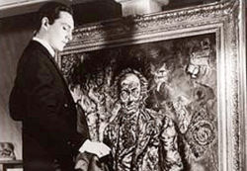

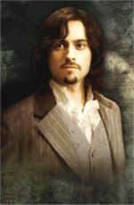

Decadence: Lord Henry guides Dorian along a path that ends in total moral decline and decay. He himself indulges in a lifestyle totally uncommon and condemned by Victorian society.
Describe Dorian’s moral descent throughout the novel.

What is Oscar Wilde saying about Victorian society?
How was the novel received by the society of the time?

What does he say about the purpose of art? Explain the concept of aestheticism.

Do you agree? What role does art play for you?

core question

COURAGE

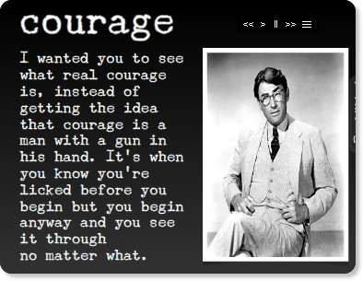

from: Harper Lee, To Kill a Mockingbird

Think of characters from your reading list as well as famous historical figures that we have discussed in English.

Choose three characters or persons who have shown courage as defined above.
Briefly explain what they have done and what their aims were.

How would you personally define courage? Have you met any courageous people?

core question

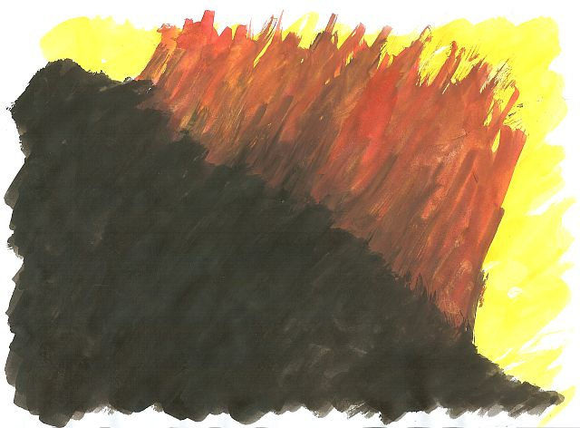
What happens to a dream deferred?
Does it dry up
like a raisin in the sun?
Or fester like a sore—
And then run?
Does it stink like rotten meat?
Or crust and sugar over—
like a syrupy sweet?
Maybe it just sags
like a heavy load.
Or does it explode?

Explain the meaning of the above poem.

What was the original context of Langston Hughes’ poem?

Point out similar circumstances in our present day world.

Core question

A Riddle

A riddle is making the rounds that goes like this: A man and his young son were in an automobile accident. The father was killed and the son, who was critically injured, was rushed to a hospital. As attendants wheel the unconscious boy into the emergency room, the doctor on duty looked down at him and said, "My God, it's my son!"

What was the relationship of the doctor to the injured boy?



As you will certainly have noticed, the above riddle plays on stereotypes of men and women. List some of the stereotypes associated with men and women.
Then find examples from the literature you have read. How are women and men portrayed in the literature you have read? Choose some fitting examples.

Core question

The Role of Women
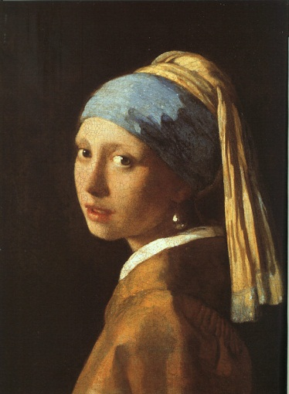
In
The Girl With The Pearl Earring

and

Virginia Woolf

A Room of One's Own
Read the short extract from A Room of One’s Own where Virginia Woolf writes about Shakespeare’s imaginary sister Judith. Discuss the role of women at that time. What were their options. What was expected of them? How has the situation changed?
Continue this imaginary biography of Shakespeare's sister. What would her fate have been?
"...I could not help thinking as I looked at the works of Shakespeare on the shelf, ...; it would been impossible, completely and entirely, for any woman to have written the plays of Shakespeare in the age of Shakespeare. Let me imagine, since facts are so hard to come by, what would have happened had Shakespeare had a wonderfully gifted sister, called Judith, let us say. Shakespeare himself went, very probably – his mother was an heiress- to the grammar school, where he may have learnt Latin – Ovide, Virgil and Horace – and the elements of grammar and logic. He was, it is well known, a wild boy who poached rabbits, perhaps shot a deer, and had, rather sooner that he should have done, to marry a woman in the neighbourhood, who bore him a child rather quicker than was right. That escapade sent him to seek his fortune in London. He had, it seemed, a taste for the theatre; he began by holding horses at the stage door. Very soon he got work in the theatre, became a successful actor, and live d at the hub of the universe, meeting everybody, knowing everybody, practicing his art on the boards, exercising his wits in the street, and even getting access to the palace of the queen. Meanwhile his extraordinarily gifted sister, let us suppose....."

Compare the role of women in the Girl with a Pearl Earring with the extract from A Room of One’s Own. Give examples from the book.

Thinking of the literature you have read, what has changed since Shakespeare's and Vermeer’s time? Give examples from the heroines of women's literature.
List some of the limitations that these women have encountered. Which strategies have they developed to overcome them?

Core question

Violence, Rape and Murder

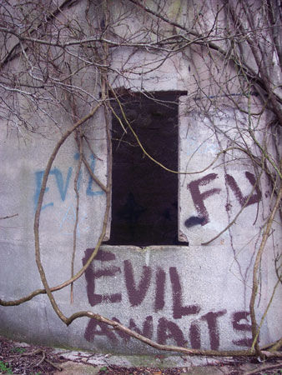

Your reading list reeks of violence, rape and murder.
Take a closer look at the evil characters in the literature you have read.

1. Make a quick list of all the incidents of violence against others.
Perpetrator/criminal | Crime/ activity | Victim

2. Imagine you were a criminal defense attorney and you were asked to defend one of the above perpetrators.
Which of the criminals would you defend most readily?
Which one would be your last choice?
Give reasons.

Core question

Susan Vreeland, Girl in Hyacinth Blue

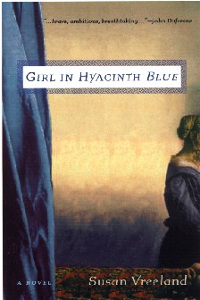

What does the Girl in Hyacinth Blue suggest about the value (personal and monetary) and purpose of art? How does art serve us? Why do we need it?
Give examples from the different stories in the book.
How would you describe the value and purpose of art for yourself?

Core question

Resistance is fertile

Resistance is futile

You might remember the above slogans that were blinking on top of the Kunsthaus a few years ago.

Looking at your reading list, which of the characters have most strongly attempted to resist and rebel against the social norms of their time?
Give a few examples and explain what these characters rebelled against and what they gained by doing so. To what extent was their resistance fertile or futile.

Core question

In Cold Blood
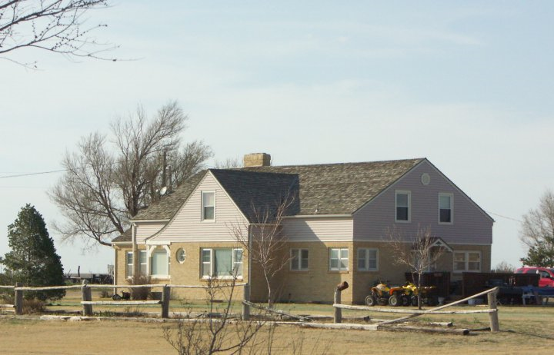
Clutter home Holcomb, KS

Spacini at en.wikipedia

1. Briefly sum up what happened in this house on November 15, 1959.

2. Describe the landscape in the area of Holcomb, KS.
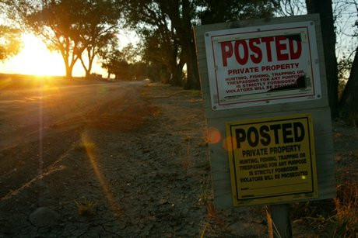
NO TRESPASSING
Because of so many visitors, the lane to the former Clutter house, between rows of Chinese elms, is posted with No Trespassing signs. Donna and Leonard Mader say they sometimes see 20 cars a month come slowly cruising into the lane, stop near the house, and just as quietly back away.

3. This book is neither a who-done-it nor a will-they-be caught. What makes this novel different from other crime novels?

Core question

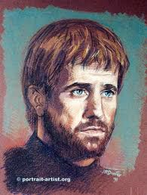
Hamlet, a typical Renaissance man.

Explain the meaning of the most famous soliloquy in English literature. What is Hamlet's dilemma? What are his problems in life? What final decision does he take and why?
In what way is Hamlet a typical Renaissance character?

To be, or not to be (from Hamlet 3/1)
To be, or not to be: that is the question:
Whether 'tis nobler in the mind to suffer
The slings and arrows of outrageous fortune,
Or to take arms against a sea of troubles,
And by opposing end them? To die: to sleep;
No more; and by a sleep to say we end
The heart-ache and the thousand natural shocks
That flesh is heir to, 'tis a consummation
Devoutly to be wish'd. To die, to sleep;
To sleep: perchance to dream: ay, there's the rub;
For in that sleep of death what dreams may come
When we have shuffled off this mortal coil,
Must give us pause: there's the respect
That makes calamity of so long life;
For who would bear the whips and scorns of time,
The oppressor's wrong, the proud man's contumely,
The pangs of despised love, the law's delay,
The insolence of office and the spurns
That patient merit of the unworthy takes,
When he himself might his quietus make
With a bare bodkin? who would fardels bear,
To grunt and sweat under a weary life,
But that the dread of something after death,
The undiscover'd country from whose bourn
No traveller returns, puzzles the will
And makes us rather bear those ills we have
Than fly to others that we know not of?
Thus conscience does make cowards of us all;
And thus the native hue of resolution
Is sicklied o'er with the pale cast of thought,
And enterprises of great pith and moment
With this regard their currents turn awry,
And lose the name of action. - Soft you now!
The fair Ophelia! Nymph, in thy orisons
Be all my sins remember'd.

Hamlet

Explain the meaning of the most famous soliloquy in English literature. What is Hamlet's dilemma? What are his problems in life? What final decision does he take and why?
Compare Hamlet to other characters from your reading who have also been at the verge of committing suicide. What were their reasons for or against life?

To be, or not to be (from Hamlet 3/1)
To be, or not to be: that is the question:
Whether 'tis nobler in the mind to suffer
The slings and arrows of outrageous fortune,
Or to take arms against a sea of troubles,
And by opposing end them? To die: to sleep;
No more; and by a sleep to say we end
The heart-ache and the thousand natural shocks
That flesh is heir to, 'tis a consummation
Devoutly to be wish'd. To die, to sleep;
To sleep: perchance to dream: ay, there's the rub;
For in that sleep of death what dreams may come
When we have shuffled off this mortal coil,
Must give us pause: there's the respect
That makes calamity of so long life;
For who would bear the whips and scorns of time,
The oppressor's wrong, the proud man's contumely,
The pangs of despised love, the law's delay,
The insolence of office and the spurns
That patient merit of the unworthy takes,
When he himself might his quietus make
With a bare bodkin? who would fardels bear,
To grunt and sweat under a weary life,
But that the dread of something after death,
The undiscover'd country from whose bourn
No traveller returns, puzzles the will
And makes us rather bear those ills we have
Than fly to others that we know not of?
Thus conscience does make cowards of us all;
And thus the native hue of resolution
Is sicklied o'er with the pale cast of thought,
And enterprises of great pith and moment
With this regard their currents turn awry,
And lose the name of action. - Soft you now!
The fair Ophelia! Nymph, in thy orisons
Be all my sins remember'd.

