Questions for the Oral Final Exam

Core topics

1. Minorities in America
From Melting Pot to Multiculturalism

cartoons: melting pot (chicano package, mosaic… Indian package) or "Those Who Don't" extra short story by Sandra Cisneros!!!
poem "Chinese Hot Pot" by Wing Tek Lum (Asian package)
Comment on the above cartoons and pictures. Has the age-old notion of the American melting pot come true? Explain the other metaphors of the American national character. Which of the concepts is more accurate?

How is this national character reflected in modern and contemporary American literature?

(answer: Amy Tan, Joy Luck Club : Mother desperately wants to be assimmilated, wants daughter to be fulfill the American dream, prodigy, piano …
…
Chicano/Latino Literature

Confession

(poem in Chicano package)

by David Nava Monreal

Vocabulary: 1. language of Mexican thiefs and scoundrels

Read the above poem and explain in what way it is typical of contemporary Chicano Literature in America. What do you know about Hispanic Americans? What are the main topics and genres in their literature? Give examples from your reading list.

(answer: basically summary of Peter's intro A.)

Chicano/Latino Literature

Refugee Ship

(poem )

by Lorna Dee Cervantes

Read the above poem and explain in what way it is typical of contemporary Chicano Literature in America. What do you know about Hispanic Americans? What are the main topics and genres in their literature? Give examples from your reading list.

(answer: basically summary of Peter's intro A.)

Asian American Literature ???

The American Dream

first page of "Two Kinds", extract from Joy LuckClub by Amy Tan

Read the extract… and explain the role of the American Dream in the literature that we have read. What are the expectations of the different characters? Do they ever come true? What are the consequences of these expectations on the characters in different examples from literature?

(high expectations as in Amy Tan's story almost always lead to disappointment. see also Jewish lit (Sobel, …)

Invisibility Is an Unnatureal Disaster

extract from this essay by Mitsuye Yamada (marked passage)

Read the passage by Mitsuye Yamada and explain what invisibility means for her.
What does invisibility mean for other American authors? Give examples.

(e.g.: Ralph Ellison, Invisible Man, or Paul Laurence Dunbar "We Wear a Mask")

What Is an Indian? (not possible! not enough time to prepare)

Listen to the short speech by Ralph Keene and take notes. Summarize the speech for the commission. How do outsiders see the Indian, how does Ralph Keene describe the Indian?

Explain some of the most important differences between Native American culture and our culture.

(see list of study questions for details)

Native Americans

This Earth is Precious
…
"So, when the Great Chief in Washington sends word that he wishes to buy our land, he asks much of us. The Great Chief sends word he will reserve us a place so that we can live comfortably to ourselves. He will be our father and we will be his children. So we will consider your offer to buy our land. But it will not be easy."

Read the following extract of Chief Seattle's reply to the American Government and explain its meaning it its historical context. Why won't it be easy for Chief Seattle to sell his land? Why is land ownership seen so differently by the American Indians? What are allotment programs and why did they fail?

Native Americans

Twelfth Song of the Thunder

The voice that beautifies the land!
The voice above,
The voice of the thunder
Within the dark cloud
Again and again it sounds,
The voice that beautifies the land.

The voice that beautifies the land!
The voice below;
The voice of the grasshopper
Among the plants
Again and again it sounds,
The voice that beautifies the land.

Read the anonymous Indian song and explain its meaning and purpose.
What are the underlying values and beliefs.
Compare the Native American view of living things with the European notion of the "great chain of being".

(Indian Rel, Pantheism, View of Nature)

Core question

Civil Rights

Read the following quotations and decide who could have said them. Explain their meanings and backgrounds.
"There is nothing in our book, the Koran, that teaches us to suffer peacefully. Our religion teaches us to be intelligent."
"The cost of freedom is death." "You get your freedom by letting your enemy know that you'll do anything to get your freedom… by any means necessary."
"The experience in Montgomery did more to clarify my thinking in regard to the question of nonviolence than all of the books that I had read. As the days unfolded, I became more and more convinced of the power of nonviolence. Nonviolence became more than a method to which I gave intellectual assent; it became a commitment to a way of life."

"Civil disobedience means capacity for unlimited suffering without the intoxicating excitement of killing"
"Disobedience to be civil implies discipline, thought, care, attention."
"Noncooperation is not a hymn of hate. My noncooperation is with methods and systems, never with men."
"Even as a tree has a single trunk but many branches and leaves, there is one religion – human religion—but any number of faiths."
"My effort should never be to undermine another's faith but to make him a better follower of his own faith."

Jewish Literature
Read the poem "Mountain Jews" by Scott Coffel. In what way is this a typically Jewish poem? Which common theme of Jewish literature does it exemplify?

Give some other examples of Jewish literature that deal with the same theme.
What is a shlemiel and a shlimazel?

Handcrafted lampshade where the heat of the lightbulb causes a painted paper cylinder to revolve around an axle, thus creating moving pictures.

The Sixties (Alice Fischer)
Listen to the well-known song "San Fransisco" by Scott McKenzie. Explain the meaning of the lyrics in the context of the sixties. What were the values and political ideas of the time?
Do you know any literature of the Fifties or Sixties that represents the same values?

(Jack Kerouac, On the Road)

song!!! text

What role does education play in our lives?

Booker T. and W.E.B.

….poem

Read the poem by Dudley Randall and explain Booker T. Washington's and W.E.B. DuBois' views of education.
What role does education play for members of minorities in America. Give examples from literature.

What role does education play in our lives?

"Indian education is an alien system designed not to meet Indian needs and goals but to minimize the havoc and embarrassment caused by the disruption of Indian institutions by outside influences. Social disorganization is the name of the game, and a chief contributor over the years has been the federal education program. The chief effort toward helping Indians has been through education. The result of the federal participation is cultural deprivation. The Indian community is deprived of its most energetic and creative members…
The success is measured in terms of how permanently the Indians become removed from their families. In other words, he does not go back to the blanket. Indians send their children to schools with mixed emotion. They want them to eat, but they send them off to school at the dire risk of losing them."
from "School is the Enemy" by William Penseno

Read the passage about Indian education and explain the ambivalent attitude many Native Americans have towards education and schools.
Compare the Indian attitude towards education to the attitudes of other American minorities. Give examples from literature.

What role does education play in our lives?

"We had each earned fourteen dollars for eight hours of work, the most money I had ever made in one day. Two days later, on May 27,1969, I deposited those dollars; on June 9th I made my first withdrawal – four dollars to buy a belt to match a pair of pants. I had just been hired to sell encyclopedias, and the belt was intended to dazzle my prospective clients when they opened the door to receive me. But in reality few welcomed my presence on their doorsteps and the only encyclopedias I sold that summer were to families on welfare who so desperately wanted to rise from their soiled lives. Buy a set, I told them, and your problems will disappear. Knowledge is power. Education is the key to the future, and so on…."

from "The Savings Book" by Gary Soto

What role does education play in the lives of many immigrants or members of minorities in America? Give examples from your reading.

Australia and its people

Read the story "Toonkoo and Ngaardi". What type of story is this?
Sum up the story and explain its meaning.
What is the importance and purpose of such stories in their culture of origin?
What are the typical topics of this story and similar ones?

(tale! typ. features of tales) (ev. compare to Ind. stories)

Black Americans

Yet Do I Marvel

poem

Read the poem by Countee Cullen and briefly explain its meaning. Why does God "make a poet black and bid him sing"?
Explain the importance of the major survival strategies that Black Americans have used over the centuries. What role does God and religion play in Black American literature? Give examples.

Black Americans: The Role of Religion, Black English

Gospelsong: Give me that oldtime religion

Read the lyrics of the well-known gospel-song and explain its meaning for Black Americans. What is the purpose of this song? What role does religion play here?
Compare the role of religion as it is described in this song with the role religion plays in other examples from literature.
Briefly explain some of the typical features of Black English that you can find in this song.

What is a Jew?

poem: For Johannes Edfeldt

Read the poem by ??????? and briefly sum up its meaning. In what way is this poem typical of contemporary Jewish American literature?
If contemporary Jews cannot define themselves through their religion, how else do they explain their Jewishness? Give examples from your reading.

Humor as a Survival Strategy

The Moose
by Woody Allen

story

Read the short story and sum up its content. Explain in what way this story is typical of Woody Allen's humor. How does he achieve this effect?
How would you characterize the narrator and the Berkowitzes?
Explain the ending of the story. In what way is it ironic?

What is the purpose of using irony in literature. How is it achieved. Give examples of other ironic texts that you have read.

Cross-curricular questions: English-History

The Sixties

Who's Next
by Tom Lehrer

One of the big news items of the past year concerned the fact that China, which we call Red China, exploded a nuclear bomb, which we called a "device".
Then Indonesia announced that it was going to have one soon and proliferation became the word of the day. Here's a song about that:

First we got the bomb, and that was good, 'cause we love peace and motherhood
Then Russia got the bomb, but that's OK, 'cause the balance of power's maintained that way,
Who's next? France got the bomb, but don't you grieve, 'cause they're on our side, (I believe).
China got the bomb, but have no fears, they can't wipe us out for at least five years.
And then Indonesia claimed that they were gonna get one any day.
South Africa wants two, that's right, one for the black and one for the white.
Egypt's gonna get one too, just to use on you-know-who, so…
Israel's getting tense, wants one in self-defense.
The Lord our shepherd, says the psalm, but just in case, better get a bomb!
Luxembourg is next to go, and who knows, maybe Monaco.
We'll try to stay serene and calm, when Alabama gets the bomb.

Read or listen to the song "Who's Next" by Tom Lehrer and sum up its content. What is Tom Lehrer’s view of America’s role in the world?
What would Barbara Kingsolver say about this issue?

Briefly describe the political situation in America during the sixties.

Jewish Literature in America

poem, The second coming

Read the poem "The Second Coming" by Mark Halperin and explain its meaning. Who is talking in the poem? Who are "they"?
Briefly sketch the history of Jewish immigration to America. Where did the Jews come from, for what reasons did they come and what have they contributed to American society and culture?

English-Geography: Michi Menzinger

Immigrants in America

Read the extract from the article "Look West, Miss Liberty, and ShineYour Light…" and sum up its content.
In the past year you have read literature from several different minority and immigrant groups in America. Can you discern any similarities between the different groups?
What are the main topics and themes you have found in minority literatures?
What are the main problems that the different groups face in their new country?

…
geography: push and pull factors….?

Australia and its people

Look at the pictures below and sketch the history and ancestry of Australia's population. Briefly describe the major problems each group of settlers had to face.
Then describe the present demographic situation in Australia. What are the main problems of Australian society today?

Tennessee Williams, The Glass Menagerie

Tennesse Williams is a master of symbolism and uses scenery and props as important components of his plays. Explain the significance of the Unicorn in The Glass Menagerie.

In what way is the Unicorn typical of Laura?

What are the main themes of the play and how do the following symbols reinforce them?



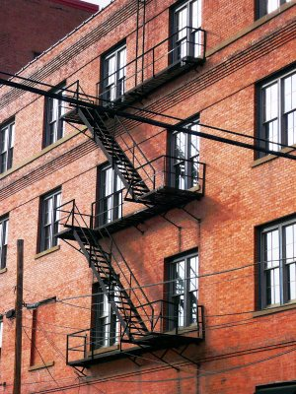

Fire Escape Victrola Movies

Act III, Scene 1, A Midsummer Night's Dream

Believe a Play?
Read the scene from A Midsummer Night's Dream .
What does this scene tell you about the Mechanicals and how they think about plays?

In what ways does this scene and the other scenes involving the Mechanicals reflect Elisabethan theater?
Think of the audience, the actors, the topics and purpose of theater and the playhouses.

Answer:
(lay actors, unprofessional acting groups, typical audience, roles of theater, playhouses…)

Act III, Scene 1, A Midsummer Night's Dream

Believe a Play?
Read the scene from A Midsummer Night's Dream .
What does this scene tell you about the Mechanicals and how they think about plays?

In what ways does this scene and the other scenes involving the Mechanicals reflect Elisabethan theater?
Think of the audience, the actors, the topics and purpose of theater and the playhouses.

Copy Act 3, scene 1 extract here

Act I, Scene 2, A Midsummer Night's Dream

Read the scene from A Midsummer Night's Dream and focus on the language and style or the Mechanicals. Is this typical of Elisabethan plays?
Briefly analyse the language in this scene as compared to other scenes in the play.
What do you know about Shakespeare's language in general.

Can we be sure that the words as we see them written here are the exact words written by Shakespeare?

Answer:
(folio/quarto editions, printing process…)

(usually more formal language of court scenes, blank verse, iambic pentameter, new verse form, close to natural speech rhythm, This helped dramatists break up speeches,, individualise them and to present the give and take, the interruptions, the dialogue of characters and not just the delivery of set speeches.

here: informal, prose to contrast with court scenes, make several errors (they try to use good style, difficult words but don't know how to… course jokes…

in general: language of Renaissance: lots of new words to express new ideas (from French)
rapid growth of Engl society, holding on to the langu of diff. trades, professions and local activities, imported or created vast new voc to deal with the material entering Engl. In polit. theory, scientific experiment, theolotgy, new words were needed for new ideas.

Act I, Scene 2, A Midsummer Night's Dream

Read the scene from A Midsummer Night's Dream and focus on the language and style of the Mechanicals. Is this typical of Elisabethan plays?
Briefly analyse the language in this scene as compared to other scenes in the play.
What do you know about Shakespeare's language in general.

Can we be sure that the words as we see them written here are the exact words written by Shakespeare?

The Middle Ages in England: Geoffrey Chaucer

Read the following extract of "The Miller's Tale" and explain its form and meaning in the context of Chaucer's Canterbury Tales.
Then talk about the role of the English language and the social conditions at Chaucer`s time

Text: miller's tale extract

Poems and Love

Read the following two poems and explain the poet's idea of love. Is it the same in both poems? Who could have written these poems?
Talk about meaning and formal aspects of the poems.

Sonnet 116
Sonnet 130

War Poems

Read the following two poems and explain their meaning. What do they have in common? What are the differences ? Talk about content and formal aspects.

Ball Turret gunner

Arms and the Boy

Shape and Meaning

As you read the following poems remember that poets have reasons for shaping their poems as they do. Explain how the shape of each poem reflects its subject and its meaning.

Easter wings

women

Cross-curricular question

William Shakespeare, Hamlet

Explain the meaning of the most famous soliloquy in English literature. What is Hamlet's dilemma? What are his problems in life? What final decision does he take and why?

William Shakespeare - To be, or not to be (from Hamlet 3/1)
To be, or not to be: that is the question:
Whether 'tis nobler in the mind to suffer
The slings and arrows of outrageous fortune,
Or to take arms against a sea of troubles,
And by opposing end them? To die: to sleep;
No more; and by a sleep to say we end
The heart-ache and the thousand natural shocks
That flesh is heir to, 'tis a consummation
Devoutly to be wish'd. To die, to sleep;
To sleep: perchance to dream: ay, there's the rub;
For in that sleep of death what dreams may come
When we have shuffled off this mortal coil,
Must give us pause: there's the respect
That makes calamity of so long life;
For who would bear the whips and scorns of time,
The oppressor's wrong, the proud man's contumely,
The pangs of despised love, the law's delay,
The insolence of office and the spurns
That patient merit of the unworthy takes,
When he himself might his quietus make
With a bare bodkin? who would fardels bear,
To grunt and sweat under a weary life,
But that the dread of something after death,
The undiscover'd country from whose bourn
No traveller returns, puzzles the will
And makes us rather bear those ills we have
Than fly to others that we know not of?
Thus conscience does make cowards of us all;
And thus the native hue of resolution
Is sicklied o'er with the pale cast of thought,
And enterprises of great pith and moment
With this regard their currents turn awry,
And lose the name of action. - Soft you now!
The fair Ophelia! Nymph, in thy orisons
Be all my sins remember'd.

Ernest Jones, one of Freud’s followers, suggests that in the play Hamlet, the actions of the protagonist were encouraged by an Oedipus complex.
“In reality his (Hamlet’s) uncle incorporates the deepest and most buried part of his own personality, so that he cannot kill him without also killing himself.”
Ernest Jones, Hamlet and Oedipus, W.W.Norton, N.Y. 1976

Explain the term Oedipus Complex in the context of Freud’s theory of the Psychosexual Stages.
Core-question

William Shakespeare, Hamlet

Explain the meaning of the most famous soliloquy in English literature. What is Hamlet's dilemma? What are his problems in life? What final decision does he take and why?

William Shakespeare - To be, or not to be (from Hamlet 3/1)
To be, or not to be: that is the question:
Whether 'tis nobler in the mind to suffer
The slings and arrows of outrageous fortune,
Or to take arms against a sea of troubles,
And by opposing end them? To die: to sleep;
No more; and by a sleep to say we end
The heart-ache and the thousand natural shocks
That flesh is heir to, 'tis a consummation
Devoutly to be wish'd. To die, to sleep;
To sleep: perchance to dream: ay, there's the rub;
For in that sleep of death what dreams may come
When we have shuffled off this mortal coil,
Must give us pause: there's the respect
That makes calamity of so long life;
For who would bear the whips and scorns of time,
The oppressor's wrong, the proud man's contumely,
The pangs of despised love, the law's delay,
The insolence of office and the spurns
That patient merit of the unworthy takes,
When he himself might his quietus make
With a bare bodkin? who would fardels bear,
To grunt and sweat under a weary life,
But that the dread of something after death,
The undiscover'd country from whose bourn
No traveller returns, puzzles the will
And makes us rather bear those ills we have
Than fly to others that we know not of?
Thus conscience does make cowards of us all;
And thus the native hue of resolution
Is sicklied o'er with the pale cast of thought,
And enterprises of great pith and moment
With this regard their currents turn awry,
And lose the name of action. - Soft you now!
The fair Ophelia! Nymph, in thy orisons
Be all my sins remember'd.

Hamlet is a story of murder, suicide, madness, to those who call for melodrama, but for others it is a most subtle analysis of character.

Who is Hamlet?

A troubled young man striving for philosophy and poetry?
A brutal character who causes several violent deaths?
A victim of circumstances?
A manic-depressive person , victim of melancholy ?
A victim of the Oedipus complex?
A madman?

Explain Hamlet's character and behavior throughout the play? In what way is Hamlet a typical Renaissance character?

(might be too difficult, doesn't have a text!!!!!!!!!!!!!!!!!!!!!!!!!!!)

Cross-curricular question: English - Psychology

Hamlet and Oedipus

The critical applications of the famous theory of the Oedipus complex to the tragedy of Hamlet are innumerable. It was Freud himself who, in an essay published in 1905, was the first to try and resolve in psychoanalytical terms the enigma offered by Hamlet's behaviour.

Read the following extract from the famous bedroom scene. Hamlet is horrified by the thought that his mother could feel desire for Claudius.
Explain the scene in the context of the play and apply Freud's theory of the Oedipus complex.
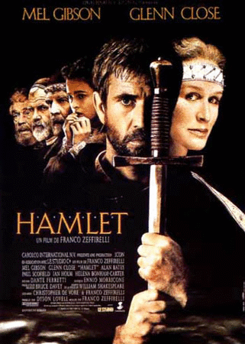

Hamlet. Such an act
That blurs the grace and blush of modesty;
Calls virtue hypocrite; takes off the rose
From the fair forehead of an innocent love,
And sets a blister there; makes marriage vows 2435
As false as dicers' oaths. O, such a deed
As from the body of contraction plucks
The very soul, and sweet religion makes
A rhapsody of words! Heaven's face doth glow;
Yea, this solidity and compound mass, 2440
With tristful visage, as against the doom,
Is thought-sick at the act.
(Act III, Scene 4)

There are many other ways to explain Hamlet's behavior: He has been described as
- a madman,
- a victim of melancholy,
- a troubled young man striving for philosophy and poetry
- and as a brutal character who causes several violent deaths.

Which of these explanations of Hamlet's character seem (most) plausible to you? Explain.

Cross-curriacular question: Englisch – Psychology

Richard III

'I am determined to prove a villain'

Read Richard's opening speech. What do we learn about Richard's character? What are his problems and goals?
Explain Richard's behavior according to Freud's theory of the Division of the Mind. Discuss to what extent his family background has formed his character.

Explain the concept of Freudian Defense Mechanisms. What role does compensation play in Richard's behavior?

Opening speech I.1 1 – 30

Richard III, The multifaced villain

It certainly needs a good actor to play the role of Richard III, because we can call him a genuine hypocrite. Richard is multi-faced within the drama and shows his different faces considering the situation he finds himself in.
Within the drama the audience is able to recognize more than seven different faces, which Richard exposes:
- the devoted brother
- the witty wooer
- the loyal subject
- the pious convert
- the benevolent uncle
- the cornered, sweating rat
- the brave soldier

Give examples of the above roles in the play and explain the following quotes.

'

Shakespearian Sonnets

Complete the following sonnet based upon your knowledge of the characteristic rhyme scheme of a Shakespearian sonnet. Then explain the typical form and themes of Shakespeare's sonnets and briefly explain the meaning of Sonnet 18

Sonnet 18

Shall I compare thee to a summer's day?
.................................................................
Rough winds do shake the darling buds of May,
And summer's lease hath all too short a date:
Sometime too hot the eye of heaven shines,
And often is his gold complexion dimm'd;
....................................................................
By chance, or nature's changing course, untrimm'd;
But thy eternal summer shall not fade
Nor lose possession of that fair thou ow'st;
........................................................................
........................................................................
........................................................................
So long lives this, and this gives life to thee.

These lines have been taken out of Sonnet 18. Put them in the right places.

And every fair from fair some time declines,
Nor shall Death brag thou wand'rest in his shade,
When in eternal lines to time thou grow'st.
Thou art more lovely and more temperate.
So long as men can breathe or eyes can see,

True Traditions – Fake Traditions

Read the following extracts from a Native American and a Black American short story. Both stories deal with the importance of traditions in people's lives. Explain the importance of traditions in the two stories. Why are traditions so important to minority groups.

Extract 1: from "Everyday Use", by Alice Walker

Extract 2: from "Chee's Daughter", by Juanita Platero and Siyowin Miller

The decline of Native American Culture:

Genocide or Suicide?

Read the following extract from the story "Wounded Chevy at Wounded Knee" by Diane Hume George and explain the two theories concerning the decline of the Native American people. What is your personal point of view? Give reasons.

§ 28

We Shall Overcome: 1963-1965

'We Shall Overcome' was the theme song of the civil rights movement in the early 60s in the USA. After a peaceful march on Washington in August 1963, Martin Luther King made his most famous speech.
Here are some extracts from the speech. Read them and describe the feeling Martin Luther King is creating here.
How could you tell from the speech that Martin Luther King is a black man speaking to black people? Briefly describe the situation of black people in the US at the time.

Martin Luther King uses many stylistic devices in this speech. Find examples of:
- poetic language
- biblical language (or hymns or spirituals)
- repetition of key phrases
- strong images
- building to a climax

extracts from I have a dream

Where Have All The Flowers Gone?

Read the following description of the Woodstock festival. What was the mood at the time? The young people at the festival wanted to change the world. What were they revolting against? What were their wishes and aims?

What has come of the the flower-power movement? Have the sixties left any traces in today`s society?

P 54,
For..... political ends.

The Renaissance in England

Robert Bolt, A Man For All Seasons

Read the following extract from the play and explain the historical background of the play. Why is More charged with High Treason? Why does More believe the charge to be unjust?
Briefly characterize More and Henry VIII.

VIE 56

The Renaissance in England

John Donne
In the following extracts John Donne expresses the insecurity of the people of his time faced with a world whose order was turned upside down through fundamental discoveries and innovations. Which changes and innovations does Donne refer to in the extracts? Point out some other changes of the time.

Short Stories

Read the following short story by Howard McMillen. It's a parody of a well known Hemingway story that we have read in class. Mark and discuss all the parallels you find between McMillen's story and Hemingway's original.
In what way is this story typical of the short story genre?

Howard McMillen
A Rainy Day...............p43

Fables, Tales and Short Stories

Read the fable 'The Lion and the Mouse' and answer the following questions:
- What qualities do you generally associate with lions? With mice? Do the animals in this story show these qualities?
- What is the lion's attitude towards mice at the beginning of the fable? Do you think that his attitude might change now?
- Does the lion behave in the way that a human would in a similar situation? Does the mouse? Is this story really about animal behavior or human behavior? Explain.
- What are the typical characteristics of a fable and how is a fable different from a tale or a short story?

The lion and the mouse p 76 McDougal, Literature

Fable, Tale and Short Story

Read the fable 'The Ant and the Grasshopper' and answer the following questions.

What are the typical characteristics of a fable?
Explain the symbolism and personification used in this fable.
How is a fable different from a tale or a short story?

Ant + grasshopper, p 80

Poverty in India

Read the following passage and look at the cartoons. What do they tell you about the social and political situation in India at the time of Mahatma Gandhi?
Explain the meaning of the cartoons. Why is Gandhi so often depicted with a spinning wheel? Who are the people riding on the elephant?
What are the reasons for the poverty of the Indian population and what measures did Gandhi advocate in order to change this situation?

Elephant cartoon (no text),
sketch of gandhi, london + spinning wheel (+ text)

Animal Farm

Read the following extracts from Animal Farm and explain the changes that have been made on the farm between extract 1 ('The Seven commandements') , extract 2 ('Comrade Napoleon') and extract 3 (final commandement). What is Napoleon's role? Who is Squealer? How and why do the other animals accept these changes?

Extract 1: 'The Seven Commandments' (p. 23)

Extract 2: 'Comrade Napoleon' (p.80)

Extract 3: One single commandement (p. 114)

ALL ANIMALS ARE EQUAL
BUT SOME ANIMALS ARE MORE
EQUAL THAN OTHERS

Animal Farm

Just as in any classical fable the different animals in Animal Farm are given human qualities which exemplify the different types of human character. Thus the animals on the farm can be taken as a cross-section of human society or more specifically they represent certain political leaders of the time.
Look at the following list of the main characters? What types of people or which political leaders do they stand for?

- Old Major

- Napoleon

- Snowball

- Squealer

- Mr. Jones

- The sheep and the horses

- The dogs

Briefly explain the political background and allusions of the novel.

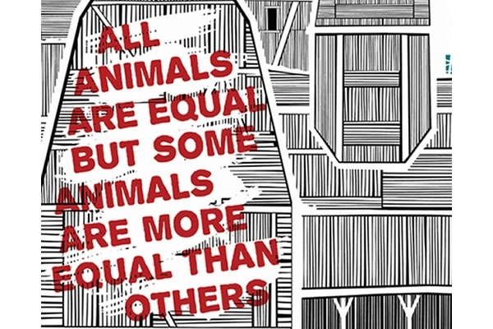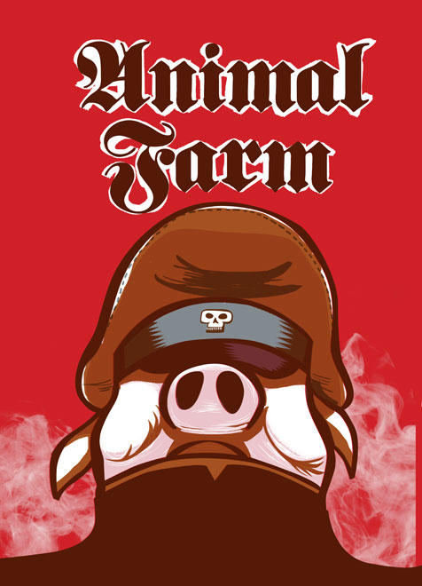

George Orwell:

Animal Farm and Nineteen Eighty-Four

Animal Farm and Nineteen Eighty-Four are George Orwell's best known novels. Both are political satires in which he condemns totalitarian society. Compare the two works. What is Orwell warning his readers of?
What does Orwell say about mind-control and freedom of speech? How are the masses controlled and manipulated in the two novels?

How do the following names and concepts fit in?

The Party | Mr. Jones
Newspeak | Napoleon
Big Brother | Squealer
Two Minutes Hate | The dogs
Ministry of Truth | The sheep and the horses
The Proles | Snowball
Doublethink | Old Major
Winston Smith
Thought Police

The Short Story
William Carlos Williams, 'Verbal transcription – 6 a.m.'

Read the following story and briefly sum up what is happening. Who is the woman talking to? What does the title tell us? In what way is this story typical of the short story genre? What can you say about the setting and characters of the story?

Here are some inferences about the story. Which do you agree with? Add some of your own if you wish.
- The woman in the story is elderly.
- She is more concerned with her pets than with the sick man.
- The sick man is her husband.
- She is lonely.
- She is kind-hearted.
- She is suffering from shock.
- She doesn't care too much about the sick man.
- She accepts the situation calmly.

Remember that William Carlos Williams is also the author of the poem 'The Red Wheelbarrow'. In what way are the story and the poem similar?

The Red Wheelbarrow
so much depends
upon
a red wheel
barrow
glazed with rain
water
beside the white
chickens

Arthur Miller, All My Sons

Read the extract from the last scene of the play and explain its meaning in the context of the play. What is the conflict about? Why does Joe Keller say 'Chris, a man can't be a Jesus in this world!' What has he done? What are Joe Keller's values and beliefs?
What values and beliefs does his son Chris stand for?
Explain the title of the play.

Extr. From p 169, 170

Arthur Miller, All My Sons

In this play Arthur Miller confronts the different scales of values of father and son.
Read the following extract from the play and explain its meaning. What are Joe Keller and his wife talking about? Why is Chris angry with his father? Explain the fundamental conflict between Chris and his father.What values and beliefs do they stand for?

The play also deals with the question of illusion and reality. What illusions do Joe Keller and Kate Keller (mother) live in?

William Shakespeare,'All the World's a Stage'

Read the following poem by William Shakespeare and briefly paraphrase it. What can you say about the rhyme and rhythm of the poem.

In what way does the poem reflect William Shakespeare's life? Show the parallels between the poem and Shakespeare's life. What do we know about William Shakespeare?

All the world's a stage

Black Like Me

Read the following poem by Wole Soyinka and briefly explain its content. In what way does the poem remind you of the book Black Like Me by John Howard Griffin?

Poem: Telephone Conversation
P23

Civil Rights: DO THE RIGHT THING

It's the hottest day of the summer.
You can do nothing,
You can do something,
Or you can
DO THE RIGHT THING

There have been various attempts to improve the situation of Blacks and other minority groups in America. Who do you think has done 'the right thing'?
What is your opinion on using violence to gain freedom? What do you think of M.L. King's and Malcolm X's statements and attitudes. What attitudes towards violence did you observe in the movie Do the Right Thing.

Black Literature: Survival Strategies

Read the following poem by the black poet Owen Dodson and briefly sum up its content. Who is the speaker of the poem? What is his problem?
Explain the importance of . Give other examples from the literature we have read.

Briefly explain some of the typical features of Black English that you can find in this poem.

Cross-curricular question: English- Psychology
Barbara Peichl

Mental Problems and Depression in American Literature
The Bell Jar by Sylvia Plath

Read the following poem by Sylvia Plath and briefly summarize its meaning.
What did the speaker of the poem do? Where is she? What does she look like? What does she say about suicide? What does she say about doctors?
Explain the meaning of lines 58 to 63. Why is there a very large charge for a word or a touch?
What might be the reasons for her depression and suicide?

Compare the poem to the novel The Bell Jar.
What are the reasons for Esther's depressions?.
How does Esther cope with her problems? Can you find any parallels between Esther and Sylvia Plath herself?
The title is an important key to the understanding of the novel's main themes. Explain the image of the bell jar in Esther's life.

The fact that Esther received Electro Shock Therapy and other forms of psychotherapy indicates that she suffered from a severe psychotic illness. Give the name and describe the symptoms of this disorder.

African American Literature
The Role of Music as a Survival Strategy

Read the following poem and explain in what way it is typical of Black American Literature.
What role does music play in the lives of Black Americans? Give other examples from the literature you have read.

The Weary Blues
Langston Hughes

Droning a drowsy syncopated tune,
Rocking back and forth to a mellow croon,
I heard a Negro play.
Down on Lenox Avenue the other night
By the pale dull pallor of an old gas light
He did a lazy sway . . .
He did a lazy sway . . .
To the tune o' those Weary Blues.
With his ebony hands on each ivory key
He made that poor piano moan with melody.
O Blues!
Swaying to and fro on his rickety stool
He played that sad raggy tune like a musical fool.
Sweet Blues!
Coming from a black man's soul.
O Blues!
In a deep song voice with a melancholy tone
I heard that Negro sing, that old piano moan--
"Ain't got nobody in all this world,
Ain't got nobody but ma self.
I's gwine to quit ma frownin'
And put ma troubles on the shelf."

Thump, thump, thump, went his foot on the floor.
He played a few chords then he sang some more--
"I got the Weary Blues
And I can't be satisfied.
Got the Weary Blues
And can't be satisfied--
I ain't happy no mo'
And I wish that I had died."
And far into the night he crooned that tune.
The stars went out and so did the moon.
The singer stopped playing and went to bed
While the Weary Blues echoed through his head.
He slept like a rock or a man that's dead.

Edward Albee

The American Dream

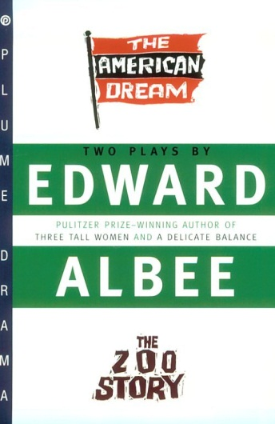

In The American Dream, a mythic American couple, Mommy and Daddy, seek "satisfaction" from the Bye-Bye Adoption Service's mysterious representative, Mrs. Barker. Grandma, who occupies the same apartment as Mommy and Daddy, is harboring a secret of her own. It all becomes evident when Grandma reveals to Mrs. Barker the story of the botched adoption of a "bumble of joy" twenty years ago by Mommy and Daddy. The plot thickens with the arrival of another mysterious caller; this time a handsome Young Man, who may or may not be related to the family. He's muscular, well-spoken, the answer to Mommy and Daddy's prayers: Grandma convinces him to assist in her master plan. She puts one over on everybody, and escapes the absurdly realistic world which she finds so predictable. Albee challenges our perception of American family life by examining the relationships between these characters with a fresh, yet bitter eye.

The New Yorker hailed The American Dream as "unique... brilliant... a comic nightmare, fantasy of the highest order." The story of one of America's most dysfunctional families, it is a ferocious, uproarious attack on the substitution of artificial values for real values – a startling tale of murder and morality that rocks middle-class ethics to its complacent foundations.

The above blurbs are rather enigmatic for anybody who hasn't read or seen the play. Explain their meaning concentrating on the underlined parts.

Explain the meaning of the title. Who or what represents the American Dream in the play?

The American Dream

Langston Hughes

Harlem

What happens to a dream deferred?

Does it dry up
like a raisin in the sun?
Or fester like a sore-
And then run?
Does it stink like rotten meat?
Or crust and sugar over-
like a syrupy sweet?

Maybe it just sags
like a heavy load.

Or does it explode?

What dream is Langston Hughes referring to? Explain the images he uses in the poem.

Which other forms or types of the "American Dream" do you know? Give examples from the literature you have read.

The American Dream

American paintings through the ages have reflected the changing dreams and attitudes of society.
Explain in what way the following pictures represent the American Dream.
Which examples from literature do they remind you of?

insert pictures here!!!!!!!!
see extra file (dream+arts.doc)

Core question:
The Beat Generation in New York

Chelsea Hotel  by Leonard Cohen  I remember you well in the Chelsea Hotel,  you were talking so brave and so sweet,  giving me head on the unmade bed,  while the limousines wait in the street.  Those were the reasons and that was New York,  we were running for the money and the flesh.  And that was called love for the workers in song  probably still is for those of them left.  Ah but you got away, didn't you babe,  you just turned your back on the crowd,  you got away, I never once heard you say,  I need you, I don't need you,  I need you, I don't need you  and all of that jiving around.  I remember you well in the Chelsea Hotel  you were famous, your heart was a legend.  You told me again you preferred handsome men  but for me you would make an exception.  And clenching your fist for the ones like us  who are oppressed by the figures of beauty,  you fixed yourself, you said, "Well never mind,  we are ugly but we have the music."  Ah but you got away, didn't you babe,  you just turned your back on the crowd,  you got away, I never once heard you say,  I need you, I don't need you,  I need you, I don't need you  and all of that jiving around.  I don't mean to suggest that I loved you the best,  I can't keep track of each fallen robin.  I remember you well in the Chelsea Hotel,  that's all, I don't even think of you that often.  © by Leonard Cohen. | 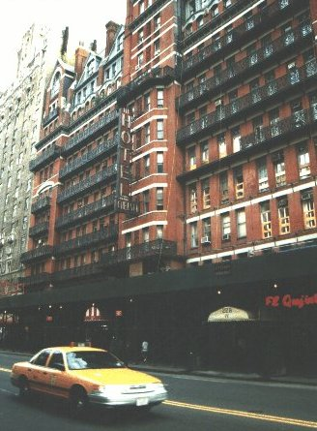  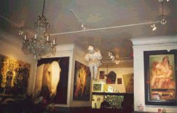

What is so special about the Chelsea Hotel?
Give some examples of the famous inhabitants of the hotel, their works and their lives.
In what way is the Chelsea so typical of Bohemian New York?

Other Side of the Story

Virginia Woolf

A Room of One's Own

"...I could not help thinking as I looked at the works of Shakespeare on the shelf, ...; it would have been impossible, completely and entirely, for any woman to have written the plays of Shakespeare in the age of Shakespeare. Let me imagine, since facts are so hard to come by, what would have happened had Shakespeare had a wonderfully gifted sister, called Judith, let us say. Shakespeare himself went, very probably – his mother was an heiress- to the grammar school, where he may have learnt Latin – Ovide, Virgil and Horace – and the elements of grammar and logic. He was, it is well known, a wild boy who poached rabbits, perhaps shot a deer, and had, rather sooner that he should have done, to marry a woman in the neighbourhood, who bore him a child rather quicker than was right. That escapade sent him to seek his fortune in London. He had, it seemed, a taste for the theatre; he began by holding horses at the stage door. Very soon he got work in the theatre, became a successful actor, and live d at the hub of the universe, meeting everybody, knowing everybody, practicing his art on the boards, exercising his wits in the street, and even getting access to the palace of the queen. Meanwhile his extraordinarily gifted sister, let us suppose....."

Continue this imaginary biography of Shakespeare's sister. What would her fate have been?

Thinking of the literature you have read, what has changed since Shakespeare's time? Give examples from the heroines of women's literature.
List some of the limitations that these women have encountered. Which strategies have they developed to overcome them?

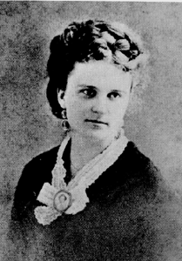
The Other Side of the Story

"The Storm"
by Kate Chopin

The following passages have been taken from Kate Chopin's story. They describe the changes of weather in the course of the story.
Explain the symbolism of this setting. What is Kate Chopin saying about women, marriage and passion?

I
The leaves were so still that even Bibi thought it was going to rain. Bobinôt, who was accustomed to converse on terms of perfect equality with his little son, called the child's attention to certain sombre clouds that were rolling with sinister intention from the west, accompanied by a sullen, threatening roar...

II
Calixta, at home, felt no uneasiness for their safety. She sat at a side window sewing furiously on a sewing machine. She was greatly occupied and did not notice the approaching storm. But she felt very warm and often stopped to mop her face on which the perspiration gathered in beads. She unfastened her white sacque at the throat. It began to grow dark, and suddenly realizing the situation she got up hurriedly and went about closing windows and doors.
...
The rain beat upon the low, shingled roof with a force and clatter that threatened to break an entrance and deluge them there. They were in the dining room—the sitting room—the general utility room.
...
"The rain was coming down in sheets obscuring the view of far-off cabins and enveloping the distant wood in a gray mist. The playing of the lightning was incessant. A bolt struck a tall chinaberry tree at the edge of the field. It filled all visible space with a blinding glare and the crash seemed to invade the very boards they stood upon.
...
The growl of the thunder was distant and passing away. The rain beat softly upon the shingles, inviting them to drowsiness and sleep.

III
The rain was over; and the sun was turning the glistening green world into a palace of gems.
...

The Other Side of the Story

A Riddle

A riddle is making the rounds that goes like this: A man and his young son were in an automobile accident. The father was killed and the son, who was critically injured, was rushed to a hospital. As attendants wheel the unconscious boy into the emergency room, the doctor on duty looked down at him and said, "My God, it's my son!"

What was the relationship of the doctor to the injured boy?



As you will certainly have noticed, the above riddle plays on stereotypes of men and women. List some of the stereotypes associated with men and women.
Then find examples from the literature you have read. How are women and men portrayed in the stories we have read in the course? Choose some fitting examples.

Women’s roles and self-concepts


Woman
by Nikki Giovanni

she wanted to be a blade
of grass amid the fields
but he wouldn't agree
to be the dandelion

she wanted to be a robin singing
through the leaves
but he refused to be
her tree

she spun herself into a web
and looking for a place to rest
turned to him
but he stood straight
declining to be her corner

she tried to be a book
but he wouldn't read

she turned herself into a bulb
but he wouldn't let her grow

she decided to become
a woman
and though he still refused
to be a man
she decided it was all
right

Explain the meaning of this poem. How does this woman define herself?
Have you come across any women characters in literature who remind you of the speaker of this poem? Who are they?
Choose one or two fitting characters and describe their developments.
The Other Side of the Story

The Bell Jar

Many of the women characters in the samples we have read have felt trapped in their situations and circumstances. The Bell Jar can be seen as a symbol of this confined existence.

Name some of the women characters from literature.

- What limitations did they encounter?
- What strategies did they use to free themselves?
- Did they succeed?

Scandals in Literature

Ulysses
by James Joyce

Foreword

The new deal in the law of letters is here. Judge Woolsey has exonerated Ulysses of the charge of obscenity, handing down an opinion that bids fair to become a major event in the history of the struggle for free expression. Joyce's masterpiece, for the circulation of which people have been branded criminals in the past, may now freely enter this country.
It would be difficult to overestimate the importance of Judge Woolsey's decision. For decades the censors have fought to emasculate literature. They have tried to set up the sensibilities of the prudery-ridden as a criterion for society, have sought to reduce the reading matter of adults to the level of adolescents and subnormal persons, and have nurtured evasions and sanctimonies.
The Ulysses case marks a turning point. It is a body-blow for the censors. The necessity for hypocrisy and circumlocution in literature has been eliminated. Writers need no longer seek refuge in euphemisms. They may now describe basic human functions without fear of the law.!
...
New York, December11, 1933

- Explain the importance of Judge Woolsey's landmark decision.
- We have read the most criticized chapter from Ulysses. Did it shock you? Would you consider the chapter pornographic?
- Look at the drawings some of your fellow students made during our course and explain in what way they reflect the key scenes of chapter XIII.

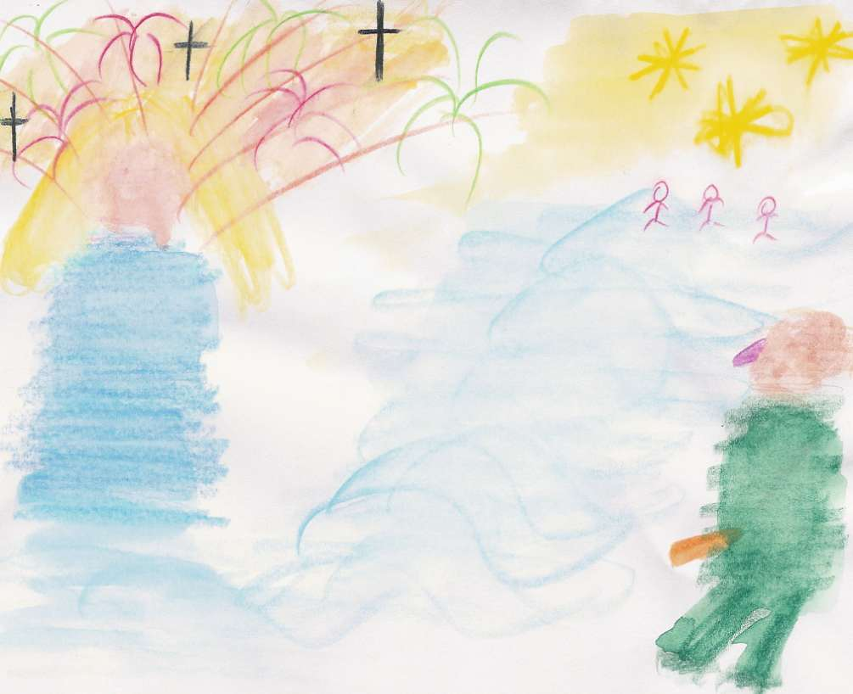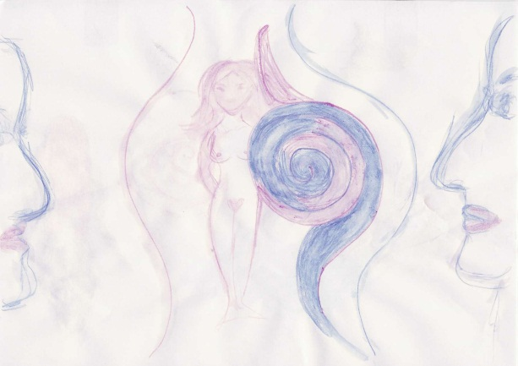


The Other Side of the Story

The Bell Jar
by Sylvia Plath

Read the following poem by Sylvia Plath and briefly summarize its meaning.
What did the speaker of the poem do? Where is she? What does she look like? What does she say about suicide? What does she say about doctors?
Explain the meaning of lines 58 to 63 (printed boldface). Why is there a very large charge for a word or a touch?
What might be the reasons for her depression and suicide?
Compare the poem to the novel The Bell Jar.

What are the reasons for Esther's depressions?.
How does Esther cope with her problems? Can you find any parallels between Esther and Sylvia Plath herself?

The title is an important key to the understanding of the novel's main themes. Explain the image of the bell jar in Esther's life.

Lady Lazarus

I have done it again.
One year in every ten
I manage it--

A sort of walking miracle, my skin
Bright as a Nazi lampshade,
My right foot

A paperweight,
My face featureless, fine
Jew linen.

Peel off the napkin
O my enemy.
Do I terrify?--

The nose, the eye pits, the full set of teeth?
The sour breath
Will vanish in a day.

Soon, soon the flesh
The grave cave ate will be
At home on me

And I a smiling woman.
I am only thirty.
And like the cat I have nine times to die.

This is Number Three.
What a trash
To annihilate each decade.

What a million filaments.
The peanut-crunching crowd
Shoves in to see

Them unwrap me hand and foot--
The big strip tease.
Gentlemen, ladies

These are my hands
My knees.
I may be skin and bone,

Nevertheless, I am the same, identical woman.
The first time it happened I was ten.
It was an accident.

The second time I meant
To last it out and not come back at all.
I rocked shut

As a seashell.
The y had to call and call
And pick the worms off me like sticky pearls.
Dying
Is an art, like everything else.
I do it exceptionally well.

I do it so it feels like hell.
I do it so it feels real.
I guess you could say I've a call.

It's easy enough to do it in a cell.
It's easy enough to do it and stay put.
It's the theatrical

Comeback in broad day
To the same place, the same face, the same brute
Amused shout:

'A miracle!'
That knocks me out.
There is a charge

For the eyeing of my scars, there is a charge
For the hearing of my heart--
It really goes.

And there is a charge, a very large charge
For a word or a touch
Or a bit of blood

Or a piece of my hair or my clothes.
So, so, Herr Doktor.
So, Herr Enemy.

I am your opus,
I am your valuable,
The pure gold baby

That melts to a shriek.
I turn and burn.
Do not think I underestimate your great concern.

Ash, ash--
You poke and stir.
Flesh, bone, there is nothing there--

A cake of soap,
A wedding ring,
A gold filling.

Herr god, Herr Lucifer
Beware
Beware.
Out of the ash
I rise with my red hair
And I eat men like air.

1962
Australian Aboriginees

Read the story "Toonkoo and Ngaardi" below. What type of story is this? Sum up the story and explain its meaning. What is the importance and purpose of such stories in the culture of their origin? What are the typical topics of this story and similar ones?

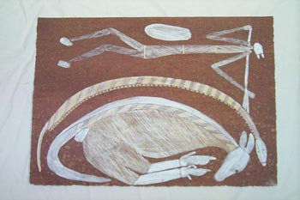

"Toonkoo and Ngaardi"

Cross-curricular question: English/Arts

Australian Aboriginees

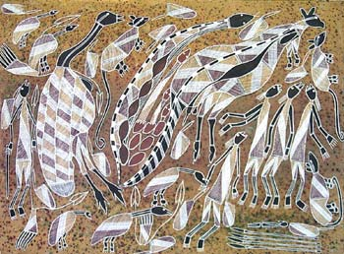
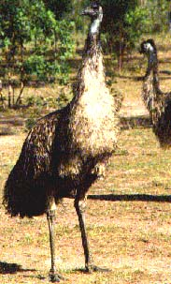

Ngurrudu (Emu) Story
Artist: Mukguddu Nabegeyo
Language Group: Kunwinjku
Medium: Natural Ochres on Arches Cotton paper
This story originates in country south of Gunbalanya (Oenpelli)called Woymul near Bulman. A group of nayuhyungki (early) people were living in the area many years ago. There was an old Ngalkangila woman who was known to be greedy, she is shown to the left carrying her dilly bag and digging stick. She would hide food and not share it. She particularly favoured the djarrbarl yam shown at her knee. There were some young boys who were brothers who were very hungry. They ate possum and python (shown in the apinting) but it was not enough. They were around the camp playing when they saw a korlobarr or red kangaroo on a hill. They told their big brother who took his spear and killed it. They then decided that they didn’t want to be humans anymore and so changed into animals and birds. The parrot family became dedded parrots and the woman became ngurrudu the emu.

What type of story is this? What is the importance and purpose of such stories in the culture of their origin? What are the typical topics and themes of this story and similar ones?

Arts: Compare the Aboriginal story tradition and their artwork and contrast it with Western Art.
Cross-curricular question: English/Arts:



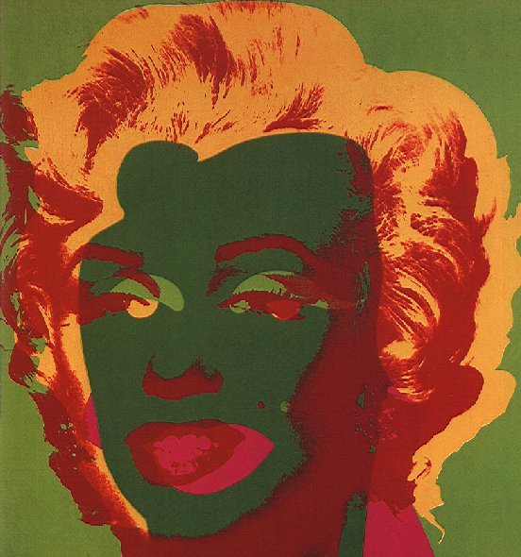



Everything is beautiful. Pop is everything."
Andy Warhol

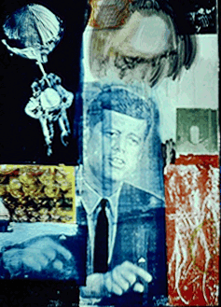
Look at the pictures. In what way do they reflect the lifestyle, values and political ideas of the Sixties?

Arts: How does Pop-art capture the attitudes of the time?
What are the characteristics of Pop-art? Who are the most important artists?
Cross-curricular question: English/Arts
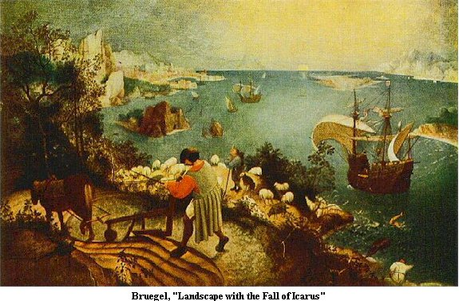


Landscape With The Fall of Icarus
William Carlos Williams

According to Brueghel
when Icarus fell
it was spring

a farmer was ploughing
his field
the whole pageantry

of the year was
awake tingling
near

the edge of the sea
concerned
with itself

sweating in the sun
that melted
the wings' wax

unsignificantly
off the coast
there was

a splash quite unnoticed
this was
Icarus drowning

Explain the above poem and its relation to the paintings. If you look at the Icarus legend as an extended metaphor, what is Williams saying about himself as a poet and about art and artists in general?
Compare the form and style of the paintings and the poem. Can you guess the approximate time and the artists who painted them?
Cross-curricular question: English/Arts

Automat  I thought when I came here  I'd get as rich as a secretary  and marry my boss.  I dreamt about that so long  I thought it would happen.  Maybe I should go back.  I hate small places though,  and when I sit eating in the automat  I pretend I'm a celebrity  and all those walls of plastic doors  are really crowds of camera lenses  waiting to take my picture.  Julie O'Callaghan | 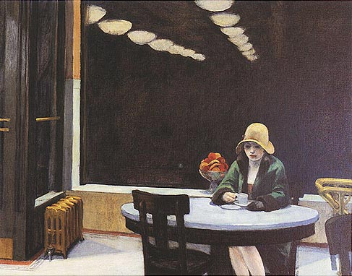

In what way does Julie O'Callaghan's poem reflect the American Dream?
What are her dreams? Have they been fulfilled?
Give other examples of similar dreams from the literature you have read.
Compare the American Dream with American Reality.

'A Poem is a Painting'
A poem is a painting that is not seen;
A painting is a poem that is not heard
Phoebe Hesketh

Edward Hopper has been called a pictorial poet. What does he "say" in his paintings?
How does Edward Hopper's painting express this American reality? What are his typical themes and motifs?
Cross-curricular question: English/Arts

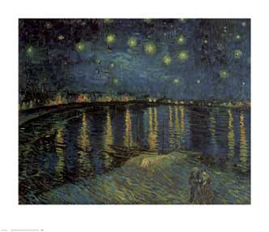
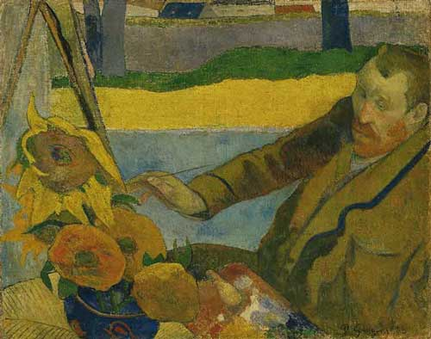

Two Poems

Just Passing  A scene  Seen  Is captured  In a painter's  Head  Is captured  Frozen and colourful  Mr. Gogh  Shot his head  To fragments  But the scene  Seen  Remains.  Francis Barker | The Artist, Arles 1890  Yellow, yellow  Watch the yellow always,  Fascinated, from the corner of your eye.  Its terrible intensity has sting  To bleach the brain, to take the skin  From off your inner eye. To drive you back  Against a buckled wall that echoes yellow, yellow,  Pain. You cannot let it from your mind.  Colin Rowbotham

Explain the form and meaning of the two poems in relation to Van Gogh's art and life.
Cross-curricular question: English/Arts:

The Renaissance in Art and Literature
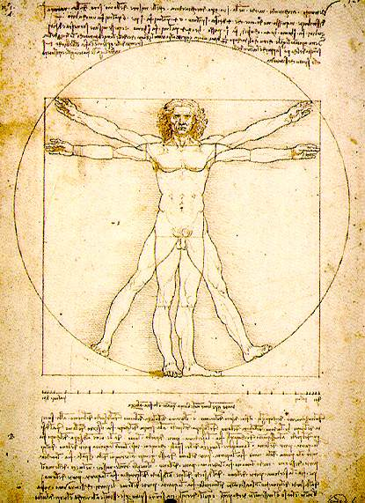...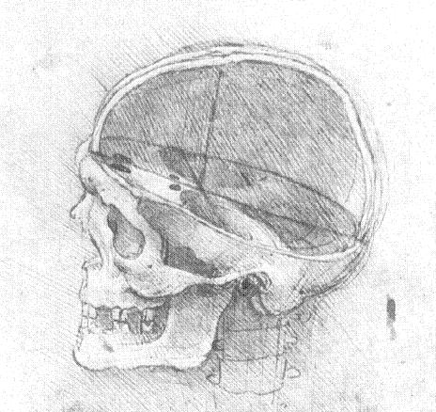
John Donne  The Good-Morrow  I WONDER by my troth, what thou, and I  Did, till we lov'd? were we not wean'd till then?  But suck'd on countrey pleasures, childishly?  Or snorted we in the seaven sleepers den?  T'was so; But this, all pleasures fancies bee. 5  If ever any beauty I did see,  Which I desir'd, and got, t'was but a dreame of thee.  And now good morrow to our waking soules,  Which watch not one another out of feare;  For love, all love of other sights controules, 10  And makes one little roome, an every where.  Let sea-discoverers to new worlds have gone,  Let Maps to other, worlds on worlds have showne,  Let us possesse one world, each hath one, and is one.  My face in thine eye, thine in mine appeares, 15  And true plaine hearts doe in the faces rest,  Where can we finde two better hemispheares  Without sharpe North, without declining West?  What ever dyes, was not mixt equally;  If our two loves be one, or, thou and I 20  Love so alike, that none doe slacken, none can die. | 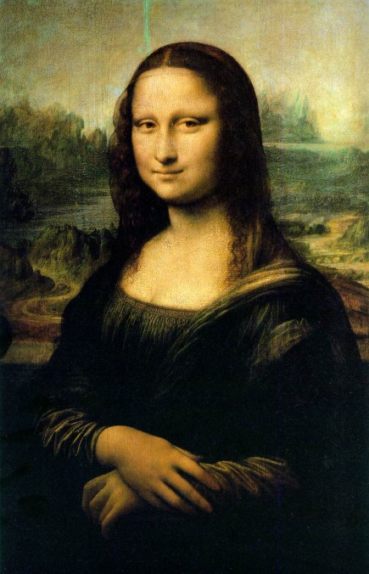

Read John Donne's poem and explain in what way it reflects the changes and innovations of the Renaissance Age.
In what way are Leonardo da Vinci's paintings representative of the age?
Cross-curricular question: English/Arts

'A Poem is a Painting'
A poem is a painting that is not seen;
A painting is a poem that is not heard
Phoebe Hesketh

William Carlos Williams  The Great Figure  Among the rain  and lights  I saw the figure 5  in gold  on a red  firetruck  moving  tense  unheeded  to gong clangs  siren howls  and wheels rumbling  through the dark city. | 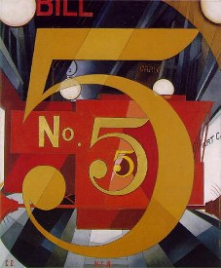

Explain William Carlos Williams' poem. In what way is it typical of the Imagist tradition in poetry? Do you know any other examples of imagist poetry?

How does the above painting by Williams' friend Charles Demuth reflect American modernism? Do you know any other representatives of this movement? What do they have in common?

Cross-curricular question: English/Arts

The Unicorn in Art and Literature

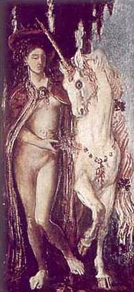

Unicorn
Moreau, Gustave

The Unicorn in Tennessee Williams' The Glass Menagerie

Tennessee Williams is a master of symbolism and uses scenery and props as important components in his plays. Explain the significance of the Unicorn in The Glass Menagerie.
In what way is the Unicorn typical of Laura?

Gustave Moreau: "I believe only in what I do not see."

Describe the painting "The Unicorn" by the French Symbolist Gustave Moreau. In what way is this painting typical of the Symbolist movement? What were the main intentions of the Symbolists? Give other examples of Symbolist art that you know.

The Pearl

by John Steinbeck
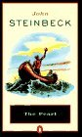

Foreword
"In the town they tell the story of the great pearl—how it was found and how it was lost again. They tell of Kino, the fisherman, and of his wife, Juana, and of the baby, Coyotito. And because the story has been told so often, it has taken root in every man's mind. And, as with all retold tales that are in people's hearts, there are only good and bad things and black and white things and good and evil things and no in-between anywhere.
If this story is a parable, perhaps everyone takes his own meaning from it and reads his own life into it..."

As Steinbeck says in the foreword to The Pearl, the story is full of symbols of good and evil.
Explain the symbolism of the pearl and the symbolic use of music and songs in the story.

What meaning do you take from The Pearl? What do you consider to be the moral of the story?

Scandals in Literature

 | Newsletter | 
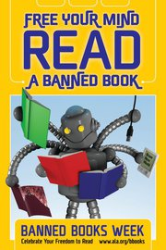
Banned Books Week or Caution! Some People Consider These Books Dangerous: At this time each fall, WPL presents its annual display of titles that were at one time or another the targets of censors in our society. The Banned Book exhibit draws attention to the danger that exists when restraints are imposed on the availability of information in a free society. The message is not only that individuals must have the freedom to choose or express opinions, even if they are unconventional or unpopular, but also that we must ensure the availability of unpopular viewpoints to all who wish to read them.



Do you agree with the opinion voiced in this newsletter?
What reasons might a society or government have for banning books?
Who does the banning?
Give examples of famous books that have been banned at some time during their printed life.
For what reasons were these books banned? (Focus on a few examples in detail)
Scandals in Literature

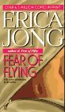
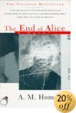

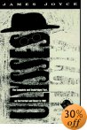

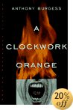
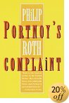

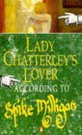

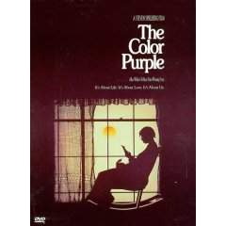

All of the above novels have been banned or criticized for their pornographic or violent content.
Should all these novels be freely available to any readers? Can they harm anybody?
Where would you draw the line?
Can you think of any other books that should not be available to the general public?

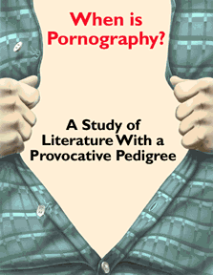

The Other Side of the Story

Kate Chopin
The Awakening

“But when she was there beside the sea, absolutely alone, she cast the unpleasant, pricking garments from her, and for the first time in her life she stood naked in the open air, at the mercy of the sun, the breeze that beat upon her, and the waves that invited her.
How strange and awful it seemed to stand naked under the sky! How delicious! She felt like some new-born creature ,opening its eyes in a familiar world that it had never known.”
(p. 175)

The above passage appears close to the end of Kate Chopin’s famous novel The Awakening. Explain its meaning and symbolism.
Why is Edna alone and naked? What do the pricking garments stand for?
Is this new freedom only positive?
Will she be able to enjoy it?
Core question:

Hamlet
and
Rosencrantz and Guildenstern are Dead

Compare the two plays. What parallels and differences do you find?
1. In which way do the two plays reflect the values of the contexts in which they were written.
2. What are the main themes of the two plays? Give examples.
3. Explain the significance of the following quote:

GUIL: Yes, I’m fond of boats myself. I like the way they’re – contained. You don’t have to worry about which way to go, or whether to go at all – the question doesn’t arise, because you’re on a boat, aren’t you? Boats are safe areas in the game of tag . . . the players will hold their positions until the music starts . . . I think I’ll spend most of my life on beats.

The American Dream

picture

Look at the critical poster about the American Dream. Which of the texts that we have discussed in the American Dream project does the poster remind you of?
Collect all your associations, then choose the most important ones and explain them.
Use the reading list below to help you remember the texts.

Reading list

The American Dream

Compare and contrast the two poems by Walt Whitman and Allen Ginsberg. What are their views of America?
Give some other examples from the literature that you have read that support the one or the other image.

I Hear America Singing
I hear America singing, the varied carols I hear,
Those of mechanics, each one singing his as it should be blithe and strong,
The carpenter singing as he measures his plank or beam,
The mason singing his as he makes ready for work, or leaves off work,
The boatman singing what belongs to him in his boat, the deckhand singing on the steamboat deck,
The showmaker singing as he sits on his bench, the hatter singing as he stands,
The wood-cutter's song, the ploughboy's on his way in the morning, or at noon intermission or at sundown,
The delicious singing of the mother, or of the young wife at work, or of the girl sewing or washing,
Each singing what belongs to him or her or to none else,
The day what belongs to the day--at night the party of young fellows, robust, friendly,
Singing with open mouths their strong melodious songs.
From Leaves of Grass, Walt Whitman (1900)

A Supermarket in California

What thoughts I have of you tonight, Walt Whitman, for I walked down the
streets under the trees with a headache self-conscious looking at the full moon.

In my hungry fatigue, and shopping for images, I went into the neon fruit
supermarket, dreaming of your enumerations!
What peaches and what penumbras! Whole families shopping at night! Aisles
full of husbands! Wives in the avocados, babies in the tomatoes! --- and you,
Garcia Lorca, what were you doing down by the watermelons?
I saw you, Walt Whitman, childless, lonely old grubber, poking among the
meats in the refrigerator and eyeing the grocery boys.
I heard you asking questions of each: Who killed the pork chops? What price
bananas? Are you my Angel?
I wandered in and out of the brilliant stacks of cans following you, and
followed in my imagination by the store detective.
We strode down the open corridors together in our solitary fancy tasting
artichokes, possessing every frozen delicacy, and never passing the cashier.
Where are we going, Walt Whitman? The doors close in an hour. Which way does
your beard point tonight?
(I touch your book and dream of our odyssey in the supermarket and feel
absurd.)
Will we walk all night through solitary streets? The trees add shade to
shade, lights out in the houses, we'll both be lonely.
Will we stroll dreaming of the lost America of love past blue automobiles in
driveways, home to our silent cottage?
Ah, dear father, graybeard, lonely old courage-teacher, what America did you
have when Charon quit poling his ferry and you got out on a smoking bank and
stood watching the boat disappear on the black waters of Lethe?
-- Allen Ginsberg
The Multi-ethnic New York

Broadway

Read the following extracts about Broadway. What do they say about this area of NYC?
Briefly sketch the historical development of Broadway and compare the descriptions with your own impression during your trip to New York.

…Gad, I was sick and tired of life. But the madman drove me home to New York.
Suddenly I found myself on Times Square. I had traveled eight thousand miles around the American continent and I was back on Times Square; and right in the middle of a rush hour, too, seeing with my innocent road-eyes the absolute madness and fantastic hoorair of New York with its millions and millions hustling forever for a buck among themselves, the mad dream-grabbing, taking, giving, sighing, dying, just so they could be buried in those awful cemetery cities beyond Long Island City. …
Where Dean? Where everybody? Where life? I had my home to go to, may place to lay my head down and figure the losses and figure the gain that I knew was in there somewhere too.
From On the Road by Jack Kerouac

Pleasure without guilt – it was no mean legacy. Before him, curiosity museums had been furtive, dust-ridden mausoleums. Usually they featured a few skeletons, a couple of death masks, perhaps a lecture with lantern slides. Barnum, by contrast, offered “educated dogs, industrious fleas, automatons, jugglers, ventriloquists, living statuary, tableaux, gypsies, albinos, fat boys, giants, dwarfs, rope dancers, live ‘Yankees,’ pantomime, instrumental music, singing and dancing in great variety…
At every block, it seemed, there was the latest, the greatest. And somewhere along the line, the street became an idea. The idea boiled down to a single word, the most potent in the language. And that word was action.
From Nik Cohn, The Heart of the World

… And certainly perdition sucked at the feet of the people who walked there; and cried in the lights, in the gigantic towers; the marks of Satan could be found in the faces of the people who waited at the doors of movie houses; his words were printed on the great movie posters that invited people to sin. It was the roar of the damned that filled Broadway, where motor-cars and buses and the hurry on people disputed every inch with death. Broadway: the way that led to death was broad, and many could be found thereon; but narrow was the way that led to lifer eternal, and few there were who found it. But he did not long for the narrow way, where all his people walked; where the houses did not rise, piecing, as it seemed, the unchanging clouds, but huddled, flat, ignoble, close to the filthy ground, where the streets and the hallways and the rooms were dark, and where the unconquerable odour was of dust, and sweat, and urine, and home-made grin. In the narrow way, the way of the cross, there awaited him only humiliation for ever…
From Go Tell it on the Mountain, James Baldwin

Glitz and Glamour in New York

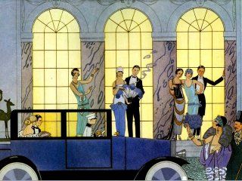

Walking along 5th Avenue tourists can admire the world of glitz and glamour in New York.
This world has been portrayed in several works of literature. Give examples from the works that you have read. How do different authors describe this glamorous world? Does it makes the characters happy? Choose some of the following works and discuss the main characters’ experiences in these surroundings. Can you discern any parallels and common themes? What do the texts say about the high society of their time?

Dorothy Parker, “From the Diary of a New York Lady”
Truman Capote, Breakfast at Tiffany’s
Scott F. Fitzgerald, The Great Gatsby, “My Lost City”, “Winter Dreams”
Bret Easton Ellis, American Psycho

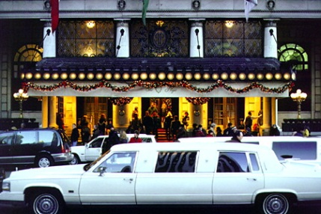
The Plaza Hotel

Gentrification in Lower Manhattan

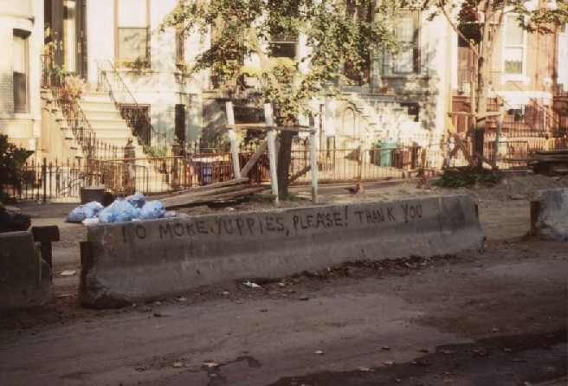
“No more yuppies, please!”

1. Explain the term “gentrification” in the context of lower Manhattan. How have the neighborhoods in the East Village, Greenwich Village and Soho changed in the last few decades? Where is the process of gentrification happening at the moment?

2. How does Allen Ginsberg’s poem “Howl” portray the bohemian lifestyle of his generation? Name a few other artists that were friends and contemporaries of Ginsberg in New York.

I saw the best minds of my generation
destroyed by madness, starving hysterical
naked,
dragging themselves through the negro
streets at dawn looking for an angry fix
angelheaded hipsters burning for the ancient
heavenly connection to the starry dynamo
in the machinery of night,
Who poverty and tatters and hollow-eyed and high sat up smoking in the supernatural darkness of cold-water flats
Floating across the tops of cities contemplating jazz,
Who bared their brains to Heaven under the El and saw Mohammedan angels staggering on tenement roofs…
From: “Howl”
The Black Experience in New York
Harlem
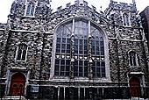 | 
LANGSTON HUGHES  (1902-1967) | 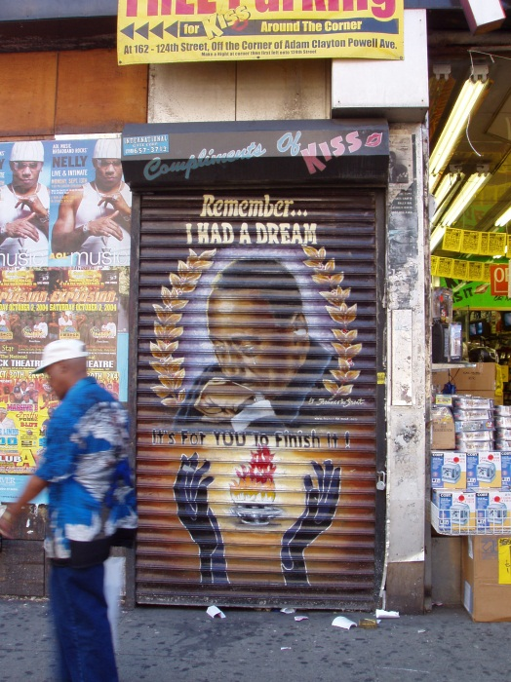
  What happens to a dream deferred?
  Does it dry up
  like a raisin in the sun?
  Or fester like a sore--
  and then run?
  Does it stink like rotten meat?
  Or crust and sugar over--
  like a syrupy sweet?
  Maybe it just sags
  like a heavy load
  Or does it just explode?
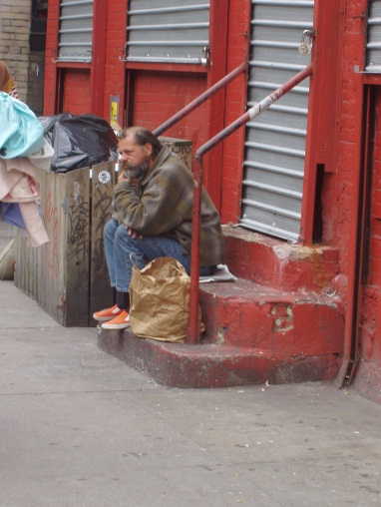 | 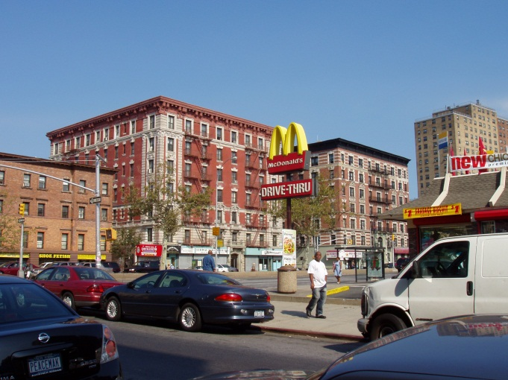

Give an overview of the development of Harlem in the last few decades. How do the pictures and Langston Hughes’ poem fit in?
Explain the terms Harlem Renaissance, Gentrification and name some important artists and Black leaders who have lived and worked in Harlem.
What was your personal experience with Harlem? In what way is 125th street different from the rest of the area?

tor Beat Generation in New York

Chelsea Hotel

by Leonard Cohen
I remember you well in the Chelsea Hotel,
you were talking so brave and so sweet,
giving me head on the unmade bed,
while the limousines wait in the street.
Those were the reasons and that was New York,
we were running for the money and the flesh.
And that was called love for the workers in song
probably still is for those of them left.
Ah but you got away, didn't you babe,
you just turned your back on the crowd,
you got away, I never once heard you say,
I need you, I don't need you,
I need you, I don't need you
and all of that jiving around.
I remember you well in the Chelsea Hotel
you were famous, your heart was a legend.
You told me again you preferred handsome men
but for me you would make an exception.
And clenching your fist for the ones like us
who are oppressed by the figures of beauty,
you fixed yourself, you said, "Well never mind,
we are ugly but we have the music."
Ah but you got away, didn't you babe,
you just turned your back on the crowd,
you got away, I never once heard you say,
I need you, I don't need you,
I need you, I don't need you
and all of that jiving around.
I don't mean to suggest that I loved you the best,
I can't keep track of each fallen robin.
I remember you well in the Chelsea Hotel,
that's all, I don't even think of you that often.
© by Leonard Cohen.

What is so special about the Chelsea Hotel?
Give some examples of the famous inhabitants of the hotel, their works and their lives.
In what way is the Chelsea so typical of Bohemian New York?
core question

The Many Faces of Evil in Literature

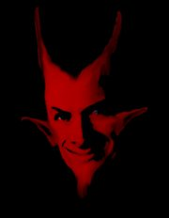

The evil characters in literature help to create some of the greatest plots in history. Authors use good and evil in literature to provide examples for recognizing morality and depravity.

Choose some suitable works that you have read and show how the characters use evil deeds for their own profit. What are these characters’ motivations?
Can some of their behavior be explained by the characters’ background or previous experience?

Character | Examples of his evil deeds | His motivation | Possible explanations (circumstances, background)

Ideas for Evil Characters
Jack in Lord of the Flies
Bateman (American Psycho)
Richard III
Macbeth
All my Sons
Ian McEwan characters
The devil in Young Goodman Brown (Hawthorne)
Poe, the narrator of the Tell Tale Heart
Picture of Dorian Grey
Cal: the other guy?
Scandals: A is for Axe
The End of Alice, narrator

A Clockwork Orange, (Alex)
Animal Farm: pigs, Napoleon, dogs, …
Truman Capote, In cold blood (Dick and Perry)
…

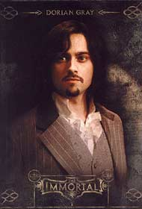 | The Picture of Dorian Grey |   American Psycho

Read the definition of narcissistic personality disorder given below and examine whether Dorian Grey and Patrick Bateman meet any of the criteria. Give examples from the novels to back up your diagnosis.

Narcissistic Personality Disorder
DSMV CRITERIA 301.81(NARCISSISTIC PERSONALITY DISORDER)
http://www.behavenet.com/capsules/disorders/narcissisticpd.htm
An all-pervasive pattern of grandiosity (in fantasy or behaviour), need for admiration or adulation and lack of empathy, usually beginning by early adulthood and present in various contexts. Five (or more) of the following criteria must be met:
1. Feels grandiose and self-importance (e.g., exaggerates achievements and talents to the point of lying, demands to be recognized as superior without commensurate achievements)
2. Is obsessed with fantasies of unlimited success, fame, fearsome power or omnipotence, unequalled brilliance (the cerebral narcissist), bodily beauty or sexual performance (the somatic narcissist), or ideal, everlasting, all-conquering love or passion
3. Firmly convinced that he or she is unique and, being special, can only be understood by, should only be treated by, or associate with, other special or unique, or high-status people (or institutions)
4. Requires excessive admiration, adulation, attention and affirmation - or, failing that, wishes to be feared and to be notorious (narcissistic supply)
5. Feels entitled. Expects unreasonable or special and favourable priority treatment.
6. Demands automatic and full compliance with his or her expectations Is "interpersonally exploitative", i.e., uses others to achieve his or her own ends
7. Devoid of empathy. Is unable or unwilling to identify with or acknowledge the feelings and needs of others
8. Constantly envious of others or believes that they feel the same about him or her
9. Arrogant, haughty behaviours or attitudes coupled with rage when frustrated, contradicted, or confronted
Lost at Sea

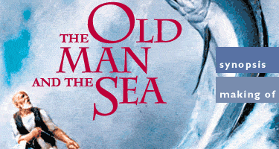 | 

Read the following conversation between Mr. Chiba – the Japanese investigator, and Pi Patel. (This dialogue is found in Chapter 99, pages 370 – 371.) What is Pi attempting to convey to Mr. Chiba in this dialogue about the development of human understanding of the universe? What about Mr. Chiba’s claim that he knows well enough the “possible and impossible”? How and by what methods do we learn the possible and impossible?
Mr. Chiba: “I’m sorry to say it bluntly, we don’t mean to hurt your feelings, but you don’t really expect us to believe you, do you? Carnivorous trees? A fish-eating algae that produces fresh water? Tree-dwelling aquatic rodents? These things don’t exist.”
Pi Patel: “Only because you’ve never seen them.”
Mr. Chiba: “That’s right. We believe what we see.”
Pi Patel: “So did Columbus. What do you do when you’re in the dark?”
Mr. Chiba: “Your island is botanically impossible.”
Pi Patel: “Said the fly just before landing in the Venus flytrap.”
Mr. Chiba: “Why has no one else come upon it?”
Pi Patel: “It’s a big ocean crossed by busy ships. I went slowly, observing much.”
Mr. Chiba: “No scientist would believe you.”
Pi Patel: “These would be the same who dismissed Copernicus and Darwin. Have scientists finished coming upon new plants? In the Amazon basin, for example?”
Mr. Chiba: “Not plants that contradict the laws of nature.”
Pi Patel: “Which you know through and through?”
Mr. Chiba: “Well enough to know the possible from the impossible.”

2. The novel has often been compared to Hemingway’s The Old Man and the Sea. Can you find any parallels between the main characters? Would the Old Man agree with Mr. Chiba or with Pi? What is his understanding of “the laws of nature and the universe”?

Scandals in Literature

Salmon Rushdie, “Is nothing sacred?”

In his essay Salmon Rushdie asks himself whether the freedom of speech or writing is sacred to him. Sum up Rushdie’s views. What is Rushdie’s conclusion?
How does the following quote from this essay fit in?

More than twenty years ago, I listened to a lecture by Arthur Koestler. He propounded the thesis that language, not territory, was the prime cause of aggression, because once language reached the level of sophistication at which it could express abstract concepts, it acquired the power of totemization; and once peoples had erected totems, they would go to war to defend them. (I ask pardon of Koestler's ghost. I am relying on an old memory, and that's an untrustworthy shoulder to lean on.)
In support of his theory, he told us about two tribes of monkeys living on, I think, one of the northern islands of Japan. The two tribes lived in close proximity in the woods near a certain stream, and subsisted, not unusually, on a diet of bananas. One of the tribes, however, had developed the curious habit of washing its bananas in the stream before eating them, while the other tribe continued to be non-banana- washers. And yet, said Koestler, the two tribes continued to live contentedly as neighbors, without quarrelling. And why was this? It was because their language was too primitive to permit them to totemize either the act of banana-washing or that of eating bananas unwashed. With a more sophisticated language at their disposal, both wet and dry bananas could have become the sacred objects at the heart of a religion, and then, look out! - Holy war.

What is your personal opinion? Is the freedom of speech sacred for you or is it more important to protect vulnerable groups in society? Give examples of banned books and explain why you agree or disagree with the banning.

Scandals in Literature

Salmon Rushdie, “Is nothing sacred?”

SALMAN RUSHDIE lost his religious faith at the age of fifteen. The event took place in a Latin class at Rugby and he later celebrated it by eating a stale ham sandwich. He has himself spoken of how he attempted to fill the ‘god-shaped hole’ left by his loss of faith with the art of the novel.
What does Rushdie say about religion and literature?
Read the following extract from the essay “Is nothing sacred?” and explain the significance of literature according to the author. Is literature sacred to Rushdie?

Imagine this. You wake up one morning and find yourself in a large, rambling house. As you wander through it you realize it is so enormous that you will never know it alt. In the house are people you know, family members, friends, lovers, colleagues; also many strangers. The house is full of activity: conflicts and seductions, celebrations and wakes. At some point you realize there is no way out. You find that you can accept this. The house is not what you'd have chosen, it's in fairly bad condition, the corridors are often full of bullies, but it will have to do. Then one day you enter an unimportant-looking little room. The room is empty, but there are voices in it, voices that seem to be whispering just to you. You recognize some of the voices, others are completely unknown to you. The voices are talking about the house, about everyone in it, about everything that is happening and has happened and should happen. Some of them speak exclusively in obscenities. Some are bitchy. Some are loving. Some are funny. Some are sad. The most interesting voices are all these things at once. You begin to go to the room more and more often. Slowly you realize that most of the people in the house use such rooms sometimes. Yet the rooms are all discreetly positioned and unimportant-looking.
Now imagine that you wake up one morning and you are still in the large house, but all the voice- rooms have disappeared. It is as if they have been wiped out. Now there is nowhere in the whole house where you can go to hear voices talking about everything in every possible way. There is nowhere to go for the voices that can be funny one minute and sad the next, that can sound raucous and melodic in the course of the same sentence. Now you remember: There is no way out of this house. Now this fact begins to seem unbearable. You look into the eyes of the people in the corridors - family, lovers, friends, colleagues, strangers, bullies, priests. You see the same thing in everybody's eyes. How do we get out of here? It becomes clear that the house is a prison. People begin to scream, and pound the walls. Men arrive with guns. The house begins to shake. You do not wake up. You are already awake.
Literature is the one place in any society where, within the secrecy of our own heads, we can hear voices talking about everything in every possible way. The reason for ensuring that that privileged arena is preserved is not that writers want the absolute freedom to say and do whatever they please. It is that we, all of us, readers and writers and citizens and generals and godmen, need that little, unimportant- looking room. We do not need to call it sacred, but we do need to remember that it is necessary.
"Everybody knows," wrote Saul Bellow in The Adventures of Augie March, "there is no fineness or accuracy of suppression. If you hold down one thing, you hold down the adjoining."

Scandals in Literature

Erica Jong, Fear of Flying

Read the following opinions about the novel Fear of Flying. How does the novel compare to the other sexual scandals we have read in the course? Where would you draw the line between literature and pornography? Give examples.

Copy of my book-cover, front and back
Core-question
The Great Depression
John Steinbeck
Scott F. Fitzgerald

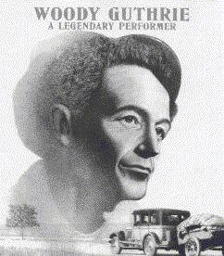

Seen the pitcher last night, Grapes of Wrath, best cussed pitcher I ever seen.
The Grapes of Wrath, you know is about us pullin' out of Oklahoma and Arkansas, and down south, and a driftin' around over state of California, busted, disgusted, down and out, and a lookin' for work.
Shows you how come us to be that a way. Shows the dam bankers men that broke us and the dust that choked us, and comes right out in plain old English and says what to do about it.
It says you got to get together and have some meetins, and stick together, and raise old billy hell till you get youre job, and get your farm back, and your house and your chickens and your groceries and your clothes, and your money back.
Go to see Grapes of Wrath, pardner, go to see it and don't miss.
You was the star in that picture. Go and see your own self and hear your own words and your own song.

Woody Guthrie, in one of his People's World columns (1939-'40), reprinted in Woody Sez, New York, NY, 1975, p. 133.

Explain the significance of the above quotation in the context of the Great Depression.
Briefly explain the causes and development of the depression and draw parallels between the historical facts and the works of fiction that you have read.

Existence is Absurd

Waiting for Godot
Read the opening of the play and explain in what way it is typical of the Theater of the Absurd.
What is Samuel Beckett's message in the play? Can you already see any hints in the opening passage?

ACT I
A country road. A tree.
Evening.
Estragon, sitting on a low mound, is trying to take off his boot. He pulls at it with both hands, panting. He gives up, exhausted, rests, tries again.
As before.
Enter Vladimir.
ESTRAGON: (giving up again). Nothing to be done.
VLADIMIR: (advancing with short, stiff strides, legs wide apart). I'm beginning to come round to that opinion. All my life I've tried to put it from me, saying Vladimir, be reasonable, you haven't yet tried everything. And I resumed the struggle. (He broods, musing on the struggle. Turning to Estragon.) So there you are again.
ESTRAGON: Am I?
VLADIMIR: I'm glad to see you back. I thought you were gone forever.
ESTRAGON: Me too.
VLADIMIR: Together again at last! We'll have to celebrate this. But how? (He reflects.) Get up till I embrace you.
ESTRAGON: (irritably). Not now, not now.
VLADIMIR: (hurt, coldly). May one inquire where His Highness spent the night?
ESTRAGON: In a ditch.
VLADIMIR: (admiringly). A ditch! Where?
ESTRAGON: (without gesture). Over there.
VLADIMIR: And they didn't beat you?
ESTRAGON: Beat me? Certainly they beat me.
VLADIMIR: The same lot as usual?
ESTRAGON: The same? I don't know.
VLADIMIR: When I think of it . . . all these years . . . but for me . . . where would you be . . . (Decisively.) You'd be nothing more than a little heap of bones at the present minute, no doubt about it.
ESTRAGON: And what of it?
VLADIMIR: (gloomily). It's too much for one man. (Pause. Cheerfully.) On the other hand what's the good of losing heart now, that's what I say. We should have thought of it a million years ago, in the nineties.

Existence is Absurd

Waiting for Godot

Read the following scene from the play and answer Estragon's question (see underlined phrases). Are Estragon and Vladimir free to decide their own fate or are they "tied" in any way?
Compare the two men to other characters from absurd plays that you have read or seen. What are the typical patterns of behavior in these plays? Give examples.

ESTRAGON: (chewing). I asked you a question.
VLADIMIR: Ah.
ESTRAGON: Did you reply?
VLADIMIR: How's the carrot?
ESTRAGON: It's a carrot.
VLADIMIR: So much the better, so much the better. (Pause.) What was it you wanted to know?
ESTRAGON: I've forgotten. (Chews.) That's what annoys me. (He looks at the carrot appreciatively, dangles it between finger and thumb.) I'll never forget this carrot. (He sucks the end of it meditatively.) Ah yes, now I remember.
VLADIMIR: Well?
ESTRAGON: (his mouth full, vacuously). We're not tied?
VLADIMIR: I don't hear a word you're saying.
ESTRAGON: (chews, swallows). I'm asking you if we're tied.
VLADIMIR: Tied?
ESTRAGON: Ti-ed.
VLADIMIR: How do you mean tied?
ESTRAGON: Down.
VLADIMIR: But to whom? By whom?
ESTRAGON: To your man.
VLADIMIR: To Godot? Tied to Godot! What an idea! No question of it. (Pause.) For the moment.
ESTRAGON: His name is Godot?
VLADIMIR: I think so.
ESTRAGON: Fancy that. (He raises what remains of the carrot by the stub of leaf, twirls it before his eyes.) Funny, the more you eat the worse it gets.
VLADIMIR: With me it's just the opposite.
ESTRAGON: In other words?
VLADIMIR: I get used to the muck as I go along.
ESTRAGON: (after prolonged reflection). Is that the opposite?
VLADIMIR: Question of temperament.
ESTRAGON: Of character.
VLADIMIR: Nothing you can do about it.
ESTRAGON: No use struggling.
VLADIMIR: One is what one is.
ESTRAGON: No use wriggling.
VLADIMIR: The essential doesn't change.
ESTRAGON: Nothing to be done. (He proffers the remains of the carrot to Vladimir.) Like to finish it?
A terrible cry, close at hand. Estragon drops the carrot. They remain motionless, then together make a sudden rush towards the wings. Estragon stops halfway, runs back, picks up the carrot, stuffs it in his pocket, runs to rejoin Vladimir who is waiting for him, stops again, runs back, picks up his boot, runs to rejoin Vladimir. Huddled together, shoulders hunched, cringing away from the menace, they wait.
Existence is Absurd
Waiting for Godot
Read the passage below and explain the importance of religious symbols in Beckett's play.
What role does chance play here? Give other examples where chance or the law of probability plays a role in absurd plays. What other typical absurdist features can you find in this passage?

VLADIMIR: Did you ever read the Bible?
ESTRAGON: The Bible . . . (He reflects.) I must have taken a look at it.
VLADIMIR: Do you remember the Gospels?
ESTRAGON: I remember the maps of the Holy Land. Coloured they were. Very pretty. The Dead Sea was pale blue. The very look of it made me thirsty. That's where we'll go, I used to say, that's where we'll go for our honeymoon. We'll swim. We'll be happy.
VLADIMIR: You should have been a poet.
ESTRAGON: I was. (Gesture towards his rags.) Isn't that obvious?
Silence.
VLADIMIR: Where was I . . . How's your foot?
ESTRAGON: Swelling visibly.
VLADIMIR: Ah yes, the two thieves. Do you remember the story?
ESTRAGON: No.
VLADIMIR: Shall I tell it to you?
ESTRAGON: No.
VLADIMIR: It'll pass the time. (Pause.) Two thieves, crucified at the same time as our Saviour. One–
ESTRAGON: Our what?
VLADIMIR: Our Saviour. Two thieves. One is supposed to have been saved and the other . . . (he searches for the contrary of saved) . . . damned.
ESTRAGON: Saved from what?
VLADIMIR: Hell.
ESTRAGON: I'm going.
He does not move.
VLADIMIR: And yet . . . (pause) . . . how is it —this is not boring you I hope— how is it that of the four Evangelists only one speaks of a thief being saved. The four of them were there —or thereabouts— and only one speaks of a thief being saved. (Pause.) Come on, Didi, return the ball, can't you, once in a while?
ESTRAGON: (with exaggerated enthusiasm). I find this really most extraordinarily interesting.
VLADIMIR: One out of four. Of the other three two don't mention any thieves at all and the third says that both of them abused him.
ESTRAGON: Who?
VLADIMIR: What?
ESTRAGON: What's all this about? Abused who?
VLADIMIR: The Saviour.
ESTRAGON: Why?
VLADIMIR: Because he wouldn't save them.
ESTRAGON: From hell?
VLADIMIR: Imbecile! From death.
ESTRAGON: I thought you said hell.
VLADIMIR: From death, from death.
ESTRAGON: Well what of it?
VLADIMIR: Then the two of them must have been damned.
ESTRAGON: And why not?
VLADIMIR: But one of the four says that one of the two was saved.
ESTRAGON: Well? They don't agree and that's all there is to it. (...)
VLADIMIR: Pah!
He spits. Estragon moves to center, halts with his back to auditorium.
ESTRAGON: Charming spot. (He turns, advances to front, halts facing auditorium.) Inspiring prospects. (He turns to Vladimir.) Let's go.
VLADIMIR: We can't.
ESTRAGON: Why not?
VLADIMIR: We're waiting for Godot.
ESTRAGON: (despairingly). Ah! (Pause.) You're sure it was here?
VLADIMIR: What?
ESTRAGON: That we were to wait.
VLADIMIR: He said by the tree. (They look at the tree.) Do you see any others?
ESTRAGON: What is it?
VLADIMIR: I don't know. A willow.
ESTRAGON: Where are the leaves?
VLADIMIR: It must be dead.
ESTRAGON: No more weeping.
Existence is Absurd

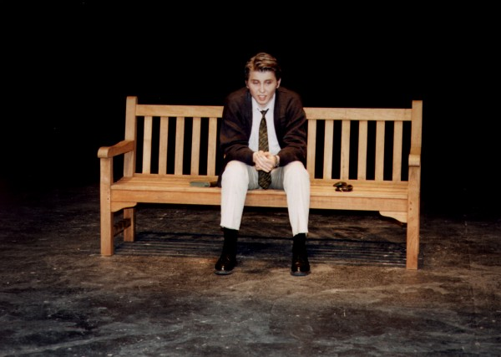

The Zoo Story
by Edward Albee

"Now I'll let you in on what happened at the zoo; but first, I should tell you why I went to the zoo. I went to the zoo to find out more about the way people exist with animals, and the way animals exist with each other, and with people too. It probably wasn't a fair test, what with everyone separated by bars from everyone else, the animals for the most part from each other, and always the people from the animals. But, if it's a zoo, that's the way it is."

In many absurd plays the theme of communication plays an important role. Explain the meaning of the above passage from the Zoo Story and give examples from other absurd plays where the same theme is treated.
What are the other typical themes and characteristics of absurd plays?

Core question

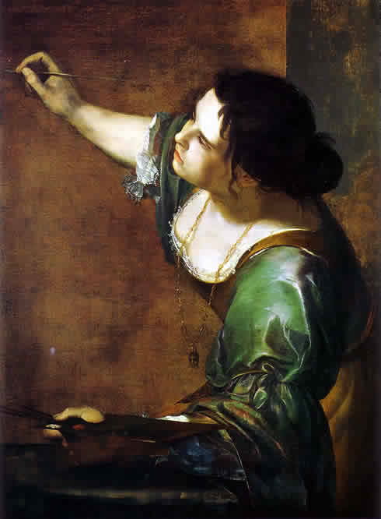

The Passion of Artemisia

“You’ve got to use your own emotions and paint with your own blood if need be in order to discover and prove the truth of your vision.” p. 252

“If a person loves something above all else, if he values the work of his heart and hands, then he should naturally, without hesitation, pour into it his whole soul, undivided and pure. Great art demands nothing less.” p. 103

Explain the meaning of the above quotes in the context of Susan Vreeland’s novel.
In what way does the term passion apply to Artemisia, Orazio, Galileo, and Graziela?
In what way is Artemisia a typically Baroque character?

Artemisia Gentileschi is an exceptionally strong woman even according to modern standards.
Compare her to other female characters from your reading list (novels or short-stories)

Core question

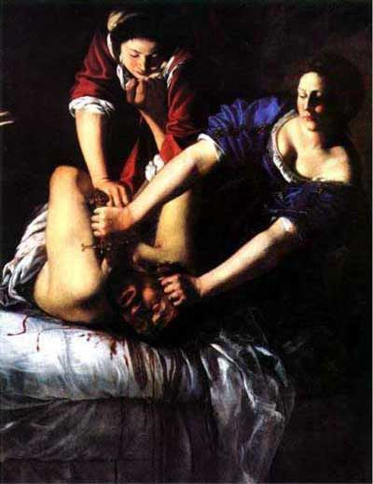

Self portrait Judith Slaying Holofernes

The Passion of Artemisia

“You’ve got to use your own emotions and paint with your own blood if need be in order to discover and prove the truth of your vision.” p. 252

“If a person loves something above all else, if he values the work of his heart and hands, then he should naturally, without hesitation, pour into it his whole soul, undivided and pure. Great art demands nothing less.” p. 103

Explain the meaning of the above quotes in the context of Susan Vreeland’s novel.
In what way does the term passion apply to Artemisia, Orazio, Galileo, and Graziela?
In what way is Artemisia a typically Baroque character?
What might have been her secret thoughts while painting Judith Slaying Holofernes?

What makes Artemisia such an interesting character even for the modern reader?

Core question

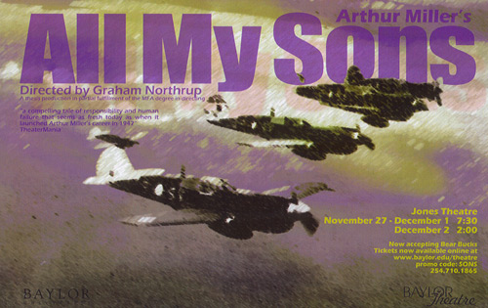

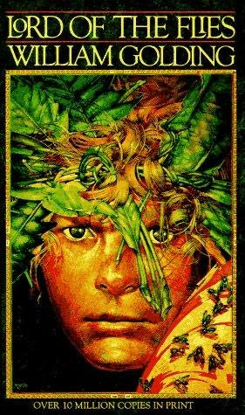


All three novels deal with the horrors of World War II. Compare the different ways the authors chose to portray the effects of the war.
Briefly present the main messages of the three novels.

If the characters of the three novels could meet after their experiences in the respective novels, who would they want to be friends with.
Find at least two possible friendships and explain what these characters have in common.

Core-question Existence is absurd

Existence is Absurd

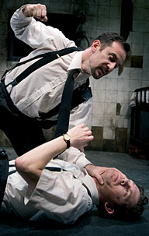
The Dumb Waiter
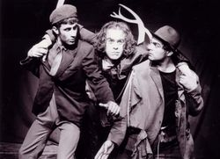

Waiting For Godot

Compare the two absurd plays and present the similarities between them.
What are the typically absurdist elements that Harold Pinter and Samuel Beckett are using in the plays?

What are absurdist writers saying about the world they lived in?

Core-question Existence is Absurd

Theatre of the Absurd

Look at the following list of characteristics of the Theatre of the Absurd. Then collect examples from the plays you have read or seen. Explain in what way these plays are representative of the Theatre of the Absurd.

Characteristics of Theatre of the Absurd
- Situations and characters’ emotional states may be represented through poetic metaphor (dreamlike, fantastical or nightmarish images).
- The notion of realism is rejected: situations and characters are not “realistic” and characters are often placed in obviously unreal situations.
- Set and costumes may not reflect an outward reality.
- Dialogue is often nonsensical, clichéd or gibberish.
- Communication is fractured.
- There is usually an emphasis on “theatricality” as opposed to realism.
- Absurdist playwrights often use dark comedy for satiric effect.
- Characters exist in a bubble without the possibility of communication.
- Characters may be one-dimensional, with no clear motivation or purpose.
- Characters may be symbolic of universal situations.
- Behavior and situations may not follow the rules of logic.
- Structure may be circular, without a precise resolution.
- Action may be minimal.
- Setting of the play may be in one locale.
- Often characters perceive a threat from the “outside”, leading to a sense of powerlessness.

Core question

Native American Culture and Literature



Read the following speech by Ralph Keene. Then discuss which of these types of Indians you have come across in the literature that you have read. Give examples.
Have you met any of them during your trip to Rapid City?

Ralph Keene asks: What is an Indian?
Many questions have been asked by Non-Indians concerning Indians. The questions vary but they all add up to one question: What is an Indian?

Many Non-Indians say and Indian is
- a person who doesn't work but receives a monthly check from the government
- they say he is lazy
- they say an Indian is a man who got a wrought deal from government and therefore he deserves what can get from this government
- he is a drunkard who doesn't amount to anything and therefore the government should terminate him and let him make his own way in the white man's society
I do not see the Indian as these people do.
- I see them as a group of people all different in their ways, but held together by a common bond called culture.
- I see them as a group of people who fought for what was rightfully theirs and were branded as savages.
- I see the Indians as a group of people who fought courageously agains overwhelming odds, and after giving in and signing a peace treaty lived to see the treaties broken one by one.
- I see the Indians as individuals who, when their country was in danger, went to the front voluntarily to save this country, for example in the Civil War, WWI, WWII, the Korean conflict, and Vietnam.
- I see the Indians as a group of people who are proud and rightfully so, because they possessed the secrets of life, the white man has never discovered.
- I see the Indians as a group of people who ,even in their broken English, will tell you how important it is to gain an education.
- They are a group of people who, once they have crossed the culure barrier into the dominate society, become the best in their chosen profession, be it in medicine, as athletes, in law, politics, or fighting for freedom.
And when I think of the Indian in this light I think of the question "What is an Indian?"
My chest suddenly expands and I think I am an Indian.
Core question

Lakota Spirituality
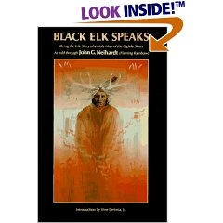


Read the extract from Black Elk Speaks. Then explain the significance of the traditional colors of the Lakota Medicine Wheel.

After the heyoka ceremony, I came to live here where I am now between Wounded Knee Creek and Grass Creek. Others came too, and we made these little gray houses of logs that you see, and they are square. It is a bad way to live, for there can be no power in a square.
You have noticed that everything an Indian does is in a circle, and that is because the Power of the World always works in circles, and everything tries to be round. In the old days when we were a strong and happy people, all our power came to us from the sacred hoop of the nation, and so long as the hoop was unbroken, the people flourished. The flowering tree was the living center of the hoop, and the circle of the four quarters nourished it. The east gave peace and light, the south gave warmth, the west gave rain, and the north with its cold and mighty wind gave strength and endurance. This knowledge came to us from the outer world with our religion. Everything the Power of the World does is done in a circle. The sky is round, and I have heard that the earth is round like a ball, and so are all the stars. The wind, in its greatest power, whirls. Birds make their nests in circles, for theirs is the same religion as ours. The sun comes forth and goes down again in a circle. The moon does the same, and both are round. Even the seasons form a great circle in their changing, and always come back again to where they were. The life of a man is a circle from childhood to childhood, and so it is in everything where power moves. Our tepees were round like the nests of birds, and these were always set in a circle, the nation's hoop, a nest of many nests, where the Great Spirit meant for us to hatch our children.
But the Wasichus have put us in these square boxes. Our power is gone and we are dying, for the power is not in us any more. You can look at our boys and see how it is with us. When we were living by the power of the circle in the way we should, boys were men at twelve or thirteen years of ago. But now it takes them very much longer to mature.
Well, it is as it is. We are prisoners of war while we are waiting here. But there is another world. Black Elk Speaks, p. 194

What else do you know about Lakota culture and spirituality? Talk about the most important ceremonies and their significance in Lakota culture.
Why does Black Elk seem to think it important that his story be told? Why does John Neihardt think it is important? Do they both have the same reasons?
In the second (1961) edition of Black Elk Speaks, John Neihardt changed the title page of the text from "as told to John Neihardt" to "as told through John Neihardt." Explain the significance of this change, and interpret the relationship it suggests between Neihardt and Black Elk, and between Neihardt and Black Elk Speaks.


Solutions to Medicine Wheel
Black Elk…

Core question

Reservation Blues

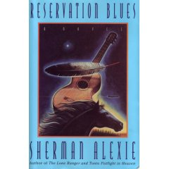
Reservation Blues
Dancing all alone, feeling nothing good
It’s been so long since someone understood
All I’ve seen is, is why I weep
And all I had for dinner was some sleep

You know I’m lonely, I’m so lonely
My heart is empty and I’ve been so hungry
All I need for my hunger to ease
Is anything that you can give me please

Chorus:
I ain’t got nothing, I heard no good news
I fill my pockets with those reservation blues
Those old, those old rez blues, those old reservation blues
And if you ain’t got choices
What else do you choose?

And if you ain’t got choices
Ain’t got much to lose

Explain the lyrics of “Reservation Blues”, the opening song of Sherman Alexie’s novel.
Identify the main themes of the novel and explain how they reflect the history and present-day situation of Native Americans.

Core question Melting Pot

Colour Blind

Read the above poem by Lemn Sissay, a new young poet from Manchester and explain its meaning.
The poem touches the theme of ‘invisibility’. Which other texts does the poem remind you of?

Core question
Shakespearian Sonnets

Read Shakespeare’s sonnet 130 and explain its symbolism and formal aspects.
What are the typical themes of sonnets?
What is different here?

SONNET 130
My mistress' eyes are nothing like the sun;
Coral is far more red than her lips' red;
If snow be white, why then her breasts are dun;
If hairs be wires, black wires grow on her head.
I have seen roses damask'd, red and white,
But no such roses see I in her cheeks;
And in some perfumes is there more delight
Than in the breath that from my mistress reeks.
I love to hear her speak, yet well I know
That music hath a far more pleasing sound;
I grant I never saw a goddess go;
My mistress, when she walks, treads on the ground:
And yet, by heaven, I think my love as rare
As any she belied with false compare.

Do you think this visual interpretation of the poem, which was done by one of your classmates,
represents the message of the poem well? Would you make any changes?

SONNET 130 - COMMENTARY
Sonnet 130 is the poet's pragmatic tribute to his uncomely mistress, commonly referred to as the dark lady because of her dun complexion. The dark lady, who ultimately betrays the poet, appears in sonnets 127 to 154.
Sonnet 130 is clearly a parody of the conventional love sonnet, made popular by Petrarch and, in particular, made popular in England by Sidney's use of the Petrarchan form in his epic poem Astrophel and Stella.
If you compare the stanzas of Astrophel and Stella to Sonnet 130, you will see exactly what elements of the conventional love sonnet Shakespeare is light-heartedly mocking.
In Sonnet 130, there is no use of grandiose metaphor or allusion; he does not compare his love to Venus, there is no evocation to Morpheus, etc. The ordinary beauty and humanity of his lover are important to Shakespeare in this sonnet, and he deliberately uses typical love poetry metaphors against themselves. In Sidney's work, for example, the features of the poet's lover are as beautiful and, at times, more beautiful than the finest pearls, diamonds, rubies, and silk. In Sonnet 130, the references to such objects of perfection are indeed present, but they are there to illustrate that his lover is not as beautiful -- a total rejection of Petrarch form and content. Shakespeare utilizes a new structure, through which the straightforward theme of his lover’s simplicity can be developed in the three quatrains and neatly concluded in the final couplet.
Thus, Shakespeare is using all the techniques available, including the sonnet structure itself, to enhance his parody of the traditional Petrarchan sonnet typified by Sidney’s work. But Shakespeare ends the sonnet by proclaiming his love for his mistress despite her lack of adornment, so he does finally embrace the fundamental theme in Petrarch's sonnets: total and consuming love.
One final note: Shakespeare's reference to hair as 'wires' confuses modern readers because we assume it to mean our current definition of wire, i.e., a thread of metal, which is hardly a fitting word in the context of the poem. However, to a Renaissance reader, wire would refer to the finely-spun gold threads woven into fancy hair nets. Many poets of the time used this term as a benchmark of beauty, including Spenser:
Core question William Shakespeare

Read the following sonnet and explain its meaning and formal aspects.
The sonnet is addressed to a “fair youth”. Who could this be?
What questions does the sonnet raise about Shakespeare and the authorship of the sonnets?

Sonnet 20
by William Shakespeare
A woman's face with nature's own hand painted,
Hast thou, the master mistress of my passion;
A woman's gentle heart, but not acquainted
With shifting change, as is false women's fashion:
An eye more bright than theirs, less false in rolling,
Gilding the object whereupon it gazeth;
A man in hue all hues in his controlling,
Which steals men's eyes and women's souls amazeth.
And for a woman wert thou first created;
Till Nature, as she wrought thee, fell a-doting,
And by addition me of thee defeated,
By adding one thing to my purpose nothing.
But since she prick'd thee out for women's pleasure,
Mine be thy love and thy love's use their treasure.

Core question

The Role of Women
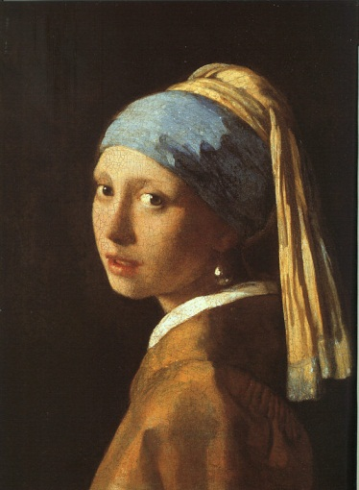

In
The Girl With The Pearl Earring
The Girl in Hyacinth Blue

and

Virginia Woolf

A Room of One's Own
Read the short extract from A Room of One’s Own where Virginia Woolf writes about Shakespeare’s imaginary sister Judith. Discuss the role of women at that time. What were their options. What was expected of them? How has the situation changed?
Continue this imaginary biography of Shakespeare's sister. What would her fate have been?

"...I could not help thinking as I looked at the works of Shakespeare on the shelf, ...; it would have been impossible, completely and entirely, for any woman to have written the plays of Shakespeare in the age of Shakespeare. Let me imagine, since facts are so hard to come by, what would have happened had Shakespeare had a wonderfully gifted sister, called Judith, let us say. Shakespeare himself went, very probably – his mother was an heiress- to the grammar school, where he may have learnt Latin – Ovide, Virgil and Horace – and the elements of grammar and logic. He was, it is well known, a wild boy who poached rabbits, perhaps shot a deer, and had, rather sooner that he should have done, to marry a woman in the neighbourhood, who bore him a child rather quicker than was right. That escapade sent him to seek his fortune in London. He had, it seemed, a taste for the theatre; he began by holding horses at the stage door. Very soon he got work in the theatre, became a successful actor, and live d at the hub of the universe, meeting everybody, knowing everybody, practicing his art on the boards, exercising his wits in the street, and even getting access to the palace of the queen. Meanwhile his extraordinarily gifted sister, let us suppose....."

Compare the role of women in the Girl with a Pearl Earring and/or The Girl In Hyacinth Blue with the extract from A Room of One’s Own. Give examples from the book(s).

Thinking of the literature you have read, what has changed since Shakespeare's and Vermeer’s time? Give examples from the heroines of women's literature.
List some of the limitations that these women have encountered. Which strategies have they developed to overcome them?

Core question

The Role of Women
In
The Girl With The Pearl Earring

and

Virginia Woolf

A Room of One's Own
Read the short extract from A Room of One’s Own where Virginia Woolf writes about Shakespeare’s imaginary sister Judith. Discuss the role of women at that time. What were their options. What was expected of them? How has the situation changed?
Continue this imaginary biography of Shakespeare's sister. What would her fate have been?

"...I could not help thinking as I looked at the works of Shakespeare on the shelf, ...; it would been impossible, completely and entirely, for any woman to have written the plays of Shakespeare in the age of Shakespeare. Let me imagine, since facts are so hard to come by, what would have happened had Shakespeare had a wonderfully gifted sister, called Judith, let us say. Shakespeare himself went, very probably – his mother was an heiress- to the grammar school, where he may have learnt Latin – Ovide, Virgil and Horace – and the elements of grammar and logic. He was, it is well known, a wild boy who poached rabbits, perhaps shot a deer, and had, rather sooner that he should have done, to marry a woman in the neighbourhood, who bore him a child rather quicker than was right. That escapade sent him to seek his fortune in London. He had, it seemed, a taste for the theatre; he began by holding horses at the stage door. Very soon he got work in the theatre, became a successful actor, and live d at the hub of the universe, meeting everybody, knowing everybody, practicing his art on the boards, exercising his wits in the street, and even getting access to the palace of the queen. Meanwhile his extraordinarily gifted sister, let us suppose....."

Compare the role of women in the Girl with a Pearl Earring with the extract from A Room of One’s Own. Give examples from the book.

Thinking of the literature you have read, what has changed since Shakespeare's and Vermeer’s time? Give examples from the heroines of women's literature.
List some of the limitations that these women have encountered. Which strategies have they developed to overcome them?

Core question

The Role of Art

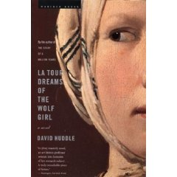
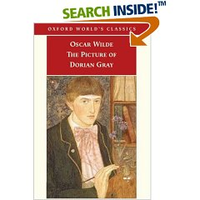
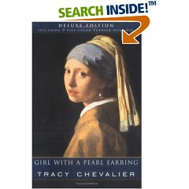

All the books shown on this page deal with the value and purpose of art in some way. Choose at least two of the books. What do they suggest about the value (personal and monetary) and purpose of art? How does art serve us (or the characters)? Why do we need it? How should one look at a painting?

Core question

The Painter and His Model

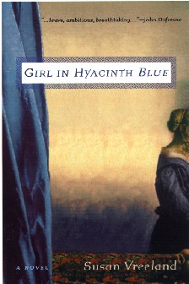

Modeling for a painter is a very long, quiet task that allows a lot of reflection and contemplation. Compare the thoughts of different women as they are being painted.
What are their relationships with the painter?
What do they learn about themselves?
What are their hopes or goals?

Why have the painters chosen them? What are their goals?
What do the books say about the joys and difficulties of being an artist?

Vivienne - LaTour
Griet - Vermeer
Magdalene - Vermeer

Cross-curricular questions: English-History

The Sixties

Who's Next
by Tom Lehrer

One of the big news items of the past year concerned the fact that China, which we call Red China, exploded a nuclear bomb, which we called a "device".
Then Indonesia announced that it was going to have one soon and proliferation became the word of the day. Here's a song about that:

First we got the bomb, and that was good, 'cause we love peace and motherhood
Then Russia got the bomb, but that's OK, 'cause the balance of power's maintained that way,
Who's next? France got the bomb, but don't you grieve, 'cause they're on our side, (I believe).
China got the bomb, but have no fears, they can't wipe us out for at least five years.
And then Indonesia claimed that they were gonna get one any day.
South Africa wants two, that's right, one for the black and one for the white.
Egypt's gonna get one too, just to use on you-know-who, so…
Israel's getting tense, wants one in self-defense.
The Lord our shepherd, says the psalm, but just in case, better get a bomb!
Luxembourg is next to go, and who knows, maybe Monaco.
We'll try to stay serene and calm, when Alabama gets the bomb.

Read and listen to the song "Who's Next" by Tom Lehrer and sum up its content.
Do you know any American writers who would agree with Tom Lehrer? Give examples.

Briefly describe the political situation in America during the sixties.

Cross-curricular question: English/Arts:

Everything is beautiful. Pop is everything."
Andy Warhol

Look at the pictures. In what way do they reflect the lifestyle, values and political ideas of the Sixties?

Arts: How does Pop-art capture the attitudes of the time?
What are the characteristics of Pop-art? Who are the most important artists?
Cross-curricular question: English/Arts

Automat

I thought when I came here
I'd get as rich as a secretary
and marry my boss.
I dreamt about that so long
I thought it would happen.
Maybe I should go back.

I hate small places though,
and when I sit eating in the automat
I pretend I'm a celebrity
and all those walls of plastic doors
are really crowds of camera lenses
waiting to take my picture.
Julie O'Callaghan

In what way does Julie O'Callaghan's poem reflect the American Dream?
What are her dreams? Have they been fulfilled?
Give other examples of similar dreams from the literature you have read.
Compare the American Dream with American Reality.

'A Poem is a Painting'
A poem is a painting that is not seen;
A painting is a poem that is not heard
Phoebe Hesketh

Edward Hopper has been called a pictorial poet. What does he "say" in his paintings?
How does Edward Hopper's painting express this American reality? What are his typical themes and motifs?
Cross-curricular question: English/Arts
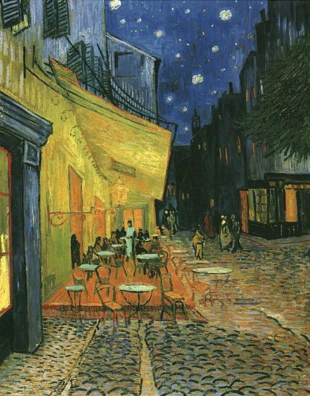

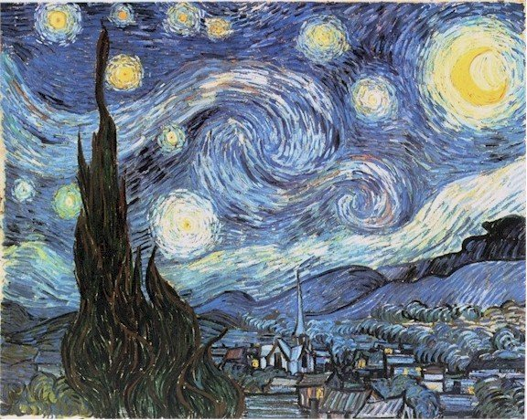

C D

Two Poems

Just Passing  A scene  Seen  Is captured  In a painter's  Head  Is captured  Frozen and colourful  Mr. Gogh  Shot his head  To fragments  But the scene  Seen  Remains.  Francis Barker | The Artist, Arles 1890  Yellow, yellow  Watch the yellow always,  Fascinated, from the corner of your eye.  Its terrible intensity has sting  To bleach the brain, to take the skin  From off your inner eye. To drive you back  Against a buckled wall that echoes yellow, yellow,  Pain. You cannot let it from your mind.  Colin Rowbotham

Explain the form and meaning of the two poems in relation to Van Gogh's art and life.

Using the images C and D, explain the development of Vincent Van Gogh’s painting style. In what way is he considered one of the fathers of modern art. Explain why he is considered one of the most influential artists of the late 19th century. (Visuals C & D)

Cross-curricular: English-Arts
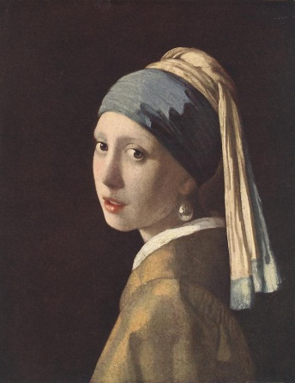

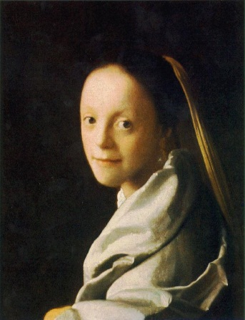

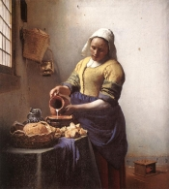

Girl In Hyacinth Blue
A Dutch painting of a young girl, possibly a Vermeer, survives three and a half centuries through loss, flood, anonymity, theft, secrecy, even the Holocaust. This is the story of its owners whose lives are influenced by its beauty and mystery. Despite their unsatisfied longings, their own and others' flaws, the girl in hyacinth blue has the power to engender love in all its human variety.
One of the 25 most distinguished novels of 1999. --Publishers Weekly
"Insightful observations about the worth and the truth of art....Elegantly executed, with characters who have the solidity, and the elusive mystery, of Vermeer's subjects....One wants to read these tales at one sitting....Vreeland paints her canvas with the sure strokes of a talented artist. " -- Publishers Weekly

Choose some of the main characters of the stories told in the Girl in Hyacinth Blue and explain in what way the painting has influenced their lives, what role it plays in their lives.

In the story “Still Life” Vermeer reflects upon his work. What is his goal? How does he go about it? He asks himself whether “the world need(s) another painting of people quietly going about their lives? Could another painting make up for the scarcity of meat on his family’s table?”
What is going to be Vermeer’s answer?

What are Vermeer’s typical subjects? What can you say about his style of painting.
Explain the function and goal of the camera obscura that Vermeer used.
Describing the images G and H, explain the importance of Jan Vermeer’s work. Explain the characteristics of his painting style. (Visual A & B)

Cross curricular question: English – Arts

Alienation in the Big City

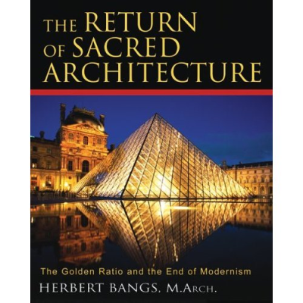 | “The architecture of alienation is an architecture that refuses to recognize the instinctive roots of man in his relation to the earth, to the sky, to the elements of his material existence. It seeks to deny the unconscious mind, the intuition, and the supernatural awareness. In the name of “science” it has foisted upon us a narrow, mechanistic vision of human life, without purpose and without God. Our architecture reflects that vision.”  Herbert Bangs
Discuss the following review of the above book. What do you think of the comment? Do you see a connection between modern architecture and alienation in the big cities?
Give some historic and contemporary examples to support your argument and describe some of the main principals or features of these buildings.

Choose a few characters from your reading list and explain how the settings of the novels and the architecture of their surroundings match or influence their behavior and attitudes. Focus mainly on New York settings.

The ugly buildings that characterize the modern landscape are inferior not only to the great cathedrals of medieval Europe and the temples of ancient Egypt and Greece, but even to lesser buildings of the more recent past. The great masterworks of our ancestors spoke to humanity’s higher nature. Architect Herbert Bangs reveals how today’s dysfunctional buildings bring out the worst in humanity, reinforcing that which is most base within us. He shows how, through the ancient laws of proportion and number, architecture once expressed the harmonious relationship between man and the cosmos. In early times, the architect worked within a sacred and esoteric tradition of creating structures through which human beings could gain insight into the nature of the divine reality. Today, that tradition has been abandoned in favor of narrowly defined utilitarian principles of efficiency and economy.
In The Return of Sacred Architecture, Bangs provides the key to freeing architecture from the crude functionality of the twentieth century: the architects of the modern human landscape must find the deep-felt connection to the cosmos that guided the inner lives of those who built the temples of the past. The form of their buildings will then reflect the sacred patterns of geometry and proportion and bring forth greater harmony in the world.
For teacher:
THE ARCHITECTURE OF ALIENATION
The architecture of alienation is an architecture that refuses to recognize the instinctive roots of man in his relation to the earth, to the sky, to the elements of his material existence. It seeks to deny the unconscious mind, the intuition, and the supernatural awareness. In the name of “science” it has foisted upon us a narrow, mechanistic vision of human life, without purpose and without God. Our architecture reflects that vision.
The most influential “scientific” architect of the 20th century and the apostle of alienation was undoubtedly Le Corbusier. La Ville Radieuse was written early in his long career, and he recognized that the home was the basic “unit” of urban life. But to Le Corbusier the home was a “machine for living” and the enormous apartment towers with which he proposed to replace the West Bank of Paris were based on a limited group of typical floor plans that could be substituted for one another like the parts of a machine. These in turn were based on a “minimum living unit”--which he called, appropriately, the “cell.”
The arrogance and ignorance expressed in this statement are appalling, and the implications for the dignity of human life are fearful. The statement is, nevertheless, typical of the men of 20th century science. As a representative of that science Corbusier was a hero to the architects of my generation and his ideas were accepted without question by his followers. Huge, public-housing, elevator apartment houses in imitation of Le Corbusier were built all over the world and acclaimed by the media and the architectural press.
The same buildings have been thoroughly hated by those forced by circumstances to live within their walls. In covert rebellion, their inhabitants have often allowed them to slide into a disgusting squalor that was worse than that of the slums they were intended to replace. In some of these buildings social disorganization became so great, crime and violence so endemic, that the only solution, finally, was total demolition.
The enormous structures proposed by Le Corbusier were to be sealed from the outside air. He wrote at length about the advantages of sunlight and “pure, fresh air,” but the sunlight was to be filtered through glass and the air recirculated mechanically. Corbusier’s proposal was nevertheless enthusiastically accepted by the “scientific” architects of the 20th century and has become the normal way in which a building is designed and constructed. But there was no logical or “scientific” reason why buildings should be so constructed. I am convinced that the real reason for sealing the buildings was an unconscious desire to break the link between man and the natural environment, the sunlight and the air.
Architecture was once regarded as shelter that opened to the world beyond the window or door. It was the opening, the window and door, that was detailed and emphasized. When we look at contemporary buildings we see hard, sheer, walls without openings and only a minimum of flat detailing. Through the use of large sheets of glass these building “envelopes,” as they are called, provide those who are powerful enough to seize a location near a perimeter wall with a “view,” or panoramic picture of the world outside. If located on the upper floors of a building such a view may be spectacular, and provide an enormous satisfaction to the egos of the few who have the power to direct the allocation of space in the structure. Most of the others are condemned to spend their lives at a desk juggling papers under fluorescent lights and an air diffuser.
Anyone who has designed the floor plans of one of these buildings will be aware of the battles that are waged by mid-level employees to secure an office with a window. While prestige and status are certainly involved the struggle is more over access to the space and light of the world beyond the polished glass skin of the “curtain” wall. The desperation of those who dwell in these spaces for much of their waking life is a measure of their dissatisfaction with the typical environment of a corporate office building. Some corporate leaders are aware of this dissatisfaction, and in recent years have tried to relocate their staff to suburban buildings, surrounded by lawns and trees. In these huge, new buildings, however, the struggle for a window, for light and air, still goes on, and is intensified because of the more desirable environment outside the wall. And even here, in suburbia, where noise and pollution are not a problem, the windows do not open, but only present a picture, as it were, of the grass and trees.
With single-minded intensity, the architects of the 20th century have pursued this vision of the sealed environment to its ultimate conclusion, which was not an office at all, but the Farnsworth House by Mies van der Rohe.
The Farnsworth House is essentially a unit of one of the large corporate glass and steel structures designed by Mies van der Rohe, in this case set down in meadow near a river. The clear, pure geometry of this translucent, rectangular prism, floating over the meadow and linked only to the ground by eight steel, wide-flanged sections used as columns is beautiful, but the beauty is that of a highly polished and finished sculptural artifact rather than a dwelling. The entire exterior wall is glass. While the interior is visually open to the natural landscape, it is relatively inaccessible, for there are only two small, low, operable windows, and one unobtrusive double door. The visual openness is belied by the impermeability of the glass barrier and the functional distinction between the interior and exterior space is clear-cut.
‹ Return to Product Overview

Cross-curricular question: English – History

The Great Depression

Read the lyrics of Woody Guthrie’s song. What historical facts and times is Guthrie referring to? Explain the events that lead up to the Great Depression. What were the effects in America and in Europe?

How have these times been described in John Steinbeck’s work? Give examples from the novel(s) you have read.

Dust Bowl Refugee
I'm a dust bowl refugee,
Just a dust bowl refugee,
From that dust bowl to the peach bowl,
Now that peach fuzz is a-killin' me.
'Cross the mountains to the sea,
Come the wife and kids and me.
It's a hot old dusty highway
For a dust bowl refugee.
Hard, it's always been that way,
Here today and on our way
Down that mountain, 'cross the desert,
Just a dust bowl refugee.
We are ramblers, so they say,
We are only here today,
Then we travel with the seasons,
We're the dust bowl refugees.
From the south land and the drought land,
Come the wife and kids and me,
And this old world is a hard world
For a dust bowl refugee.
Yes, we ramble and we roam
And the highway that's our home,
It's a never-ending highway
For a dust bowl refugee.
Yes, we wander and we work
In your crops and in your fruit,
Like the whirlwinds on the desert
That's the dust bowl refugees.
I'm a dust bowl refugee,
I'm a dust bowl refugee,
And I wonder will I always
Be a dust bowl refugee?

Core question
The Great Depression
Read the lyrics of Woody Guthrie’s song and explain its significance in the context of the Great Depression in the United States.
How have these times been described in John Steinbeck’s work? Give examples from the novel(s) you have read.

Tom Joad
Tom Joad got out of the old McAlester Pen;
There he got his parole.
After four long years on a man killing charge,
Tom Joad come a-walkin' down the road, poor boy,
Tom Joad come a-walkin' down the road.
Tom Joad, he met a truck driving man;
There he caught him a ride.
He said, "I just got loose from McAlester Pen
On a charge called homicide,
A charge called homicide."
That truck rolled away in a cloud of dust;
Tommy turned his face toward home.
He met Preacher Casey, and they had a little drink,
But they found that his family they was gone,
He found that his family they was gone.
He found his mother's old fashion shoe,
Found his daddy's hat.
And he found little Muley and Muley said,
"They've been tractored out by the cats,
They've been tractored out by the cats."
Tom Joad walked down to the neighbor's farm,
Found his family.
They took Preacher Casey and loaded in a car,
And his mother said, "We've got to get away."
His mother said, "We've got to get away."
Now, the twelve of the Joads made a mighty heavy load;
But Grandpa Joad did cry.
He picked up a handful of land in his hand,
Said: "I'm stayin' with the farm till I die.
Yes, I'm stayin' with the farm till I die."
They fed him short ribs and coffee and soothing syrup;
And Grandpa Joad did die.
They buried Grandpa Joad by the side of the road,
Grandma on the California side,
They buried Grandma on the California side.
They stood on a mountain and they looked to the west,
And it looked like the promised land.
That bright green valley with a river running through,
There was work for every single hand, they thought,
There was work for every single hand.
The Joads rolled away to the jungle camp,
There they cooked a stew.
And the hungry little kids of the jungle camp
Said: "We'd like to have some, too."
Said: "We'd like to have some, too."
Now a deputy sheriff fired loose at a man,
Shot a woman in the back.
Before he could take his aim again,
Preacher Casey dropped him in his track, poor boy,
Preacher Casey dropped him in his track.
They handcuffed Casey and they took him in jail;
And then he got away.
And he met Tom Joad on the old river bridge,
And these few words he did say, poor boy,
These few words he did say.
"I preached for the Lord a mighty long time,
Preached about the rich and the poor.
Us workin' folkses, all get together,
'Cause we ain't got a chance anymore.
We ain't got a chance anymore."
Now, the deputies come, and Tom and Casey run
To the bridge where the water run down.
But the vigilante thugs hit Casey with a club,
They laid Preacher Casey on the ground, poor Casey,
They laid Preacher Casey on the ground.
Tom Joad, he grabbed that deputy's club,
Hit him over the head.
Tom Joad took flight in the dark rainy night,
And a deputy and a preacher lying dead, two men,
A deputy and a preacher lying dead.
Tom run back where his mother was asleep;
He woke her up out of bed.
An' he kissed goodbye to the mother that he loved,
Said what Preacher Casey said, Tom Joad,
He said what Preacher Casey said.
"Ever'body might be just one big soul,
Well it looks that a-way to me.
Everywhere that you look, in the day or night,
That's where I'm a-gonna be, Ma,
That's where I'm a-gonna be.
Wherever little children are hungry and cry,
Wherever people ain't free.
Wherever men are fightin' for their rights,
That's where I'm a-gonna be, Ma.
That's where I'm a-gonna be."

Cross-curricular question: English and Religion

Opus Dei and the DaVinci Code

Church fights Da Vinci Code novel
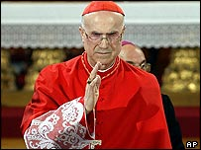
Cardinal Bertone will host a seminar to rebut the book's claims
The Roman Catholic Church in Italy has spoken out against what it says are "shameful and unfounded lies" in the best-selling novel The Da Vinci Code.
Cardinal Tarcisio Bertone, Archbishop of Genoa, broke the church's official silence on the controversial book.
Its story about the Church suppressing the "truth" that Jesus had a child with Mary Magdalene has convinced many fans.
But the cardinal's spokesman denied reports that the clergyman was asked by the Vatican to hit back at the book.
Carlo Arcolao told the BBC's News website that it had been the cardinal's own decision to make a public statement about the book.
Mr Arcolao confirmed that the cardinal told an Italian newspaper: "It astonishes and worries me that so many people believe these lies."

Explain what the commotion about the DaVinci Code might be about. What lies is Mr. Arcolao referring to.
What is the central quest of the novel? How do Robert Langdon and Sophie Neveu solve the puzzle – give examples that lead to the solution.

Talk about the history and structure of the Opus Dei. Does the novel paint a fair picture of this organization?
What facts and features give Opus Dei away as a sect within the church?

Cross-curricular question: English – Religion

Religion and Power

Hitler's Religion

by Anne Nicol Gaylor
The first legislative hearing I ever attended was in the mid-1960's at the Wisconsin capital, and the subject was the modernization of Wisconsin's birth control law. Wisconsin, the last state in the country to legalize contraceptives for unmarried persons, had a law until 1974 that was hostile to birth control for anyone and denied it to the unmarried, no matter what the circumstances. A fifty-year-old widower, for example, could not legally buy a condom.
Toward the end of the hearing, which had featured calm and reasonable presentations by professional people who supported liberalization of the law and emotional outbursts about morals from clergy and Catholic matrons opposed to change, a frail, elderly man took the podium. He explained that he was an atheist concerned with separation of state and church, and that he regarded the birth control issue as one where the Catholic Church was imposing its doctrine on the state, an observation that resulted in immediate uneasiness among the legislators hearing testimony, especially the Catholic chairperson. The atheist then began a brief summary of the historic problems of state-church entanglement, citing the bloodshed and wars in European history that were religion related. When he referred to religion's role in World War II and Adolf Hitler's Catholicism, the chairman of the committee became enraged, and, in a red-faced frenzy struck his gavel repeatedly until the elderly man tremblingly left the podium.
For some reason, Catholics are not eager to claim Hitler.
Even today, when I refer to Hitler's Catholicism in conversation or a speech, it immediately becomes apparent that I have said something "not quite nice," and I am often challenged. Nontheists, I then explain, know that many modern tyrants, whether petty tyrants such as Richard Nixon, or more successful tyrants such as Hitler, have regarded themselves as exemplary Christians, an estimate their followers had no trouble accepting. Hitler's religiosity -- he was a Catholic until his death -- is often glossed over, but it is critical in understanding his motivation.
I have often reflected, wistfully, on how much happier modern history might have been had Hitler been brought up as an atheist, an agnostic, or, at least, a Unitarian. Born and bred a Catholic, he grew up in a religion and in a culture that was anti-semitic, and in persecuting Jews, he repeatedly proclaimed he was doing the "Lord's work."
From http://ffrf.org/fttoday/back/hitler.html, June 2007

Explain Hitler’s Catholicism and how it helped him gain power and control the masses.

The issue of religion and power has been dealt with by many contemporary writers.
What does Salman Rushdie say about this issue. Refer to Rushdie’s article “Is Nothing Sacred” and explain the difference between the truths told in literature and religion. Is anything sacred to Rushdie?

Cross-curricular question: English- History

The Renaissance in England

John Donne
In the following extracts John Donne expresses the insecurity of the people of his time faced with a world whose order was turned upside down through fundamental discoveries and innovations.
Which changes and innovations does Donne refer to in the extracts?

Point out some other changes in people’s attitudes.
Where did the Renaissance originate?

A new Philosophy calls all in doubt,
The Elements of fire is quite put out;
The Sun is lost, and th’earth, and no man’s wit
Can well direct him where tolooke for it.
And freely men confesse that this world’s spent,
When in the Planets, and the Firmament
They seeke so many new; they see that this
Is crumbled out againe to his Atomies.
‘Tis all in peeces, all cohaerence gone;
All just supply, and all Relation:
Prince, Subject, Father, Sonne, are Things forgot,
(“First anniversary”?

Knowst thou but how the stone doth enter in
The bladders cave, and never breake the skinne?
Knowst thou how blood, which to the heart doth flow,
Doth from one ventricle to th’other goe?
And for the putrid stuffe, which thou dost spit,
Know’st thou how thy lungs have attracted it?
…
And of those many opinions whichl men raise
Of Nailes and Haires, dost thou know which to praise?
Wee see in Authors, too stiffe to recant
A hundred controversies of an Ant;

Cross-curricular question: English – History

The Russian Revolution

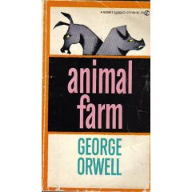

Interpret the following passage from Animal Farm in respect to the Russian Revolution.
Explain the role of the birds – including the black raven Moses.
In what way do the pigs represent the leaders of Russia?
Explain the parallels between Orwell’s Seven Commandments and communist reality.

…The birds did not understand Snowball’s long words, but they accepted his explanation, and all the humbler animals set to work to learn the new maxim by heart. Four legs good, two legs bad, was inscribed on the wall of the barn, above the Seven Commandments and in bigger letters. When they had once got it by heart the sheep developed a great liking for this maxim, and often as they lay in the field they would all start bleating “Four legs good, two legs bad!”

The Seven Commandments
- Whatever goes upon two legs is an enemy.
- Whatever goes upon four legs, or has wings is a friend.
- No animal shall war clothes.
- No animal shall sleep in a bed.
- No animal shall drink alcohol.
- No animal shall kill another animal.
- All animals are equal.

Core question

Violence, Rape and Murder

Your reading list reeks of violence, rape and murder.
Take a closer look at the evil characters in the literature you have read.

1. Make a quick list of all the incidents of violence against others.
Perpetrator/criminal | Crime/ activity | Victim

2. Imagine you were a criminal defense attorney and you were asked to defend one of the above perpetrators.
Which of the criminals would you defend most readily?
Which one would be your last choice?
Give reasons.

Core question

Short Stories

Read the following short story by Howard McMillen. It's a parody of the well known short story “Hills Like White Elephants by Hemingway, which we have read in class. Mark and discuss all the parallels you find between McMillen's story and Hemingway's original.
In what way is this story typical of the short story genre?

Howard McMillen
A Rainy Day...............p43

Core-question Business English

Cultural Studies

Nobody actually wants to cause offence but, as business is becoming more and more international, it is increasingly easy to get it wrong. When doing business with foreign partners, what should you keep in mind?
Mention some problems that might occur.
What would you tell a foreign visitor about “good manners” in Austria?
Elaborate on the following terms:

- small talk topics,
- body language and
- appearance

core-question Business English

Games people play at meetings

Business people spend quite a lot of time in meetings, and meetings come in all shapes and sizes, ranging from formal committee meetings to informal one-to-one meetings.

- There are several reasons why meetings are held. Elaborate on these reasons and mention some advantages and disadvantages.

- What is the role of a chairperson and what are some qualities of a good chairperson?

- All meetings have one thing in common: that is role-playing. Talk about what “games” people play at meetings and identify certain roles that people take on in meetings.

Scandals in Literature
Ulysses
by James Joyce

Foreword

The new deal in the law of letters is here. Judge Woolsey has exonerated Ulysses of the charge of obscenity, handing down an opinion that bids fair to become a major event in the history of the struggle for free expression. Joyce's masterpiece, for the circulation of which people have been branded criminals in the past, may now freely enter this country.
It would be difficult to overestimate the importance of Judge Woolsey's decision. For decades the censors have fought to emasculate literature. They have tried to set up the sensibilities of the prudery-ridden as a criterion for society, have sought to reduce the reading matter of adults to the level of adolescents and subnormal persons, and have nurtured evasions and sanctimonies.
The Ulysses case marks a turning point. It is a body-blow for the censors. The necessity for hypocrisy and circumlocution in literature has been eliminated. Writers need no longer seek refuge in euphemisms. They may now describe basic human functions without fear of the law.!
...
New York, December11, 1933

- Explain the importance of Judge Woolsey's landmark decision.
- We have read the most criticized chapter from Ulysses. Did it shock you? Would you consider the chapter pornographic?
- Look at the drawings some of your fellow students made during our course and explain in what way they reflect the key scenes of chapter XIII.




Core-question Murder, Madness and Mayhem

Murder, Madness and Mayhem in British and American Literature

The Black Cat and The Tell-Tale Heart by Edgar Allan Poe

The Black Cat and The Tell-Tale Heart by Edgar Allan Poe, classic works of Gothic fiction, are both narrated by first-person narrators who assure us at the outset that they are not mad.
To what extent can we trust these narrators? Is there a supernatural explanation for the events they narrate?

Core question

It’s a phoney world

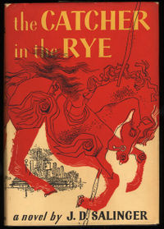

The Catcher in the Rye

In the novel The Catcher in the Rye Holden Caulfield spends a few days wandering restlessly through New York City.
He arrives at Penn Station and says:
The first thing I did when I got off at Penn Station, I went into his phone booth, I felt like giving somebody a buzz. I left my bags right outside the booth so that I could watch them, but as soon as I was inside, I couldn’t think of anybody to call up.
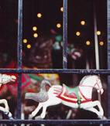
In the course of the novel he spends time in
Greenwich Village
Central Park
The American Museum of Natural History
A matinee on Broadway
Rockefeller Centre
Grand Central Station
The Metropolitan Museum of Art
Central Park Zoo
The Carrousel

Explain the role and symbolism of these settings with regard to the main themes of the novel.

Explain the meaning of the title.

Core question

Lord of the Flies

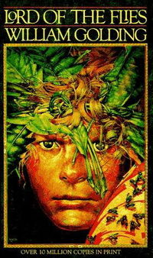

“ Nothing prospered but the flies who blackened their lord and made the spilt guts look like a heap of glistening coal. ”

The novel Lord of the Flies, by William Golding, is a parable that communicates the theme that in the absence of a structured system of society, all humans possess the potential to succumb to their most evil instincts and desires. At the beginning of the novel, the boys work to build a functional society.
Explain how they do this, give examples.

Later things deteriorate and the crisis develops. Give examples and explain how and why Jack can become so powerful. Draw parallels to historical and political events and leaders.

Core question
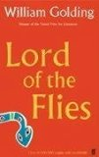
Lord of the Flies

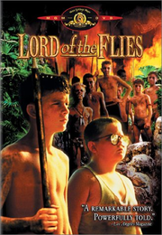

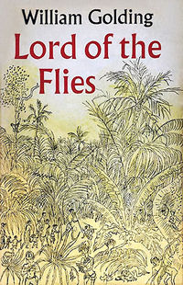

Lord of the Flies as a Symbolic and Allegorical Work

The Second World War was a disaster for humanity and brought big disillusionment to the entire world.
Discuss the symbolic and allegorical meaning of the novel. In what ways do the characters, events and settings represent the society of the time.

How do the different book covers express the main themes of the novel?

Core question

The Picture of Dorian Gray

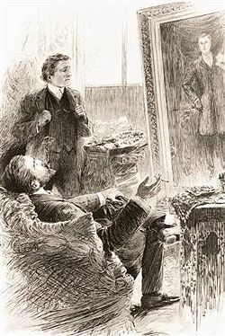

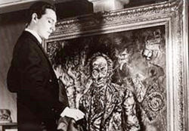

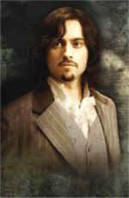

Decadence: Lord Henry guides Dorian along a path that ends in total moral decline and decay. He himself indulges in a lifestyle totally uncommon and condemned by Victorian society.
Describe Dorian’s moral descent throughout the novel.

What is Oscar Wilde saying about Victorian society?
How was the novel received by the society of the time?

What does he say about the purpose of art? Explain the concept of aestheticism.

Core question

Power and Fear
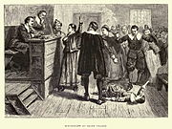

Arthur Miller’s play The Crucible is based on the events surrounding the 1692 witch trials of Salem, Massachusetts. Miller used that event as an allegory for McCarthyism and the Red Scare in the 1950. Nowadays the play has become very topical again because of its parallels to the right wing socio-political climate in the USA today. Explain these parallels.

The Crucible | The Salem Witch Trials  Puritanism | Right-wing America  and the Patriot Act

Core question: African Kaleidoscope

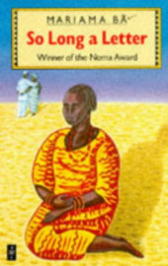

Investigate how African author Miriama Ba is addressing the cultural and religious traditions, such as polygamy, that hinder her efforts at greater equality.
Describe the setting of So Long a Letter and the different fates of the two protagonists, Ramatoulaye and Aissatou.

Core question: African Kaleidoscope

African Kaleidoscope

“City Lovers”

Outline the setting of Nadine Gordimer’s short story “City Lovers”.
What brings Dr.Leinsdorfer and the colored girl together? What happens to their relationship? Explain the system of Apartheid in the context of the short story.

“He recognized her. He had never seen her standing before, and she was wearing a coat. She was rather small and finely made, for one of them...”
My Notes
City Lovers: Summary

The subject of racism links two of the shorter films in this year's New York Film Festival, a South African dramatic film and an American documentary. Barney Simon's ''City Lovers,'' based on a story by Nadine Gordimer, tells of an unlikely and illegal love affair, while Josh Hanig's ''Coming of Age'' studies interracial encounter groups in a setting that could only be California.
Yvonne Jacobs (Denise Newman), a sweet, naive ''colored'' supermarket clerk in Johannesburg, meets the distinguished, white, middleaged German geologist Dr. Franz Von Leinsdorff (Joe Stewardson) when he comes in to buy some razor blades. The store is out of his brand.
A few days later, Yvonne sees the geologist on a television talk show and is genuinely amazed. ''I know that man!'' she cries to her mama and grandma, with whom she lives. When Dr. Leinsdorff happens to cross paths with Yvonne a few days later, she is childishly eager to run back to the supermarket and get him the blades. He tries to tip her for the favor.
But romance soon blooms, and Yvonne begins furtively visiting the all-white apartment complex where the geologist lives. Harmless as the love affair appears to be, it arouses the curiosity of racist neighbors, and it's only a matter of time before something terrible happens. Mr. Simon's film builds to, and ends on, a note of quiet outrage and brutality. The course the story follows is not surprising, nor is his telling of it, but ''City Lovers'' moves effectively toward its horrifying conclusion.

Nadine Gordimer

Photo: © Bloomsbury

Biography
Nadine Gordimer was born in Springs, Transvaal, South Africa in 1923. She has remained in South Africa, having lived in Johannesburg since 1948. She was educated at a convent school and spent a year at Witwaterstrand University. Since then, her life has been devoted to her writing.
She has travelled extensively, has written non-fiction on South African subjects and made TV documentaries, collaborating with her son Hugo Cassirer on the television film Choosing Justice: Allan Boesak. She was responsible for the script of the 1989 BBC film, Frontiers, and for four of the seven screenplays for a television drama based on her own short stories, entitled The Gordimer Stories 1981-82. She has also published, in forty languages, thirteen novels and ten short story collections.

Her first short story was published at the age of fifteen in the liberal Johannesburg magazine, Forum, and during her twenties, her stories appeared in many local magazines. In 1951 the New Yorker took one of her short stories. Her short story collections include A Soldier's Embrace (1980); Something Out There (1984); and Jump and Other Stories (1991). Loot (2003), is a collection of ten short stories widely varied in theme and place.
Nadine Gordimer's subject matter in the past has been the effect of apartheid on the lives of South Africans and the moral and psychological tensions of life in a racially-divided country, which she often wrote about by focusing on oppressed non-white characters. She was an ardent opponent of apartheid and refused to accommodate the system, despite growing up in a community in which it was accepted as normal. Her work has therefore served to chart, over a number of years, the changing response to apartheid in South Africa. Her first novel, The Lying Days (1953), was based largely on her own life and set in her home town. Her next three novels, A World of Strangers (1958); Occasion for Loving (1963), which focuses on an illicit love affair between a black man and a white woman; and The Late Bourgeois World (1966) deal with master-servant relations in South African life. In 1974, her novel The Conservationist, was joint winner of the Booker Prize for Fiction. Burger's Daughter (1979) was written during the aftermath of the Soweto uprising, and was banned, along with other books she has written. The House Gun (1998), explores, through a murder trial, the complexities of violence-ridden post-apartheid South Africa. The Pickup (2001), is set in South Africa and Saudi Arabia, and its theme is the tragedy of forced emigration. Her latest novel is Beethoven Was One-Sixteenth Black (2007).
Nadine Gordimer has been awarded fifteen honorary degrees from universites in USA, Belgium, South Africa, and from York, Oxford and Cambridge Universities in the UK. She was made a Commandeur de l'Ordre des Arts et des Lettres (France), and is Vice President of International PEN and a Fellow of the Royal Society of Literature. She was also a founder of the Congress of South African Writers.

In 1991 she was awarded the Nobel Prize for Literature, and in 2007, the Chevalier de la Légion d'Honneur (France).

Core question: African Kaleidoscope

Post-Apartheid South Africa

Using the example of “Ten Seconds to Hate” outline the situation in post-Apartheid South Africa.
What does the incident in the theatre illustrate? How has South Africa tried to overcome the past? What are the current problems?

“You cannot turn in this city without wondering when it will be your turn?
Well, it was my turn.
You cope. You go to a braai (barbeque) and sit listening when a woman describes her hijacking. You stare, absorbed by her story, although it is nothing new.
You are fascinated by what you perceive as her bravery, her courage, her decision to remain in the country. You do not realize that that is her only way of coping, that there is no other alternative for her.”
Core question Culture through Literature

New York in Literature
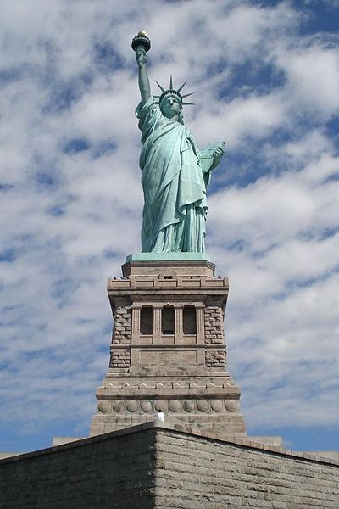

New York City has been the setting of numerous novels. The city has often been described as a patchwork quilt or a bowl of tossed salad for people of different origin and background who have all tainted their neighborhoods with their distinctive flairs.

Present some of the neighborhoods or quarters that are described in the New York novels and stories that you have read.
In what way do these settings represent the time and society described in the literature?
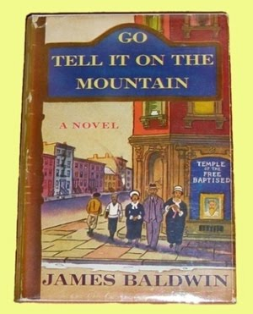
How do the settings support the themes?
Compare the settings to your own experience in these places.

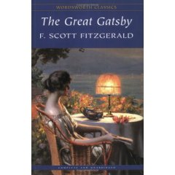
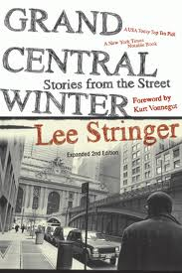
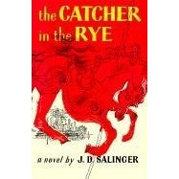

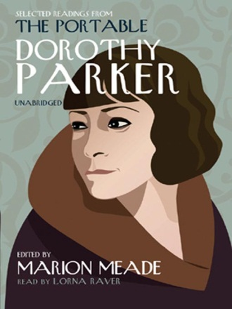

Core question Culture through Literature

New York in Literature

New York City has been the setting of numerous novels. The city has often been described as a patchwork quilt or a bowl of tossed salad for people of different origin and background who have all tainted their neighborhoods with their distinctive flairs.

Present some of the neighborhoods or quarters that are described in the New York novels and stories that you have read.
In what way do these settings represent the time and society described in the texts?
How do the settings support the themes?

Core question Culture through Literature

New York in Literature

New York City has been the setting of numerous novels. The city has often been described as a patchwork quilt or a bowl of tossed salad for people of different origin and background who have all tainted their neighborhoods with their distinctive flairs.

Present some of the neighborhoods or quarters that are described in the New York novels and stories that you have read.
In what way do these settings represent the time and society described in the texts?
How do the settings support the themes?

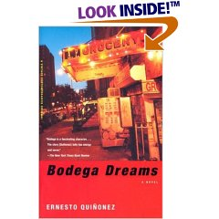

Core question

The Pearl

by John Steinbeck

Foreword
"In the town they tell the story of the great pearl—how it was found and how it was lost again. They tell of Kino, the fisherman, and of his wife, Juana, and of the baby, Coyotito. And because the story has been told so often, it has taken root in every man's mind. And, as with all retold tales that are in people's hearts, there are only good and bad things and black and white things and good and evil things and no in-between anywhere.
If this story is a parable, perhaps everyone takes his own meaning from it and reads his own life into it..."

As Steinbeck says in the foreword to The Pearl, the story is full of symbols of good and evil.
Explain the symbolism of the pearl and the symbolic use of music and songs in the story.

What meaning do you take from The Pearl? What do you consider to be the moral of the story?

Core question

Money makes the world go round, but does it make you happy?

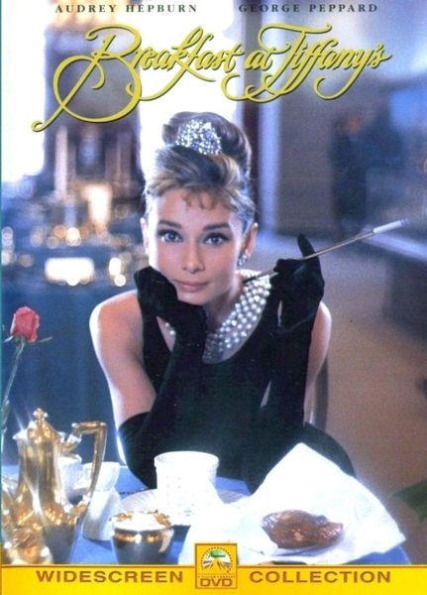
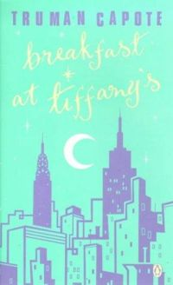
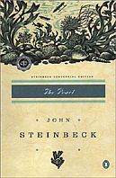

In both novels the characters dream of being rich and even succeed to some extent.
Discuss the role of money or material wealth in the two novels. Does it help solve the characters’ problems? What are the effects on the character’s lives?

Can you think of any other works of literature that deal with the same theme? Discuss any similarities or differences that you can find.

Core question

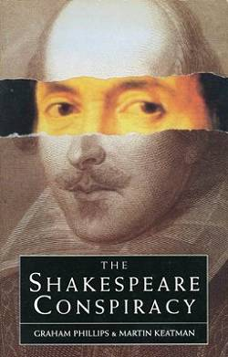

For years a controversy has raged over the true authorship of the works of William Shakespeare. That the authorship is in doubt sounds totally inconceivable to the uninitiated.
An Identity problem? An Authorship Problem ? A Conspiracy Theory? Viewed as sheer Sacrilege or Heresy by many.

Explain why many scholars doubt William Shakespeare’s authorship?

Who might have written the plays and poems? Give reasons.

Was the Bard a Woman?
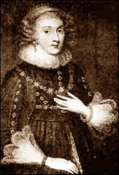
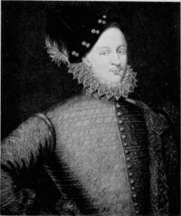

Edward de Vere, 17th Earl of Oxford
Mary Sidney Herbert, the Countess of Pemboke

“I think Oxford wrote Shakespeare. If you don’t agree, there are some awfully funny coincidences to explain away…”
Orson Welles
“I am… haunted by the conviction that the divine William is the biggest and most successful fraud ever practiced on a patient world.”
Henry James
Core-question:

Broadway
The Great White Way
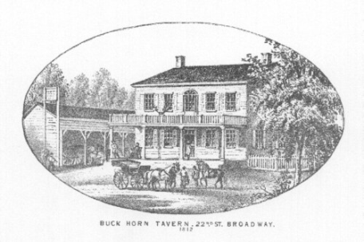
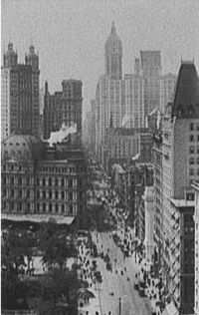
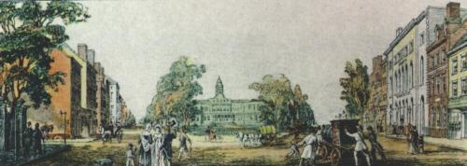

Buck Horn Tavern, 1812

Broadway, 1820
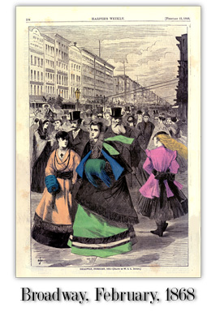
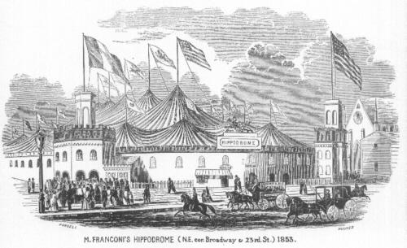

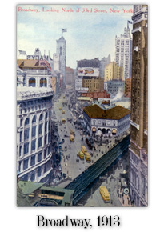

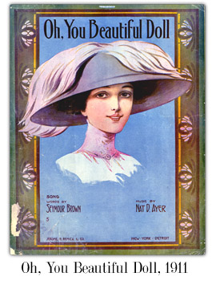



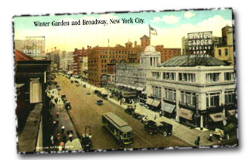

The Great Depression: 1930 – 1940

“Really, it was Barnum’s fault. Before him, Broadway had been just a Main Street, the city’s heart of business and affairs. Its history did not stem from any mystic quality of placed, but simply from its centrality. Der Hagh Wagh Way, the High Wagon Way, it abound Manhattan together, a thick, strong spine. So great men gathered, great things happened there. But there was no abstract involved. Nobody came to Broadway on a dream.
Then Phineas. T. Barnum appeared. …” (Nick Cohn, The Heart of the World)
Explain the development of Broadway and the role of P.T. Barnum. What was his aim? What was his background?

Core question

William Shakespeare, Hamlet

Explain the meaning of the most famous soliloquy in English literature. What is Hamlet's dilemma? What are his problems in life? What final decision does he take and why?
In what way is Hamlet a typical Renaissance character?

William Shakespeare - To be, or not to be (from Hamlet 3/1)
To be, or not to be: that is the question:
Whether 'tis nobler in the mind to suffer
The slings and arrows of outrageous fortune,
Or to take arms against a sea of troubles,
And by opposing end them? To die: to sleep;
No more; and by a sleep to say we end
The heart-ache and the thousand natural shocks
That flesh is heir to, 'tis a consummation
Devoutly to be wish'd. To die, to sleep;
To sleep: perchance to dream: ay, there's the rub;
For in that sleep of death what dreams may come
When we have shuffled off this mortal coil,
Must give us pause: there's the respect
That makes calamity of so long life;
For who would bear the whips and scorns of time,
The oppressor's wrong, the proud man's contumely,
The pangs of despised love, the law's delay,
The insolence of office and the spurns
That patient merit of the unworthy takes,
When he himself might his quietus make
With a bare bodkin? who would fardels bear,
To grunt and sweat under a weary life,
But that the dread of something after death,
The undiscover'd country from whose bourn
No traveller returns, puzzles the will
And makes us rather bear those ills we have
Than fly to others that we know not of?
Thus conscience does make cowards of us all;
And thus the native hue of resolution
Is sicklied o'er with the pale cast of thought,
And enterprises of great pith and moment
With this regard their currents turn awry,
And lose the name of action. - Soft you now!
The fair Ophelia! Nymph, in thy orisons
Be all my sins remember'd.

Core question
Glitz and Glamour in New York

Walking along 5th Avenue tourists can admire the world of glitz and glamour in New York.
This world has been portrayed in several works of literature. Give examples from the works that you have read. How do different authors describe this glamorous world? Does it make the characters happy? Choose some of the following works and discuss the main characters’ experiences in these surroundings. Can you discern any parallels and common themes? What do the texts say about the high society of their time?

Dorothy Parker, “From the Diary of a New York Lady”
Truman Capote, Breakfast at Tiffany’s
Scott F. Fitzgerald, The Great Gatsby, “My Lost City”, “Winter Dreams”
Bret Easton Ellis, American Psycho

CORE QUESTION

Murder, Madness and Mayhem in British and American Literature

Macbeth and Othello by William Shakespeare

We could say that in Macbeth murder leads to madness and in Othello madness leads to murder. What form does the “madness” of Macbeth, Lady Macbeth and Othello take?
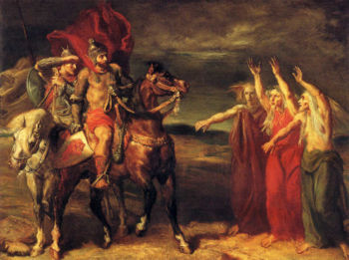

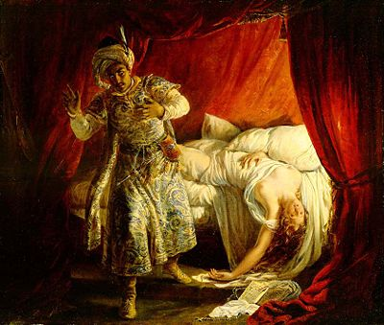

CORE QUESTION

Murder, Madness and Mayhem in British and American Literature

The Black Cat by Edgar Allan Poe

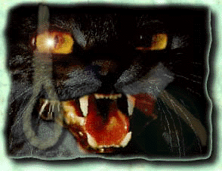

Edgar Allan Poe`s short story The Black Cat is considered to be a classic work of Gothic fiction. Explain what is meant by the term Gothic fiction, referring to narrative features of
The Black Cat (such as character, setting, plot, theme) to illustrate your answer.
What does the story gain by being narrated from the first-person point of view?

Core question

Greenwich Village

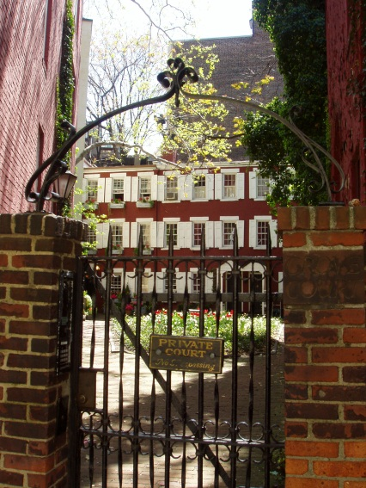
Grove Court, the setting of O’Henry’s story.

“The Last Leaf” , O’ Henry

In a little district west of Washington Square the streets have run crazy and broken themselves into small strips called "places." These "places" make strange angles and curves. One Street crosses itself a time or two. An artist once discovered a valuable possibility in this street. Suppose a collector with a bill for paints, paper and canvas should, in traversing this route, suddenly meet himself coming back, without a cent having been paid on account!
So, to quaint old Greenwich Village the art people soon came prowling, hunting for north windows and eighteenth-century gables and Dutch attics and low rents. Then they imported some pewter mugs and a chafing dish or two from Sixth Avenue, and became a "colony."…

Briefly sum up the story, then explain in what way the story is typical of Greenwich Village and the time at the turn of the century.
Core question Scandals in Literature

Banned Books Week or Caution! Some People Consider These Books Dangerous:

"And Tango Makes Three" tops ALA's 2006 list
of most challenged books

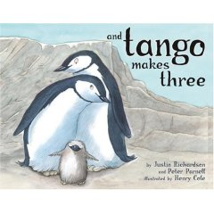
CHICAGO – Justin Richardson and Peter Parnell’s award-winning "And Tango Makes Three," about two male penguins parenting an egg from a mixed-sex penguin couple, tops the list of most challenged books in 2006 by parents and administrators, due to the issues of homosexuality.
The list also features two books by author Toni Morrison. "The Bluest Eye" and "Beloved" are on the list due to sexual content and offensive language.

What do you think of banning the above children’s book?
Is there any book that you would rather see banned?
What is more important: freedom of speech or protecting people from negative influences and literature that might offend them?

What reasons might a society or government have for banning books?
Who does the banning?
Give examples of famous books that have been banned at some time during their printed life.
For what reasons were these books banned? (Focus on a few examples in detail)

Core question

Susan Vreeland, Girl in Hyacinth Blue

What does Girl in Hyacinth Blue suggest about the value (personal and monetary) and purpose of art? How does art serve us? Why do we need it?
Give examples from the different stories in the book.
Core question

Chinatown
A Portrait of a Closed Society

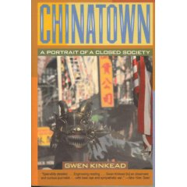

Gwen Kinkead vividly describes the variety, poverty, resilience and frenzy of Chinatown and its residents.
Explain the main problems of Chinatown residents.

What was your impression of Chinatown on your short visit to New York City?
Core question

The Zoo Story
by Edward Albee

"Now I'll let you in on what happened at the zoo; but first, I should tell you why I went to the zoo. I went to the zoo to find out more about the way people exist with animals, and the way animals exist with each other, and with people too. It probably wasn't a fair test, what with everyone separated by bars from everyone else, the animals for the most part from each other, and always the people from the animals. But, if it's a zoo, that's the way it is."

In many absurd plays the theme of communication plays an important role. Explain the meaning of the above passage from the Zoo Story.

Explain the symbolism in the play:
Two empty picture frames in Jerry’s apartment:

The story of the dog:

The significance of the zoo: Why does Jerry want to go to the zoo?

Core question Scandals in Literatue

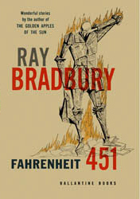

Read the following extract from an interview with Ray Bradbury and compare his views with those of other writers we have discussed in the course.
What is your personal opinion about censorship?

"There is more than one way to burn a book. And the world is full of people running about with lit matches. Every minority, be it Baptist / Unitarian, Irish / Italian / Octogenarian / Zen Buddhist, Zionist / Seventh-day Adventist, Women’s Lib / Republican, Mattachine / FourSquareGospel feel it has the will, the right, the duty to douse the kerosene, light the fuse….Fire-Captain Beatty, in my novel Fahrenheit 451, described how the books were burned first by the minorities, each ripping a page or a paragraph from the book, then that, until the day came when the books were empty and the minds shut and the library closed forever."
... "Only six months ago, I discovered that, over the years, some cubby-hole editors at Ballantine Books, fearful of contaminating the young, had, bit by bit, censored some 75 separate sections from the novel. Students, reading the novel which, after all, deals with the censorship and book-burning in the future, wrote to tell me of this exquisite irony. Judy-Lynn del Rey, one of the new Ballantine editors, is having the entire book reset and republished this summer with all the damns and hells back in place."

Core question

Money makes the world go round, but does it make you happy?
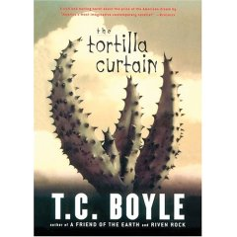


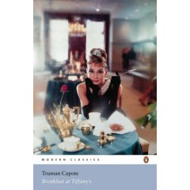



In many of the novels on your reading list money plays an important role in the main characters’ lives. Some have a lot of money, some dream of being rich, some are poor and don’t have any money, not even enough to survive.

Collect characters from your reading that are somehow affected by money and explain the different effects it has on their lives. Also think of the short stories that we have read.
Core question

Politics and Literature
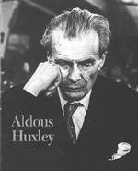
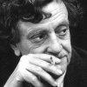

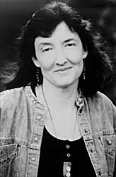
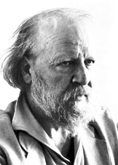
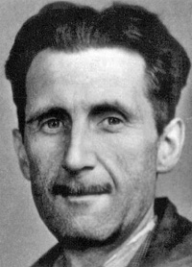

Look at the world,
We’ve warned you, but…

Imagine George Orwell, Aldous Huxley, William Golding, Kurt Vonnegut and Barbara Kingsolver could meet on planet Trafalmadore and discuss politics. They would, of course, find that many of their fictitious scenarios have in the meantime come true or have been repeated throughout history and point out parallels between their characters and our leaders.

To warm up for their discussion they would do a silent round of “brainwriting”. (The silent brainstorming activity we’ve done in class. Each participant adds comments on a common sheet)

Present at least three writers’ statements and explain what they are referring to. Give examples from their works.
Quotes from political novels: unfinished question

Read the following extracts from famous political novels on your reading list. Identify them and discuss

To the future or to the past, to a time when thought is free, when men are different from one another and do not live alone – to a time when truth exists and what is done cannot be undone:
From the age of uniformity, from the age of solitude, from the age of Big Brother, from the age of doublethink – greetings!
p.26 1984

‘Even after decanting, he’s still inside a bottle – an invisible bottle of infantile and embryonic fixations. Each one of us, of course,’ the Controller meditatively continued, ‘goes through life inside a bottle. But if we happen to be Alphas, our bottles are, relatively speaking, enormous.’
p.175 BNW

“And another thing. You can’t have an ordinary hunt because the beast doesn’t leave tracks. If it did you’d have seen them. For all we know, the beast may swing through the trees like what’s its name.”…
LF126

Friend of the fatherless!
Fountain of happiness!
Lord of the swill-bucket! Oh, how my soul is on
Fire when I gaze at thy
Calm and commanding eye,
Like the sun in the sky,
Comrade Napoleon!
AF80

"And I say to Sam now: 'Sam-here's the book.' It's so short and jumbled and jangled, Sam, because there is nothing intelligent to say about a massacre. Everybody is supposed to be dead, to never say anything or want anything ever again. Everything is supposed to be very quiet after a massacre, and it always is, except for the birds. And what do the birds say? All there is to say about a massacre, things like 'Poo-tee-weet?"
SH5 (19)

Core question

Mother Earth Won’t Let You Down



Twelfth song of the Thunder

The voice that beautifies the land!
The voice above,
The voice of the thunder
Within the dark cloud
Again and again it sounds,
The voice that beautifies the land.

The voice that beautifies the land!
The voice below;
The voice of the grasshopper
Among the plants
Again and again it sounds,
The voice that beautifies the land.
(Anonymous song)

Explain the meaning of this song in the context of Native American culture and belief.
What role does the land play for Native Americans?

Discuss the question of land ownership, allotment programs and reservation policies and explain why these programs were doomed to fail.

Give examples of the importance of the land from your reading.

Core question

Resistance is fertile

Resistance is futile

You might remember the above slogans that were blinking on top of the Kunsthaus a few years ago.

Looking at your reading list, which of the characters have most strongly attempted to resist and rebel against the social norms of their time?
Give a few examples and explain what these characters rebelled against and what they gained by doing so. To what extent was their resistance fertile or futile.

Core question

Let’s meet in New York

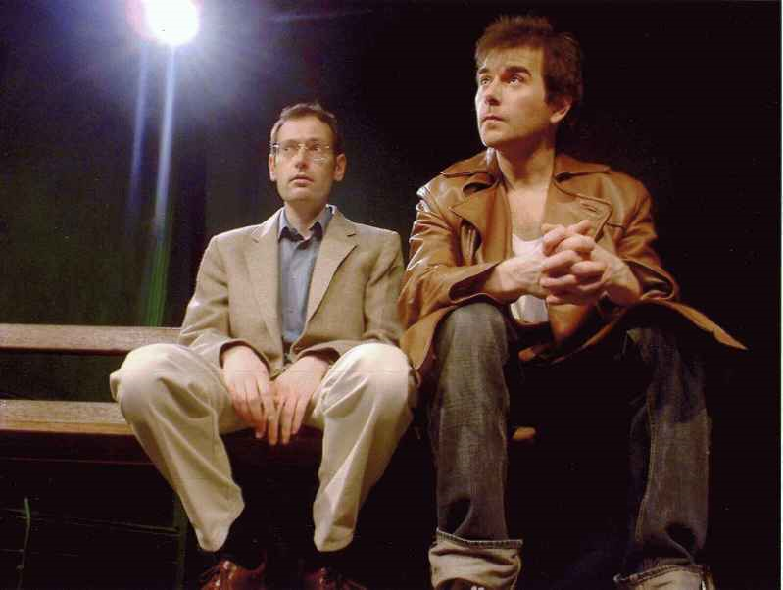


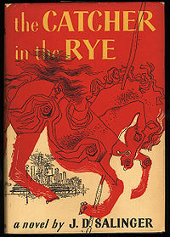

The Zoo Story, Edward Albee

First edition cover, authored under Sylvia Plath's pseudonym, Victoria Lucas.

Imagine the main characters of the above novels could all meet in New York City and get to know one another. Let some of the characters take a walk and meet at Peter’s bench in Central Park. Pick 3 interesting pairs and describe their meetings.
- Describe the circumstances of the meetings.
- What would they talk about?
- What would they think of each other?

 | Holden Caulfield | Phebe | Holly Golightly | Peter | Jerry | Esther Greenwood
Holden Caulfield

Phebe

Holly Golightly

Peter

Jerry

Esther Greenwood

Core question

The World According to Garp
“The Pension Grillparzer”

Then we heard Grandmother scream down the hall. Mother put on her pretty green dressing gown; Father put on his bathrobe and glasses. I pulled on a pair of pants, over my pajamas. Robo was in the hall first. We saw the light coming from under the W.C. door. Grandmother was screaming rhythmically in there.
“Here we are!” I called to her.
“Mother, what is it?” my mother asked.
We gathered in the broad slot of light. We could see Grandmother’s mauve slippers and her porcelain-white ankles under the door. She stopped screaming. “I heard whispers when I was in my bed,” she said.
“It was Robo and me,” I told her.
“Then, when everyone seemed to have gone, I came into the W.C.,” Johanna said. “I left the light off. I was very quiet,” she told us. “Then I saw and heard the wheel.”
“The wheel?” Father asked.
“A wheel went by the door a few times,” Grandmother said. “It rolled by and came back and rolled by again.”
Father made his fingers roll like wheels alongside his head; he made a face at Mother. “Somebody needs a new set of wheels,” he whispered, but Mother looked crossly at him, (…)
“Then someone came and looked under the door.” Grandmother said, “and that is when I screamed.”
“Someone?” Said Father.
“I saw his hands, a man’s hands – there was hair on his knuckles,” Grandmother said. “His hands were o the rug right outside the door. He must have been looking up at me.”
“No, Grandmother,” I said. “I think he was just standing out here on his hands.”
“Don’t be fresh,” my mother said.
“But we saw a man walking on his hands,” Robo said.
“You did not,” Father said.
“We did,” I said.
“We‘re going to wake everyone up,” Mother cautioned us.
The toilet flushed and Grandmother shuffled out the door with only a little of her former dignity intact.

- Briefly describe the situation at the Pension Grillparzer. What are they doing there and what has Grandmother seen? Who else lives and works there?

- Explain in what way this story is typical of John Irving’s work. What role do all the bizarre, eccentric characters and all the seemingly absurd incidents and accidents play? What is Irving saying about our lives?

- Much of the controversy surrounding Irving's fiction centers on his graphic depiction of violence. Rape, mutilation, car- and plane-crashes aren't the least bit funny. . . . Still, the way that Irving writes about them, they are.
Some critics find these incidents sensational and gratuitous, while others argue that they are necessary to underscore the irony of his novels.
What is your opinion on this issue? Is The World According to Garp brutal, morbid and negative or does it have a life-affirming quality?

Core question

Jewish Literature in America

Israel: Can It Survive the Peace?
The Arab world ahs tried every which way to undo the State of Israel: war, attrition, Scuds, terrorism, boycott, using the United Nations as a blunt instrument. But, as the whole world now realizes, es vet gornisht helfen. Nothing works. At the end of the day, Israel is still there, an invincible sliver on the map, feisty and enduring.
The Arabs are on the wrong track. There is only one way to defeat the Jewish state. Give the Jews what they most desperately want: peace. Nothing in the world would so destroy the common purpose as removing the common enemy. What would be the Jewish agenda? What would such a catastrophe do to Jewish fund-raising? To rabbinic sermons? To the relationship between Israel and the Diaspora? To Zionism? To Jewish literature? Don’t ask. Just imagine the day peace breaks out between Israel and all her neighbors, including the Palestinians. Imagine the moment:

Read the extract from Albert Vorspan's humorous book Start Worrying and explain in what way it is typical of the contemporary Jewish American situation. How do modern American Jews define themselves? What is Jewishness today? What are the typical themes in modern and contemporary Jewish literature?

Give examples from the Jewish literature that you have read.

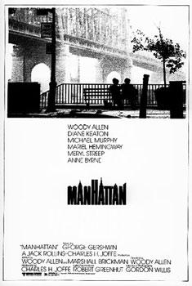

Cross-curricular question: English- Psychology

Ian Mc Ewan

Comfort of Strangers

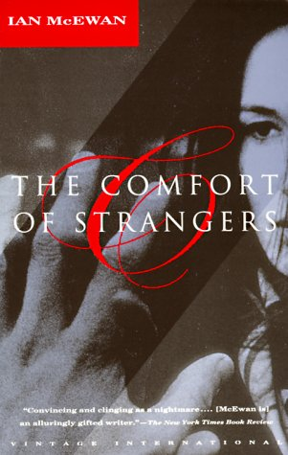

The Cement Garden (1978) and The Comfort of Strangers (1981) were Ian McEwan’s two earliest novels. The nature of these works caused him to be nicknamed "Ian Macabre."
Discuss some of the typical features of Ian McEwan’s stories and give examples from the novel you have read.

“By in love I mean that you would do anything for the other person.” She hesitated, her eyes were extraordinarily bright. “And you’d let them do anything to you.”
(Caroline talking to Mary , p. 65)

In Ian McEwans’s novel The Comfort of Strangers it becomes apparent that Robert and Caroline's relationship is based on violence, on his brutality and her masochistic acceptance of it.
Elaborate on the importance of secure attachment in childhood and the consequences for later adult relationships.

Some of the recurring features of Ian McEwan’s stories are
- Alienated often deeply disturbed characters
- Strange, deteriorating relationships between the characters
- Characters pulled into a vicious circle that pulls them deeper and deeper into the vortex of events.
- Interest in the macabre and perverse written in a realistic style

Core question

Politics and Literature

Look at the world,
We’ve warned them but…

Imagine George Orwell, Aldous Huxley, William Golding, Kurt Vonnegut and Barbara Kingsolver could meet on planet Trafalmadore and discuss politics. They would, of course, find that many of their fictitious scenarios have in the meantime come true or have been repeated throughout history and point out parallels between their characters and our leaders.

To warm up for their discussion they would do a silent round of “brainwriting”. (The silent brainstorming activity we’ve done in class. Each participant adds comments on a common sheet)

Present the writers’ statements and explain what they are referring to.

Core question

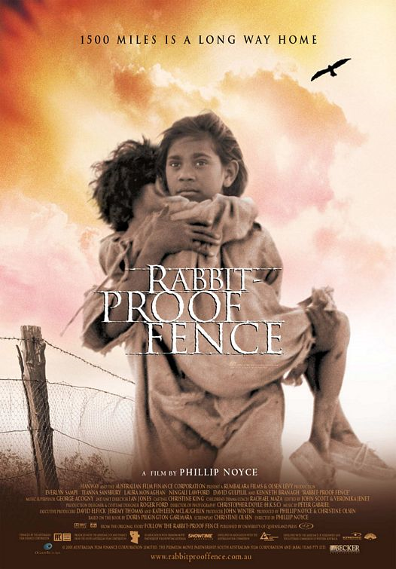
Childhood and Adolescence

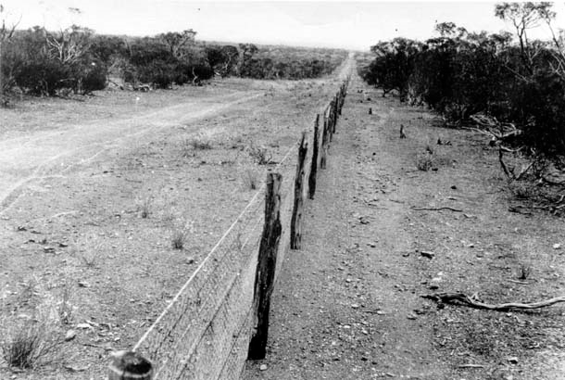

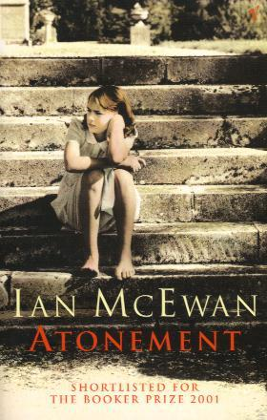
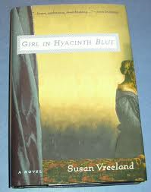

Several books on your reading list describe children and teenagers growing up in difficult circumstances or experiencing difficult situations.

Choose two interesting characters and describe the circumstances and problems they were faced with.

core question

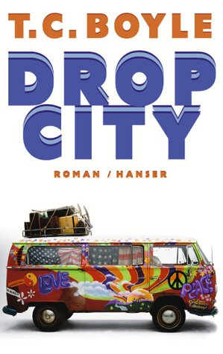
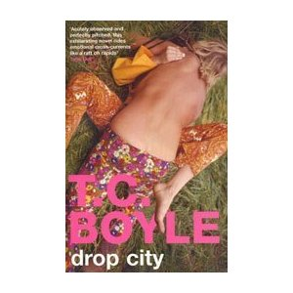
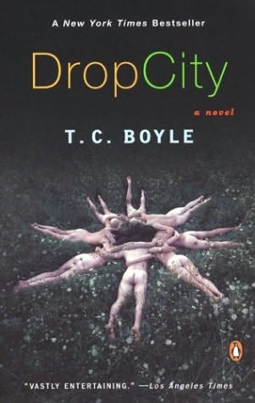

Look at the pictures. In what way do they reflect the lifestyle, values and political ideas of the Sixties?

How does the novel Drop City describe this time? Do the Hippies’ dreams of unlimited freedom come true?

core question

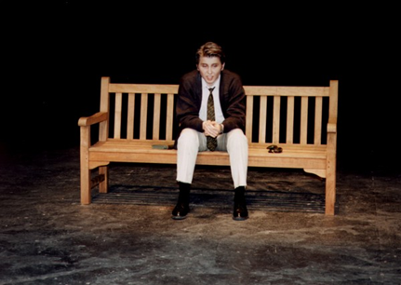
Life in a Big City

"Now I'll let you in on what happened at the zoo; but first, I should tell you why I went to the zoo. I went to the zoo to find out more about the way people exist with animals, and the way animals exist with each other, and with people too. It probably wasn't a fair test, what with everyone separated by bars from everyone else, the animals for the most part from each other, and always the people from the animals. But, if it's a zoo, that's the way it is."

“The first thing I did when I got off at Penn Station, I went into this phone booth. I felt like giving somebody a buzz […] but as soon as I was inside, I couldn't think of anybody to call up. My brother D.B. was in Hollywood. My kid sister Phoebe […] was out. Then I thought of giving Jane Gallagher's mother a buzz […]. Then I thought of calling this girl […] Sally Hayes. […] I thought of calling […] Carl Luce. […] So I ended up not calling anybody. I came out of the booth, after about twenty minutes or so. “(9.1)

Compare the two characters’ experiences in New York.
What are the authors saying about life in the big city?

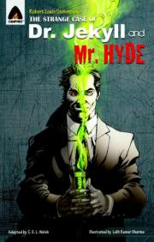
core question



The two sides of Edinburgh

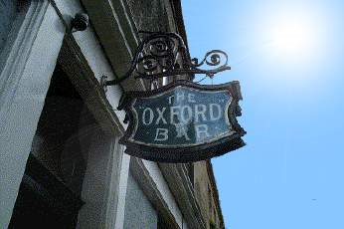

“Maybe Rebus will be in the back bar”
Reviewed 4 October 2010
Excellent small bar just near Charlotte Square in Edinburgh. Make the effort to find it, particularly if you are an Ian Rankin/Rebus fan. This is the bar mentioned regularly in the Rebus novels and Ian Rankin the author lives nearby and frequents the Ox. You may possibly see him at the bar.

The "Ox", or Oxford Bar, is a pub on Young Street where the dish of the day is as unchanged as the cracked lino and smoke-stained walls. It is also the refuge of choice for Rebus after a hard night on the tiles and a place where Rankin still drinks and does much of his research. The fact that it actually exists, along with the other bars, shops and monuments featured in the books, makes Rebus - and Rankin - fascinating companions for visitors wanting to explore both the celebrated and the darker sides of the city.

You have read Ian Rankin’s descriptions of Edinburgh and you been to Edinburgh yourself. Compare the two views of the city. Describe some of the “celebrated and darker sides of the city” that you have seen or read about.


Core question

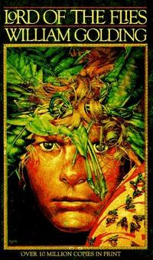
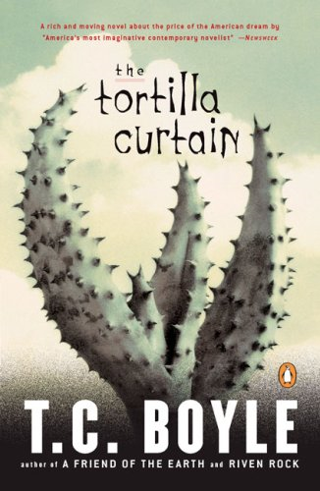
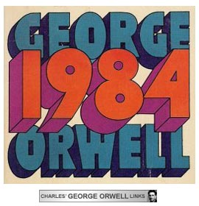

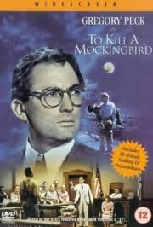

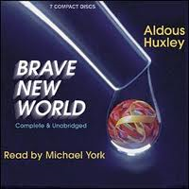

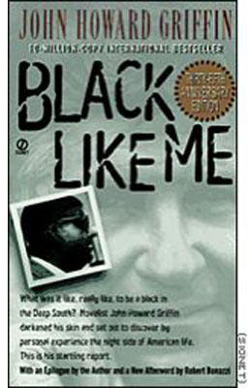
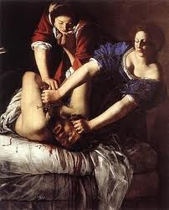
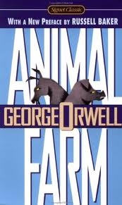

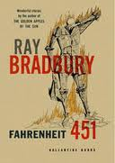

The Passion of Artemisia

You have read several novels that describe and criticize social or political systems in different places and at different times.
If each of the writers had chosen to write a newspaper article instead of the novel, what titles might they have chosen to express the same main ideas?

Briefly present your choice of titles and explain the authors’ main points of criticism.
(Choose at least 4 books.)

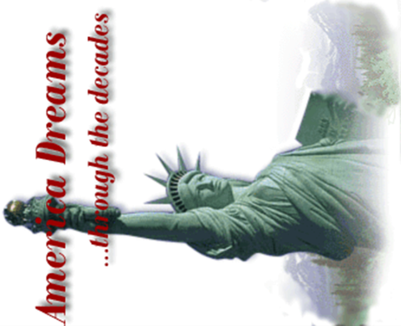
core question

The American Dream

What do these pictures say about different aspects of the American Dream?
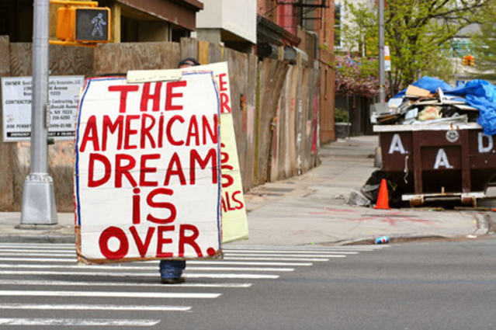

Give examples from your reading and your personal experience.

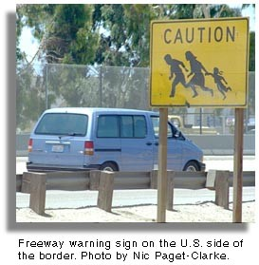

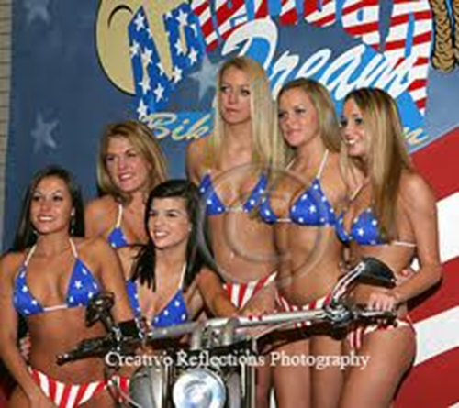

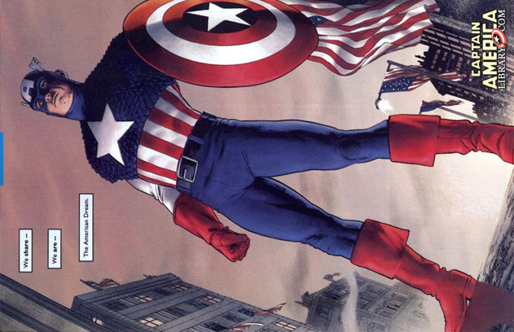
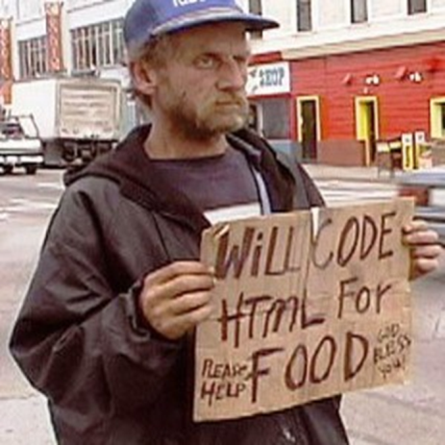

Core question

The Picture of Dorian Gray

Decadence: Lord Henry guides Dorian along a path that ends in total moral decline and decay. He himself indulges in a lifestyle totally uncommon and condemned by Victorian society.
Describe Dorian’s moral descent throughout the novel.

What is Oscar Wilde saying about Victorian society?
How was the novel received by the society of the time?

What does he say about the purpose of art? Explain the concept of aestheticism.

Do you agree? What role does art play for you?

core question

COURAGE

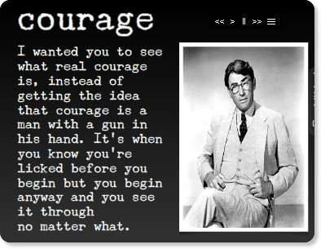

from: Harper Lee, To Kill a Mockingbird

Think of characters from your reading list as well as famous historical figures that we have discussed in English.

Choose three characters or persons who have shown courage as defined above.
Briefly explain what they have done and what their aims were.

How would you personally define courage? Have you met any courageous people?

core question


What happens to a dream deferred?
Does it dry up
like a raisin in the sun?
Or fester like a sore—
And then run?
Does it stink like rotten meat?
Or crust and sugar over—
like a syrupy sweet?
Maybe it just sags
like a heavy load.
Or does it explode?

Explain the meaning of the above poem.

What was the original context of Langston Hughes’ poem?

Point out similar circumstances in our present day world.

Core question

A Riddle

A riddle is making the rounds that goes like this: A man and his young son were in an automobile accident. The father was killed and the son, who was critically injured, was rushed to a hospital. As attendants wheel the unconscious boy into the emergency room, the doctor on duty looked down at him and said, "My God, it's my son!"

What was the relationship of the doctor to the injured boy?

As you will certainly have noticed, the above riddle plays on stereotypes of men and women. List some of the stereotypes associated with men and women.
Then find examples from the literature you have read. How are women and men portrayed in the literature you have read? Choose some fitting examples.

Core question

The Role of Women
In
The Girl With The Pearl Earring

and

Virginia Woolf

A Room of One's Own
Read the short extract from A Room of One’s Own where Virginia Woolf writes about Shakespeare’s imaginary sister Judith. Discuss the role of women at that time. What were their options. What was expected of them? How has the situation changed?
Continue this imaginary biography of Shakespeare's sister. What would her fate have been?
"...I could not help thinking as I looked at the works of Shakespeare on the shelf, ...; it would been impossible, completely and entirely, for any woman to have written the plays of Shakespeare in the age of Shakespeare. Let me imagine, since facts are so hard to come by, what would have happened had Shakespeare had a wonderfully gifted sister, called Judith, let us say. Shakespeare himself went, very probably – his mother was an heiress- to the grammar school, where he may have learnt Latin – Ovide, Virgil and Horace – and the elements of grammar and logic. He was, it is well known, a wild boy who poached rabbits, perhaps shot a deer, and had, rather sooner that he should have done, to marry a woman in the neighbourhood, who bore him a child rather quicker than was right. That escapade sent him to seek his fortune in London. He had, it seemed, a taste for the theatre; he began by holding horses at the stage door. Very soon he got work in the theatre, became a successful actor, and live d at the hub of the universe, meeting everybody, knowing everybody, practicing his art on the boards, exercising his wits in the street, and even getting access to the palace of the queen. Meanwhile his extraordinarily gifted sister, let us suppose....."

Compare the role of women in the Girl with a Pearl Earring with the extract from A Room of One’s Own. Give examples from the book.

Thinking of the literature you have read, what has changed since Shakespeare's and Vermeer’s time? Give examples from the heroines of women's literature.
List some of the limitations that these women have encountered. Which strategies have they developed to overcome them?

Core question

Violence, Rape and Murder

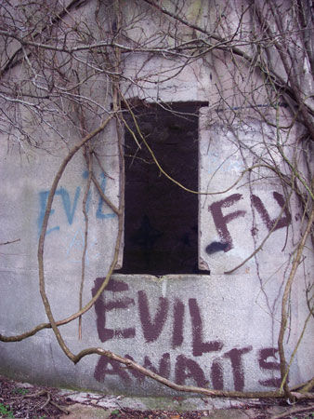

Your reading list reeks of violence, rape and murder.
Take a closer look at the evil characters in the novels and short-stories you have read.

1. Make a quick list of some of the incidents of violence or crime that you have come across in your reading.
Perpetrator/criminal | Crime/ activity | Victim

2. Imagine you were a criminal defense attorney and you were asked to defend one of the above perpetrators.
Which of the criminals would you defend most readily?
Which one would be your last choice?
Give reasons.

Core question

Susan Vreeland, Girl in Hyacinth Blue

What does the Girl in Hyacinth Blue suggest about the value (personal and monetary) and purpose of art? How does art serve us? Why do we need it?
Give examples from the different stories in the book.
How would you describe the value and purpose of art for yourself?

Core question

Resistance is fertile

Resistance is futile

You might remember the above slogans that were blinking on top of the Kunsthaus a few years ago.

Looking at your reading list, which of the characters have most strongly attempted to resist and rebel against the social norms of their time?
Give a few examples and explain what these characters rebelled against and what they gained by doing so. To what extent was their resistance fertile or futile.

Core question

In Cold Blood

Clutter home Holcomb, KS

Spacini at en.wikipedia

1. Briefly sum up what happened in this house on November 15, 1959.

2. Describe the landscape in the area of Holcomb, KS.
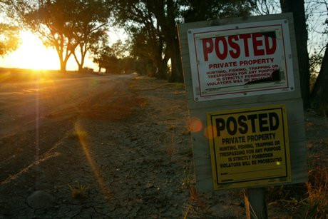
NO TRESPASSING
Because of so many visitors, the lane to the former Clutter house, between rows of Chinese elms, is posted with No Trespassing signs. Donna and Leonard Mader say they sometimes see 20 cars a month come slowly cruising into the lane, stop near the house, and just as quietly back away.

3. This book is neither a who-done-it nor a will-they-be caught. What makes this novel different from other crime novels?

Core question

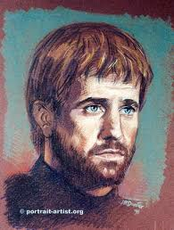
Hamlet, a typical Renaissance man.

Explain the meaning of the most famous soliloquy in English literature. What is Hamlet's dilemma? What are his problems in life? What final decision does he take and why?
In what way is Hamlet a typical Renaissance character?

To be, or not to be (from Hamlet 3/1)
To be, or not to be: that is the question:
Whether 'tis nobler in the mind to suffer
The slings and arrows of outrageous fortune,
Or to take arms against a sea of troubles,
And by opposing end them? To die: to sleep;
No more; and by a sleep to say we end
The heart-ache and the thousand natural shocks
That flesh is heir to, 'tis a consummation
Devoutly to be wish'd. To die, to sleep;
To sleep: perchance to dream: ay, there's the rub;
For in that sleep of death what dreams may come
When we have shuffled off this mortal coil,
Must give us pause: there's the respect
That makes calamity of so long life;
For who would bear the whips and scorns of time,
The oppressor's wrong, the proud man's contumely,
The pangs of despised love, the law's delay,
The insolence of office and the spurns
That patient merit of the unworthy takes,
When he himself might his quietus make
With a bare bodkin? who would fardels bear,
To grunt and sweat under a weary life,
But that the dread of something after death,
The undiscover'd country from whose bourn
No traveller returns, puzzles the will
And makes us rather bear those ills we have
Than fly to others that we know not of?
Thus conscience does make cowards of us all;
And thus the native hue of resolution
Is sicklied o'er with the pale cast of thought,
And enterprises of great pith and moment
With this regard their currents turn awry,
And lose the name of action. - Soft you now!
The fair Ophelia! Nymph, in thy orisons
Be all my sins remember'd.

Hamlet

Explain the meaning of the most famous soliloquy in English literature. What is Hamlet's dilemma? What are his problems in life? What final decision does he take and why?
Compare Hamlet to other characters from your reading who have also been at the verge of committing suicide. What were their reasons for or against life?

To be, or not to be (from Hamlet 3/1)
To be, or not to be: that is the question:
Whether 'tis nobler in the mind to suffer
The slings and arrows of outrageous fortune,
Or to take arms against a sea of troubles,
And by opposing end them? To die: to sleep;
No more; and by a sleep to say we end
The heart-ache and the thousand natural shocks
That flesh is heir to, 'tis a consummation
Devoutly to be wish'd. To die, to sleep;
To sleep: perchance to dream: ay, there's the rub;
For in that sleep of death what dreams may come
When we have shuffled off this mortal coil,
Must give us pause: there's the respect
That makes calamity of so long life;
For who would bear the whips and scorns of time,
The oppressor's wrong, the proud man's contumely,
The pangs of despised love, the law's delay,
The insolence of office and the spurns
That patient merit of the unworthy takes,
When he himself might his quietus make
With a bare bodkin? who would fardels bear,
To grunt and sweat under a weary life,
But that the dread of something after death,
The undiscover'd country from whose bourn
No traveller returns, puzzles the will
And makes us rather bear those ills we have
Than fly to others that we know not of?
Thus conscience does make cowards of us all;
And thus the native hue of resolution
Is sicklied o'er with the pale cast of thought,
And enterprises of great pith and moment
With this regard their currents turn awry,
And lose the name of action. - Soft you now!
The fair Ophelia! Nymph, in thy orisons
Be all my sins remember'd.

Relationships in Ian McEwan’s Works



In Ian McEwan’s novels the characters often seem to spiral into an inescapable nightmare. Logical and realistic reasoning give way to irrational and pathological behavior that eventually destroys the characters and their relationships.

Give examples of such developments in the novels and stories that you have read.

Core question

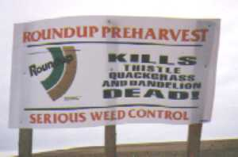
Man and the Environment

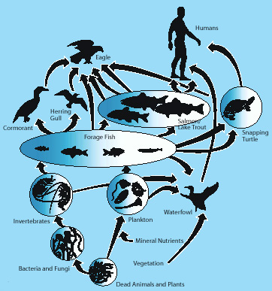

The world might survive if mankind can turn "I'm right and you have to do what I say!" into "Let's figure out what works best and do it!"- Rick
“He who controls the seed, controls the world.”

Explain the significance of the above statements and pictures. Give examples of critical views on these issues from literature and the media.
What is your personal opinion concerning these issues?

Cross-curricular question: English/Arts:

Everything is beautiful. Pop is everything."
Andy Warhol

Look at the pictures.
In what way do they reflect the
- lifestyle,
- values and
- political issues of the Sixties?

Core-topic (Big Names in Literature)

Ian Mc Ewan

Comfort of Strangers
On Chesil Beach
“Dead as the Come”
“Butterflies”





Some of the recurring features of Ian McEwan’s stories are
- Alienated often deeply disturbed characters (often at the fringe of society)
- Strange, deteriorating relationships between the characters
- Characters pulled into a vicious circle that pulls them deeper and deeper into the vortex of events.
- Interest in the macabre and perverse written in a realistic style

Discuss examples of the above features in the works that you have read and explain how McEwan uses these to make a statement about society and life in the 21st century.

