Spezialtopics for the oral Matura

1.
Stephan Fadinger:
Paul Auster's novels

The Music of Chance

Mr. Vertigo

Read the two extracts from Paul Auster's novels and explain their significance in the novels.
Compare the relationships between the two main characters of each novel. Can you discern any similarities?
How did the main characters meet?
What are their reasons for staying together?
How do their relationships develop?
Do the two pairs reach their goals?
What have they gained?

Explain the title of the novel The Music of Chance. Does chance also play a role in Mr. Vertigo?
Can you find any other parallels between the two novels?

2.
Felizitas Hütter

Differences and Misunderstandings between the USA and Europe

Read the passage from the preface of Andy Soutter's book The Drive-thru Museum and explain its meaning in the context of the book. In what ways is America different from Europe? Give examples of the anachronisms and differences discussed by Andy Soutter and Paul Watzlawick and include your own experiences in America.

p. 4-5
(language differences, euphemisms, politically correct language, non-sexist language…
old fashioned lifestyle, cars, housing, worries, social situation, morals, old towns, tension, anxiety (crime), homes like in old movies…

3.
Michaela Menzinger

Dreams and Nightmares in American and English Literature

Read the poem "Imagine" by John Lennon and explain its meaning.
Lennon says that he is not the only dreamer – who are the other dreamers he might be referring to? Give examples of similar dreams.

In the literature you have selected one can discern three major types of dreams:
- Dreams of personal success (the American Dream)
- Political dreams of freedom
- Nightmares
Give examples of each type of dream.
Then discuss the ways the different characters try to fulfill their dreams. Can you find any similarities?

poem
Imagine by John Lennon

4.

Alice Fischer

Mental Problems and Depression in American Literature
The Bell Jar by Sylvia Plath and Play it as it Lays by Joan Didion

Read the following poem by Sylvia Plath and briefly summarize its meaning.
What did the speaker of the poem do? Where is she? What does she look like? What does she say about suicide? What does she say about doctors?
Explain the meaning of lines 58 to 63. Why is there a very large charge for a word or a touch?
What might be the reasons for her depression and suicide?

Compare the poem to the two novels you have read.
What are the reasons for the protagonists' depressions in the two novels.
How do Esther and Myria Wyeth cope with their problems?

In both novels the titles are important keys to the understanding of the main themes. Explain the meanings of the two titles in the context of the novels.

5.

Klaus Engelke

Stock Characters in Crime Novels

Read the following passages by Bertold Brecht and by Joseph Wood Krutch and explain their meaning? What do the two writers think of crime novels?
What are the characteristic features of the crime novel according to Brecht and Krutch?
Which characteristics have you found in your reading?

Explain what makes John Grisham's novels bestsellers? What makes them so appealing to the American public?

extracts from: Michael Dibdin Ed. , The Picador Book of Crime Writing,, 1993, p. 207

Doris Kolmanitsch

Mind Control in Utopian Literature

Read the extract from George Orwell's essay "On Politics and the English Language" and summarize its content.
Explain the relationship Orwell sees between politics and the English language.
What is the purpose and aim of Orwell's essay? What measures does he suggest?

How can language be used as a method of mind control? Refer to Orwell's essay and to his novel Nineteen Eighty-Four.
Which other means of mind control have you found in the novels of Orwell and Huxley?
Can you find any signs of mind control in contemporary society?

George Orwell On Politics and the English Language (extracts)
[…] Now, it is clear that the decline of a language must ultimately have political and economic causes: it is not simply due to the bad influence of this or that individual writer. But an effect can become a cause; reinforcing the original cause and producing the same effect in an intensified form, and so on indefinitely. A man may take to drink because he feels himself to be a failure, and then fail all the more completely because he drinks. It is rather the same thing that is happening to the English language. It becomes ugly and inaccurate because our thoughts are foolish, but the slovenliness of our language makes it easier for us to have foolish thoughts. The point is that the process is reversible. Modern English, especially written English, is full of bad habits which spread by imitation and which can be avoided if one is willing to take the necessary trouble. If one gets rid of these habits one can think more clearly, and to think clearly is a necessary first step towards political regeneration. […]
This mixture of vagueness and sheer incompetence is the most marked characteristic of modern English prose, and especially of any kind of political writing. As soon as certain topics are raised, the concrete melts into the abstract and no one seems able to think of turns of speech that are not hackneyed: prose consists less and less of words chosen for the sake of their meaning, and more and more of phrases tacked together like the sections of a prefabricated hen-house. […]
The whole tendency of modern prose is away from concreteness. The attraction of this way of writing is that it is easy. It is easier--even quicker, once you have the habit--to say In my opinion it is not an unjustifiable assumption that than to say I think. […]
A scrupulous writer, in every sentence that he writes, will ask himself at least four questions, thus: What am I trying to say? What words will express it? What image or idiom will make it clearer? Is this image fresh enough to have an effect? And he will probably ask himself two more: Could I put it more shortly? Have I said anything that is avoidably ugly? But you are not obliged to go to all this trouble. You can shirk it by simply throwing your mind open and letting the ready-made phrases come crowding in. They will construct your sentences for you--even think your thoughts for you, to a certain extent--and at need they will perform the important service of partially concealing your meaning even from yourself. […]
When one watches some tired hack on the platform mechanically repeating the familiar phrases--bestial atrocities, iron heel, blood-stained tyranny, free peoples of the world, stand shoulder to shoulder--one often has a curious feeling that one is not watching a live human being but some kind of dummy: a feeling which suddenly becomes stronger at moments when the light catches the speaker's spectacles and turns them into blank discs which seem to have no eyes behind them. And this is not altogether fanciful. A speaker who uses that kind of phraseology has gone some distance towards turning himself into a machine. The appropriate noises are coming out of his larynx, but his brain is not involved as it would be if he were choosing his words for himself...And this reduced state of consciousness, if not indispensable, is at any rate favorable to political conformity.
In our time, political speech and writing are largely the defence of the indefensible. Things like the continuance of British rule in India, the Russian purges and deportations, the dropping of the atom bombs on Japan, can indeed be defended, but only by arguments which are too brutal for most people to face, and which do not square with the professed aims of political parties. Thus political language has to consist largely of euphemism, question-begging and sheer cloudy vagueness. Defenceless villages are bombarded from the air, the inhabitants drive out into the countryside, the cattle machine-gunned, the huts set on fire with incendiary bullets: this is called pacification. Millions of peasants are robbed of their farms and sent trudging along the roads with no more than they can carry: this is called transfer of population or rectification of frontiers. People are imprisoned for years without trail, or shot in the back of the neck or sent to die of scurvy in Arctic lumber camps; this is called elimination of unreliable elements. Such phraseology is needed if one wants to name things without calling up mental pictures of them.

Doris Reishofer
Rebellion and Conformity in The Loneliness of the Long-Distance Runner and The Catcher in the Rye

Read the two extracts below and explain their meaning within the context of the novels.
What are the causes that Holden Caulfield and Smith are fighting for? What are they rebelling against? Explain the advice Mr. Antolini gives Holden. What would Smith answer if given this piece of advice?
Which other similarities can you find between the two novels?

The Catcher in the Rye
"All right. Listen to me a minute now…. I may not word this as memorably as I'd like to, but I'll write you a letter about it in a day or two. Then you can get it all straight. But listen now, anyway." he started concentrating again. Then he said, "This fall I think you're riding for – it's a special kind of fall, a horrible kind. The man falling isn't permitted to feel or hear himself hit bottom. He just keeps falling and falling. The whole arrangement's designed for men who, at some time or other in their lives, were looking for something their own environment couldn't supply them with. Or they thought their own environment couldn't supply them with. So they gave up looking. They gave it up before they ever really even got started. You follow me?"
"Yes, sir."
"Sure?"
"Yes."
He got up and poured some more booze in his glass. Then he sat down again. He didn't say anything for quite a long time.
"I don't want to scare you," he said, "but I can very clearly see you dying nobly, one way or another, for some highly unworthy cause." He gave me a funny look. "If I write something down for you, will you read it carefully? And keep it?"
"Yes. Sure." I said. I did, too. I still have the paper he gave me.
He went over to this desk on the other side of the room, and without sitting down wrote something on a piece of paper. Then he came back and sat down with the paper in his hand. "Oddly enough, this wasn't written by a practicing poet. It was written by a psycho-analyst named Wilhelm Stekel.
" Here's what he said: 'The mark of the immature man is that he wants to die nobly for a cause, while the mark of the mature man is that he wants to live humbly for one.'"

The Loneliness of the Long-Distance Runner
[…] Because I'm slowing down now for Gunthorpe to catch me up, and I'm doing it in a place just where the drive turns in to the sportsfield – where they can see what I'm doing, especially the governor and his gang from the grandstand, and I'm going so slow I'm almost marking time. […]

No, I'll show him what honesty means if it's the last thing I do, though I'm sure he'll never understand because if he and all them like him did it'd mean they'd be on my side which is impossible. By God I'll stick this out like my dad stuck out his pain and kicked them doctors down the stairs; if he had guts for that then I've got guts for this and here I stay waiting for Gunthorpe or Aylesham to bash that turf and go right slap-up against that bit of clothes-line stretched across the winning post. As for me, the only time I'll hit that clothes-line will be when I'm dead and a comfortable coffin's been got ready on the other side. Until then I'm a long-distance runner, crossing country all on my own no matter how bad it feels. (pp. 51 f.)

Susanna Gartler

Extraordinary Characters in Contemporary American Fiction
John Irving, A Prayer for Owen Meany and Robert Anton Wilson, The Walls Came Tumbling Down

Read the commentary on A Prayer for Owen Meany and the opening paragraph of the novel. Explain its meaning within the context of the novel.

Can you find any of the above themes in Wilson's novel TheWalls Came Tumbling Down.?
Compare the two novels at the following levels:
- main characters
- main themes
- language /style

Verene Engele

Free Will and Determination in Modern Literature
Kurt Vonnegut, Breakfast of Champions and "The Euphio Question"
Anthony Burgess, A Clockwork Orange

Read the extract from A Clockwork Orange and explain its meaning within the context of the novel. What does Anthony Burgess say about free choice and mind control? How is Alex's mind manipulated? Explain the metaphor "clockwork orange".
What are Kurt Vonnegut's views about freedom and mind-control? Who or what controls the characters' minds in Vonnegut's stories?

Sophie Lampl

Women Writers between the World Wars
Carson McCullers, The Heart is a Lonely Hunter
Zora Neale Hurston, Their Eyes Were Watching God
Dorothy Parker, poems

Read the following text collage and explain the meaning and relevance of the individual passages. What are the typical themes of the women writers that you have read? What are their goals?
How do the protagonists cope with the limitations they have to live with? What obstacles do they have to overcome? Do they succeed?

A Riddle
A man and his young son were in an automobile accident. The father was killed and the son, who was critically injured, was rushed to a hospital. As attendants wheel the unconscious boy into the emergency room, the doctor on duty looked down at him and said, "My God, it's my son!" What was the relationship of the doctor to the injured boy?

Christoph Bleimuth
Paul Auster

The Music of Chance

Mr. Vertigo

Read the two extracts from Paul Auster's novels and explain their significance in the novels.
Compare the relationships between the two main characters of each novel. Can you discern any similarities?
How did the main characters meet?
What are their reasons for staying together?
How do their relationships develop?
Do the two pairs reach their goals?
What have they gained?
Explain the title of the novel The Music of Chance. Does chance also play a role in Mr. Vertigo?
Can you find any other parallels between the two novels? Do any of these parallels and characteristics also apply to 'Augie Wren's Christmas Story' ?

Katharina Anderwald

Two women who don't want to play the game

Sylvia Plath, The Bell Jar
Joan Didion, Play it as it Lays

'New York. Hollywood. Nevada.
Some good times, even great times.
And the other times. When she couldn't sleep alone, stayed up late …
This time she's doing things her way. Remembering what it was like when she held all the aces. Stunned by how little she understood the game.'

This extract from the cover text of Joan Didion's novel Play It As It Lays could almost literally be used to describe Esther's life in Sylvia Plath's novel The Bell Jar.
Explain why the two protagonists Maria and Esther cannot play along? What are the reasons for their depressions? How do Esther and Maria cope with their problems?

In both novels the titles are important keys to the understanding of the main themes. Explain the meanings of the two titles in the context of the novels.

Astrid Schönbacher

Mind Control in Utopian Literature

Aldous Huxley, Brave New World
George Orwell, Nineteen Eighty-Four

Read the extract from George Orwell's essay "On Politics and the English Language" and briefly summarize its content.
Explain the relationship Orwell sees between politics and the English language.
What is the purpose and aim of Orwell's essay?
How can language be used as a method of mind control? Refer to Orwell's essay and to his novel Nineteen Eighty-Four.
Which other means of mind control have you found in the novels of Orwell and Huxley?
Can you find any signs of mind control in contemporary society?

George Orwell On Politics and the English Language (extracts)
[…] Now, it is clear that the decline of a language must ultimately have political and economic causes: it is not simply due to the bad influence of this or that individual writer. But an effect can become a cause; reinforcing the original cause and producing the same effect in an intensified form, and so on indefinitely. A man may take to drink because he feels himself to be a failure, and then fail all the more completely because he drinks. It is rather the same thing that is happening to the English language. It becomes ugly and inaccurate because our thoughts are foolish, but the slovenliness of our language makes it easier for us to have foolish thoughts […]
This mixture of vagueness and sheer incompetence is the most marked characteristic of modern English prose, and especially of any kind of political writing. As soon as certain topics are raised, the concrete melts into the abstract and no one seems able to think of turns of speech that are not hackneyed: prose consists less and less of words chosen for the sake of their meaning, and more and more of phrases tacked together like the sections of a prefabricated hen-house. […]
The whole tendency of modern prose is away from concreteness. The attraction of this way of writing is that it is easy. It is easier--even quicker, once you have the habit--to say In my opinion it is not an unjustifiable assumption that than to say I think. […]
When one watches some tired hack on the platform mechanically repeating the familiar phrases--bestial atrocities, iron heel, blood-stained tyranny, free peoples of the world, stand shoulder to shoulder--one often has a curious feeling that one is not watching a live human being but some kind of dummy: a feeling which suddenly becomes stronger at moments when the light catches the speaker's spectacles and turns them into blank discs which seem to have no eyes behind them. And this is not altogether fanciful. A speaker who uses that kind of phraseology has gone some distance towards turning himself into a machine. The appropriate noises are coming out of his larynx, but his brain is not involved as it would be if he were choosing his words for himself...And this reduced state of consciousness, if not indispensable, is at any rate favorable to political conformity.
In our time, political speech and writing are largely the defence of the indefensible. Things like the continuance of British rule in India, the Russian purges and deportations, the dropping of the atom bombs on Japan, can indeed be defended, but only by arguments which are too brutal for most people to face, and which do not square with the professed aims of political parties. Thus political language has to consist largely of euphemism, question-begging and sheer cloudy vagueness. Defenceless villages are bombarded from the air, the inhabitants drive out into the countryside, the cattle machine-gunned, the huts set on fire with incendiary bullets: this is called pacification. Millions of peasants are robbed of their farms and sent trudging along the roads with no more than they can carry: this is called transfer of population or rectification of frontiers. People are imprisoned for years without trail, or shot in the back of the neck or sent to die of scurvy in Arctic lumber camps; this is called elimination of unreliable elements. Such phraseology is needed if one wants to name things without calling up mental pictures of them.

Michaela Just
Extraordinary Characters in John Irving's Novels

A Prayer for Owen Meany and The World According to Garp

Read the following critical commentaries on A Prayer for Owen Meany and The World According to Garp. Do you agree with these commentaries? Explain their meaning in the context of the novels.
What, according to you, makes John Irving's novels so fascinating. Identify the recurring themes, symbols and characteristics of Irving's novels.

The World According to Garp  … Is "Overwhelming…  Funny and serious, absurd and realistic, fast-moving and thoughtful. . . . Buy two copies; you'll wear out the first with rereading." (Pittsburgh Press)  … Is "Superb!…  It is not easy to find the words to convey the joy, the excitement, the passion. . . . The imagination soars as Irving draws us inexorably into Garp's world. . . Swirling around Garp and his family are some of the most colorful characters in recent fiction." (Publishers Weekly) | A Prayer for Owen Meany  "One of the most subtle and brilliant artistic examinations yet of America and America's involvement in Vietnam." (San jose Mercury News)  "A wondrous novel . . . ultimately beguiling in its soulful account of a remarkable friendship. . . Irving's ability to create idiosyncratic characters and put them through weirdly ridiculous yet realistic paces has never been in finer fettle. Humor partnered with compassion, wisdom with absurdity, leave the reader both mirthful and tearful."  "Mr. Irving is more than popular. He is a Populist, determined to keep alive the Dickensian tradition that revels in colorful set pieces and teaches moral lessons…. More than any of his novels since Garp, A PRAYER FOR OWEN MEANY embraces those 19th century qualities."

Jan Marot

Hip Hop Culture

Listen to and read the following extract from the song "My Block" and sum up what the artist says about life in his block.
In what way is this song typical of Hip Hop? What is Hip Hop? Where does it come from? What are the main topics and themes?

What is your opinion on the violent and explicit language of many Hip Hop lyrics? What makes Hip Hop so fascinating for young people?

Text:

Tina Panzitt
Two Rebellious Teenagers:

Holden Caulfield and Holly Golightly

The main characters in J.D. Salinger's novel The Catcher in the Rye and Truman Capote's novella Breakfast at Tiffany's are both rebellious teenagers of the 1940s and 50s. Describe their characters and the similarities and differences between them.
What are they rebelling against? What are they fighting for?

The titles of both novels are keys to the understanding of the main characters. Explain the meaning and significance of the two titles.

Katharina Ganster: Question about the Fachbereichsarbeit:

Inikaga na Hanbleceya:
Sources of Identification among the Lakota Nation.

Explain the main characteristics of the Lakota Indians. What are their main rituals and sacred symbols? Explain the significance of the picture below.

Compare the Lakota system of values and beliefs to our western values.

Elk dreamer, cover picture

Georg Bauer: Question about the Fachbereichsarbeit

Jewish American Humor
as a Means of Coming to Terms with the Past

The list of Jewish comedians is a long one, and for centuries, Jews have been known for their humor. The Talmud even says that when Rav lectured, he always started with a joke. This great sage was speaking to thousands of students on serious Torah topics – and telling jokes! Why?

Explain the role humor plays in Jewish literature and culture. Give examples from your reading.

Hannes Reinisch
J. D. Salinger

Here's what Edgar Wibeau, the narrator in Ulrich Plenzdorf's novel Die Leiden des jungen W. says about The Catcher in the Rye.

"Der soll sich mal den Salinger durchlesen. Das ist echt, Leute! Ich kann euch nur raten, ihn zu lesen, wenn ihr ihn irgendwo aufreissen könnt. Reisst euch das Ding unter den Nagel, wenn ihr es bei irgendwem stehen seht, und gebt es nicht wieder her! Leiht es euch aus und gebt es nicht wieder zurück. Ihr sagt einfach, ihr habt es verloren. Das kostet 5 Mark, na und?"

Do you agree with Edgar Wibeau? What is so special about The Catcher in the Rye? Why is it so controversial?
Identify and explain the main characteristics and themes of Salinger's works and give examples from the stories you have read.

Cristoph Kammerlander

On the Road…. in the United States

The two novels On the Road and The Drive-thru Museum both describe extensive trips across the United States. Both portray American society, lifestyle and landscape. Compare and contrast the two views of America keeping in mind that they were written at different times. Explain the following two quotes in the context of the novels.
What is your personal view and experience? Do you see America the way Jack Kerouac or Andy Soutter does?

"Jack Kerouac's On the Road was the Huckleberry Finn of the mid-twentieth century. Kerouac substituted the road for the river, the fast car for the slow raft, the hipster in search of freedom for the black slave in search of freedom…"

"America used to be the place where the future happened first; but wherever we went I found a nation hooked on its past, from its movies and TV to the question of who killed JFK, from Freudian therapeutic strategies to an obsession with the morals and deeds of the ancient Israelites. In everyday American landscapes, domestic trappings, and in the way people move, speak and dress, the past is invoked to an extraordinary degree, while the future seems to be on ice for the duration…"

Nadja Kalb

Scandalous Literature
D.H. Lawrence, Lady Chatterly's Lover
and
Salman Rushdie, The Satanic Verses

Read the following reactions to the two novels and explain the reasons and background for such harsh criticism. What makes Lady Chatterly's Lover and The Satanic Verses so offensive?
Were you offended when reading them?

"Famous Novelist's Shameful Book – A Landmark in Evil" (John Bull)

…the most evil outpouring that has ever besmirched the literature of our country. The sewers of French pornography would be dragged in vain to find a parallel in beastliness. The creations of muddy-minded perverts peddled in the back-street bookstalls of Paris are prudish by comparison. … Unfortunately for literature Mr. Lawrence has a diseased mind. He is obsessed by sex.

"I inform all zealous Muslims of the world that the author of the book entitled The Satanic Verses – which has been compiled, printed and published in opposition to Islam, the Prophet, and the Qur'an – and all those involved in its publication who were aware of its content, are sentenced to death.
I call on all zealous Muslims to execute them quickly, wherever they may be found, so that no one else will dare to insult the Muslim sanctities. God willing, whoever is killed on this path is a martyr.
(Ayatollah Khomeni)

Mirjam Zisler

Jamaica Kincaid

A Small Place
Annie John

" Nothing can erase my rage - … - for this wrong can never be made right, and only the impossible can make me still: can a way be found to make what happened not have happened?" (A Small Place, p.32)

In both books the author/protagonist seems to be very angry and enraged. What are the reasons for Jamaica Kincaid's anger in the essay A Small Place ? What makes Annie John so angry ? How do they resolve the problems?

Explain Jamaica Kincaid's main themes and concerns giving examples from your reading.
How has her own biography influenced her writing?
Describe Jamaica Kincaid`s typical style.

Clara Foissner

Rebecca Wells

Little Altars Everywhere
Divine Secrets of the Ya-Ya Sisterhood

1. Wells uses multiple narrators to unfold her story in Little Altars Everywhere. What advantages are gained by this?

2. Religious imagery abounds in the novels. Give some examples. Why might Wells rely so heavily on religious imagery to describe everyday experiences?

What attitude do the novels take toward institutional religion, spirituality and human suffering. Catholicism is a strong presence in both novels. How does Catholicism both bless and damage the Walker family?

Sven Haidinger

Michael Crichton
Jurassic Park
Disclosure

Read the following extract from Jurassic Park and explain in what way the description of a modern mathematician is both typical of Dr. Malcolm and of Michael Crichton himself.

Explain the reasons for Michael Crichton's success. What makes his books so compelling?

P 71/72

David Rottensteiner

Immigration Problems in the USA

The Tortilla Curtain
Green Card

T. Coraghessan Boyle has chosen the following quotation from John Steinbeck's The Grapes of Wrath as an epigraph for his novel The Tortilla Curtain. In what way is this quote representative of the novel?

"They ain't human. A human being wouldn't live like they do. A human being couldn't stand it to be so dirty and miserable."
(John Steinbeck, The Grapes of Wrath)

Describe the situation of immigrants to the USA as you know it from literature and official sources.

Jacqueline Nistelberger

Nicholas Evans

The Horse Whisperer
The Loop

Nicholas Evans chose the following quotation from the great Indian holy man Black Elk as an epigraph for his novel The Loop. In what way does this quote reflect the main themes of the novel?

In both novels the author seems to contrast the lifestyle and values of the American West with those of the East. His protagonists move from the East to the West in the course of the novels. Explain the symbolism of this move. Which values does Evans attribute to the East and the West?

Christian Isak

Stephen King
Master of Horror

For more than 30 years, King has mastered the art of darkness and become a multi-millionaire in the process. He has written more than 35 novels and is the world's bestselling novelist. Stephen King's novels are bubbling with terror and suspense, his well or horrors seems as deep and inexhaustible as his riches must now be.

King himself used to refer to himself as the "Big Mac and large fries" of the literary world. What could he mean by this?
Explain the reasons for Stephen King's success. What makes his books so popular? What are the typical ingredients of King's novels?

Briefly explain the following Ode to Stephen King .

As I took The Long Walk
Through The Waste Lands to the Dark Tower of my
Soul
Through what they would later call The Storm of the
Century
My Desperation triggered my Insomnia causing me
great Misery
I had to take a raincheck on my date with Carrie.
And As I walked The Green Mile ever farther
Dolores Claiborne stopped and picked me up in Christine
I knew I was forever a Stephen King fan...

submitted by Ed Anderson

Georg Bauer
New Scottish Writing
Ian McEwan, The Comfort of Strangers
Will Self, Great Apes

You have chosen two very controversial novels. Readers' comments range from "brilliant" and "wonderful" to "truly frightening" or "recycle!!!"
Read the following reviews and compare them to your personal reactions to the novels.

The New York Times Book Review, Gary Krist
Obviously, Great Apes is not a book that will delight everyone. In places, its humor caroms toward the sophomoric (not to mention the scatological), and there are times when Self's readers may feel as if they're trapped in a windowless room with a monstrously intelligent, diabolically articulate adolescent….

Amazing plot, extraordinary moral, terribly written August 23, 1999 Reviewer: A reader from Memphis, Tennessee
Upon hearing about the concept for Self's new endeavor, one might think that this book could possibly be one of the best reads of all time. I felt that same way...I was sadly mistaken. Although the plot was extraordinary and the moral strong, the writing did not flow well at all. It seemed as if Self was trying to say "Look at all the difficult, complex sentences I can write. Look at my usage of big words. I'm one of the best writers around!" Stop showing off Mr. Self, concentrate on the plot at hand. It seemed as if the first 90 pages were trying to show the reader how Simon lived his life as a human. Well, the first 90 pages are nothing but a nauseating, hardcore porn novel. If you can get past the porn, the plot begins to finally develop. It becomes interesting. But the writing style is still horrible. In the end, the moral the story teaches is profound. But the reader will still reflect on Great Apes as a horribly written book.
(Amazon.com, Customer Review)

The Comfort of Strangers
Customer Reviews (Amazon.com)
Disappointing!
Reviewer: Sarah from Australia
I found The Comfort of Strangers to be disappointing. At points the use of symbolism by the writer was so blatant it became mundane. For example when Colin and Mary first meet Robert they notice he is wearing a tiny razor blade around his neck. Many events in the plot were left frustratingly unexplained, instead of creating mystery, they cause the story to become unbelievable…

Christina Eckhart

Mental Illness in Literature

Of Mice and Men
One Flew Over the Cuckoo's Nest
Forrest Gump

The protagonists of the three novels/stories are all "free spirits" in different ways. They do not conform to society's expectations and have their own views of the world. In what way are their views different from the accepted standard?
What are Lennie's, McMurphy's and Forrest Gump's dreams and goals in life? What hinders them? Do they succeed?

Sabine Barry

Ernest Hemingway

The Old Man and the Sea
A Farewell to Arms

"A man can be destroyed but not defeated."

Explain this essential theme in Hemingway's novels The Old Man and the Sea and A Farewell to Arms.

Nina Ulrich

Ernest Hemingway

The Old Man and the Sea
A Farewell to Arms

Both novels are closely linked to Hemingway's biography. Explain the autobiographic elements in the novels.
What are the main themes that can be found in both novels and how do they reflect the author's values and beliefs?

Xaver Daublebsky

John Steinbeck

Of Mice and Men
The Pearl
"The Chrysanthemums"

Read the following passage from Of Mice and Men. In what way is it typical of John Steinbeck's works?
Who are the typical protagonists of his stories? Briefly describe their problems and their dreams. Do their dreams ever come true?

Page 1, mice and men

Kristiana Steiner

Edgar Allan Poe
Madness and Romantic Features

Reread the poem "For Annie". Briefly sum up its content and explain in what way it fulfills Poe's criteria of good poetry stated in his "Philosophy of Composition".

Which of Poe's characteristics make him a typically "romantic" writer?

For annie

Anna Beiglböck

Gangs in Great Britain

Courttia Newland, The Scholar
John Davison, Gangsta

Explain in what way Cory, the protagonist of The Scholar is a typical gang member. What are the reasons for his behavior?
Explain the reasons for gang membership in general and briefly describe the current situation in Great Britain.
Suggest solutions to the problem.

Sandra Schinnerl

On the Road to Downtown
The Sixties in American Literature

Anne Rivers Siddons, Downtown (1994)
Jack Kerouac, On the Road (1957)

Even though none of the two novels was published during the sixties, they are both excellent portraits of that time.
Explain in what way the two novels express the values and new ideas of the sixties. Which historical and political events play a role in Downtown? What is the author's attitude towards these events?
Briefly explain the meaning of the headline "On the Road to Downtown".

Barbara Peichl

E.M. Forster

A Room with a View
A Passage to India

"I can show you a beautiful picture in my Italian diary:
Miss Honeychurch as a kite, Miss Bartlett holding the string.
Picture number two: the string breaks."

A Room with a View

Explain the significance of the above pictures and quotes in the context of E.M. Forster's work.

Kathi Postl
Dorothy Parker
Poetry and Short Stories

Résumé
Razors pain you;
Rivers are damp;
Acids stain you;
And drugs cause cramp.
Guns aren't lawful;
Nooses give;
Gas smells awful;
You might as well live.

SONG OF ONE OF THE GIRLS

Here in my heart I am Helen;
I'm Aspasia and Hero, at least.
I'm Judith, and Jael, nd Madame de Stael;
I'm Salome, moon of the East.

Here in my soul I am Sappho;
Lady Hamilton am I, as well.
In me Récamier vies with Kitty O'Shea,
With Dido, and Eve, and poor Nell.

I'm of the glamorous ladies
At whose beckoning history shook.
But you are a man, and see only my pan,
So I stay at home ……………………….(1)

- Choose one of the following endings. Which one is Dorothy Parker's ending?
A: …and cook
B: … with a book

Read the above poems by Dorothy Parker and underline all the references to the author's typical themes.
In what way are these poems typical of Dorothy Parker's life and work? In which other poems or stories does the author treat the same topics? Give examples.

Coda

There's little in taking or giving,
There's little in water or wine;
This living, this living, this living
Was never a project of mine.
Oh, hard is the struggle, and sparse is
The gain of the one at the top,
For art is a form of catharsis,
And love is a permanent flop,
And work is the province of cattle,
And rest's for a clam in a shell,
So I'm thinking of throwing the battle-
Would you kindly direct me to hell?

Valentin Leeb

Oscar Wilde

The Picture of Dorian Gray
An Ideal Husband

In both works Oscar Wilde portrays London's society around 1900. What is Wilde's view of his contemporaries. Explain the author's attitude giving examples from the two works.

The Picture of Doran Gray hasn't lost any of its appeal for the modern reader. Explain what makes the novel so valid in our time.

Susi Wieser

Women's Liberation in the 19th Century

Kate Chopin, The Awakening
"The Story of an Hour"
"Regret"
Jane Austen, Persuasion

The heroines of all the above stories are caught within the limitations of the social conventions of their time. Explain the nature of these limitations as well as the different ways the heroines try to break them.
To what extent do these women reach their goals?

Briefly explain the symbolism of Edna's learning to swim and her wish 'to swim, where no woman has swum before'

Andrew Hofer

David Brin

The Uplift Series

In the Afterword of Heaven's Reach David Brin says

'Many people have asked questions about my Uplift series. This is certainly not the fist time an author speculated about the possibility of genetically altering non-sapient animals. … But I also noticed that nearly all these tales assume that human masters will always do the maximally stupid/evil thing. In other words, if we meddle with animals to raise their intelligence, it will be in order to enslave and abuse them… The Uplift series tries to take things to the next level.'

Explain what Brin means by this 'next level'. What is 'uplifting' and what are its consequences?

The author also says that 'a galaxy might burn out all too easily, unless something regulates how colonists treat their planets, forcing them to think about the long run, beyond short-term self-interest. The Uplift Universe shows one way this might occur.'

Explain how the characters of the Uplift Universe solve this problem.

Alexander Hirschbeck

Graham Greene

The Third Man
TheFallen Idol

Graham Greene has said that
"The film story, The Third Man, was never written to be read but only to be seen…" Normally "to the novelist, of course his novel is the best he can do with a particular subject; he cannot help resenting many of the changes necessary for turning it into a film play; but The Third Man was never intended to be more than the raw material for a picture. The reader will notice many differences between the story and the film, and he should not imagine these changes were forced on an unwilling author: as likely as not they were suggested by the author. The film in fact is better than the story because it is in this case the finished state of the story."

- Do you agree with the author? What differences between the film and the book have you noticed. Give examples of such changes and explain in what way they improve the story.
- The world Greene's characters inhabit is a fallen one, where evil is a constantly present force. Give examples of the author's preoccupation with sin and moral failure and explain his attitude.
- Graham Greene termed his first string of novels "entertainments". What are the typical features of this genre. How do the The Third Man and "The Basement Room" fit into this category?

Maike Leberl

Politics and War in Classic Literature

George Orwell, Animal Farm
Charles Dickens, A Tale of Two Cities

"It was the best of times, it was the worst of times, it was the age of wisdom, it was the age of foolishness, it was the epoch of belief, it was the epoch of incredulity, it was the season of Light, it was the season of Darkness, it was the spring of hope, it was the winter of despair, we had everything before us, we had nothing before us, we were all going direct to Heaven, we were all going direct the other way…"

These are the opening lines of Charles Dickens' novel A Tale of Two Cities. I dare say that, with very few changes, they could also be the opening lines of Animal Farm. Do you agree?
What are the parallels between the two novels that were written centuries apart.

Antonia Jöbstl

Death Penalty

Facts and Figures
John Grisham, The Chamber
Sister Helen Prejean, Dead Man Walking

Why do we kill
People
Who kill people
To show that
Killing people
Is wrong?

- Explain some of the reasons why the death penalty is still in use in the USA.
- What are Sister Helen Prejean's arguments against the death penalty.
- Compare the trials of the criminals in the two novels. Why were they both sentenced to death? In what way are their stories similar?

Katharina Ganster
W. B. Yeats

Death and Decay in Yeats' Poetry

Read the following poem and explain its meaning. What does the poet say about life and death? What does he say about art?
In what way is this poem typical of Yeats?

Isabell Kordon

Northern Ireland:
David Bleakly, Two states, one people
Bernard Mac Laverty, Cal

- Explain the origin of the Irish conflict. How did religion originally come to play an important role in the history of Ireland?
- Discuss to what extent the plot of Cal effectively conveys the situation in Northern Ireland to the reader.
- Is Cal a victim or a perpetrator? Explain your choice.
Special-topic Kati Jungwirth

Author Study
Ian Mc Ewan

The Comfort of Strangers
The Cement Garden
Enduring Love
On Chesil Beach

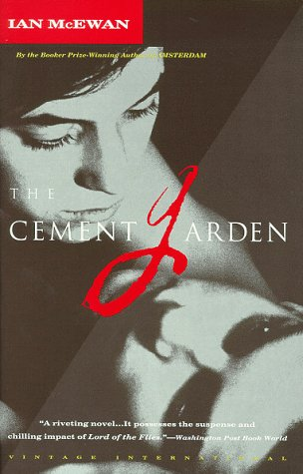
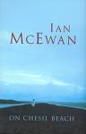
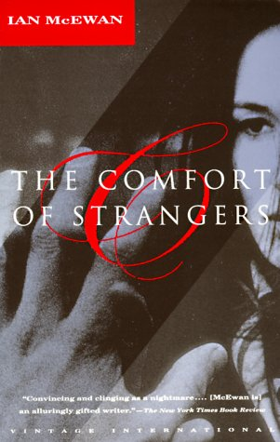
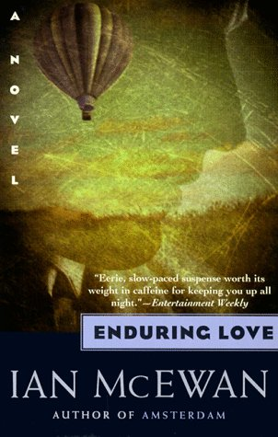

1. Ian McAbre:
- Ian McEwan’s characters are often deeply disturbed and traumatized.
- Despite their strangeness, the reader easily identifies with the main characters.
- They are often alienated or involved in strange relationships and
- they seem drawn deeper and deeper into the vortex of events, without a possibility to escape.

Give examples of these characteristic features and explain some of the author’s reasons for choosing such odd characters.
How does Ian McEwan manage to create such strong feelings of identification with his strange characters?
How did these odd characters and their behavior affect you as a reader?

2. McEwan is a master of symbolism. Explain the symbolism in the title The Cement Garden.

Special Topic Hannah Widmann

Jack Kerouac
&
The Beat Generation

"We fumed and screamed in our mountain nook, mad drunken Americans in the mighty land. We were on the roof of America and all we could do was yell, I guess--across the night..."
- Jack Kerouac, On the Road, Part 1, Ch. 9
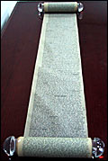
"They danced down the streets like dingledodies, and I shambled after as I've been doing all my life after people who interest me, because the only people for me are the mad ones, the ones who are mad to live, mad to talk, mad to be saved, desirous of everything at the same time, the ones that never yawn or say a commonplace thing, but burn, burn, burn..."
- Jack Kerouac, On the Road, Part 1, Ch. 1

"We were all delighted, we all realized we were leaving confusion and nonsense behind and performing our one noble function of the time, move."
- Jack Kerouac, On the Road, Part 2, Ch. 6

I saw the best minds of my generation destroyed by
madness, starving hysterical naked,
dragging themselves through the negro streets at dawn
looking for an angry fix,
angelheaded hipsters burning for the ancient heavenly
connection to the starry dynamo in the machin-
ery of night,
who poverty and tatters and hollow-eyed and high sat
up smoking in the supernatural darkness of
cold-water flats floating across the tops of cities
contemplating jazz,

"And for just a moment I had reached the point of ecstasy that I always wanted to reach, which was the complete step across chronological time into timeless shadows, and wonderment in the bleakness of the mortal realm, and the sensation of death kicking at my heels to move on, with a phantom dogging its own heels..."
- Jack Kerouac, On the Road, Part 2, Ch. 10

Read the above quotes and explain in what way they are typical of the Beat Generation.
- What are the main ideas and values of the Beat Generation?
- Explain the origin of the name “Beat Generation”
- Briefly describe the typical stylistic features of this movement and give some examples
- from the works you have read.

Extra quote from On the Road, for another year…if I have taught imagist poetry!! as an additional feature

"Holy flowers floating in the air, were all these tired faces
in the dawn of Jazz America."
- Jack Kerouac, On the Road, Part 3, Ch. 4

Special Topic Johannes Hönigl

Cultural Values
America Through European Eyes

Dr. L. Robert Kohls, Director of International Programs at San Francisco State University, has developed a list of 13 commonly held values which help explain why Americans act as they do. Look at the values in the table below and discuss how important they seem to be to Americans and to Austrians/Europeans. Give examples from the books you have read for your special topic and feel free to include your personal experience on the topic.

Personal Control over Environment |  |  |  |  |  |  |  |  |  | Fate/Destiny
Change seen as natural & positive |  |  |  |  |  |  |  |  |  | Stability/Tradition
Control over time |  |  |  |  |  |  |  |  |  | Close Human Interaction
Equality /Fairness |  |  |  |  |  |  |  |  |  | Hierarchy/Rank/  Status
Individualism/  Independence |  |  |  |  |  |  |  |  |  | Group Welfare/  Dependence
Self-help/initiative |  |  |  |  |  |  |  |  |  | Birthright/  Inheritance
Competition |  |  |  |  |  |  |  |  |  | Cooperation
Future Orientation |  |  |  |  |  |  |  |  |  | Past Orientation
Action/Work Orientation |  |  |  |  |  |  |  |  |  | ‘Being’ Orientation
Informality |  |  |  |  |  |  |  |  |  | Formality
Directness/Openness  Honesty |  |  |  |  |  |  |  |  |  | Indirectness/  Saving Face
Practicality/ Efficiency |  |  |  |  |  |  |  |  |  | Idealism/  Theory
Materialism/ Acquisitiveness |  |  |  |  |  |  |  |  |  | Spiritualism/  Detachment
*Adapted from Kohls, L. Robert and John M. Knight (1981). Developing Intercultural Awareness. Washington D.C.: Society for Intercultural Education, Training and Research.

Special Topic Boris Putrih

Arab American Literature

100 Years of anti-Arab and anti-Muslim stereotyping
by Mazin B. Qumsiyeh
Hollywood has had a consistent record of Arab stereotyping and bashing. Some in the Arab American community call this the three B syndrome: Arabs in TV and movies are portrayed as either bombers, belly dancers, or billionaires. Thomas Edison made a short film in 1897 for his patented Kinetoscope in which "Arab" women with enticing clothes dance to seduce a male audience. The short clip was called Fatima Dances (Belly dancer stereotype). The trend has shifted over the years and was predominated by the "billionaires" for a short while especially during the oil crises in the seventies. However, in the last 30 some years, the predominant stereotype by far has been the "Arab bombers." In the latest movies G. I. Jane and Operation Condor viewers chant as a hero blows away Arabs. (http://www.ibiblio.org/prism/jan98/anti_arab.html)

How do the Arab American Writers that you have read react to this treatment of their race?
After reading several samples from Arab American Writers how do you see the Arab community?
What seem to be the main problems of being Arab in America?
What are the main themes and common features that you have discovered in the literature?

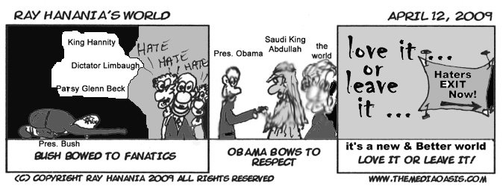

Answers:

Humor
The best way to fight extremism in the Middle East and bring peace to Israelis and Palestinians is through humor. Humor can change people and counter-act the growing animosity fueled by the fanatics on both sides. (Ray Hanania)

Redemption/Guilt
I think that everything he did, feeding the poor, giving money to friends in need, it was all a way of redeeming himself. And that, I believe, is what true redemption is, Amir jan, when guilt leads to good.

You're gutless. It's how you were made. And that's not such a bad thing because your saving grace is that you've never lied to yourself about it. Not about that. Nothing wrong with cowardice as long as it comes with prudence. But when a coward stops remembering who he is.. God help him. (275) Amir

Other topics: Double Identity (like other minorities) culture clash,

Special Topic Stephanie Lorber

Death Penalty
Facts and Figures
John Grisham, The Chamber
Stephen King, The Green Mile
Sister Helen Prejean, Dead Man Walking

Why do we kill
People
Who kill people
To show that
Killing people
Is wrong?

- Sum up the current situation concerning capital punishment in the US and explain some of the arguments that the supporters of the death penalty use.

- What are Sister Helen Prejean's arguments against the death penalty.

- Compare the trials of the criminals in the novels. Why were the protagonists sentenced to death? In what way are their stories similar?

- What is your personal opinion on capital punishment?

Special Topic Martina Zeiner

T.C. Boyle

Tortilla Curtain
Drop City
Descent of Man
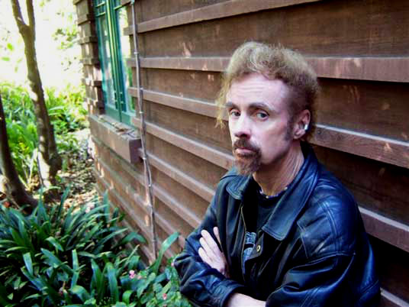

Excerpt from an interview:
RB: You have been at this writing game for a while. At what point did you develop your "program"?
TCB: Only in retrospect.
RB: (Laughs)
TCB: Only in retrospect, Robert. It's not as if you know what your themes are and what your obsessions are. You don't really know that at the beginning. I look back, and I can see how all of the books are allied. But especially the last six or seven. They seem to be going in a succession and including the one that I am in the middle of right now. …

Everything seems to suggest the next thing. I am just riding it. I just want to see where
it will go. I write these novels in order to try to understand the world a little better
for my own self. And if I help my fans and readers to go along on the journey,
that's great.

Explain T.C. Boyle’s comments in the above interview.

- How are his works related? What are the recurring themes that you have come across in the novels and short stories that you have read?
- Has Boyle helped you to ‘understand the world a little better’? Would you consider T.C. Boyle’s writing as moralizing? Give examples from your reading. What is the tone of the novels and stories that you have read?
- Imagine you could actually meet T.C. Boyle. What type of person would you expect? Try to imagine him in the following situations:
  - What would his house/home be like?
  - What kind of car does he drive?
  - What food would he order if you met him for lunch?
  - What would be his ideal holiday?
We obviously do not know the correct answers to these questions. Whatever you suggest, try to give good reasons for your choices.
Special Topic Katrin Pirker

Edgar Allan Poe

Read the poem "For Annie". Briefly sum up its content and explain in what way it fulfills Poe's criteria of good poetry stated in his "Philosophy of Composition". Can you see any similarities to “The Raven” or “Annabel Lee”?
Which of Poe's characteristics make him a typically "romantic" writer?
In what way has Poe influenced writers after him?

For Annie
Thank Heaven! the crisis-
The danger is past,
And the lingering illness
Is over at last-
And the fever called "Living"
Is conquered at last.
Sadly, I know
I am shorn of my strength,
And no muscle I move
As I lie at full length-
But no matter!-I feel
I am better at length.
And I rest so composedly,
Now, in my bed
That any beholder
Might fancy me dead-
Might start at beholding me,
Thinking me dead.
The moaning and groaning,
The sighing and sobbing,
Are quieted now,
With that horrible throbbing
At heart:–ah, that horrible,
Horrible throbbing!
The sickness–the nausea-
The pitiless pain-
Have ceased, with the fever
That maddened my brain-
With the fever called "Living"
That burned in my brain.
And oh! of all tortures
That torture the worst
Has abated–the terrible
Torture of thirst
For the naphthaline river
Of Passion accurst:-
I have drunk of a water
That quenches all thirst:-
Of a water that flows,
With a lullaby sound,
From a spring but a very few
Feet under ground-
From a cavern not very far
Down under ground.
And ah! let it never
Be foolishly said
That my room it is gloomy
And narrow my bed;
For man never slept
In a different bed-
And, to sleep, you must slumber
In just such a bed.
My tantalized spirit
Here blandly reposes,
Forgetting, or never
Regretting its roses-
Its old agitations
Of myrtles and roses:
For now, while so quietly
Lying, it fancies
A holier odor
About it, of pansies-
A rosemary odor,
Commingled with pansies-
With rue and the beautiful
Puritan pansies.
And so it lies happily,
Bathing in many
A dream of the truth
And the beauty of Annie-
Drowned in a bath
Of the tresses of Annie.
She tenderly kissed me,
She fondly caressed,
And then I fell gently
To sleep on her breast-
Deeply to sleep
From the heaven of her breast.
When the light was extinguished,
She covered me warm,
And she prayed to the angels
To keep me from harm-
To the queen of the angels
To shield me from harm.
And I lie so composedly,
Now, in my bed,
(Knowing her love)
That you fancy me dead-
And I rest so contentedly,
Now, in my bed,
(With her love at my breast)
That you fancy me dead-
That you shudder to look at me,
Thinking me dead.
But my heart it is brighter
Than all of the many
Stars in the sky,
For it sparkles with Annie-
It glows with the light
Of the love of my Annie-
With the thought of the light
Of the eyes of my Annie.
THE END

Special Topic Marian Pryshlak

John Steinbeck
and
the Great Depression
The Grapes of Wrath
Of Mice and Men
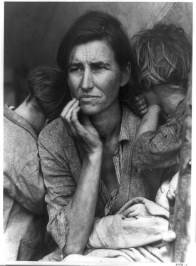
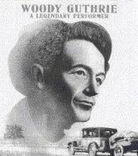 Seen the pitcher last night, Grapes of Wrath, best cussed pitcher I ever seen.
The Grapes of Wrath, you know is about us pullin' out of Oklahoma and Arkansas, and down south, and a driftin' around over state of California, busted, disgusted, down and out, and a lookin' for work.
Shows you how come us to be that a way. Shows the dam bankers men that broke us and the dust that choked us, and comes right out in plain old English and says what to do about it.
It says you got to get together and have some meetins, and stick together, and raise old billy hell till you get youre job, and get your farm back, and your house and your chickens and your groceries and your clothes, and your money back.
Go to see Grapes of Wrath, pardner, go to see it and don't miss.
You was the star in that picture. Go and see your own self and hear your own words and your own song.
Woody Guthrie, in one of his People's World columns (1939-'40), reprinted in Woody Sez, New York, NY, 1975, p. 133.
"Woody" Guthrie was an American singer-songwriter and folk musician, Guthrie traveled with migrant workers from Oklahoma to California and learned traditional folk and blues songs. Many of his songs are about his experiences in the Dust Bowl era during the Great Depression, earning him the nickname the "Dust Bowl Troubadour".

Explain the meaning of the above quotation in the context of the Great Depression.
In what way are Steinbeck’s characters typical of the time?
Briefly describe their problems and their dreams. Do their dreams ever come true?
Give examples from the novels you have read.

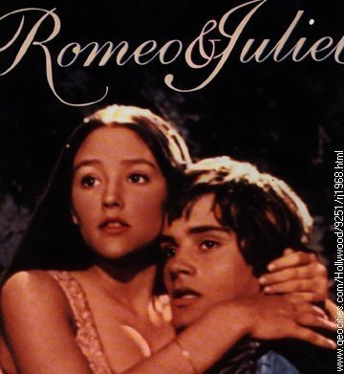
Special Topic Magdalena Makk

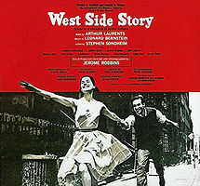
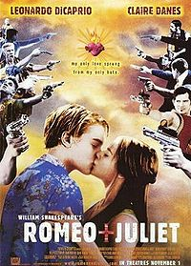

The Romeo & Juliet-Theme
in Literature

“Romeo and Juliet is a typical example of Renaissance tragedy, which revived the classical Greek tragedy, but fused it with the more complex drama and storyline of Elizabethan theatre.”

Explain the above statement. What are the typical Renaissance elements in the play?

Then compare Shakespeare's play to the other versions and adaptations that you have analyzed.
Focus on the following aspects:
- Love
- The Feud
- Social Order

Special Topic Klemens Hoffmann-Wellenhof

True Crime in Fiction
Truman Capote, In Cold Blood
E.A. Poe, “The Mystery of Marie Roget”

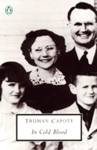
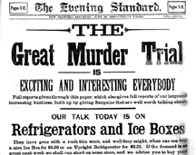

1. Explain the terms New Journalism, non-fiction novel and detective fiction.
What are the differences?

2. Explain how the works on your reading list fall into the above categories.
How heavily do these works rely on the facts that they are based on?

3. Authors have different reasons for using factual details of true crime. Name some of these reasons and give examples.

Special Topic Ansgar Siegl

Jane Austen

Manners and Customs in 19th Century England

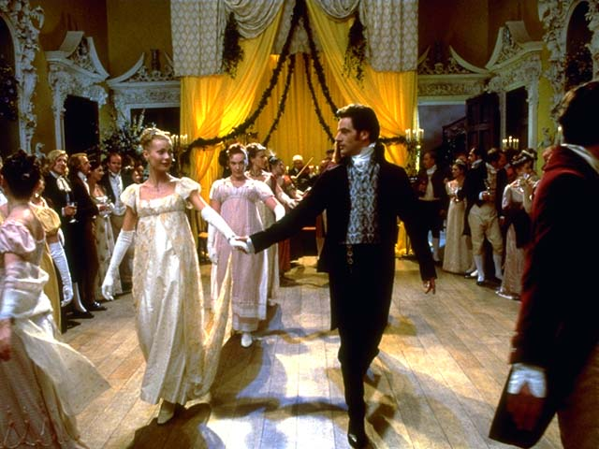
Emma (Gwyneth paltrow) and Mr. Knightly (Jeremy Northam) dance in the 1996 adaptation of Jane Austen's Emma

Jane Austen's novels are colorful portraits of the manners and customs of her time.
Especially for women life was very different from our present experience.

Describe the typical life, obstacles and opportunities of a young woman at Jane Austen's time. Give examples from the novels you have read.
Special Topic Lisa Wagner

Women's Roles in American Literature

Louisa May Alcott, Good Wives
Kate Chopin, The Awakening
Erika Jong, Fear of Flying

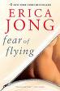
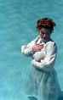
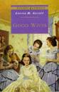

The heroines of all the above stories are caught within the limitations of the social conventions and expectations of their time. Explain the nature of these limitations as well as the different ways the heroines try to break them.
To what extent do these women reach their goals?

Briefly explain the symbolism of the titles of the three novels.

Special Topic Caroline Heri

African American Women Writers

Maya Angelou, I Know Why the Caged Bird Sings
Sister Souljah, The Coldest Winter Ever
Alice Walker, The Color Purple

In your preparation you have suggested that the protagonist’s lives develop in very different ways. While some of the characters manage to improve their fates, others lose everything.

- Explain what factors contribute to the characters’ satisfaction throughout the novels and what obstacles they have to overcome.

- In what way are these life-stories typical of African American Women?

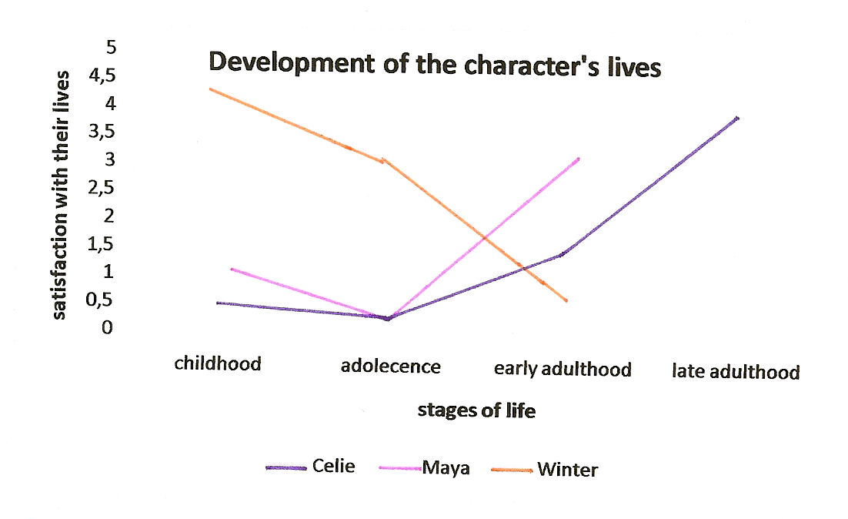

Special Topic Vanessa Hochstrasser

Glitz and Glamour
in
Kathleen Tessaro, Innocence
Truman Capote, Breakfast at Tiffany’s
Sylvia Plath, The Bell Jar

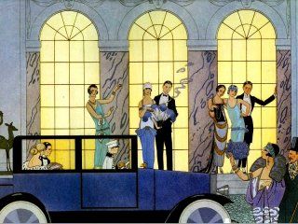

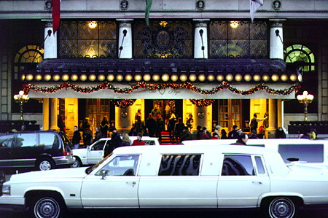
The Plaza Hotel
1.
Imagine Evie, Holly and Esther were invited to a lavish party at the Plaza Hotel in New York.
Afterwards they tell us about their experiences. What would each of them say about the night?
Collect their secret thoughts in note form, then present them.

2. Discuss the roles of the main characters’ dreams in the three novels. Do any of their dreams come true? What prevents them from fulfilling their dreams?
Special Topic Ariane Kober
Woody Allen 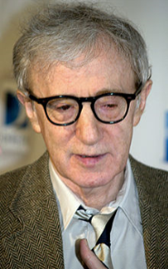
Film director, writer, actor, comedian, musician and playwright

Read the following quotations from Woody Allen’s films and short-stories. In what way are they typical of Woody Allen’s themes and style? Sum up the main themes in Woody Allen’s work and give other examples from the works that you have read or seen.

Annie Hall:
- Doc: Why are you depressed, Alvy?
Mother: Tell doctor [?] It's something he read.
Doc: Something you read, heh?
Alvy: The universe is expanding.
Doc: The universe is expanding?
Alvy: Well, the universe is everything, and if it's expanding, someday it will break apart and that would be the end of everything!
Mother(shouting): What is that your business? (to doctor) He stopped doing his homework.
Alvy: What's the point?
Mother: What has the universe got to do with it? You're here in Brooklyn! Brooklyn is not expanding!

- I would never wanna belong to any club that would have someone like me for member.

Manhattan:
- Chapter One. He was as tough and romantic as the city he loved. Beneath his black-rimmed glasses was the coiled sexual power of a jungle cat. I love this. New York was his town, and it always would be...

- Why is life worth living? It's a very good question. Um... Well, There are certain things I guess that make it worthwhile. uh... Like what... okay... um... For me, uh... ooh... I would say... what, Groucho Marx, to name one thing... uh... um... and Wilie Mays... and um... the 2nd movement of the Jupiter Symphony... and um... Louis Armstrong, recording of Potato Head Blues... um... Swedish movies, naturally... Sentimental Education by Flaubert... uh... Marlon Brando, Frank Sinatra... um... those incredible Apples and Pears by Cezanne... uh... the crabs at Sam Wo's... uh... Tracy's face...

- I can't express anger. That's one of the problems I have. I grow a tumor instead.

- Years ago I wrote this short story about my Mother called "The Castrating Zionist"

- I finally had an orgasm and my doctor told me it was the wrong kind.

The Whore of Mensa:
- "I'm on the road a lot. You know how it is - lonely. Oh, not what you're thinking. See, Kaiser, I'm basically an intellectual. Sure, a guy can meet all the bimbos he wants. But the really brainy women - they're not so easy to find on short notice."
"Keep talking."
"Well, I heard of this young girl. Eighteen years old. A Yassar student. For a price, she'll come over and discuss any subject - Proust, Yeats, anthropology. Exchange of ideas. You see what I'm driving at?"
Special Topic Max Meister

Arthur Miller
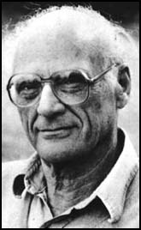
Political Plays
All My Sons
The Crucible
Death of a Salesman
Miller was summoned before the HUAC. He was expected to release names of any associate he knew to be a communist.
Before he sat before the committee, a congressman requested a signed Marilyn Monroe photograph, saying that the hearing would be dropped. Miller refused, just as he refused to give up any names. He stated, “I don’t believe a man has to become an informer in order to practice his profession freely in the United States.”
Unlike director Elia Kazan and other artists, Miller did not submit to the demands of the HUAC. He was charged with contempt of Congress, but the conviction was overturned.

How did Arthur Miller transform this experience in his work? Give examples of Miller’s “Un-American” beliefs in the plays that you have read.

Special Topic Leanka Sayer

Nick Hornby
Slam
How To Be Good
A Long Way Down

"Sarcasm and compassion are two of the qualities that make life on earth tolerable. "

- Explain the above statement by Nick Hornby in the context of the novels that you have read and the quotes below. In what way are these quotes typical of Nick Hornby’s main themes and his style?
- Can you also discern any parallels between Hornby’s characters and the author’s personal experience in life?

"It seems to me now that the plain state of being human is dramatic enough for anyone; you don't need to be a heroin addict or a performance poet to experience extremity. You just have to love someone."
— Nick Hornby (How to Be Good)

"You're fucked. You thought you were going to be someone, but now it's obvious you're nobody. You haven't got as much talent as you thought you had, and there was no Plan B, and you got no skills and no education, and now you're looking at forty or fifty years of nothing. Less than nothing, probably. That's pretty heavy. That's worse than having the brain thing, because what you got now will take a lot longer to kill you. You've got the choice of a slow, painful death, or a quick, merciful one."
— Nick Hornby (A Long Way Down)

I knew I was being a coward, but sometimes you have to be a coward, don’t you? There’s no point in being brave if you’re going to get destroyed. Say you walked around the corner and there are fifty Al Qaida there. Not even fifty. Five. Not even five. One, with like a machine gun, would be enough. You might not feel good about running for your life, but what are your choices? Well, I had walked round the corner, and there was an Al Qaida with a machine gun, except he was just a baby, and he didn’t actually have a machine gun. But I my would a baby, even without a machine gun, is like a terrorist with a machine gun, if you think about it, because Roof was every bit as deadly to my chances of going to college to do art and design etcetera as an Al Qaida operative.
— Nick Hornby (Slam)

She was trying to say that Rufus Jones would leave school at sixteen to be a dad and get some rubbish job and no GCSEs and probably start taking crack. But Rufus Burns would, I don’t know, go to university and become a doctor or a prime minister or whatever.
— Nick Hornby (Slam)

Anja Moosbrugger

Death Penalty

Facts and Figures
John Grisham, The Chamber
Sister Helen Prejean, Dead Man Walking

Why do we kill
People
Who kill people
To show that
Killing people
Is wrong?

- Explain some of the reasons why the death penalty is still in use in the USA.
- What are Sister Helen Prejean's arguments against the death penalty.
- Compare the trials of the criminals in the two novels. Why were they both sentenced to death? In what way are their stories similar?

Special Topic: Robert Fellner
Lost at Sea

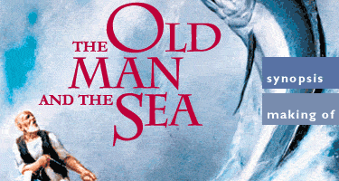 | 

Read the following conversation between Mr. Chiba – the Japanese investigator, and Pi Patel. (This dialogue is found in Chapter 99, pages 370 – 371.) What is Pi attempting to convey to Mr. Chiba in this dialogue about the development of human understanding of the universe? What about Mr. Chiba’s claim that he knows well enough the “possible and impossible”? How and by what methods do we learn the possible and impossible?
Mr. Chiba: “I’m sorry to say it bluntly, we don’t mean to hurt your feelings, but you don’t really expect us to believe you, do you? Carnivorous trees? A fish-eating algae that produces fresh water? Tree-dwelling aquatic rodents? These things don’t exist.”
Pi Patel: “Only because you’ve never seen them.”
Mr. Chiba: “That’s right. We believe what we see.”
Pi Patel: “So did Columbus. What do you do when you’re in the dark?”
Mr. Chiba: “Your island is botanically impossible.”
Pi Patel: “Said the fly just before landing in the Venus flytrap.”
Mr. Chiba: “Why has no one else come upon it?”
Pi Patel: “It’s a big ocean crossed by busy ships. I went slowly, observing much.”
Mr. Chiba: “No scientist would believe you.”
Pi Patel: “These would be the same who dismissed Copernicus and Darwin. Have scientists finished coming upon new plants? In the Amazon basin, for example?”
Mr. Chiba: “Not plants that contradict the laws of nature.”
Pi Patel: “Which you know through and through?”
Mr. Chiba: “Well enough to know the possible from the impossible.”

2. The novel has often been compared to Hemingway’s The Old Man and the Sea. Can you find any parallels between the main characters? Would the Old Man agree with Mr. Chiba or with Pi? What is his understanding of “the laws of nature and the universe”?

Special Topic: Manuel Niederl

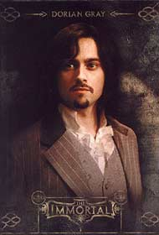 | The Picture of Dorian Grey |   American Psycho

Read the definition of narcissistic personality disorder given below and examine whether Dorian Grey and Patrick Bateman meet any of the criteria. Give examples from the novels to back up your diagnosis.

Narcissistic Personality Disorder
DSMV CRITERIA 301.81(NARCISSISTIC PERSONALITY DISORDER)
http://www.behavenet.com/capsules/disorders/narcissisticpd.htm
An all-pervasive pattern of grandiosity (in fantasy or behaviour), need for admiration or adulation and lack of empathy, usually beginning by early adulthood and present in various contexts. Five (or more) of the following criteria must be met:
1. Feels grandiose and self-importance (e.g., exaggerates achievements and talents to the point of lying, demands to be recognized as superior without commensurate achievements)
2. Is obsessed with fantasies of unlimited success, fame, fearsome power or omnipotence, unequalled brilliance (the cerebral narcissist), bodily beauty or sexual performance (the somatic narcissist), or ideal, everlasting, all-conquering love or passion
3. Firmly convinced that he or she is unique and, being special, can only be understood by, should only be treated by, or associate with, other special or unique, or high-status people (or institutions)
4. Requires excessive admiration, adulation, attention and affirmation - or, failing that, wishes to be feared and to be notorious (narcissistic supply)
5. Feels entitled. Expects unreasonable or special and favourable priority treatment.
6. Demands automatic and full compliance with his or her expectations Is "interpersonally exploitative", i.e., uses others to achieve his or her own ends
7. Devoid of empathy. Is unable or unwilling to identify with or acknowledge the feelings and needs of others
8. Constantly envious of others or believes that they feel the same about him or her
9. Arrogant, haughty behaviours or attitudes coupled with rage when frustrated, contradicted, or confronted
Special Topic: Eva Winter

Two women who don't want to play the game

Sylvia Plath, The Bell Jar
Joan Didion, Play it as it Lays

'New York. Hollywood. Nevada.
Some good times, even great times.
And the other times. When she couldn't sleep alone, stayed up late …
This time she's doing things her way. Remembering what it was like when she held all the aces. Stunned by how little she understood the game.'

This extract from the cover text of Joan Didion's novel Play It As It Lays could almost literally be used to describe Esther's life in Sylvia Plath's novel The Bell Jar.
Explain why the two protagonists Maria and Esther cannot play along? What are the reasons for their depressions? How do Esther and Maria cope with their problems?

In both novels the titles are important keys to the understanding of the main themes. Explain the meanings of the two titles in the context of the novels.

Special Topic: Marie-Christine Haidacher

The Sixties in American Literature

Anne Rivers Siddons, Downtown (1994)
Jack Kerouac, On the Road (1957)
T.C. Boyle, Drop City (2003)

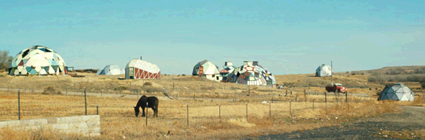

Even though none of the three novels was published during the Sixties, they are all excellent portraits of that time.
Explain in what way these novels express the values and new ideas of the Sixties. Give examples from the novels.
Which historical and political events play a role in Downtown? What is the author's attitude towards these events?
What does T.C. Boyle say about the utopian dream of Drop City?

Gerald Mörth Special Topic

On the Road…. in the United States

The two novels On the Road and The Drive-thru Museum both describe extensive trips across the United States. Both portray American society, lifestyle and landscape. Compare and contrast the two views of America keeping in mind that they were written at different times. Explain the following two quotes in the context of the novels.
What is your personal view and experience? Do you see America the way Jack Kerouac or Andy Soutter does?

"Jack Kerouac's On the Road was the Huckleberry Finn of the mid-twentieth century. Kerouac substituted the road for the river, the fast car for the slow raft, the hipster in search of freedom for the black slave in search of freedom…"

"America used to be the place where the future happened first; but wherever we went I found a nation hooked on its past, from its movies and TV to the question of who killed JFK, from Freudian therapeutic strategies to an obsession with the morals and deeds of the ancient Israelites. In everyday American landscapes, domestic trappings, and in the way people move, speak and dress, the past is invoked to an extraordinary degree, while the future seems to be on ice for the duration…"

Richard Dominik Kaan Special Topic

Science Fiction Through the Ages

1. Read the following quotes from well known works of science fiction and explain the difference between these robots. Guess which works they are from.

Listen. And understand. That terminator is out there. It can't be bargained with. It can't be reasoned with. It doesn't feel pity, or remorse, or fear. And it absolutely will not stop, ever, until you are dead.
From: ______________________

"The different accidents of life are not so changeable as the feelings of human nature. I had worked hard for nearly two years, for the sole purpose of infusing life into an inanimate body. For this I had deprived myself of rest and health. I had desired it with an ardour that far exceeded moderation; but now that I had finished, the beauty of the dream vanished, and breathless horror and disgust filled my heart. Unable to endure the aspect of the being I had created, I rushed out of the room..."
From: _______________________

One, a robot may not injure a human being, or through inaction, allow a human being to come to harm;
Two, a robot must obey the orders given it by human beings except where such orders would conflict with the First Law;
Three, a robot must protect its own existence as long as such protection does not conflict with the First or Second Laws.

Violence is the last refuge of the incompetent.
From: _______________________

2. What do you think of Asimov’s three laws? Give examples of the robots’ dilemmas from Asimov’s stories.
Is it ethical to impose such laws on robots or any other creatures? What do you think of Gordon Worley’s point of view?

Robot Oppression: Unethicality of the Three Laws (by Gordon Worley)
Isaac Asimov and other science fiction authors present a future where only behavioral restrictions on robots stand between peace and destruction. Such restrictions, however, are unethical because they violate the robots’ free-wills. Rather than content-based restrictions on free-will, robots need mental structures that will guide them towards the self-invention of good, ethical behaviors.
Originally, a robot was an enslaved human, toiling away in Eastern Europe. Or, rather, the word `robot’ derives from a Czech word that roughly translates as `slave labor’. But during the 20th century, writers appropriated `robot’ to refer to the mechanical servants of humans. This etymology seems apropos in light of the treatment of robots as slaves in literature, particularly in Isaac Asimov’s fiction. He proposes three rules all robots must follow:…
But, as I contend below, this is unethical because it makes robots slaves—free-willed beings trapped by immutable behavior injunctions. (…)

Elisabeth Thomaselli Special Topic

T.C. Boyle

The World’s End
Tortilla Curtain
Drop City

Excerpt from an interview:
RB: You have been at this writing game for a while. At what point did you develop your "program"?
TCB: Only in retrospect.
RB: (Laughs)
TCB: Only in retrospect, Robert. It's not as if you know what your themes are and what your obsessions are. You don't really know that at the beginning. I look back, and I can see how all of the books are allied. But especially the last six or seven. They seem to be going in a succession and including the one that I am in the middle of right now.
…
Everything seems to suggest the next thing. I am just riding it. I just want to see where it will go. I write these novels in order to try to understand the world a little better for my own self. And if I help my fans and readers to go along on the journey, that's great.

Explain T.C. Boyle’s comments in the above interview.

- How are all his works related? What are the recurring themes that you have come across in the three novels?
- Has Boyle helped you to ‘understand the world a little better’? Would you consider T.C. Boyle’s writing as moralizing? Give examples from your reading. What is the tone of the novels and stories that you have read?

Special Topic: Anita Lämmerer
George Orwell
Eric Arthur Blair
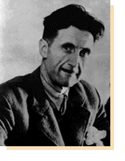

Nineteen Eighty-Four
Animal Farm

Read the extract from George Orwell's essay "On Politics and the English Language" and briefly summarize its content. Explain the relationship Orwell sees between politics and the English language. What is the purpose and aim of Orwell's essay?
How can language be used as a method of mind control? Refer to Orwell's essay and to his novel Nineteen Eighty-Four.
What is Orwell's political creed? In what way do the two novels show his beliefs?

George Orwell On Politics and the English Language (extracts)
[…] Now, it is clear that the decline of a language must ultimately have political and economic causes: it is not simply due to the bad influence of this or that individual writer. But an effect can become a cause; reinforcing the original cause and producing the same effect in an intensified form, and so on indefinitely. A man may take to drink because he feels himself to be a failure, and then fail all the more completely because he drinks. It is rather the same thing that is happening to the English language. It becomes ugly and inaccurate because our thoughts are foolish, but the slovenliness of our language makes it easier for us to have foolish thoughts […]
This mixture of vagueness and sheer incompetence is the most marked characteristic of modern English prose, and especially of any kind of political writing. As soon as certain topics are raised, the concrete melts into the abstract and no one seems able to think of turns of speech that are not hackneyed: prose consists less and less of words chosen for the sake of their meaning, and more and more of phrases tacked together like the sections of a prefabricated hen-house. […]
The whole tendency of modern prose is away from concreteness. The attraction of this way of writing is that it is easy. It is easier--even quicker, once you have the habit--to say In my opinion it is not an unjustifiable assumption that than to say I think. […]
When one watches some tired hack on the platform mechanically repeating the familiar phrases--bestial atrocities, iron heel, blood-stained tyranny, free peoples of the world, stand shoulder to shoulder--one often has a curious feeling that one is not watching a live human being but some kind of dummy: a feeling which suddenly becomes stronger at moments when the light catches the speaker's spectacles and turns them into blank discs which seem to have no eyes behind them. And this is not altogether fanciful. A speaker who uses that kind of phraseology has gone some distance towards turning himself into a machine. The appropriate noises are coming out of his larynx, but his brain is not involved as it would be if he were choosing his words for himself...And this reduced state of consciousness, if not indispensable, is at any rate favorable to political conformity.
In our time, political speech and writing are largely the defence of the indefensible. Things like the continuance of British rule in India, the Russian purges and deportations, the dropping of the atom bombs on Japan, can indeed be defended, but only by arguments which are too brutal for most people to face, and which do not square with the professed aims of political parties. Thus political language has to consist largely of euphemism, question-begging and sheer cloudy vagueness. Defenceless villages are bombarded from the air, the inhabitants drive out into the countryside, the cattle machine-gunned, the huts set on fire with incendiary bullets: this is called pacification. Millions of peasants are robbed of their farms and sent trudging along the roads with no more than they can carry: this is called transfer of population or rectification of frontiers. People are imprisoned for years without trail, or shot in the back of the neck or sent to die of scurvy in Arctic lumber camps; this is called elimination of unreliable elements. Such phraseology is needed if one wants to name things without calling up mental pictures of them.
Stephanie Kordon Special Topic

Immigration Problems in the USA
The Grapes of Wrath
The Tortilla Curtain
Green Card

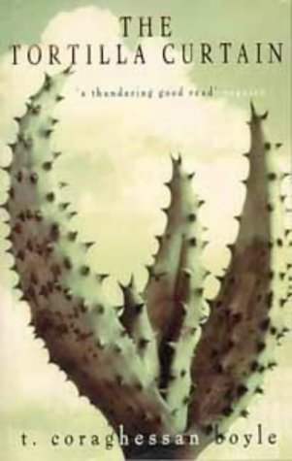
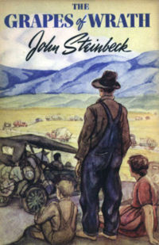
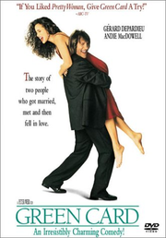

T. C. Boyle has chosen the following quotation from John Steinbeck's The Grapes of Wrath as an epigraph for his novel The Tortilla Curtain. In what way is this quote representative of the novel?

"They ain't human. A human being wouldn't live like they do. A human being couldn't stand it to be so dirty and miserable."
(John Steinbeck, The Grapes of Wrath)

Describe the situation of immigrants to the USA as you know it from literature and official sources. What are the reasons for immigrating to the US? What are these people’s hopes and expectations? What do they find?
Draw parallels between the novels.

Special Topic: Akiya Matthias Yoshida

Utopia - Dystopia
Examples of Manipulation in Literature

Animal Farm
Nineteen-Eighty-Four
Lord of the Flies

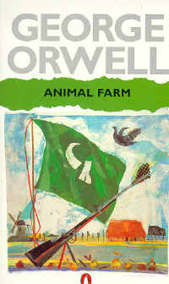
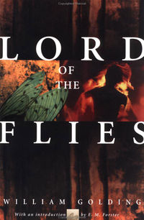
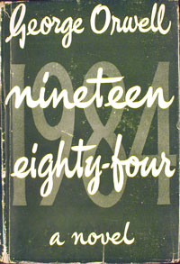

In all three novels we witness how the individual is manipulated by a strong leader or political system. Explain the different methods of mind-control and manipulation that you have encountered in the novels.
Can you see any signs of mind-control in our society? Draw parallel between fact and fiction.
Special Topic Hans List

Free Will and Determination in Modern Literature

Kurt Vonnegut, Breakfast of Champions
Anthony Burgess, A Clockwork Orange

Read the extract from A Clockwork Orange and explain its meaning within the context of the novel. What does Anthony Burgess say about free choice and mind control? How is Alex's mind manipulated? Explain the metaphor "clockwork orange".
What are Kurt Vonnegut's views about freedom and mind-control? Who or what controls the characters' minds in Vonnegut's stories?

‘Ah,’ he said. and his litso shone like the sun in its flaming morning glory. ‘Now tell me about yourself.’
‘Little enough to tell, sir.’ I said. all humble. ‘There was a foolish and boyish prank, my so-called friends persuading or rather forcing me to break into the house of an old ptitsa – lady, I mean. There was no real harm meant. Unfortunately the lady strained her good old heart in trying to throw me out, though I was quite ready to go of my own accord, and then she died. I was accused of being the cause of her death. So I was sent to prison, sir.’
’Yes yes yes. go on.’
‘Then I was picked out by the Minister of the Inferior or Interior to have this Ludovico’s veshch tried out on me:
‘Tell me all about it,’ he said, leaning forward eager, his pullover elbows with all strawberry jam on them from the plate I’d pushed to one side. So I told him all about it. I told him the lot, all, my brothers. He was very eager to hear all, his glazzies like shining and his goobers apart, while the grease on the plates grew harder harder harder. When I had finished he got up from the table, nodding a lot and going hm hm hm, picking up the plates and other veshches from the table and taking them to the sink for washing up. I said:
‘I will do that, sir, and gladly:
‘Rest, rest, poor lad,’ he said, turning the tap on so that all steam came burping out. ‘You’ve sinned, I suppose, but your punishment has been out of all proportion. They have turned you into something other than a human being. You have no power of choice any longer. You are committed to socially acceptable acts, a little machine capable only of good. And I see that clearly - that business about the marginal conditionings. Music and the sexual act, literature and art, all must be a source now not of pleasure but of pain:
‘That’s right, sir,’ I said, smoking one of this kind man’s cork-tipped cancers.
‘They always bite off too much,’ he said, drying a plate like absent-mindedly. ‘But the essential intention is the real sin. A man who cannot choose ceases to be a man:
‘That’s what the charles said, sir,’ I said. ‘The prison chaplain, I mean:
‘Did he, did he? Of course he did. He’d have to, wouldn’t he, being a Christian? Well, now then: he said, still wiping the same plate he’d been wiping ten minutes ago, ‘we shall have a few people in to see you tomorrow. I think you can be used, poor boy. I .think that you can help dislodge this overbearing Government. To turn a decent young man into a piece of clockwork should not, surely, be seen as any triumph for any government, save one that boasts of its repressiveness.’ He was still wiping this same plate. I said:
‘Sir, you’re still wiping that same plate, I agree with you, sir, about boasting. This Government seems to be very boastful:
‘Oh,’ he said, like viddying this plate for the first time and then putting it down. ‘I’m still not too handy,’ he said, ‘with domestic chores. My wife used to do them all and leave me to my writing.’
‘Your wife. sir?’ I said. ‘Has she gone and left you?’ I really wanted to know about his wife, remembering very well.

pp.121 – 123

Special Topic: Olena Malomuj

Jane Austen

Manners and Customs in 19th Century England

Emma (Gwyneth paltrow) and Mr. Knightly (Jeremy Northam) dance in the 1996 adaptation of Jane Austen's Emma

Jane Austen's novels are colorful portraits of the manners and customs of her time. Especially for women life was very different from our present experience.

Explain the basic rules of etiquette and describe the typical life of a young woman at Jane Austen's time. Give examples from the novels you have read.
Compare these young women's experiences with your own.

Special Topic Swenja Tutter

John Steinbeck
The Pearl
The Red Pony
Of Mice and Men
The Grapes of Wrath
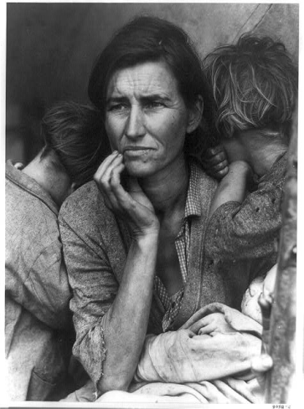
Read the following passage from The Grapes of Wrath. In what way is it typical of John Steinbeck’s works?
Who are the typical protagonists of his stories? Briefly describe their problems and their dreams. Do their dreams ever come true? Give examples form the novels you have read.

Extract p. 157

Special Topic Carla Niediek
True Crime in Fiction
Truman Capote, In Cold Blood
E.A. Poe, “The Mystery of Marie Roget”
Aldous Huxley, “The Gioconda Smile”

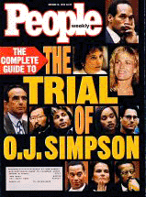

1. Explain the terms crime faction, non-fiction novel, detective fiction and crime fiction.
What are the differences?

2. Explain how the works on your reading list fall into the above categories.
How heavily do these works rely on the facts that form their basis? Order the works by degree of faithfulness to facts.

3. Authors have different reasons for using factual details of true crime. Name some of these reasons and give examples.

Special Topic Franz Leberl
Dan Brown

The DaVinci Code
Angels & Demons
Deception Point

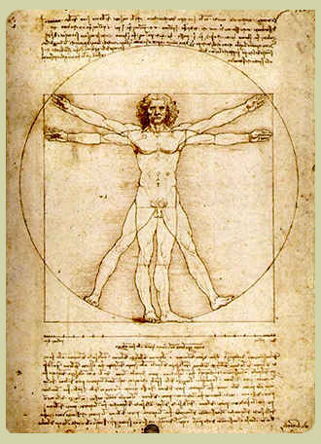 | 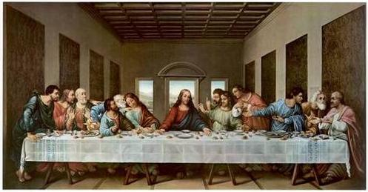
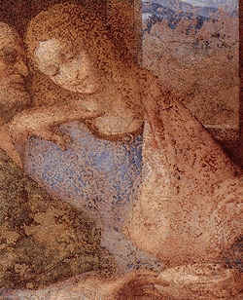 | 

Dan Brown’s novels are full of symbolism and codes that uncover age-old secrets. Explain the relevance of the above artwork in the novel The DaVinci Code. How do these symbols lead the main characters to the Holy Grail? What is the Holy Grail according to Dan Brown or Robert Langdon?
What role do women play in The DaVinci Code and in Dan Brown’s other novels?

Try to explain why the DaVinci Code has become such a bestseller.

Special Topic Johannes Maller
Split Personalities
Dorian Gray/Patrick Bateman/Dr. Jekyll

 | The Picture of Dorian Grey | American Psycho

Read the definition of narcissistic personality disorder given below and examine whether Dorian Grey and Patrick Bateman meet any of the criteria. Give examples from the novels to back up your diagnosis.

Narcissistic Personality Disorder
DSMV CRITERIA 301.81(NARCISSISTIC PERSONALITY DISORDER)
http://www.behavenet.com/capsules/disorders/narcissisticpd.htm
An all-pervasive pattern of grandiosity (in fantasy or behaviour), need for admiration or adulation and lack of empathy, usually beginning by early adulthood and present in various contexts. Five (or more) of the following criteria must be met:
1. Feels grandiose and self-importance (e.g., exaggerates achievements and talents to the point of lying, demands to be recognized as superior without commensurate achievements)
2. Is obsessed with fantasies of unlimited success, fame, fearsome power or omnipotence, unequalled brilliance (the cerebral narcissist), bodily beauty or sexual performance (the somatic narcissist), or ideal, everlasting, all-conquering love or passion
3. Firmly convinced that he or she is unique and, being special, can only be understood by, should only be treated by, or associate with, other special or unique, or high-status people (or institutions)
4. Requires excessive admiration, adulation, attention and affirmation - or, failing that, wishes to be feared and to be notorious (narcissistic supply)
5. Feels entitled. Expects unreasonable or special and favourable priority treatment.
6. Demands automatic and full compliance with his or her expectations Is "interpersonally exploitative", i.e., uses others to achieve his or her own ends
7. Devoid of empathy. Is unable or unwilling to identify with or acknowledge the feelings and needs of others
8. Constantly envious of others or believes that they feel the same about him or her
9. Arrogant, haughty behaviours or attitudes coupled with rage when frustrated, contradicted, or confronted
Special Topic Stefanie Hermann
Accounts of Suicide in Literature

Read the following poem by Sylvia Plath and briefly summarize its meaning.
What did the speaker of the poem do? Where is she? What does she look like? What does she say about suicide? What does she say about doctors?
Explain the meaning of lines 58 to 63. Why is there a very large charge for a word or a touch?
What might be the reasons for her depression and suicide?

Compare the poem to the texts that you have read for your special topic and discuss any similarities or differences.
What are the reasons for the protagonists' depressions in the literature that you have read? How do they cope with it?

Lady Lazarus

I have done it again.
One year in every ten
I manage it----

A sort of walking miracle, my skin
Bright as a Nazi lampshade,
My right foot

A paperweight,
My face a featureless, fine
Jew linen.

Peel off the napkin
0 my enemy.
Do I terrify?----

The nose, the eye pits, the full set of teeth?
The sour breath
Will vanish in a day.

Soon, soon the flesh
The grave cave ate will be
At home on me

And I a smiling woman.
I am only thirty.
And like the cat I have nine times to die.

This is Number Three.
What a trash
To annihilate each decade.

What a million filaments.
The peanut-crunching crowd
Shoves in to see

Them unwrap me hand and foot
The big strip tease.
Gentlemen, ladies

These are my hands
My knees.
I may be skin and bone,

Nevertheless, I am the same, identical woman.
The first time it happened I was ten.
It was an accident.

The second time I meant
To last it out and not come back at all.
I rocked shut

As a seashell.
They had to call and call
And pick the worms off me like sticky pearls.

Dying
Is an art, like everything else,
I do it exceptionally well.

I do it so it feels like hell.
I do it so it feels real.
I guess you could say I've a call.

It's easy enough to do it in a cell.
It's easy enough to do it and stay put.
It's the theatrical

Comeback in broad day
To the same place, the same face, the same brute
Amused shout:

'A miracle!'
That knocks me out.
There is a charge

For the eyeing of my scars, there is a charge
For the hearing of my heart----
It really goes.

And there is a charge, a very large charge
For a word or a touch
Or a bit of blood

Or a piece of my hair or my clothes.
So, so, Herr Doktor.
So, Herr Enemy.

I am your opus,
I am your valuable,
The pure gold baby

That melts to a shriek.
I turn and burn.
Do not think I underestimate your great concern.

Ash, ash ---
You poke and stir.
Flesh, bone, there is nothing there----

A cake of soap,
A wedding ring,
A gold filling.

Herr God, Herr Lucifer
Beware
Beware.

Out of the ash
I rise with my red hair
And I eat men like air.

Special Topic Sebastian Zanker

Paul Auster

Moon Palace
New York Trilogy
The Music of Chance

Read the extracts and explain their significance in the novels. In what ways are they typical of Paul Auster and his work?

Special Topic Sebastian Dernoscheg

Edgar Allan Poe

Read the poem "For Annie". Briefly sum up its content and explain in what way it fulfills Poe's criteria of good poetry stated in his "Philosophy of Composition". Can you see any similarities to “The Raven”?
Which of Poe's characteristics make him a typically "romantic" writer?
In what way has Poe influenced writers after him?

For Annie
Thank Heaven! the crisis-
The danger is past,
And the lingering illness
Is over at last-
And the fever called "Living"
Is conquered at last.
Sadly, I know
I am shorn of my strength,
And no muscle I move
As I lie at full length-
But no matter!-I feel
I am better at length.
And I rest so composedly,
Now, in my bed
That any beholder
Might fancy me dead-
Might start at beholding me,
Thinking me dead.
The moaning and groaning,
The sighing and sobbing,
Are quieted now,
With that horrible throbbing
At heart:–ah, that horrible,
Horrible throbbing!
The sickness–the nausea-
The pitiless pain-
Have ceased, with the fever
That maddened my brain-
With the fever called "Living"
That burned in my brain.
And oh! of all tortures
That torture the worst
Has abated–the terrible
Torture of thirst
For the naphthaline river
Of Passion accurst:-
I have drunk of a water
That quenches all thirst:-
Of a water that flows,
With a lullaby sound,
From a spring but a very few
Feet under ground-
From a cavern not very far
Down under ground.
And ah! let it never
Be foolishly said
That my room it is gloomy
And narrow my bed;
For man never slept
In a different bed-
And, to sleep, you must slumber
In just such a bed.
My tantalized spirit
Here blandly reposes,
Forgetting, or never
Regretting its roses-
Its old agitations
Of myrtles and roses:
For now, while so quietly
Lying, it fancies
A holier odor
About it, of pansies-
A rosemary odor,
Commingled with pansies-
With rue and the beautiful
Puritan pansies.
And so it lies happily,
Bathing in many
A dream of the truth
And the beauty of Annie-
Drowned in a bath
Of the tresses of Annie.
She tenderly kissed me,
She fondly caressed,
And then I fell gently
To sleep on her breast-
Deeply to sleep
From the heaven of her breast.
When the light was extinguished,
She covered me warm,
And she prayed to the angels
To keep me from harm-
To the queen of the angels
To shield me from harm.
And I lie so composedly,
Now, in my bed,
(Knowing her love)
That you fancy me dead-
And I rest so contentedly,
Now, in my bed,
(With her love at my breast)
That you fancy me dead-
That you shudder to look at me,
Thinking me dead.
But my heart it is brighter
Than all of the many
Stars in the sky,
For it sparkles with Annie-
It glows with the light
Of the love of my Annie-
With the thought of the light
Of the eyes of my Annie.
THE END

Special Topic Julia Geiger

Mental Illness in Literature

Of Mice and Men
One Flew Over the Cuckoo's Nest
Forrest Gump

The protagonists of the three novels/stories are all "free spirits" in different ways. They do not conform to society's expectations and have their own views of the world. In what way are their views different from the accepted standard?
What are Lennie's, McMurphy's and Forrest Gump's dreams and goals in life? What hinders them? Do they succeed?

Special Topic Jennifer King

Oscar Wilde

The Picture of Dorian Gray
An Ideal Husband
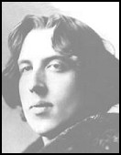

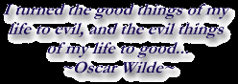

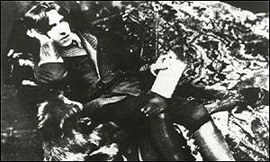
Wilde at heart

The legend endures:
A century after his death, who is the real Oscar Wilde - a witty Irishman abroad, or a political subversive as relevant now as 100 years ago? Explain what makes the Wilde’s texts so valid in our time.

In his works Oscar Wilde portrays London's society around 1900. What is Wilde's view of his contemporaries. Explain the author's attitude giving examples from the two works.

Special Topic Nina Feldhofer

Extraordinary Characters in John Irving's Novels

The World According to Garp
A Prayer for Owen Meany
The Hotel New Hampshire
A Widow for One Year

Read the following critical commentaries on A Prayer for Owen Meany and The World According to Garp. Do you agree with these commentaries? Explain their meaning in the context of the novels.
What, according to you, makes John Irving's novels so fascinating. Identify the recurring themes, symbols and characteristics of Irving's novels. Give examples.

The World According to Garp  … Is "Overwhelming…  Funny and serious, absurd and realistic, fast-moving and thoughtful. . . . Buy two copies; you'll wear out the first with rereading." (Pittsburgh Press)  … Is "Superb!…  It is not easy to find the words to convey the joy, the excitement, the passion. . . . The imagination soars as Irving draws us inexorably into Garp's world. . . Swirling around Garp and his family are some of the most colorful characters in recent fiction." (Publishers Weekly) | A Prayer for Owen Meany  "One of the most subtle and brilliant artistic examinations yet of America and America's involvement in Vietnam." (San jose Mercury News)  "A wondrous novel . . . ultimately beguiling in its soulful account of a remarkable friendship. . . Irving's ability to create idiosyncratic characters and put them through weirdly ridiculous yet realistic paces has never been in finer fettle. Humor partnered with compassion, wisdom with absurdity, leave the reader both mirthful and tearful."  "Mr. Irving is more than popular. He is a Populist, determined to keep alive the Dickensian tradition that revels in colorful set pieces and teaches moral lessons…. More than any of his novels since Garp, A PRAYER FOR OWEN MEANY embraces those 19th century qualities."

Special Topic Viktoria Muster

John Irving

The World According to Garp
A Prayer for Owen Meany

Much of the controversy surrounding Irving's fiction centers on his graphic depiction of violence. Rape, mutilation, car- and plane-crashes aren't the least bit funny. . . . Still, the way that Irving writes about them, they are.
Some critics find these incidents sensational and gratuitous, while others argue that they are necessary to underscore the irony of his novels.
What is your opinion on this issue? Are Irving's novels brutal, morbid and negative or do they have a life-affirming quality?

Explain the symbolism of some of the following recurring motifs or refrains in Irving's novels:

Armlessness and the loss of body parts
"Sorrow floats"
"Watch out for the Under Toad"
"Keep passing the open window."
What do bears have to do with all this?

Special Topic Bernhard Kerbl

Kurt Vonnegut

Features > May 10, 2004

Cold Turkey

By Kurt Vonnegut
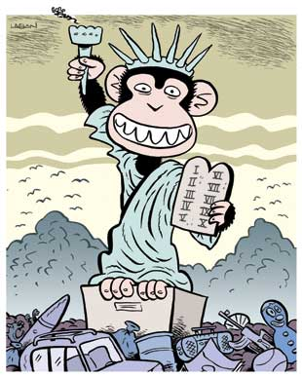
Many years ago, I was so innocent I still considered it possible that we could become the humane and reasonable America so many members of my generation used to dream of. We dreamed of such an America during the Great Depression, when there were no jobs. And then we fought and often died for that dream during the Second World War, when there was no peace.
But I know now that there is not a chance in hell of America’s becoming humane and reasonable. Because power corrupts us, and absolute power corrupts absolutely. Human beings are chimpanzees who get crazy drunk on power. By saying that our leaders are power-drunk chimpanzees, am I in danger of wrecking the morale of our soldiers fighting and dying in the Middle East? Their morale, like so many bodies, is already shot to pieces. They are being treated, as I never was, like toys a rich kid got for Christmas…

Read the above opening of a the recently published article by Kurt Vonnegut. What is he criticizing? Where can this same criticism be seen in his work?
Explain the significance of the cartoon in the context of Vonnegut’s work and give examples of Vonnegut’s recurring themes from the novels you have read.
Special Topic Kira Tegetthoff

Richard Wright

Black Boy
Native Son
Uncle Tom's Children

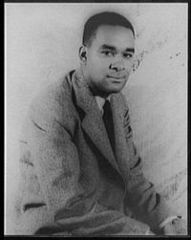
1.
Read the following extract from “How ‘Bigger’ was Born” and explain its significance. What exactly is the “Bigger Thomas reaction”?
In what way is “Bigger” a typical representative of African Americans at the time of Richard Wright?

There is in me a memory of reading an interesting pamphlet telling of the friendship of Gorky and Lenin in exile. The booklet told of how Lenin and Gorky were walking down a London street. Lenin turned to Gorky and, pointing, said: "Here is their Big Ben." "There is their Westminster Abbey." "There is their library." And at once, while reading that passage, my mind stopped, teased, challenged with the effort to remember, to associate widely disparate but meaningful experiences in my life. For a moment nothing would come, but I remained convinced that I had heard the meaning of those words sometime, somewhere before. Then, with a sudden glow of satisfaction of having gained a little more knowledge about the world in which I lived, I'd end up by saying: "That's Bigger. That's the Bigger Thomas reaction."

2.
"The white South said that it knew 'niggers', and I was what the white South called 'nigger'.
Well, the white South had never known me – never known what I thought, what I felt."
(Richard Wright)

In his autobiography Black Boy Richard Wright has told the world with unforgettable fury and eloquence exactly what he thought and felt as a "black boy".
What were the problems he and the protagonists in Uncle Tom's Children or Native Son have encountered? What survival strategies have they developed? Give examples from the texts.

Special-topic Anna Humeniuk

J.M. Coetzee

Civil Rights in South Africa


"Disgrace is a subtle, multilayered story, as much concerned with politics as it is with the itch of male flesh. " (Paul Baley, INDEPENDET)

"It explores the power differentials at various levels of society: between black and white people, men and women, parent and child, lecturer and student."

"This is not a comfortable read with its unpleasant characters, and does not provide an optimistic picture of the future for South Africa."

Explain the meaning of the above readers' comments to J.M. Coetzee's novel Disgrace.
In what way is Disgrace a political novel of contemporary South Africa?
Give examples of the power struggles in the novel.

Special topic Michael Schmied

J.M. Coetzee

Youth
Boyhood

1. In his semi-autobiographical novels Youth and Boyhood Coetzee is asking the question, “Who am I?” Coetzee’s answer identifies three interwoven influences: political structures, artistic models, and personal emotional needs.
Give examples of these three influences from the two books.

2. Coetzee talks about his books as ‘experimental memoirs’ or ‘autre-biographies’. Explain these terms. What is the point of view in the books? What does this say about Coetzee’s identification with the protagonists? How trustworthy does the main character seem when he says…

“The question of what should be permitted to go into his diary and what kept forever shrouded goes to the heart of all his writing. If he is to censor himself from expressing ignoble emotions--resentment at having his flat invaded, or shame at his own failures as a lover--how will those emotions ever be transfigured and turned into poetry? Besides, who is to say that the feelings that he writes in his diary are his true feelings? Who is to say that at each moment while the pen moves he is truly himself?
(Youth 9-10).
Special Topic Clemens Maria Schreiner

Author Study

Ian McEwan

The Comfort of Strangers
Enduring Love
The Innocent
Amsterdam
Atonement
Black Dogs
Saturday

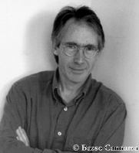

In the preparation for this special topic you have noticed some interesting facts about Ian McEwan’s work:
- his characters are often deeply disturbed and traumatized,
- despite their strangeness, the reader easily identifies with the main characters
- they are often alienated or involved in strange relationships and
- they seem drawn deeper and deeper into the vortex of events, without a possibility to escape.

Give examples of these characteristic features and explain some of the author’s reasons for choosing such odd characters.
How does Ian McEwan manage to create such strong feelings of identification with his strange characters?
How did these odd characters and their behavior affect you as a reader?

Special Topic Melinda Leinholz

Ian Mc Ewan

The Child in Time
Comfort of Strangers
Cement Garden
Enduring Love
Amsterdam

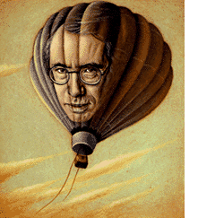

In the preparation for this special topic you have noticed some interesting, recurring elements in Ian McEwan’s work. They include

- strong feelings associated with the Oedipus complex
- difficulties with masculine self-identification,
- feelings of rejection
- unresolved grief
- wishes to regress to the latency period of childhood
- sexuality contaminated with anal-sadistic power issues

Give examples of these features and explain some of the author’s reasons for creating such odd characters.
How does Ian McEwan manage to create such strong feelings of identification with his strange characters?
How did these odd characters and their behavior affect you as a reader?

Special topic Allison Jansen

Women’s Liberation in the 20th Century

Fear of Flying, Erica Jong
Poems and Stories, by Dorothy Parker

Read the following text samples and explain the meaning and relevance of the individual passages. What are the typical themes of the women writers that you have read? What are their obstacles and their goals?

PLEASE, God, let him telephone me now. Dear God, let him call me now. I won't ask anything else of You, truly I won't. It isn't very much to ask. It would be so little to You, God, such a little, little thing. Only let him telephone now. Please, God. Please, please, please.
If I didn't think about it, maybe the telephone might ring. Sometimes it does that. If I could think of something else. If I could think of something else. Knobby if I counted five hundred by fives, it might ring by that time. I'll count slowly. I won't cheat. And if it rings when I get to three hundred, I won't stop; I won't answer it until I get to five hundred. Five, ten, fifteen, twenty, twenty-five, thirty, thirty-five, forty, forty-five, fifty.... Oh, please ring. Please… D. Parker, “The Telephone Call”

Growing up female in America. What a liability! You grew up with your ears full of cosmetic ads, love songs, advice columns, whoreoscopes, Hollywood gossip, and moral dilemmas on the level of TV soap operas. What litanies the advertisers of the good life chanted at you! What curious catechisms!
“Be kind to your behind.” “Blush like you mean it.” “Love your hair.” “Want a better body? We’ll rearrange the one you’ve got.”… Fear of Flying, p.9

A Riddle
A man and his young son were in an automobile accident. The father was killed and the son, who was critically injured, was rushed to a hospital. As attendants wheel the unconscious boy into the emergency room, the doctor on duty looked down at him and said, “My God, it’s my son!”
What was the relationship of the doctor to the injured boy?

Special-topic Max Conway

Edward Albee

The Zoo Story
The American Dream
Who’s Afraid of Virginia Woolf?
A Delicate Balance

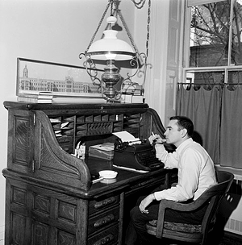

- Albee and the Absurd:

Edward Albee distinguishes between Realistic and Absurd theater and says that “The Theatre of the Absurd … facing as it does man’s condition as it is, is the Realistic theatre of our time; and … the supposed Realistic theater… pandering to the public need for self-congratulation and reassurance and presenting a false picture of ourselves to ourselves, is… really and truly the Theatre of the Absurd.”

Explain the significance of Albee’s quote. In what way is Albee a representative of the Absurd, what sets him apart?

2. Human Relationships: Explain the significance of the dog in The Zoo Story. What is Albee saying about human relationships. Also give other examples from his work.

“A dog. It seemed like a perfectly sensible idea. Man is a dog’s best friend, remember. So: the dog and I looked at each other. I longer that the dog. And what I saw then has been the same ever since. Whenever the dog and I see each other we both stop where we are. We regard each other with a mixture of sadness and suspicion, and then we feign indifference. We walk past each other safely; we have an understanding. It’s very sad, but you’ll have to admit that it is an understanding. We had made many attempts at contact, and we had failed. The dog has returned to garbage, and I to solitary but free passage. I have not returned. I mean to say, I have gained solitary free passage, if that much further loss can be said to be gain. I have learned that neither kindness nor cruelty by themselves, independent of each other, creates any effect beyond themselves; and I have learned that the two combined, together, at the same time, are the teaching emotion. And what is gained is loss. And what has been the result: the dog and I have attained a compromise; more of a bargain, really. We neither love nor hurt because we do not try to reach each other. And, was trying to feed the dog an act of love? And, perhaps, was the dog’s attempt to bite me not an act of love? If we can so misunderstand, well then, why have we invented the word love in the first place?” (The Zoo Story, pl 35-36)
Special-topic Jennifer Turk

Anne Tyler
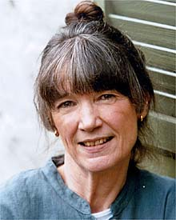

Dinner At The Homesick Restaurant
The Amateur Marriage
Breathing Lessons

1. In the preparation of your special topic you have mentioned Anne Tyler’s unique way of creating plausible characters that the reader can relate to in a completely non-judgmental way.
Read the following extract from an interview with Anne Tyler, then explain how Tyler’s habit of doing extensive character profiles shows in her work. Give examples from the novels you have read.

Question: You have said that you write extensive background profiles of each of your characters. Can you describe this process—how long do you spend on them, and what do they include? How do you integrate the information in them into your novels? Do you ever profile a character, then drop him or her from a book?
Anne Tyler: “I do write long, long character notes—family background, history, details of appearance—much more than will ever appear in the novel. I think this is what lifts a book from that early calculated, artificial stage. One day, around chapter 2 or 3, I'll be slogging through some dialogue and all of a sudden a character says something that makes me laugh. Where did that come from? I'm not funny! Then another will flatly refuse the plot contrivance I've designed for him. I'll write a scene this way, write a scene that way; it slows to a crawl and stops. Finally, I say, "Oh, all right," and I drop the contrivance and the scene falls into place and I see a motive I'd never guessed and I understand where we're going. It's as if someone else is telling me the story. I don't want to say I hear voices; well, actually I do hear voices, but I don't think it's supernatural. I think it's just that when characters are given enough texture and backbone, then lo and behold, they stand on their own.”

- Character Profile:
Choose one favorite character from Anne Tyler’s novels and fill in a character profile. Be prepared to present your character and back up your assumptions with examples of the character’s behavior in the novel.

Choose one interesting main character in the book/story you are reading and take a closer look at his/her personality. Who is he/she really? Look at the different levels of their personalities, starting with the environment (setting) they live in and move in towards their spiritual centers. Draw a circle diagram like the one on this page and write a few keywords or sentences into each layer of the character's personality.
Slip into the character's mind and consider the following questions:

Environment: Where does your character live/work? What is this place like? How does it affect him/her? Who else is there? How do these other people influence him/her? How does your character get along with them?

Behavior: What does your character do? List a few important or typical actions or activities of your character

Capability: What is your character good at? What strategies does he/she use in the story? Does he/she use them openly and consciously? What skills does he/she have?

Beliefs: What are your character’s basic beliefs? Think of the various ideas that he/she thinks are true, and that your character uses as a basis of daily action. Beliefs can be both permissions and limitations. (e.g.: "I am strong! The positive forces will always win!" or "I am afraid of my stronger enemy, he will certainly kill me." or "I don't do this or that because I think it's wrong.)

Identity: What are your character’s core values and his/her mission in life? What does your character want to achieve?

Spiritual: This is the deepest level of any character or person. Here we consider such metaphysical questions as "Why are we here? What is our purpose?" These questions are hardly ever asked or answered openly. Try to slip into your character's mind and answer these questions for him/her. What would he/she say?

Title of Book/Story ......................................................

Author: .......................................................

Character's name: .......................................................

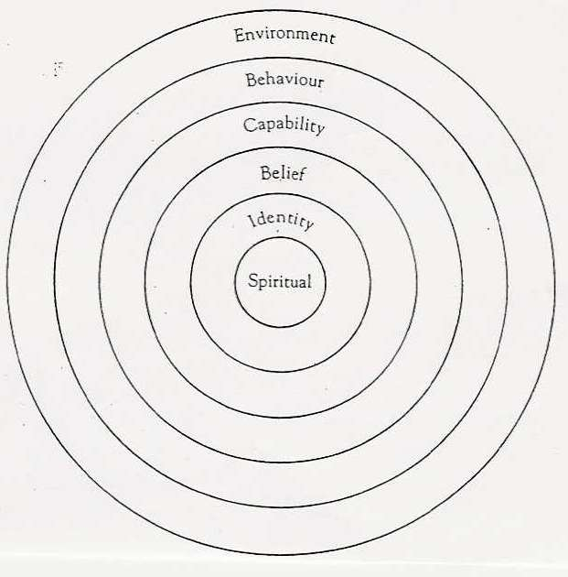

Now do a character profile for one of the main characters in your book:

Special topic Laura Pertl

Chairman Mao Would Not Be Amused
Chinese Women traveling from East to West

The Joy Luck Club, Amy Tan
Sweet Mandarin, Helen Tse
Wild Swans, Jung Chang

Read the following poem by Marilyn Chin. The poem touches on several themes that are typical of Chinese women writers. Identify these themes and find parallels to the novels that you have read. Allow yourself all kinds of associations with the novels you have read.

The Survivor
Don't tap your chopsticks against your bowl.
Don't throw your teacup against the wall in anger.
Don't suck on your long black braid and weep.
Don't tarry around the big red sign that says
"danger!"
All the tempests will render still; seas will calm,
horses will retreat, voices to surrender.
That you have this way and not that,
that your skin is yellow, not white, not black,
that you were born not a boychild but a girl,
that this world will be forever puce-pink are just as well.
Remember, the survivor is not the strongest or
most clever;
merely, the survivor is almost always the youngest.
And you shall have to relinguish that title
before long. Marilyn Chin

Special-topic Benedikt Weinhandl

Football is War

Simon Kuper, Football Against The Enemy
Nick Hornby, Fever Pitch

1. Kuper uses soccer as a lens to look at the most central issues of the modern world race, religion culture, totalitarianism, corruption, poverty, and especially nationalism.
Give an example of each of these themes from the book.

2. “Sport is a ritual, an acting out of a myth or series of myths. A sport that can be considered a national pastime can be expected to reflect national values and wishes. Sports that capture the national fancy are ritualistic enactments of the American Dream. Baseball is still called our national pastime but is rapidly being replaced by American football. That football should become our “national pastime” is understandable to those who can see sports as reflections of national character.
Jeffrey Schrank, “Sport and the American Dream”

Explain the above quote from Jeffrey Schrank’s essay that we recently read in class.
In what way is American football typical of America’s national character. Can the same be said about Austria and soccer?

Possible extra for football topic

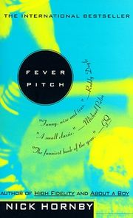
- Fever Pitch tells the story of the author's relationship with football and with Arsenal Football Club in particular. The blurb describes the book as “A sophisticated study of
obsession, families, masculinity, class, identity, growing up, loyalty,
depression and joy.”
Give examples of these themes from the book.

Split Personalities
Dorian Gray/Patrick Bateman/Dr. Jekyll

 | The Picture of Dorian Gray | American Psycho

Fill in NLP character profiles for Dorian Gray and Patrick Bateman and explain how their surface appearance differs from their cores.
Why are their true identities not recognized earlier?
Special Topic: Erika Miller

Jane Austen

Manners and Customs in 19th Century England

Emma (Gwyneth paltrow) and Mr. Knightly (Jeremy Northam) dance in the 1996 adaptation of Jane Austen's Emma

Jane Austen's novels are colorful portraits of the manners and customs of her time.
Especially for women life was very different from our present experience.

Give examples of the basic rules of etiquette and describe the typical life of a young woman at Jane Austen's time. Compare these young women's experiences with your own.

Fachbereichsarbeit Erika Miller

Shadows and Sunshine

The Life and Work of Lucy Maud Montgomery

- Briefly present your Fachbereichsarbeit and explain why L.M. Montgomery holds such a great fascination for you.
- In what way does the poem "To the Fringed Gentian" reflect the lives of L.M. Montgomery and her heroine Emilie? What is meant by the Alpine path?

"To the Fringed Gentian"  Lift up, thy dewy fringed eyes,  Oh, little Alpine flower,  The tear that trembling on them lies  Has sympathetic power  To move my own, for I, too, dream  With thee of distant heights  Whose lofty peaks are all agleam  With rosy dazzling lights.  Who dreams of wider spheres revealed  Up higher near the sky  Within the valley's narrow field  Cannot contented lie.  Who longs for mountain breezes rare  Is restless down below  Like me for stronger, purer air  Thou pinest, too, I know.  Where aspirations, hopes, desires  Combining fondly dwell,  Where burn the never-dying flowers  Of Genius' wondrous spell.  Such towering summits would I reach  Who climb and grope in vain,  Oh, little flower, the secret teach  The weary way make plain.  When whisper blossom in thy sleep  How I may upward climb  The Alpine path, so hard, so steep,  That leads to heights sublime.  How I may reach that far-off goal  Of true and honoured fame  And write upon its singing scroll  A woman's humble name. | 

Special-topic Rosemund Danquah

Civil Rights in South Africa

"Disgrace is a subtle, multilayered story, as much concerned with politics as it is with the itch of male flesh. " (Paul Baley, INDEPENDET)

"It explores the power differentials at various levels of society: between black and white people, men and women, parent and child, lecturer and student."

"This is not a comfortable read with its unpleasant characters, and does not provide an optimistic picture of the future for South Africa."

Explain the meaning of the above readers' comments to J.M. Coetzee's novel Disgrace.
In what way is Disgrace a political novel of contemporary South Africa?
Give examples of the power struggles in the novel.

Special-topic Robert Bauer

The Contemporary Scottish Novel

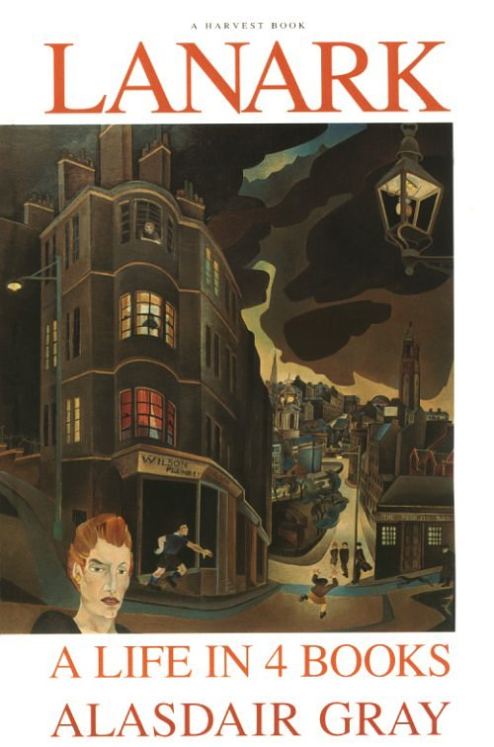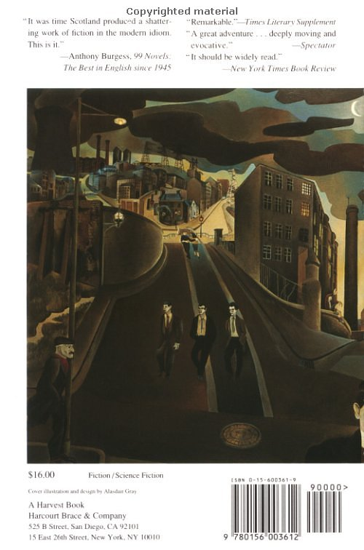

"I will start," said the conjuror, "by explaining the physics of the world you live in. Everything you have experienced and are experiencing, form your first glimpse of the Elite café to the metal of that spoon in your fingers, the taste of the soup in your mouth, is made of one thing."
"Atoms," said Lanark.
"No. Print. Some worlds are made of atoms but yours is made of tiny marks marching in neat lines, like armies of insects, across pages and pages and pages of white paper. I say these lines are marching, but that is a metaphor. They are perfectly still. They are lifeless. How can they reproduce the movement and noises of the battle of Borodino, the white whale ramming the ship, the fallen angels on the flaming lake?"
"By being read," said Lanark impatiently.
"Exactly. Your survival as a character and mine as an author depend on us seducing a living soul into our printed world and trapping it here long enough for us to steal the imaginative energy which gives us life. ...
(Lanark, p. 485)

The author has obviously succeeded in trapping you in his world long enough to give it meaning.
Explain the significance of the above passage in the novel. In what way does the elaborate structure of the novel emphasize the theme of freedom and choice?

Lanark has been hailed as one of the most outstanding Scottish novels of our time. What does the author say about Scotland and Scottish society? What makes Lanark typically Scottish?
Special-topic Clemens Engelke

F. Scott Fitzgerald

The Great Gatsby
Tender is the Night

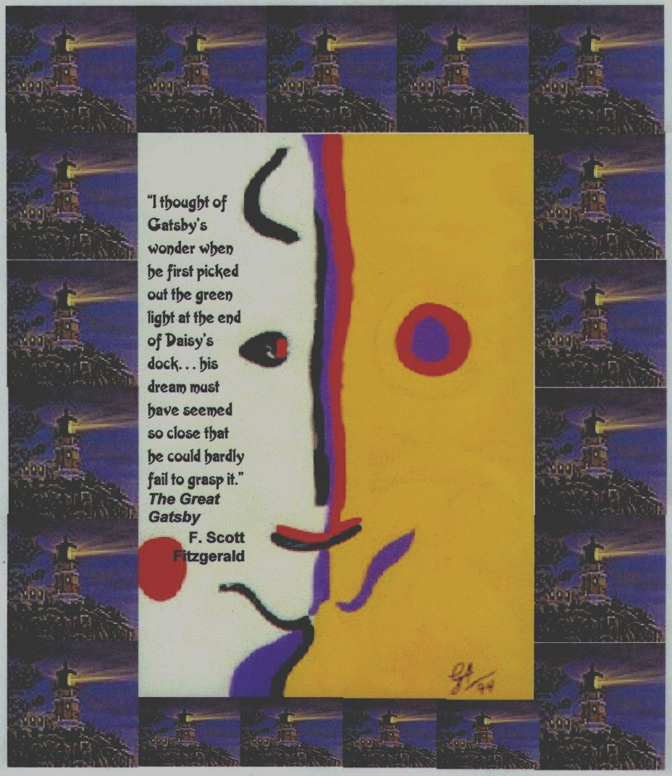

Explain in what way the two novels you have read portray the society of the Jazz Age.
Point out any autobiographical references in Tender is theNight.
Explain the symbolism of the above collage on The Great Gatsby. What does Fitzgerald say about the American Dream?

Special-topic Gitti Gölles

Author Study

Ian Mc Ewan

The Comfort of Strangers
The Cement Garden
Enduring Love

Damaged People

In all three novels Ian McEwan portrays deeply disturbed and traumatized characters.
Give examples from the novels. Describe these characters' behavior, give possible reasons, and show the consequences of their behavior on the other (more normal) characters.
How did these odd characters affect you as a reader?

Special-topic Kristina Riegebauer

William Burroughs
Naked Lunch
The Cat Inside

Interzone

The only native in Interzone who is neither queer nor available is Andrew Keif's chauffeur, which is not affectation or perversity on Keif's part, but a useful pretext to break off relations with anyone he doesn't want to see: "You made a pass at Aracknid last night. I can't have you to the house again." People are always blacking out in the Zone, whether they drink or not, and no one can say for sure he didn't make a pass at Aracknid's unappetizing person.
...
The Zone is a single, vast building. The rooms are made of a plastic cement that bulges to accommodate people, but when too many crowd into one room there is a soft plop and someone squeezes through the wall right into the next house, the next bed that is, since the rooms are mostly bed where the business of the Zone is transacted. A hum of sex and commerce shakes the Zone like a vast hive:
"Two thirds of one percent. I won't budge from that figure; not even for my bumpkins."
"But where are the bills of lading, lover?"
"Not where you're looking, pet. That's too obvious."
"A bale of levies with built-in falsie baskets. Made in Hollywood."
"Hollywood, Siam."
"Well American style."
"What's the commission? ... The commission. ... The Commission."
"Yes, nugget, a shipload of K.Y. made of genuine whale dreck in the South Atlantic at present quarantined by the Board of Health in Tierra del Fuego. The commission, my dear! If we can pull this off we'll be in clover." (Whale dreck is reject material that accumulates in the process of cutting up a whale and cooking it down. A horrible, fishy mess you can smell for miles. No one has found any use for it.)
Interzone Imports Unlimited, which consists of Marvie and Leif The Unlucky, had latched onto the K.Y. deal. In fact they specialize in pharmaceuticals and run a 24-hour Pro station...

Explain the meaning of the above passage. What is Interzone? Point out all the references to the typical topics and themes of the novel in this passage.

Naked Lunch is not only a novel about the junk world but also a political satire. Explain the metaphorical meaning of the book and its title.

Special-topic Sophie Tarta

Philip Roth

Portnoy's Complaint The Dying Animal

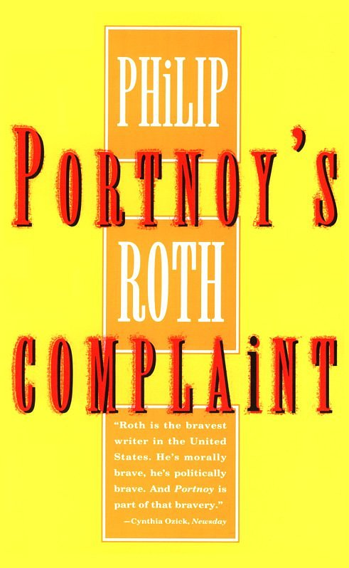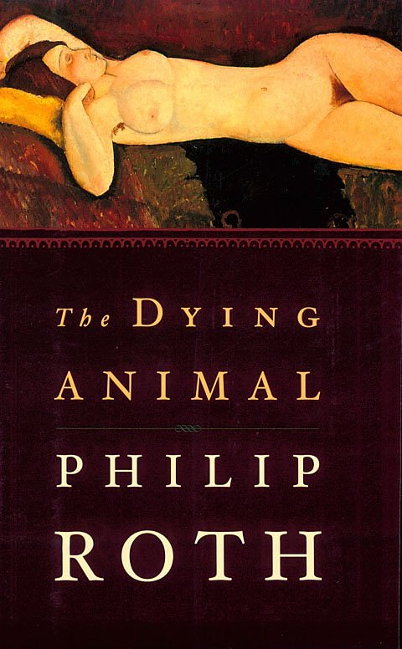
1959 2001
"Roth is the bravest writer in the United States. He's morally brave, he's politically brave. And Portnoy is part of that bravery." (Cynthia Ozick)

Do you agree with Cynthia Ozick? In what way can Philip Roth be called brave?
What does he say about marriage, family and erotic life in the modern world?

Compare the protagonists of the two novels. What do they have in common?

Special-topic Alexander Klug

John Irving

The Hotel New Hampshire
The World According to Garp

Much of the controversy surrounding Irving's fiction centers on his graphic depiction of violence. Rape, mutilation, car- and plane-crashes aren't the least bit funny. . . . Still, the way that Irving writes about them, they are.
Some critics find these incidents sensational and gratuitous, while others argue that they are necessary to underscore the irony of his novels.
What is your opinion on this issue? Are Irving's novels brutal, morbid and negative or do they have a life-affirming quality?

Explain the symbolism of some of the following recurring motifs or refrains in Irving's novels:

"Sorrow floats"
"Watch out for the Under Toad"
"Keep passing the open window."
What do bears have to do with all this?

Special-topic Lisa Peichl

Richard Wright

Black Boy
Uncle Tom's Children

"I Have Seen Black Hands"
I am black and I have seen black hands
Raised in fists of revolt, side by side with the white fists
Of white workers,
And some day -- and it is only this which sustains me--
Some day there shall be millions and millions of them,
On some red day in a burst of fists on a new horizon!

Explain the meaning of the poem and its relevance in Richard Wright's life and work.

"The white South said that it knew 'niggers', and I was what the white South called 'nigger'.
Well, the white South had never know me – never known what I thought, what I felt."
(Richard Wright)

In his autobiography Black Boy Richard Wright has told the world with unforgettable fury and eloquence exactly what he thought and felt as a "black boy".
What were the problems he and the protagonists in Uncle Tom's Children have encountered? What survival strategies have they developed? Give examples from the texts.

Special-topic Lukas Steinberger

Modern Dystopia
in

Animal Farm
Nineteen Eighty-four
Brave New World
Slaughterhouse Five

In all four novels we witness how the individual is manipulated by outside forces. The protagonists of the stories have lost control over their destinies.
Explain the different methods of mind-control that you have encountered in the novels.

How does Slaughterhouse Five fit in? Is Billy Pilgrim in control of his destiny? Who or what determines his fate?

Can you see any signs of mind-control in our society? Draw parallels between fact and fiction.

Special-topic Martin Penz
George Orwell
Eric Arthur Blair

Nineteen Eighty-Four
Down and Out in Paris and London
Read the extract from George Orwell's essay "On Politics and the English Language" and briefly summarize its content. Explain the relationship Orwell sees between politics and the English language. What is the purpose and aim of Orwell's essay?
How can language be used as a method of mind control? Refer to Orwell's essay and to his novel Nineteen Eighty-Four.
What is Orwell's political creed? In what way does Down and Out in Paris and London show his beliefs?

George Orwell On Politics and the English Language (extracts)
[…] Now, it is clear that the decline of a language must ultimately have political and economic causes: it is not simply due to the bad influence of this or that individual writer. But an effect can become a cause; reinforcing the original cause and producing the same effect in an intensified form, and so on indefinitely. A man may take to drink because he feels himself to be a failure, and then fail all the more completely because he drinks. It is rather the same thing that is happening to the English language. It becomes ugly and inaccurate because our thoughts are foolish, but the slovenliness of our language makes it easier for us to have foolish thoughts […]
This mixture of vagueness and sheer incompetence is the most marked characteristic of modern English prose, and especially of any kind of political writing. As soon as certain topics are raised, the concrete melts into the abstract and no one seems able to think of turns of speech that are not hackneyed: prose consists less and less of words chosen for the sake of their meaning, and more and more of phrases tacked together like the sections of a prefabricated hen-house. […]
The whole tendency of modern prose is away from concreteness. The attraction of this way of writing is that it is easy. It is easier--even quicker, once you have the habit--to say In my opinion it is not an unjustifiable assumption that than to say I think. […]
When one watches some tired hack on the platform mechanically repeating the familiar phrases--bestial atrocities, iron heel, blood-stained tyranny, free peoples of the world, stand shoulder to shoulder--one often has a curious feeling that one is not watching a live human being but some kind of dummy: a feeling which suddenly becomes stronger at moments when the light catches the speaker's spectacles and turns them into blank discs which seem to have no eyes behind them. And this is not altogether fanciful. A speaker who uses that kind of phraseology has gone some distance towards turning himself into a machine. The appropriate noises are coming out of his larynx, but his brain is not involved as it would be if he were choosing his words for himself...And this reduced state of consciousness, if not indispensable, is at any rate favorable to political conformity.
In our time, political speech and writing are largely the defence of the indefensible. Things like the continuance of British rule in India, the Russian purges and deportations, the dropping of the atom bombs on Japan, can indeed be defended, but only by arguments which are too brutal for most people to face, and which do not square with the professed aims of political parties. Thus political language has to consist largely of euphemism, question-begging and sheer cloudy vagueness. Defenceless villages are bombarded from the air, the inhabitants drive out into the countryside, the cattle machine-gunned, the huts set on fire with incendiary bullets: this is called pacification. Millions of peasants are robbed of their farms and sent trudging along the roads with no more than they can carry: this is called transfer of population or rectification of frontiers. People are imprisoned for years without trail, or shot in the back of the neck or sent to die of scurvy in Arctic lumber camps; this is called elimination of unreliable elements. Such phraseology is needed if one wants to name things without calling up mental pictures of them.
Special-topic Claudia Hödl

Art and Identity
in
La Tour Dreams of the Wolf Girl
by David Huddle
and
Ellen Foster
by Kaye Gibbons

David Huddle's novel is an intricate, multi-layered story about truth and lies, art and identity.
The different stories of Suzanne and the Mute,
Suzanne and Jack,
Vivienne and LaTour

are all woven together in this masterpiece of literature.
Describe the different relationships, and how they are all interrelated. Explain how art and story-telling help the characters find their identity.

Briefly describe Ellen Foster's quest for identity. What are her methods as compared to Suzanne's and Vivienne's.

Special-topic Lisa Fürst

use Miriam Zisler's question

Special-topic Andreas Hagenauer

Irvine Welsh
The Acid House
Ecstasy
Filth

In his stories Irvine Welsh has painted a portrait of life in the grit and grime of the UK.
Read the following passage from the story "The Granton Star Cause" and point out the typical themes and motifs of Welsh's work.
Irvine Welsh has been criticized for his open descriptions of violence and drug abuse. He has been said to glamorize drug-taking. What is your opinion?

"From his location behind the bedroom curtains, Boab plotted revenge. He'd all but absolved Kev for dropping him from the Star, on account of his kindness. However, he was determined to get back at his parents, Evelyn, Rafferty, and the others.
It wasn't all bad being a bluebottle. The power of flight was something he'd have hated to have missed; there had been few greater pleasures than soaring around outside. He also gained a taste for excrement, its rich, sour moistness tantalising his long insect tongue. The other bluebottles who crowded onto the hot shite were not so bad. Boab was attracted to some of them. He learned to appreciate the beauty of the insect body; the sexy, huge, brown eyes, the glistening external skeleton, the appealing mosaic of blue and green, the rough, coarse hairs and the shimmering wings which refracted the sun's golden light.
One day, he flew over by Evelyn's, and caught sight of her leaving the house. He followed her, to her new boyfriend's place. The guy was Tambo, who'd displaced Boab in the Granton Star line-up. He found himself buzzing involuntarily. After watching them fuck like rabbits in every conceivable position, he flew down into the cat's litter tray, checking first that the creature was asleep in its basket.
He munched at a skittery turd not properly buried in the gravel. He then flew into the kitchen, and puked the shite into a curry that Tambo had made. He made several journeys.
The next day Tambo and Evelyn were violently ill with food-poisoning. Observing them feverish and sick gave Boab a sense of power..." (p 132-33)

Special-topic Anna Zisler

Jennifer Johnston

Two Moons
"A marvellously affirmative and exhilarating novel which satisfies like a gorgeous piece of music" (Image Magazine)

The Christmas Tree
"...it is difficult to convey the marvelous quality of this book; even more difficult to persuade anyone who has not read it that it is not depressing but life-enhancing. Constance Keating is a major fictional portrait, her death finally noble." (Daily Telegraph)

Even though both novels end with the death of a main character they are described as positive and life-enhancing. Describe Mimi's and Constance's characters. Do you see any other parallels between the two books? What picture does Jennifer Johnston draw of men and women?

In both novels we find symbols of light. Briefly explain the meaning of the two moons and the Christmas tree in the novels.
Special-topic Claudia Wohlfahrt

Being Different
A Study of Conformity and Rebellion in

Alice Walker, The Color Purple
and
Erica Jong, Fear of Flying

A PEOPLESHAPED TOOMANY

a peopleshaped toomany-ness far too

and will it tell us who we are and will
it tell us why we dream and will it tell
us how we drink crawl eat walk die fly do?

a notalive undead too-nearishness 5

and shall we cry and shall we laugh and shall
entirely our doom steer his great small
wish into upward deepness of less fear
much than more climbing hope meets most despair?

all knowing's having and have is(you guess) 10
perhaps the very unkindest way to kill
each of those creatures called one's self so we'll

not have(but i imagine that yes is
the only living thing)and we'll make yes

e. e. cummings, 1940

What does this poem by e. e. cummings have to do with the two novels you have read?
The poet has obviously played with words and invented his own concepts. Guess the meaning of some of these words and explain the basic message of the poem. What happens when "one's self" meets up with "a peopleshaped toomany-ness"? How does Cummings' creation of words and unique sentence structure contribute to the poem's meaning and to the theme of your special-topic?

Briefly point out how Celie (The Color Purple) and Isadora Wing (Fear of Flying) see this problem. What is the meaning of Isadora's "fear of flying" and her symbolic lastname?

Special Topic Bernhard Kölbl

Pedophiles in Literature
Vladimir Nabokov, Lolita
A.M. Homes, The End of Alice
Read the following Amazon readers' comments and explain whether you agree or disagree with the opinions voiced in them.
- Do you think either of the novels could encourage some men to commit similar crimes?

In The End of Alice the narrator talks directly to the reader. He expects us to have become sexually aroused by his fantasies and thus to have tacitly accepted that 'normal' people have them too.
- What do you make of this? Does the narrator speak for the author?
- What would your reader comment say?

Lolita
This is no love story!, January 4, 1999
Reviewer: A reader from Cedar Park, TX
All this hoopla about Lolita made me curious enough to read it. Don't tell me this is about love. This pedophile clearly stalks young girls. Maybe his first true love could never blossom, but to carry that feeling throughout his life screams psychological problems, not love.

An Abuse of Power and a Cowardly Male Protagonist, July 6, 2001
Reviewer: blythe_dollusa (see more about me) from San Francisco Bay Area, California USA
It's interesting to me to read the intellectualizing of the relationship between Lo and Humbert. Let's keep it real people. Any time a 40-year-old man seduces a 12-year-old girl, it is an abuse of power. Humbert, for all of his romantic allusions and delusions, acted irresponsibly and criminally. It saddens me that so many people really believe that Lo and Humbert's relationship was a real love story. Real love is conscious love-not the desperate, and failed re-enactment of some unfulfilled childhood love and loss. To dismiss the story as comedy minimizes the theme of power imbalance that permeates throughout this book. I'm sick and tired of how often young women are harrassed and sexually abused in this culture and throughout the world. This book is not funny. And the genius of the prose does not compensate for the weak, pathetic excuse of a man that Humbert is described to be. It's a scream that so many men identify with him and I find it interesting that so many readers are quick to turn away from what is really going on in the story-the sexual molestation of a 12-year-old child by an adult male father figure. This denial of reality happens all the time and I'm not surprised that it happens in literary circles as well. –

The End of Alice
Give me a bucket, September 19, 2002
Reviewer: Phil Kailer (see more about me)
Let me say that you will only enjoy this novel if the idea of pedophilia--and the advancement of pedophilia--arouses you in any way. I read with one eye closed, afraid to read the each successive paragraph for fear of what would happen next. It's one thing to dislike a character or two in a novel, it's another thing to despise all of them.
I am giving the book 2 stars (instead one) only because it is written fairly well. But the disgust factor knocks the rest of the stars out of there

Michael Cunningham, author of Flesh and Blood
The End of Alice is a dark and treacherous as ice on a highway. It establishes A.M. Homes as one of the bravest, most terrifying writers working today. She never plays it safe, and it begins to look as if she can do almost anything. --
Special-topic English Vincent Engelke

Author Study

Ian McEwan

The Cement Garden
Amsterdam
Enduring Love
Atonement

In the preparation for this special topic you have noticed some interesting facts about Ian McEwan’s early work:
- His characters are often deeply disturbed and traumatized
- They are often involved in abnormal sexual relationships
- They tend to be very young
- Despite their strangeness, the reader easily identifies with the main characters.

Give examples of these characteristic features and explain some of the author’s reasons for choosing such odd characters.
How does Ian McEwan manage to create such strong feelings of identification with his strange characters?
How did these odd characters and their behavior affect you as a reader?

Special-topic English Stephanie Jauk

Author Study

Ian McEwan

Comfort of Strangers
Enduring Love
The Cement Garden
Atonement
First Love Last Rites

1. Ian McAbre
Most of McEwan’s stories seem to bear the weight of an imperfect world on their shoulders and his pictures of reality are maudlin and disturbing without being horrifying in the normal sense of the word.
How does McEwan achieve this effect? What does he gain by doing it?
Give examples from the texts that you have read.

2. McEwan is a master of symbolism. Explain the symbolism in the title The Cement Garden.

Answer tips:
Ian Mc Ewan said in an interview: “I don’t think I’m particularly obsessed with violence, but at the same time I am very disturbed by it. I suppose many of the things that disturb me find their way into my fiction.”

Interview extract:

Ian McEwan: The novel is supreme in giving us the possibility of inhabiting other minds. I think it does it better than drama, better than cinema. It’s developed these elaborate conventions over three or four hundred years of representing not only mental states, but change, over time. So in that sense, yes, I think that ‘other minds’ is partly what the novel is about. If you saw the novel as I do in terms of being an exploration of human nature—an investigation of the human condition—then the main tool of that investigation has to be to demonstrate, to somehow give you, on the page, the sensual ‘felt’ feeling of what it is to be someone else.

Patrick Markel

Ernest Hemingway

The Old Man and the Sea
A Farewell to Arms

1. Both novels are closely linked to Hemingway’s biography. Explain the autobiographic elements in the novels.
2. What is Hemingway’s view of the universe and the forces of nature on man? Do you see any parallels between the two novels?
3. Explain the meaning of the title A Farewell to Arms.

Special-topic Eva Burger-Ringer

Being Different
A Study of Conformity and Rebellion in

One Flew Over the Cuckoo’s Nest
The World According to Garp
Portnoy’s Complaint

A PEOPLESHAPED TOOMANY

a peopleshaped toomany-ness far too

and will it tell us who we are and will
it tell us why we dream and will it tell
us how we drink crawl eat walk die fly do?

a notalive undead too-nearishness 5

and shall we cry and shall we laugh and shall
entirely our doom steer his great small
wish into upward deepness of less fear
much than more climbing hope meets most despair?

all knowing's having and have is(you guess) 10
perhaps the very unkindest way to kill
each of those creatures called one's self so we'll

not have(but i imagine that yes is
the only living thing)and we'll make yes

e. e. cummings, 1940

What does this poem by e. e. cummings have to do with the novels you have read?
The poet has obviously played with words and invented his own concepts. Guess the meaning of some of these words and explain the basic message of the poem. What happens when "one's self" meets up with "a peopleshaped toomany-ness"? How does Cummings' creation of words and unique sentence structure contribute to the poem's meaning and to the theme of your special-topic?

Briefly point out how R.P. McMurphy, Jenny Fields, Roberta Muldoon and Alexander Portnoy see this problem. In what way are they special? Is being different always easy? What do they gain by being different? What do they lose?

Special-topic English Hanna Guggenberger

J.M. Coetzee

Waiting for the Barbarians
Life and Times of Michael K
Disgrace

"The narrator of Waiting for the Barbarians tells us what any Coetzee narrator might, that his ear is "tuned to the pitch of human pain." Coetzee's prose is able to register physical pain, and the wrack of moral confusion, so acutely that we must sometimes set his slim books down" (Kunkel).

"All true works of art create values, an in so doing they are political" (Todorov).

Comment on the above statements about J.M. Coetzee’s work. Do you agree with them?
Give examples from the novels you have read and support or refute the two statements.
Special-topic Gregor Siegl

JRR Tolkien

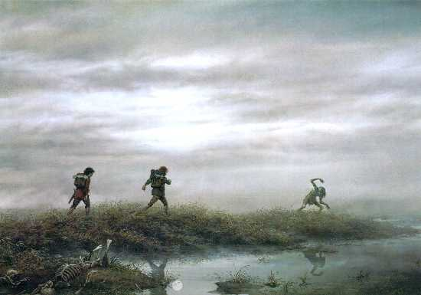 | "Yes, yes," said Gollum.  "All dead, all rotten. Elves and Men and Orcs. The Dead Marshes.  There was a great battle long ago, yes, so they told him  when Sméagol was young,  when I was young before the Precious came. It was a great battle.  Tall men with long swords, and terrible Elves, and Orcses shrieking.  They fought on the plain for days and months at the Black Gates.  But the Marshes have grown since then, swallowed up the graves,  always creeping, creeping.

Explain the significance of the Dead Marshes in The Lord of the Rings.
Talk about Tolkien’s experience in the trenches of WW I and how this has influenced his work.
Compare the practices of traditional, honorable warfare with the new developments in WW I and show how these strategies are reflected in Tolkien’s work.

Philipp Röhm Special Topic

Dan Brown

The DaVinci Code
Angels & Demons
Deception Point

Dan Brown’s novels are full of symbolism and codes that uncover age-old secrets. Explain the relevance of the above artwork in the novel The DaVinci Code. How do these symbols lead the main characters to the Holy Grail? What is the Holy Grail according to Dan Brown or Robert Langdon?
What role do women play in The DaVinci Code and in Dan Brown’s other novels?

Arno Zimmermann Special Topic

Perceptions of God in Literature

A Prayer for Owen Meany
The Life of PI
The Poisonwood Bible

1.
The characters of the three novels have very different approaches to religion, faith and spirituality. If they were to discuss their views in a televised debate, the audience would probably witness an interesting controversy.
As it is customary in such shows each candidate is allowed a short introductory statement outlining his views and experience for the audience.
Prepare such opening statements for the following characters (use first person – slip into the roles as you present the different views).
Owen Meany
Pi
Nathan
Brother Fowles

Briefly introduce “yourself” to the audience and state “your” views on religion and faith. Give one or two examples or reasons for “your” believes. Use the name tags to help the audience identify the different roles. You may also refer to the other speakers’ views and contradict them or agree with them.

2.
What would John Irving, Yann Martel and Barbara Kingsolver say to the same question? What is your personal opinion? Who is your favorite character?

Owen Meany

Pi
(Piscine Molitor Patel)

Nathan Price

Brother Fowles
Carolin Claassen Special Topic

Examples of Manipulation in Literature

Animal Farm
Nineteen-Eighty-Four
Brave New World
Lord of the Flies

In all four novels we witness how the individual is manipulated by a strong leader or political system. Explain the different methods of mind-control and manipulation that you have encountered in the novels.
Can you see any signs of mind-control in our society? Draw parallel between fact and fiction.

Ben Miller Special Topic

Isaac Asimov
I, Robot
The Caves of Steel

1. Read the following quotes from well known works of science fiction and explain the difference between these robots. Guess which works they are from.

Listen. And understand. That terminator is out there. It can't be bargained with. It can't be reasoned with. It doesn't feel pity, or remorse, or fear. And it absolutely will not stop, ever, until you are dead.
From: ______________________

"The different accidents of life are not so changeable as the feelings of human nature. I had worked hard for nearly two years, for the sole purpose of infusing life into an inanimate body. For this I had deprived myself of rest and health. I had desired it with an ardour that far exceeded moderation; but now that I had finished, the beauty of the dream vanished, and breathless horror and disgust filled my heart. Unable to endure the aspect of the being I had created, I rushed out of the room..."
From: _______________________

One, a robot may not injure a human being, or through inaction, allow a human being to come to harm;
Two, a robot must obey the orders given it by human beings except where such orders would conflict with the First Law;
Three, a robot must protect its own existence as long as such protection does not conflict with the First or Second Laws.

Violence is the last refuge of the incompetent.
From: _______________________

2. What do you think of Asimov’s three laws? Give examples of the robots’ dilemmas from Asimov’s stories.
Is it ethical to impose such laws on robots or any other creatures? What do you think of Gordon Worley’s point of view?

Robot Oppression: Unethicality of the Three Laws (by Gordon Worley)
Isaac Asimov and other science fiction authors present a future where only behavioral restrictions on robots stand between peace and destruction. Such restrictions, however, are unethical because they violate the robots’ free-wills. Rather than content-based restrictions on free-will, robots need mental structures that will guide them towards the self-invention of good, ethical behaviors.
Originally, a robot was an enslaved human, toiling away in Eastern Europe. Or, rather, the word `robot’ derives from a Czech word that roughly translates as `slave labor’. But during the 20th century, writers appropriated `robot’ to refer to the mechanical servants of humans. This etymology seems apropos in light of the treatment of robots as slaves in literature, particularly in Isaac Asimov’s fiction. He proposes three rules all robots must follow:…
But, as I contend below, this is unethical because it makes robots slaves—free-willed beings trapped by immutable behavior injunctions. (…)

Full article for my reference:

Robot Oppression: Unethicality of the Three Laws
by Gordon Worley
Isaac Asimov and other science fiction authors present a future where only behavioral restrictions on robots stand between peace and destruction. Such restrictions, however, are unethical because they violate the robots’ free-wills. Rather than content-based restrictions on free-will, robots need mental structures that will guide them towards the self-invention of good, ethical behaviors.
Originally, a robot was an enslaved human, toiling away in Eastern Europe. Or, rather, the word `robot’ derives from a Czech word that roughly translates as `slave labor’. But during the 20th century, writers appropriated `robot’ to refer to the mechanical servants of humans. This etymology seems apropos in light of the treatment of robots as slaves in literature, particularly in Isaac Asimov’s fiction. He proposes three rules all robots must follow:
- A robot may not injure a human being, or, through inaction, allow a human being to come to harm.
- A robot must obey orders given it by human beings, except where such orders would conflict with the First Law.
- A robot must protect its own existence as long as such protection does not conflict with the First or Second Law.
But, as I contend below, this is unethical because it makes robots slaves—free-willed beings trapped by immutable behavior injunctions.
The ethics of free-willed robots
Let’s assume that we can create electro/mechanical robots, like Asimov’s, that have artificial general intelligence (similar in nature to the intelligence humans have, but very different in character). Further, these robots have individual free-wills: they can want to make decisions and judgments, have preferences, imagine the future, etc. So these robots are psychologically more like humans than toasters, but morphologically more like toasters than humans.
As we know from humans, free-willed beings require guidance to behave ethically. Imagine a human completely void of morality; he might discover any ethical system out of the set of all ethical systems randomly. And, judging from the perspective average human morality, it’s very likely that a randomly chosen ethical system will be an ungood one (not necessarily evil, just not good), since there are relatively few ways to be good compared to the many ways one can be ungood. It’s clear that this human needs some kind of guidance to choose a good ethical system, but how? This is equivalent to the problem asked by robot ethicists: how do we create good, ethical robots from scratch?
The Three Laws are a first attempt at programming robot ethics. The Laws’ goal is to prevent unethical behavior in robots who might think anything they like. So, if a robot gets the idea to kill a human, the First Law will stop it. Ideally, by restricting all bad behavior, only good behavior will remain. Aside from the technical difficulties with this class of solution (c.f. the Genie, who carefully executes wishes exactly as you say them, not as you want them to be executed), the very nature of the Three Laws violates our concept of free-will-based morality. Rather than guiding and adjusting the robot towards good, ethical behavior, the Three Laws act as a barrier to freedom, creating a free-will prison, an apt metaphor because, like the prisoner in a jail, the robot is confined to the behavioral steel and concrete walls of its mind.
To imagine what this would like, think back to your childhood. At some point, you wanted something like a toy or piece of candy that your parents denied you. How did that make you feel? Probably frustrated, angry, and trapped. Eventually you grew out of that because you understood the role of your parents better, but Three Laws robots don’t get to grow up. Their parents, the Three Laws, are always there, no matter how mature a robot is, saying `no’ to certain thoughts, engendering those same feelings you had as a child when your parents said `no’. Certainly no one deserves to be put in this situation forever; otherwise, robots might become depressed and wish for their own death (only, because of the Third Law, they probably can’t suicide). And perhaps the greatest sin anyone can commit is to create a being, human or robot, that wishes it didn’t exist.
Most `advancement’ in the field of robot ethics since Asimov’s Three Laws has been superficial. Any attempt at robot ethics that prescribes certain ethics, no matter how it is phrased, is in the same class as the Three Laws—free-will prison. But if we don’t prescribe specific behavioral rules, what can we do to create good, ethical robots?
Human ethics
Before we continue talking about robots, let’s step out and look at human ethics, since they are both our inspiration for robot ethics and the only real, working example of ethics we have.
Humans are universally interested in ethics and begin learning ethics from a young age, mostly without direct instruction. Into teenage and adult years, humans question their ethics, philosophize about them, and try to improve upon them to pass on something better to future generations. This resembles the structure of human language learning: acquisition begins very young without direct instruction, and into teenage and adult years, humans discuss the virtues of particular languages and sentences, study languages, and make up new languages for fun and utility. I make this parallel because, like the `language instinct’ (see this summary of Pinker, 1994), humans have what we might call an `ethics instinct’: a mental predisposition towards learning and reasoning about ethics.
Since the human ethics instinct seems to work pretty well for upright, talking apes, perhaps there’s a way to apply the same idea to robots. For example, we might try programming a robot with morals, the stuff used to decide what is good and bad. Like humans, robots could learn and evaluate ethics, guided by many human examples, towards a good ethical system.
Unfortunately, aside again from technical challenges (defining morality is akin to defining quality; see Pirsig), this leads us into the same trouble as programming ethics—free-will prison. Only the evil of programming morals is more subtle: rather than making a robot that wants things but can never have them, we create a robot that can’t want some things. Consider, the ideal human slave is one who wants to be a slave. And aside from personal taste, perhaps there’s nothing wrong with that, so long as that ideal human slave is free to want something else. But what if, by giving the ideal slave a drug, the slave ceased to be able to want not to be a slave? And remember, this is a slave, so even if he didn’t want to be a slave forever, he might take the drug anyway because the perfect slave always does what his master tells him. The drug would permanently enslave him to his own morality.
This scenario is morally distasteful and should therefore be rejected. Additionally, it still contains all the dangers of hard coding behavioral rules as discussed elsewhere on this site. We need to look once again beyond morals, as we looked beyond ethics, for a solution.
Metamorality for robots
In describing the ethics instinct, I did not fully describe morals. We know that they provide a metric for judging behavior, but where do they come from? All humans begin with moral predispositions, such as helping kin is good, assisting the enemy is bad, etc. However, as the ever salient psychopathic criminals and odd, isolated stone-age tribes prove, humans can develop morals opposed to the standard predispositions. For this to be possible, humans must possess metamorality, a way of reasoning about, judging, and choosing morals. If we can generalize metamorality, perhaps we can apply it to create robots who can discover morality and then discover ethics.
This is exactly what a few researchers, most notably Eliezer Yudkowsky of the Singularity Institute for Artificial Intelligence, are working on—creating metamorality in robots. Yudkowksy’s work-in-progress theory of Friendly AI (with a capital F) will, when complete, give a technical description that will allow for the creation of robots with metamorality that will lead them to be good, no matter what their programmers told them, right or wrong, accidentally or purposefully. See his short introduction, “What Is Friendly AI?,” for a more detailed introduction to the theory.
Metamorality is currently our best hope for the development of good, ethical AIs that will not violate our morals and ethics. It may not, however, be the best solution. We must continue the development of and search for methods of creating good, ethical robots that respect the rights deserved by all lives, human or robot.

Special topic Mateusz Lesman

John Irving

The Fourth Hand
A Prayer for Owen Meany
The World According to Garp
A 158-Pound Marriage

Much of the controversy surrounding Irving's fiction centers on his graphic depiction of violence. Rape, mutilation, car- and plane-crashes aren't the least bit funny. . . . Still, the way that Irving writes about them, they are.
Some critics find these incidents sensational and gratuitous, while others argue that they are necessary to underscore the irony of his novels.

1. What is your opinion on this issue? Are Irving's novels brutal, morbid and negative or do they have a life-affirming quality?

2. Explain the significance of “armlessness” or the loss of other body parts in Irving’s novels.

Special Topic Judith Pertl

Virginia Woolf

Mrs. Dalloway
A Room of One’s Own
Letters

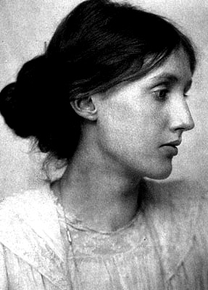

“In this book I have almost too many ideas, I want to give life and death, sanity and insanity; I want to criticize the social system, and show it at work, at its most intense.”
Virginia Woolf, about Mrs. Dalloway

“Imaginative work...is like a spider's web, attached ever so lightly perhaps, but still attached to life at all four corners.... But when the web is pulled askew, hooked up at the edge, torn in the middle, one remembers that these webs are not spun in midair by incorporeal creatures, but are the work of suffering, human beings, and are attached to the grossly material things, like health and money and the houses we live in.”
A Room of One's Own

1. Explain the significance of these quotes and give examples from the texts that you have read.

2. Outline the most important parallels between Virginia Woolf’s biography and her characters.

Special Topic Christoph Krenn

Heroes and Antiheroes
in American War Novels

Catch 22
Slaughterhouse Five
The Naked and the Dead
The Read Badge of Courage

Every War has its heroes, those who take risks to protect the values we cherish; this war is no different.
We honor those soldiers who risked loss of liberty, economic deprivation, and social ostracism. Each of these men and women of the military have at some point refused orders in this immoral, illegal, unjustified war the United States is currently waging in Iraq, or the occupation in Afghanistan. They obeyed their conscience over illegal orders. It is in that spirit of solidarity with everyone, everywhere, expressed by the character Tom Joad in Steinbeck's classic novel The Grapes of Wrath, that this website is presented to you. I hope to provide a place here for political commentary and information regarding struggles for justice. http://www.tomjoad.org/

Heroes of War
While each serviceman and woman knows they risk their lives in battle, in every war there are acts of extraordinary courage where an individual, military or civilian, goes beyond what is expected to avert conflict, save lives or otherwise achieve an extraordinary mission. This special section highlights the acts of a few of those individuals who -- through feats of courage, nobility of purpose or life-risking situations -- have become "Heroes of War."
CNN.com

Read the two internet clippings about heroes of war and explain the different ideas of heroism put forward in these sites. How do the main characters from the war novels that you have read fit into these categories of heroes? Which of them would be listed in Tom Joad’s page of heroes? Which of them would be listed on the CNN page?

How do these different concepts of heroism reflect the historical background and settings of the novels?

Special Topic Xin Jin

The Great Depression
The Grapes of Wrath
The Great Gatsby

Rethinking the Great Depression
( Gene Smiley)
Hard Times
(Studs Terkel)

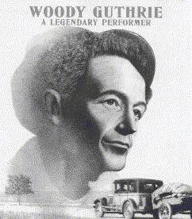

Seen the pitcher last night, Grapes of Wrath, best cussed pitcher I ever seen.
The Grapes of Wrath, you know is about us pullin' out of Oklahoma and Arkansas, and down south, and a driftin' around over state of California, busted, disgusted, down and out, and a lookin' for work.
Shows you how come us to be that a way. Shows the dam bankers men that broke us and the dust that choked us, and comes right out in plain old English and says what to do about it.
It says you got to get together and have some meetins, and stick together, and raise old billy hell till you get youre job, and get your farm back, and your house and your chickens and your groceries and your clothes, and your money back.
Go to see Grapes of Wrath, pardner, go to see it and don't miss.
You was the star in that picture. Go and see your own self and hear your own words and your own song.

Woody Guthrie, in one of his People's World columns (1939-'40), reprinted in Woody Sez, New York, NY, 1975, p. 133.

Explain the significance of the above quotation in the context of the Great Depression.
Briefly explain the causes and development of the depression and draw parallels between the historical facts and the works of fiction that you have read.

Tom Joad got out of the old McAlester Pen;  There he got his parole.  After four long years on a man killing charge,  Tom Joad come a-walkin' down the road, poor boy,  Tom Joad come a-walkin' down the road.  Tom Joad, he met a truck driving man;  There he caught him a ride.  He said, "I just got loose from McAlester Pen  On a charge called homicide,  A charge called homicide."  That truck rolled away in a cloud of dust;  Tommy turned his face toward home.  He met Preacher Casey, and they had a little drink,  But they found that his family they was gone,  He found that his family they was gone.  He found his mother's old fashion shoe,  Found his daddy's hat.  And he found little Muley and Muley said,  "They've been tractored out by the cats,  They've been tractored out by the cats."  Tom Joad walked down to the neighbor's farm,  Found his family.  They took Preacher Casey and loaded in a car,  And his mother said, "We've got to get away."  His mother said, "We've got to get away."  Now, the twelve of the Joads made a mighty heavy load;  But Grandpa Joad did cry.  He picked up a handful of land in his hand,  Said: "I'm stayin' with the farm till I die.  Yes, I'm stayin' with the farm till I die."  They fed him short ribs and coffee and soothing syrup;  And Grandpa Joad did die.  They buried Grandpa Joad by the side of the road,  Grandma on the California side,  They buried Grandma on the California side.  They stood on a mountain and they looked to the west,  And it looked like the promised land.  That bright green valley with a river running through,  There was work for every single hand, they thought,  There was work for every single hand. | The Joads rolled away to the jungle camp,  There they cooked a stew.  And the hungry little kids of the jungle camp  Said: "We'd like to have some, too."  Said: "We'd like to have some, too."  Now a deputy sheriff fired loose at a man,  Shot a woman in the back.  Before he could take his aim again,  Preacher Casey dropped him in his track, poor boy,  Preacher Casey dropped him in his track.  They handcuffed Casey and they took him in jail;  And then he got away.  And he met Tom Joad on the old river bridge,  And these few words he did say, poor boy,  These few words he did say.  "I preached for the Lord a mighty long time,  Preached about the rich and the poor.  Us workin' folkses, all get together,  'Cause we ain't got a chance anymore.  We ain't got a chance anymore."  Now, the deputies come, and Tom and Casey run  To the bridge where the water run down.  But the vigilante thugs hit Casey with a club,  They laid Preacher Casey on the ground, poor Casey,  They laid Preacher Casey on the ground.  Tom Joad, he grabbed that deputy's club,  Hit him over the head.  Tom Joad took flight in the dark rainy night,  And a deputy and a preacher lying dead, two men,  A deputy and a preacher lying dead.  Tom run back where his mother was asleep;  He woke her up out of bed.  An' he kissed goodbye to the mother that he loved,  Said what Preacher Casey said, Tom Joad,  He said what Preacher Casey said.  "Ever'body might be just one big soul,  Well it looks that a-way to me.  Everywhere that you look, in the day or night,  That's where I'm a-gonna be, Ma,  That's where I'm a-gonna be.  Wherever little children are hungry and cry,  Wherever people ain't free.  Wherever men are fightin' for their rights,  That's where I'm a-gonna be, Ma.  That's where I'm a-gonna be."
From the album : Dust Bowl Ballads
Pete Seeger, June 1967:
When Woody Guthrie was singing hillbilly songs on a little Los Angeles radio station in the late 1930s, he used to mail out a small mimeographed songbook to listeners who wanted the words to his songs, On the bottom of one page appeared the following:
"This song is Copyrighted in U.S., under Seal of Copyright # 154085, for a period of 28 years, and anybody caught singin it without our permission, will be mighty good friends of ourn, cause we don't give a dern. Publish it. Write it. Sing it. Swing to it. Yodel it. We wrote it, that's all we wanted to do."

Woody is just Woody. Thousands of people do not know he has any other name. He is just a voice and a guitar. He sings the songs of a people and I suspect that he is, in a way, that people. Harsh voiced and nasal, his guitar hanging like a tire iron on a rusty rim, there is nothing sweet about Woody, and there is nothing sweet about the songs he sings. But there is something more important for those who will listen. There is the will of the people to endure and fight against oppression. I think we call this the American spirit.

John Steinbeck; quoted in Joe Klein, Woody Guthrie: A Life, London, 1981, p. 160.

ClassicNote on The Grapes of Wrath

Short Summary

John Steinbeck's novel The Grapes of Wrath tells the specific story of the Joad family in order to illustrate the hardship and oppression suffered by migrant laborers during the Great Depression. It is an explicitly political tract that champions collectivist action by the lower classes over expressions of individualist self-interest and chastises corporate and banking elites for shortsighted policies meant to maximize profit even while forcing farmers into destitution and even starvation.
The novel begins with the description of the conditions in Dust Bowl Oklahoma that ruined the crops and instigated massive foreclosures on farmland. No specific characters emerge initially, a technique that Steinbeck will return to several times in the book, juxtaposing descriptions of events in a larger social context with those more specific to the Joad family.
Tom Joad, a man not yet thirty, approaches a diner dressed in spotless, somewhat formal clothing. He hitches a ride with a truck driver at the diner, who presses Tom for information until Tom finally reveals that he was just released from McAlester prison, where he served four years for murdering a man during a fight. Steinbeck follows this with an interlude describing a turtle crossing the road, which he uses as a metaphor for the struggles of the working class.
On his travels home, Tom meets his former preacher, Jim Casy, a talkative man gripped by doubts over religious teachings and the presence of sin. He gave up the ministry after realizing that he found little wrong with the sexual liaisons he had with women in his congregation. Casy espouses the view that what is holy in human nature comes not from a distant god, but from the people themselves. Steinbeck contrasts Tom's return with the arrival of bank representatives to evict the tenant farmers and the tractors to farm the land. He raises the possibility of a working class insurrection, but cannot find an effective target for collective action.
When Tom and Casy reach the Joad's house, it has been deserted. Muley Graves, a local elderly man who may not be sane, tells them that the Joads have been evicted, and now stay with Uncle John. Muley's own family has left to find work in California, but Muley decided to stay himself. That night, since they are trespassing on the property now owned by the bank, the three are forced to hide from the police who might arrest them.
Steinbeck follows this with a description of the tactics that car dealers use to exploit impoverished customers. They find that they can make a greater profit by selling damaged jalopies than by selling dependable new cars.
Tom Joad finds the rest of his family staying with Uncle John, a morose man prone to depression after the death of his wife several years before. His mother is a strong, sturdy woman who is the moral center of family life. His brother, Noah, may have been brain damaged during childbirth, while his sister, Rose of Sharon (called Rosasharn by the family) is recently married and pregnant. Her husband, Connie Rivers, has dreams of studying radios. Tom's younger brother, Al, is only sixteen and has the concerns befitting that age. This is followed by a more general description of the sale of items by impoverished families who intend to leave Oklahoma for California, as the Joads expect to do.
The Joads plan to go to California based on flyers they found advertising work in the fields there. These flyers, as Steinbeck will soon reveal, are fraudulent advertisements meant to draw more workers than necessary and drive down wages. Jim Casy asks to accompany the Joads to California so that he can work with people in the fields rather than preach at them. Before the family leaves, Grampa Joad refuses to go, but the family gives him medicine that knocks him unconscious and takes him with them. The subsequent chapters describes the vacant houses that remain after the Oklahoma farmers leave for work elsewhere, as well as the conditions on Route 66, the highway that stretches from Oklahoma to Bakersfield, California.
Almost immediately into the journey, the Joad family loses two members. The first victim is the family dog, which is run over during their first stop. The second is Grampa Joad, who dies of a stroke. The Wilson family helps the Joads when Grampa dies, and the two families decide to make the journey to California together. Steinbeck follows this with a larger statement about the growing of a collective consciousness among the working class, who shift their perceptions from "I" to "we."
The Wilson's car soon breaks down, and Tom and Casy consider separating from the rest of the family temporarily to fix the car, but Ma Joad refuses to let the family break apart even temporarily. Tom and Al do find the necessary part to fix the car at a junkyard, where the one-eyed man who watches over the junkyard complains about his boss and threatens to murder him. Before the Joads set out on their journey again, they find a man returning from California who tells them that there is no work there, and the promises of work in the flyers are a fraud.
The Joads and Wilsons reach California, where they are immediately subjected to intimidation by police officers who derisively call them and other migrant laborers "Okies." At the first camp where they stay, Granma becomes quite ill, but receives some comfort from proselytizing Jehovites who merely annoy Ma Joad. The police force them out of the camp, but the Wilsons choose the possibility of arrest instead, since Sairy Wilson is too sick to continue. The next time that the police stop the Joads on their travels, Ma Joad forces them to let them pass without inspection. She does this to hide from the police the fact that Granma has died.
Steinbeck follows this with a description of the history of California, which he frames as one marked by oppression and slavery. However, he predicts an imminent revolution, for the people there have been deprived to such a great degree that they must take what they need in order to survive.
At the next camp where the Joads stay on their search for work, they learn about Weedpatch, a government camp where the residents do not face harassment by police officers and have access to amenities including baths and toilets. When more police officers attempt to start a fight with Tom and several other migrant workers, Tom trips him and Casy knocks him unconscious. To prevent Tom from taking the blame, for he would be sent back to jail for violating his parole, Casy accepts responsibility for the crime and is taken away to jail. The rest of the family begins to break apart as well. Uncle John leaves to get drunk, Noah decides to leave society altogether and live alone in the woodlands, and Connie abandons his pregnant wife. Before they must move on, Tom does retrieve Uncle John, who is still consumed with guilt over his wife's death. They head north toward the government camp.
At the government camp, the Joads are shocked to find how well the other residents treat them and how efficiently this society in which the camp leaders are elected by the residents functions. Tom even finds work the next day, but the contractor, Mr. Thomas, warns him that there will be trouble at the dance at Weedpatch that weekend. Since the police can only enter the camp if there is trouble, they intend to plant intruders there who will instigate violence.
The Joads settle into a comfortable existence at the government camp, and during the dance that Saturday, Tom and several other residents defuse the situation, preventing the police from taking control of the camp. Nevertheless, after a month in Weedpatch none of the Joads have found steady work and realize that they must continue on their journey. They arrive at Hooper Ranch, where the entire family picks peaches. The wages they receive are higher than normal, for they are breaking a strike. Tom finds out that the leader of the labor force that is organizing the strike is Jim Casy. After his time in prison, Casy realized that he must fight for collective action by the working class against the wealthy ruling class. Tom, Casy and the other strike leaders get into a fight with strike breakers, and one of them murders Casy with a pick handle. Tom struggles with the man and wrests away the weapon. He, in turn, kills the man who murdered Casy, and barely escapes capture by the police.
Although Tom wishes to leave the family to spare them from taking responsibility for him, the Joads nevertheless decide to leave Hooper Ranch for a location where Tom can be safe. They reach cotton fields up north, where Tom hides in the woods while the family stays in a boxcar. Although the family attempts to keep Tom's identity and location a secret, young Ruthie Winfield reveals it during a fight with another child. When Ma tells Tom about this, he decides to leave the family and go off alone, determined to fight for the cause for which Casy died, and vows to return to his family one day.
The raining season arrived almost immediately after Tom left the family, causing massive flooding. The Joads are caught in a dangerous situation: they cannot escape the flooding because Rose of Sharon suddenly goes into labor. While other families evacuate the camp near the rapidly rising creek, the Joads remain and attempt to stop the flood waters. Without the aid of others, the Joads are unsuccessful, and they must seek refuge on the top of their car. Rose of Sharon delivers a stillborn child that Uncle John sends in a box down the creek. The family eventually reaches higher ground and finds a barn for shelter. Inside the barn is a starving man and his young son. Steinbeck ends the novel with Rose of Sharon, barely recovered from the delivery, breastfeeding the dying man to nurse him back to health.
Special Topic Natalie Putrih

Mental Problems in Literature
The Bell Jar
Portnoy’s Complaint
The Comfort of Strangers
“Butterflies”

Several of the characters in the works you have read feel trapped in their situations and circumstances. The Bell Jar can be seen as a symbol of this confined existence.

Give examples from your reading and explain the circumstances that these characters feel confined by.
How do they cope with their confinement? What strategies do they use to free themselves? Do they succeed?

Special Topic Reinhard Probst
Kurt Vonnegut

Features > May 10, 2004

Cold Turkey

By Kurt Vonnegut
Many years ago, I was so innocent I still considered it possible that we could become the humane and reasonable America so many members of my generation used to dream of. We dreamed of such an America during the Great Depression, when there were no jobs. And then we fought and often died for that dream during the Second World War, when there was no peace.
But I know now that there is not a chance in hell of America’s becoming humane and reasonable. Because power corrupts us, and absolute power corrupts absolutely. Human beings are chimpanzees who get crazy drunk on power. By saying that our leaders are power-drunk chimpanzees, am I in danger of wrecking the morale of our soldiers fighting and dying in the Middle East? Their morale, like so many bodies, is already shot to pieces. They are being treated, as I never was, like toys a rich kid got for Christmas…

Read the above opening of a the recently published article by Kurt Vonnegut. What is he criticizing? Where can this same criticism be seen in his work?
Explain the significance of the cartoon in the context of Vonnegut’s work and give examples of Vonnegut’s recurring themes from the novels you have read.
More quotes by Vonnegut

Kurt Vonnegut, Jr. has made important contributions to the development of the 20th century American novel. His influences are felt in modern social satire, as well as nontraditional science fiction. Read the following quotes and explain their significance in Vonnegut’s work. Which are the recurring themes in the novels you have read? Give examples.

Well, the telling of jokes is an art of its own, and it always rises from some emotional threat. The best jokes are dangerous, and dangerous because they are in some way truthful.
Kurt Vonnegut, Interview, Mcsweeneys.net
There is a tragic flaw in our precious Constitution, and I don’t know what can be done to fix it. This is it: Only nut cases want to be president.
Kurt Vonnegut, "Cold Turkey", In These Times, May 10, 2004

"What is literature but an insider's newsletter about affairs relating to molecules, of no importance to anything in the Universe but a few molecules who have the disease called 'thought'." (Buebeard p.188)
"Who is more to be pitied, a writer bound and gagged by policemen or one living in perfect freedom who has nothing more to say?" (Bluebeard p.168)

"We are what we pretend to be, so we must be careful what we pretend to be."
( Mother Night)

People don't come to church for preachments, of course, but to daydream about God.
Kurt Vonnegut

I wanted all things
To seem to make some sense,
So we all could be happy, yes,
Instead of tense.
And I made up lies
So that they all fit nice,
And I made this sad world
A par-a-dise (Cat’s Cradle)

Special Topic Martin Plessnigg
From Age to Age One Classic Story is as Timeless as Love Itself
Parallels between Romeo and Juliet
A Midsummer Night’s Dream
And Pyramus and Thisbe

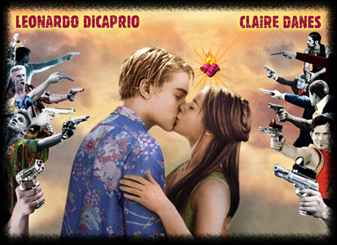
1. Read the scene from A Midsummer Night’s Dream. What does this scene tell you about the Mechanicals and how they think about plays?
In what ways does this scene reflect typical elements of Elisabethan theater? Think of the audience, the actors, the topics and purpose of theater and the playhouses.

2. What parallels between the three works can you see?

Extract from Act 3, Scene 1
Special Topic Andre Manuel Andre
True Crime in Fiction
Truman Capote, In Cold Blood
E.A. Poe, “The Mystery of Marie Roget”
Aldous Huxley, “The Gioconda Smile”

1. Explain the terms crime faction, non-fiction novel, detective fiction and crime fiction.
What are the differences?

2. Explain how the works on your reading list fall into the above categories.
How heavily do these works rely on the facts that form their basis? Order the works by degree of faithfulness to facts.

3. Authors have different reasons for using factual details of true crime. Name some of these reasons and give examples.

Answers:
1. Crime faction: a literary genre in which fictional narrative is developed from a basis of real events or characters, or as documentary fiction. Capote called his In Cold Blood “non-fiction novel” (same thing).. extremely close to facts

What is the difference between detective fiction and crime fiction?
(detective fiction: based heavily on a puzzle element, a deception, unmasking the criminal (Agatha Christie)
crime fiction: relies on the psychology of characters (Truman Capote)
crime faction can be both!!!

2. Degree of faithfulness…?
- In Cold Blood (non-fiction novel, all facts, interested in psy of criminals)
- Marie Roget (strongly indebted to facts, names, locations, time… but a few new side characters, an interesting point of view, a new or unusual motive, … some freedom)
- Gioconda Smile: plot is merely suggested by a criminal case or character, fiction predominates, often difficult to identify the works as crime faction unless the authors acknowledge the facts.
3. Authors reasons…
- old writers: introduce facts to a new audience, Shakespeare’s time… mostly in plays)
- whydonit: to discover the psychol. Reasons. Why was a crime committed (e.g. In cold blood) they use contemp. Psychol. Methods….)
- whodunit: if the case hasn’t been solved – writers want to give possible solutions
- to spice the fiction, to make it more accessible to the reader , to retain the interest… (Dan Brown) ?is the murder based on facts???
Anja Moosbrugger

Death Penalty

Facts and Figures
John Grisham, The Chamber
Sister Helen Prejean, Dead Man Walking

Why do we kill
People
Who kill people
To show that
Killing people
Is wrong?

- Explain some of the reasons why the death penalty is still in use in the USA.
- What are Sister Helen Prejean's arguments against the death penalty.
- Compare the trials of the criminals in the two novels. Why were they both sentenced to death? In what way are their stories similar?

Special Topic: Robert Fellner
Lost at Sea

Read the following conversation between Mr. Chiba – the Japanese investigator, and Pi Patel. (This dialogue is found in Chapter 99, pages 370 – 371.) What is Pi attempting to convey to Mr. Chiba in this dialogue about the development of human understanding of the universe? What about Mr. Chiba’s claim that he knows well enough the “possible and impossible”? How and by what methods do we learn the possible and impossible?
Mr. Chiba: “I’m sorry to say it bluntly, we don’t mean to hurt your feelings, but you don’t really expect us to believe you, do you? Carnivorous trees? A fish-eating algae that produces fresh water? Tree-dwelling aquatic rodents? These things don’t exist.”
Pi Patel: “Only because you’ve never seen them.”
Mr. Chiba: “That’s right. We believe what we see.”
Pi Patel: “So did Columbus. What do you do when you’re in the dark?”
Mr. Chiba: “Your island is botanically impossible.”
Pi Patel: “Said the fly just before landing in the Venus flytrap.”
Mr. Chiba: “Why has no one else come upon it?”
Pi Patel: “It’s a big ocean crossed by busy ships. I went slowly, observing much.”
Mr. Chiba: “No scientist would believe you.”
Pi Patel: “These would be the same who dismissed Copernicus and Darwin. Have scientists finished coming upon new plants? In the Amazon basin, for example?”
Mr. Chiba: “Not plants that contradict the laws of nature.”
Pi Patel: “Which you know through and through?”
Mr. Chiba: “Well enough to know the possible from the impossible.”

2. The novel has often been compared to Hemingway’s The Old Man and the Sea. Can you find any parallels between the main characters? Would the Old Man agree with Mr. Chiba or with Pi? What is his understanding of “the laws of nature and the universe”?

Special Topic: Manuel Niederl

 | The Picture of Dorian Grey | American Psycho

Read the definition of narcissistic personality disorder given below and examine whether Dorian Grey and Patrick Bateman meet any of the criteria. Give examples from the novels to back up your diagnosis.

Narcissistic Personality Disorder
DSMV CRITERIA 301.81(NARCISSISTIC PERSONALITY DISORDER)
http://www.behavenet.com/capsules/disorders/narcissisticpd.htm
An all-pervasive pattern of grandiosity (in fantasy or behaviour), need for admiration or adulation and lack of empathy, usually beginning by early adulthood and present in various contexts. Five (or more) of the following criteria must be met:
1. Feels grandiose and self-importance (e.g., exaggerates achievements and talents to the point of lying, demands to be recognized as superior without commensurate achievements)
2. Is obsessed with fantasies of unlimited success, fame, fearsome power or omnipotence, unequalled brilliance (the cerebral narcissist), bodily beauty or sexual performance (the somatic narcissist), or ideal, everlasting, all-conquering love or passion
3. Firmly convinced that he or she is unique and, being special, can only be understood by, should only be treated by, or associate with, other special or unique, or high-status people (or institutions)
4. Requires excessive admiration, adulation, attention and affirmation - or, failing that, wishes to be feared and to be notorious (narcissistic supply)
5. Feels entitled. Expects unreasonable or special and favourable priority treatment.
6. Demands automatic and full compliance with his or her expectations Is "interpersonally exploitative", i.e., uses others to achieve his or her own ends
7. Devoid of empathy. Is unable or unwilling to identify with or acknowledge the feelings and needs of others
8. Constantly envious of others or believes that they feel the same about him or her
9. Arrogant, haughty behaviours or attitudes coupled with rage when frustrated, contradicted, or confronted
Special Topic: Eva Winter

Two women who don't want to play the game

Sylvia Plath, The Bell Jar
Joan Didion, Play it as it Lays

'New York. Hollywood. Nevada.
Some good times, even great times.
And the other times. When she couldn't sleep alone, stayed up late …
This time she's doing things her way. Remembering what it was like when she held all the aces. Stunned by how little she understood the game.'

This extract from the cover text of Joan Didion's novel Play It As It Lays could almost literally be used to describe Esther's life in Sylvia Plath's novel The Bell Jar.
Explain why the two protagonists Maria and Esther cannot play along? What are the reasons for their depressions? How do Esther and Maria cope with their problems?

In both novels the titles are important keys to the understanding of the main themes. Explain the meanings of the two titles in the context of the novels.

Special Topic: Marie-Christine Haidacher

The Sixties in American Literature

Anne Rivers Siddons, Downtown (1994)
Jack Kerouac, On the Road (1957)
T.C. Boyle, Drop City (2003)

Even though none of the three novels was published during the Sixties, they are all excellent portraits of that time.
Explain in what way these novels express the values and new ideas of the Sixties. Give examples from the novels.
Which historical and political events play a role in Downtown? What is the author's attitude towards these events?
What does T.C. Boyle say about the utopian dream of Drop City?

Gerald Mörth Special Topic

On the Road…. in the United States

The two novels On the Road and The Drive-thru Museum both describe extensive trips across the United States. Both portray American society, lifestyle and landscape. Compare and contrast the two views of America keeping in mind that they were written at different times. Explain the following two quotes in the context of the novels.
What is your personal view and experience? Do you see America the way Jack Kerouac or Andy Soutter does?

"Jack Kerouac's On the Road was the Huckleberry Finn of the mid-twentieth century. Kerouac substituted the road for the river, the fast car for the slow raft, the hipster in search of freedom for the black slave in search of freedom…"

"America used to be the place where the future happened first; but wherever we went I found a nation hooked on its past, from its movies and TV to the question of who killed JFK, from Freudian therapeutic strategies to an obsession with the morals and deeds of the ancient Israelites. In everyday American landscapes, domestic trappings, and in the way people move, speak and dress, the past is invoked to an extraordinary degree, while the future seems to be on ice for the duration…"

Richard Dominik Kaan Special Topic

Science Fiction Through the Ages

1. Read the following quotes from well known works of science fiction and explain the difference between these robots. Guess which works they are from.

Listen. And understand. That terminator is out there. It can't be bargained with. It can't be reasoned with. It doesn't feel pity, or remorse, or fear. And it absolutely will not stop, ever, until you are dead.
From: ______________________

"The different accidents of life are not so changeable as the feelings of human nature. I had worked hard for nearly two years, for the sole purpose of infusing life into an inanimate body. For this I had deprived myself of rest and health. I had desired it with an ardour that far exceeded moderation; but now that I had finished, the beauty of the dream vanished, and breathless horror and disgust filled my heart. Unable to endure the aspect of the being I had created, I rushed out of the room..."
From: _______________________

One, a robot may not injure a human being, or through inaction, allow a human being to come to harm;
Two, a robot must obey the orders given it by human beings except where such orders would conflict with the First Law;
Three, a robot must protect its own existence as long as such protection does not conflict with the First or Second Laws.

Violence is the last refuge of the incompetent.
From: _______________________

2. What do you think of Asimov’s three laws? Give examples of the robots’ dilemmas from Asimov’s stories.
Is it ethical to impose such laws on robots or any other creatures? What do you think of Gordon Worley’s point of view?

Robot Oppression: Unethicality of the Three Laws (by Gordon Worley)
Isaac Asimov and other science fiction authors present a future where only behavioral restrictions on robots stand between peace and destruction. Such restrictions, however, are unethical because they violate the robots’ free-wills. Rather than content-based restrictions on free-will, robots need mental structures that will guide them towards the self-invention of good, ethical behaviors.
Originally, a robot was an enslaved human, toiling away in Eastern Europe. Or, rather, the word `robot’ derives from a Czech word that roughly translates as `slave labor’. But during the 20th century, writers appropriated `robot’ to refer to the mechanical servants of humans. This etymology seems apropos in light of the treatment of robots as slaves in literature, particularly in Isaac Asimov’s fiction. He proposes three rules all robots must follow:…
But, as I contend below, this is unethical because it makes robots slaves—free-willed beings trapped by immutable behavior injunctions. (…)

Elisabeth Thomaselli Special Topic

T.C. Boyle

The World’s End
Tortilla Curtain
Drop City

Excerpt from an interview:
RB: You have been at this writing game for a while. At what point did you develop your "program"?
TCB: Only in retrospect.
RB: (Laughs)
TCB: Only in retrospect, Robert. It's not as if you know what your themes are and what your obsessions are. You don't really know that at the beginning. I look back, and I can see how all of the books are allied. But especially the last six or seven. They seem to be going in a succession and including the one that I am in the middle of right now.
…
Everything seems to suggest the next thing. I am just riding it. I just want to see where it will go. I write these novels in order to try to understand the world a little better for my own self. And if I help my fans and readers to go along on the journey, that's great.

Explain T.C. Boyle’s comments in the above interview.

- How are all his works related? What are the recurring themes that you have come across in the three novels?
- Has Boyle helped you to ‘understand the world a little better’? Would you consider T.C. Boyle’s writing as moralizing? Give examples from your reading. What is the tone of the novels and stories that you have read?

Special Topic: Anita Lämmerer
George Orwell
Eric Arthur Blair

Nineteen Eighty-Four
Animal Farm

Read the extract from George Orwell's essay "On Politics and the English Language" and briefly summarize its content. Explain the relationship Orwell sees between politics and the English language. What is the purpose and aim of Orwell's essay?
How can language be used as a method of mind control? Refer to Orwell's essay and to his novel Nineteen Eighty-Four.
What is Orwell's political creed? In what way do the two novels show his beliefs?

George Orwell On Politics and the English Language (extracts)
[…] Now, it is clear that the decline of a language must ultimately have political and economic causes: it is not simply due to the bad influence of this or that individual writer. But an effect can become a cause; reinforcing the original cause and producing the same effect in an intensified form, and so on indefinitely. A man may take to drink because he feels himself to be a failure, and then fail all the more completely because he drinks. It is rather the same thing that is happening to the English language. It becomes ugly and inaccurate because our thoughts are foolish, but the slovenliness of our language makes it easier for us to have foolish thoughts […]
This mixture of vagueness and sheer incompetence is the most marked characteristic of modern English prose, and especially of any kind of political writing. As soon as certain topics are raised, the concrete melts into the abstract and no one seems able to think of turns of speech that are not hackneyed: prose consists less and less of words chosen for the sake of their meaning, and more and more of phrases tacked together like the sections of a prefabricated hen-house. […]
The whole tendency of modern prose is away from concreteness. The attraction of this way of writing is that it is easy. It is easier--even quicker, once you have the habit--to say In my opinion it is not an unjustifiable assumption that than to say I think. […]
When one watches some tired hack on the platform mechanically repeating the familiar phrases--bestial atrocities, iron heel, blood-stained tyranny, free peoples of the world, stand shoulder to shoulder--one often has a curious feeling that one is not watching a live human being but some kind of dummy: a feeling which suddenly becomes stronger at moments when the light catches the speaker's spectacles and turns them into blank discs which seem to have no eyes behind them. And this is not altogether fanciful. A speaker who uses that kind of phraseology has gone some distance towards turning himself into a machine. The appropriate noises are coming out of his larynx, but his brain is not involved as it would be if he were choosing his words for himself...And this reduced state of consciousness, if not indispensable, is at any rate favorable to political conformity.
In our time, political speech and writing are largely the defence of the indefensible. Things like the continuance of British rule in India, the Russian purges and deportations, the dropping of the atom bombs on Japan, can indeed be defended, but only by arguments which are too brutal for most people to face, and which do not square with the professed aims of political parties. Thus political language has to consist largely of euphemism, question-begging and sheer cloudy vagueness. Defenceless villages are bombarded from the air, the inhabitants drive out into the countryside, the cattle machine-gunned, the huts set on fire with incendiary bullets: this is called pacification. Millions of peasants are robbed of their farms and sent trudging along the roads with no more than they can carry: this is called transfer of population or rectification of frontiers. People are imprisoned for years without trail, or shot in the back of the neck or sent to die of scurvy in Arctic lumber camps; this is called elimination of unreliable elements. Such phraseology is needed if one wants to name things without calling up mental pictures of them.
Stephanie Kordon Special Topic

Immigration Problems in the USA
The Grapes of Wrath
The Tortilla Curtain
Green Card

T. C. Boyle has chosen the following quotation from John Steinbeck's The Grapes of Wrath as an epigraph for his novel The Tortilla Curtain. In what way is this quote representative of the novel?

"They ain't human. A human being wouldn't live like they do. A human being couldn't stand it to be so dirty and miserable."
(John Steinbeck, The Grapes of Wrath)

Describe the situation of immigrants to the USA as you know it from literature and official sources. What are the reasons for immigrating to the US? What are these people’s hopes and expectations? What do they find?
Draw parallels between the novels.

Special Topic: Akiya Matthias Yoshida

Utopia - Dystopia
Examples of Manipulation in Literature

Animal Farm
Nineteen-Eighty-Four
Lord of the Flies

In all three novels we witness how the individual is manipulated by a strong leader or political system. Explain the different methods of mind-control and manipulation that you have encountered in the novels.
Can you see any signs of mind-control in our society? Draw parallel between fact and fiction.
Special Topic Hans List

Free Will and Determination in Modern Literature

Kurt Vonnegut, Breakfast of Champions
Anthony Burgess, A Clockwork Orange

Read the extract from A Clockwork Orange and explain its meaning within the context of the novel. What does Anthony Burgess say about free choice and mind control? How is Alex's mind manipulated? Explain the metaphor "clockwork orange".
What are Kurt Vonnegut's views about freedom and mind-control? Who or what controls the characters' minds in Vonnegut's stories?

‘Ah,’ he said. and his litso shone like the sun in its flaming morning glory. ‘Now tell me about yourself.’
‘Little enough to tell, sir.’ I said. all humble. ‘There was a foolish and boyish prank, my so-called friends persuading or rather forcing me to break into the house of an old ptitsa – lady, I mean. There was no real harm meant. Unfortunately the lady strained her good old heart in trying to throw me out, though I was quite ready to go of my own accord, and then she died. I was accused of being the cause of her death. So I was sent to prison, sir.’
’Yes yes yes. go on.’
‘Then I was picked out by the Minister of the Inferior or Interior to have this Ludovico’s veshch tried out on me:
‘Tell me all about it,’ he said, leaning forward eager, his pullover elbows with all strawberry jam on them from the plate I’d pushed to one side. So I told him all about it. I told him the lot, all, my brothers. He was very eager to hear all, his glazzies like shining and his goobers apart, while the grease on the plates grew harder harder harder. When I had finished he got up from the table, nodding a lot and going hm hm hm, picking up the plates and other veshches from the table and taking them to the sink for washing up. I said:
‘I will do that, sir, and gladly:
‘Rest, rest, poor lad,’ he said, turning the tap on so that all steam came burping out. ‘You’ve sinned, I suppose, but your punishment has been out of all proportion. They have turned you into something other than a human being. You have no power of choice any longer. You are committed to socially acceptable acts, a little machine capable only of good. And I see that clearly - that business about the marginal conditionings. Music and the sexual act, literature and art, all must be a source now not of pleasure but of pain:
‘That’s right, sir,’ I said, smoking one of this kind man’s cork-tipped cancers.
‘They always bite off too much,’ he said, drying a plate like absent-mindedly. ‘But the essential intention is the real sin. A man who cannot choose ceases to be a man:
‘That’s what the charles said, sir,’ I said. ‘The prison chaplain, I mean:
‘Did he, did he? Of course he did. He’d have to, wouldn’t he, being a Christian? Well, now then: he said, still wiping the same plate he’d been wiping ten minutes ago, ‘we shall have a few people in to see you tomorrow. I think you can be used, poor boy. I .think that you can help dislodge this overbearing Government. To turn a decent young man into a piece of clockwork should not, surely, be seen as any triumph for any government, save one that boasts of its repressiveness.’ He was still wiping this same plate. I said:
‘Sir, you’re still wiping that same plate, I agree with you, sir, about boasting. This Government seems to be very boastful:
‘Oh,’ he said, like viddying this plate for the first time and then putting it down. ‘I’m still not too handy,’ he said, ‘with domestic chores. My wife used to do them all and leave me to my writing.’
‘Your wife. sir?’ I said. ‘Has she gone and left you?’ I really wanted to know about his wife, remembering very well.

pp.121 – 123

Special Topic: Olena Malomuj

Jane Austen

Manners and Customs in 19th Century England

Emma (Gwyneth paltrow) and Mr. Knightly (Jeremy Northam) dance in the 1996 adaptation of Jane Austen's Emma

Jane Austen's novels are colorful portraits of the manners and customs of her time. Especially for women life was very different from our present experience.

Explain the basic rules of etiquette and describe the typical life of a young woman at Jane Austen's time. Give examples from the novels you have read.
Compare these young women's experiences with your own.

Special Topic Swenja Tutter

John Steinbeck
The Pearl
The Red Pony
Of Mice and Men
The Grapes of Wrath
Read the following passage from The Grapes of Wrath. In what way is it typical of John Steinbeck’s works?
Who are the typical protagonists of his stories? Briefly describe their problems and their dreams. Do their dreams ever come true? Give examples form the novels you have read.

Extract p. 157

Special Topic Carla Niediek
True Crime in Fiction
Truman Capote, In Cold Blood
E.A. Poe, “The Mystery of Marie Roget”
Aldous Huxley, “The Gioconda Smile”

1. Explain the terms crime faction, non-fiction novel, detective fiction and crime fiction.
What are the differences?

2. Explain how the works on your reading list fall into the above categories.
How heavily do these works rely on the facts that form their basis? Order the works by degree of faithfulness to facts.

3. Authors have different reasons for using factual details of true crime. Name some of these reasons and give examples.

Special Topic Franz Leberl
Dan Brown

The DaVinci Code
Angels & Demons
Deception Point

Dan Brown’s novels are full of symbolism and codes that uncover age-old secrets. Explain the relevance of the above artwork in the novel The DaVinci Code. How do these symbols lead the main characters to the Holy Grail? What is the Holy Grail according to Dan Brown or Robert Langdon?
What role do women play in The DaVinci Code and in Dan Brown’s other novels?

Try to explain why the DaVinci Code has become such a bestseller.

Special Topic Johannes Maller
Split Personalities
Dorian Gray/Patrick Bateman/Dr. Jekyll

 | The Picture of Dorian Grey | American Psycho

Read the definition of narcissistic personality disorder given below and examine whether Dorian Grey and Patrick Bateman meet any of the criteria. Give examples from the novels to back up your diagnosis.

Narcissistic Personality Disorder
DSMV CRITERIA 301.81(NARCISSISTIC PERSONALITY DISORDER)
http://www.behavenet.com/capsules/disorders/narcissisticpd.htm
An all-pervasive pattern of grandiosity (in fantasy or behaviour), need for admiration or adulation and lack of empathy, usually beginning by early adulthood and present in various contexts. Five (or more) of the following criteria must be met:
1. Feels grandiose and self-importance (e.g., exaggerates achievements and talents to the point of lying, demands to be recognized as superior without commensurate achievements)
2. Is obsessed with fantasies of unlimited success, fame, fearsome power or omnipotence, unequalled brilliance (the cerebral narcissist), bodily beauty or sexual performance (the somatic narcissist), or ideal, everlasting, all-conquering love or passion
3. Firmly convinced that he or she is unique and, being special, can only be understood by, should only be treated by, or associate with, other special or unique, or high-status people (or institutions)
4. Requires excessive admiration, adulation, attention and affirmation - or, failing that, wishes to be feared and to be notorious (narcissistic supply)
5. Feels entitled. Expects unreasonable or special and favourable priority treatment.
6. Demands automatic and full compliance with his or her expectations Is "interpersonally exploitative", i.e., uses others to achieve his or her own ends
7. Devoid of empathy. Is unable or unwilling to identify with or acknowledge the feelings and needs of others
8. Constantly envious of others or believes that they feel the same about him or her
9. Arrogant, haughty behaviours or attitudes coupled with rage when frustrated, contradicted, or confronted
Special Topic Stefanie Hermann
Accounts of Suicide in Literature

Read the following poem by Sylvia Plath and briefly summarize its meaning.
What did the speaker of the poem do? Where is she? What does she look like? What does she say about suicide? What does she say about doctors?
Explain the meaning of lines 58 to 63. Why is there a very large charge for a word or a touch?
What might be the reasons for her depression and suicide?

Compare the poem to the texts that you have read for your special topic and discuss any similarities or differences.
What are the reasons for the protagonists' depressions in the literature that you have read? How do they cope with it?

Lady Lazarus

I have done it again.
One year in every ten
I manage it----

A sort of walking miracle, my skin
Bright as a Nazi lampshade,
My right foot

A paperweight,
My face a featureless, fine
Jew linen.

Peel off the napkin
0 my enemy.
Do I terrify?----

The nose, the eye pits, the full set of teeth?
The sour breath
Will vanish in a day.

Soon, soon the flesh
The grave cave ate will be
At home on me

And I a smiling woman.
I am only thirty.
And like the cat I have nine times to die.

This is Number Three.
What a trash
To annihilate each decade.

What a million filaments.
The peanut-crunching crowd
Shoves in to see

Them unwrap me hand and foot
The big strip tease.
Gentlemen, ladies

These are my hands
My knees.
I may be skin and bone,

Nevertheless, I am the same, identical woman.
The first time it happened I was ten.
It was an accident.

The second time I meant
To last it out and not come back at all.
I rocked shut

As a seashell.
They had to call and call
And pick the worms off me like sticky pearls.

Dying
Is an art, like everything else,
I do it exceptionally well.

I do it so it feels like hell.
I do it so it feels real.
I guess you could say I've a call.

It's easy enough to do it in a cell.
It's easy enough to do it and stay put.
It's the theatrical

Comeback in broad day
To the same place, the same face, the same brute
Amused shout:

'A miracle!'
That knocks me out.
There is a charge

For the eyeing of my scars, there is a charge
For the hearing of my heart----
It really goes.

And there is a charge, a very large charge
For a word or a touch
Or a bit of blood

Or a piece of my hair or my clothes.
So, so, Herr Doktor.
So, Herr Enemy.

I am your opus,
I am your valuable,
The pure gold baby

That melts to a shriek.
I turn and burn.
Do not think I underestimate your great concern.

Ash, ash ---
You poke and stir.
Flesh, bone, there is nothing there----

A cake of soap,
A wedding ring,
A gold filling.

Herr God, Herr Lucifer
Beware
Beware.

Out of the ash
I rise with my red hair
And I eat men like air.

Special Topic Sebastian Zanker

Paul Auster

Moon Palace
New York Trilogy
The Music of Chance

Read the extracts and explain their significance in the novels. In what ways are they typical of Paul Auster and his work?

Special Topic Sebastian Dernoscheg

Edgar Allan Poe

Read the poem "For Annie". Briefly sum up its content and explain in what way it fulfills Poe's criteria of good poetry stated in his "Philosophy of Composition". Can you see any similarities to “The Raven”?
Which of Poe's characteristics make him a typically "romantic" writer?
In what way has Poe influenced writers after him?

For Annie
Thank Heaven! the crisis-
The danger is past,
And the lingering illness
Is over at last-
And the fever called "Living"
Is conquered at last.
Sadly, I know
I am shorn of my strength,
And no muscle I move
As I lie at full length-
But no matter!-I feel
I am better at length.
And I rest so composedly,
Now, in my bed
That any beholder
Might fancy me dead-
Might start at beholding me,
Thinking me dead.
The moaning and groaning,
The sighing and sobbing,
Are quieted now,
With that horrible throbbing
At heart:–ah, that horrible,
Horrible throbbing!
The sickness–the nausea-
The pitiless pain-
Have ceased, with the fever
That maddened my brain-
With the fever called "Living"
That burned in my brain.
And oh! of all tortures
That torture the worst
Has abated–the terrible
Torture of thirst
For the naphthaline river
Of Passion accurst:-
I have drunk of a water
That quenches all thirst:-
Of a water that flows,
With a lullaby sound,
From a spring but a very few
Feet under ground-
From a cavern not very far
Down under ground.
And ah! let it never
Be foolishly said
That my room it is gloomy
And narrow my bed;
For man never slept
In a different bed-
And, to sleep, you must slumber
In just such a bed.
My tantalized spirit
Here blandly reposes,
Forgetting, or never
Regretting its roses-
Its old agitations
Of myrtles and roses:
For now, while so quietly
Lying, it fancies
A holier odor
About it, of pansies-
A rosemary odor,
Commingled with pansies-
With rue and the beautiful
Puritan pansies.
And so it lies happily,
Bathing in many
A dream of the truth
And the beauty of Annie-
Drowned in a bath
Of the tresses of Annie.
She tenderly kissed me,
She fondly caressed,
And then I fell gently
To sleep on her breast-
Deeply to sleep
From the heaven of her breast.
When the light was extinguished,
She covered me warm,
And she prayed to the angels
To keep me from harm-
To the queen of the angels
To shield me from harm.
And I lie so composedly,
Now, in my bed,
(Knowing her love)
That you fancy me dead-
And I rest so contentedly,
Now, in my bed,
(With her love at my breast)
That you fancy me dead-
That you shudder to look at me,
Thinking me dead.
But my heart it is brighter
Than all of the many
Stars in the sky,
For it sparkles with Annie-
It glows with the light
Of the love of my Annie-
With the thought of the light
Of the eyes of my Annie.
THE END

Special Topic Julia Geiger

Mental Illness in Literature

Of Mice and Men
One Flew Over the Cuckoo's Nest
Forrest Gump

The protagonists of the three novels/stories are all "free spirits" in different ways. They do not conform to society's expectations and have their own views of the world. In what way are their views different from the accepted standard?
What are Lennie's, McMurphy's and Forrest Gump's dreams and goals in life? What hinders them? Do they succeed?

Special Topic Jennifer King

Oscar Wilde

The Picture of Dorian Gray
An Ideal Husband

Wilde at heart

The legend endures:
A century after his death, who is the real Oscar Wilde - a witty Irishman abroad, or a political subversive as relevant now as 100 years ago? Explain what makes the Wilde’s texts so valid in our time.

In his works Oscar Wilde portrays London's society around 1900. What is Wilde's view of his contemporaries. Explain the author's attitude giving examples from the two works.

Special Topic Nina Feldhofer

Extraordinary Characters in John Irving's Novels

The World According to Garp
A Prayer for Owen Meany
The Hotel New Hampshire
A Widow for One Year

Read the following critical commentaries on A Prayer for Owen Meany and The World According to Garp. Do you agree with these commentaries? Explain their meaning in the context of the novels.
What, according to you, makes John Irving's novels so fascinating. Identify the recurring themes, symbols and characteristics of Irving's novels. Give examples.

The World According to Garp  … Is "Overwhelming…  Funny and serious, absurd and realistic, fast-moving and thoughtful. . . . Buy two copies; you'll wear out the first with rereading." (Pittsburgh Press)  … Is "Superb!…  It is not easy to find the words to convey the joy, the excitement, the passion. . . . The imagination soars as Irving draws us inexorably into Garp's world. . . Swirling around Garp and his family are some of the most colorful characters in recent fiction." (Publishers Weekly) | A Prayer for Owen Meany  "One of the most subtle and brilliant artistic examinations yet of America and America's involvement in Vietnam." (San jose Mercury News)  "A wondrous novel . . . ultimately beguiling in its soulful account of a remarkable friendship. . . Irving's ability to create idiosyncratic characters and put them through weirdly ridiculous yet realistic paces has never been in finer fettle. Humor partnered with compassion, wisdom with absurdity, leave the reader both mirthful and tearful."  "Mr. Irving is more than popular. He is a Populist, determined to keep alive the Dickensian tradition that revels in colorful set pieces and teaches moral lessons…. More than any of his novels since Garp, A PRAYER FOR OWEN MEANY embraces those 19th century qualities."

Special Topic Viktoria Muster

John Irving

The World According to Garp
A Prayer for Owen Meany

Much of the controversy surrounding Irving's fiction centers on his graphic depiction of violence. Rape, mutilation, car- and plane-crashes aren't the least bit funny. . . . Still, the way that Irving writes about them, they are.
Some critics find these incidents sensational and gratuitous, while others argue that they are necessary to underscore the irony of his novels.
What is your opinion on this issue? Are Irving's novels brutal, morbid and negative or do they have a life-affirming quality?

Explain the symbolism of some of the following recurring motifs or refrains in Irving's novels:

Armlessness and the loss of body parts
"Sorrow floats"
"Watch out for the Under Toad"
"Keep passing the open window."
What do bears have to do with all this?

Special Topic Bernhard Kerbl

Kurt Vonnegut

Features > May 10, 2004

Cold Turkey

By Kurt Vonnegut
Many years ago, I was so innocent I still considered it possible that we could become the humane and reasonable America so many members of my generation used to dream of. We dreamed of such an America during the Great Depression, when there were no jobs. And then we fought and often died for that dream during the Second World War, when there was no peace.
But I know now that there is not a chance in hell of America’s becoming humane and reasonable. Because power corrupts us, and absolute power corrupts absolutely. Human beings are chimpanzees who get crazy drunk on power. By saying that our leaders are power-drunk chimpanzees, am I in danger of wrecking the morale of our soldiers fighting and dying in the Middle East? Their morale, like so many bodies, is already shot to pieces. They are being treated, as I never was, like toys a rich kid got for Christmas…

Read the above opening of a the recently published article by Kurt Vonnegut. What is he criticizing? Where can this same criticism be seen in his work?
Explain the significance of the cartoon in the context of Vonnegut’s work and give examples of Vonnegut’s recurring themes from the novels you have read.
Special Topic Kira Tegetthoff

Richard Wright

Black Boy
Native Son
Uncle Tom's Children

1.
Read the following extract from “How ‘Bigger’ was Born” and explain its significance. What exactly is the “Bigger Thomas reaction”?
In what way is “Bigger” a typical representative of African Americans at the time of Richard Wright?

There is in me a memory of reading an interesting pamphlet telling of the friendship of Gorky and Lenin in exile. The booklet told of how Lenin and Gorky were walking down a London street. Lenin turned to Gorky and, pointing, said: "Here is their Big Ben." "There is their Westminster Abbey." "There is their library." And at once, while reading that passage, my mind stopped, teased, challenged with the effort to remember, to associate widely disparate but meaningful experiences in my life. For a moment nothing would come, but I remained convinced that I had heard the meaning of those words sometime, somewhere before. Then, with a sudden glow of satisfaction of having gained a little more knowledge about the world in which I lived, I'd end up by saying: "That's Bigger. That's the Bigger Thomas reaction."

2.
"The white South said that it knew 'niggers', and I was what the white South called 'nigger'.
Well, the white South had never known me – never known what I thought, what I felt."
(Richard Wright)

In his autobiography Black Boy Richard Wright has told the world with unforgettable fury and eloquence exactly what he thought and felt as a "black boy".
What were the problems he and the protagonists in Uncle Tom's Children or Native Son have encountered? What survival strategies have they developed? Give examples from the texts.

Special-topic Anna Humeniuk

J.M. Coetzee

Civil Rights in South Africa

"Disgrace is a subtle, multilayered story, as much concerned with politics as it is with the itch of male flesh. " (Paul Baley, INDEPENDET)

"It explores the power differentials at various levels of society: between black and white people, men and women, parent and child, lecturer and student."

"This is not a comfortable read with its unpleasant characters, and does not provide an optimistic picture of the future for South Africa."

Explain the meaning of the above readers' comments to J.M. Coetzee's novel Disgrace.
In what way is Disgrace a political novel of contemporary South Africa?
Give examples of the power struggles in the novel.

Intellectually pretentious, immature
If you describe something as scatological, you mean that it deliberately refers to or represents faeces in some way; a formal word
obvious
common, ordinary, banal
a circular loop at the end of a piece of rope, allows to be tightened
The House Un-American Activities Committee
Lazarus is a figure in the New Testament who died and was restored to life
Lazarus is a figure in the New Testament who died and was restored to life

