Florian Jud Special Topic

Gangs in Great Britain

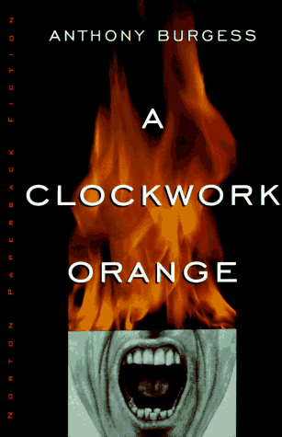
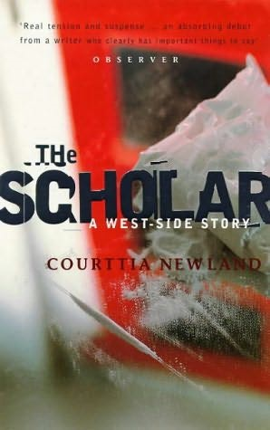

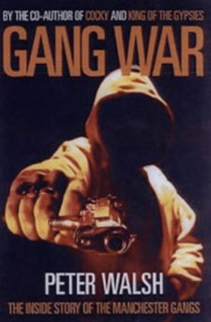

Describe the current situation concerning gangs and gang life in Manchester.
- For what reasons do young people join gangs?
- What types of gangs are there? How are they organized? What do they do?

To what extent do the fictional characters from The Scholar and A Clockwork Orange fit into this picture? How realistic and plausible are these novels? Which typical features of gang-life have you found in the novels?

Cem Unat Special Topic

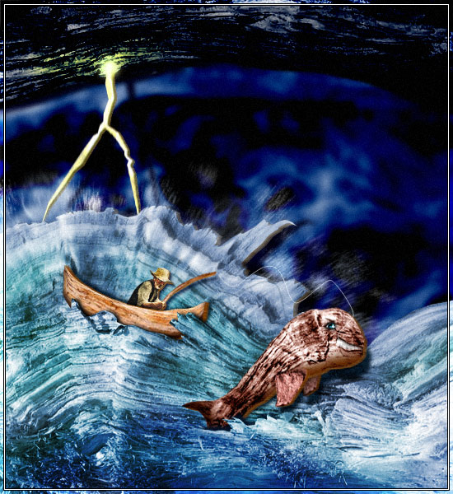
Ernest Hemingway
The Old Man and the Sea
A Farewell to Arms
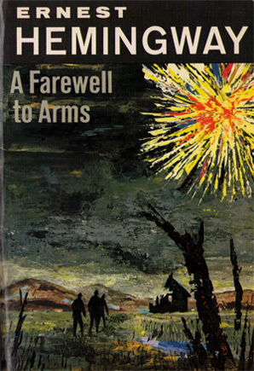

1. One of the recurring themes in Hemingway’s works is the relationship between man and nature.
Explain Hemmingway’s views on this matter and give examples from your reading.

2. Both novels are closely linked to the author’s biography. Give examples of autobiographical elements in the novels and stories that you have read.

Nina Kahr Special topic
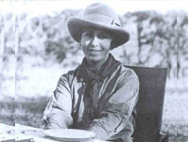



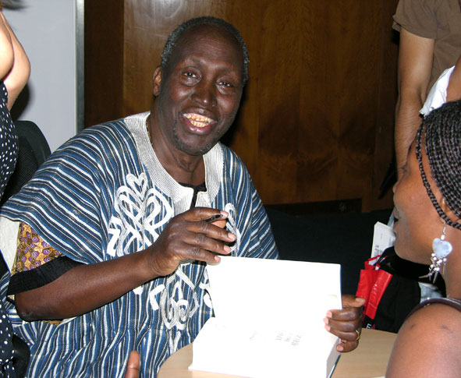
Africa
Karen Blixen Museum
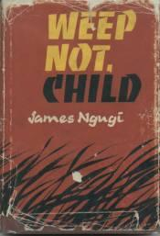

Ngugi wa Thiong’o

Compare the insider’s and the outsider’s views of Africa and African society.
How do the writers and characters of the two novels Weep Not Child and Out of Africa see life.
Consider the following aspects:

- personality and character
- cultural differences
- imperialism and racism

Ulla Vardic Special topic

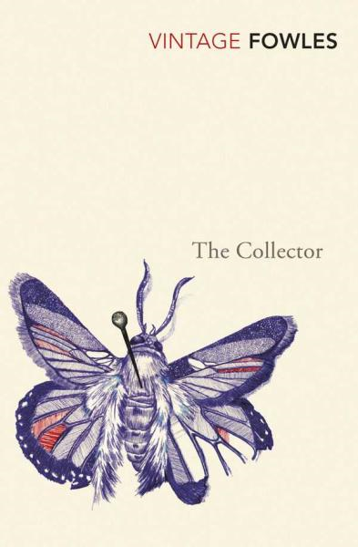
Forced Love

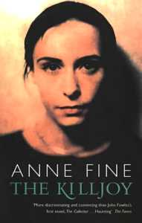

Fill in a character profile for professor Laidlaw and forFrederick. Then compare and contrast the two men and speculate about possible reasons for their behavior.

Explain the symbolism of the butterfly in The Collector

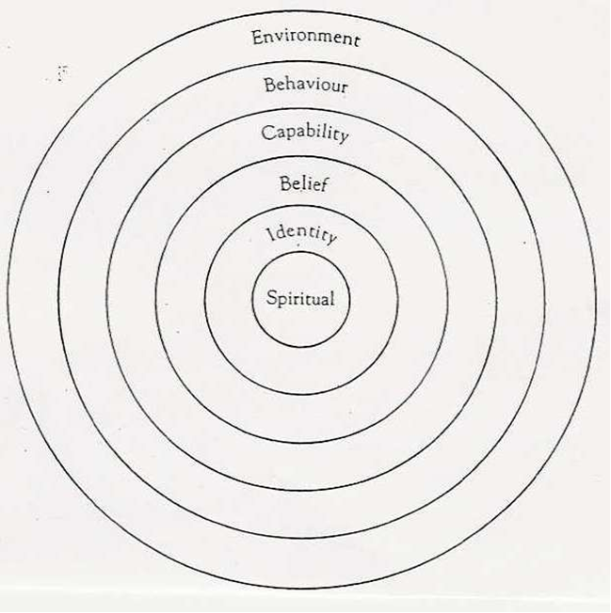
Use the full-size copy of the character profile for your notes.

Hanna Jin Special topic

Amy Tan
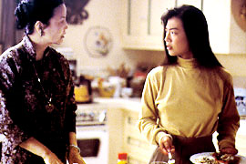
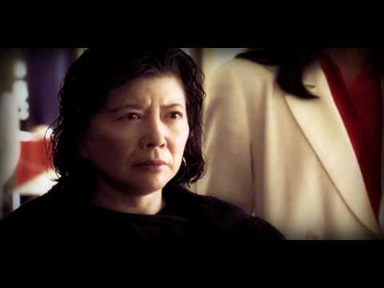



Amy Tan’s novels describe life from the perspective of an Asian American woman who is highly conscious of her dual identity.
Discuss the following themes in her work and give examples from your reading.
- mother- daughter relationships
- dual identity
Lily Zechner Special Topic

Migration from Mexico to the US

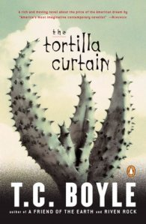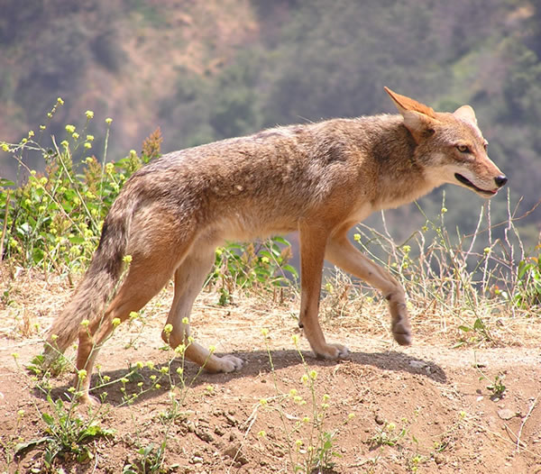

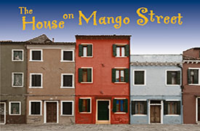

“The coyote is not to blame – he is only trying to survive, to make a living, to take advantage of the opportunities available to him” (Tortilla Curtain: 215)
Explain the metaphor of the coyote in the context of the two novels you have read.
Describe the living conditions of the Mexican immigrants and compare them to white middle class society. Give examples from your reading.
What are the immigrants’ dreams? What strategies do they use to fulfill them?
Nadja King Special Topic


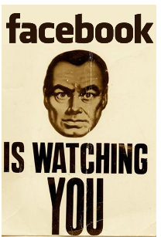
Future societies in dystopian literature

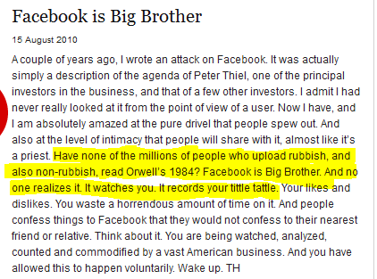

http://idler.co.uk/news/facebook-is-big-brother/

In all three dystopian novels that you have read individuals are manipulated and controlled by a strong leader or political system.
Explain some of the methods of -control and manipulation that you have encountered in the novels.
Can you see any parallels in our present-day society? Do you feel “watched” and controlled in any way?

Sebastian Wrighton Special Topic

Relationships in Ian McEwan’s Works



In Ian McEwan’s novels the characters often seem to spiral into an inescapable nightmare. Logical and realistic reasoning give way to irrational and pathological behavior that eventually destroys the characters and their relationships.

Give examples of such developments in the novels that you have read.

Klara Zeiner Special Topic

Ian McEwan

Damaged People

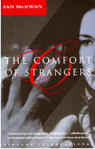
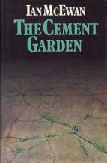
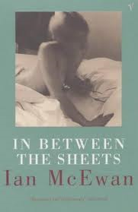

Ian McAbre:
- Ian McEwan’s characters are often deeply disturbed and traumatized.
- Despite their strangeness, the reader easily identifies with the main characters.
- They are often alienated or involved in strange relationships.
Give examples of these characteristic features in Ian McEwan’s works and explain possible reasons for choosing such odd characters.
How did these odd characters and their behavior affect you as a reader?

Furtuna Wube Special Topic

Mental Illness in Literature
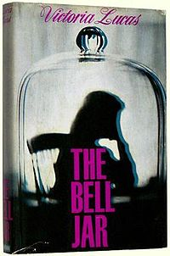
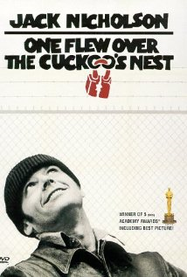

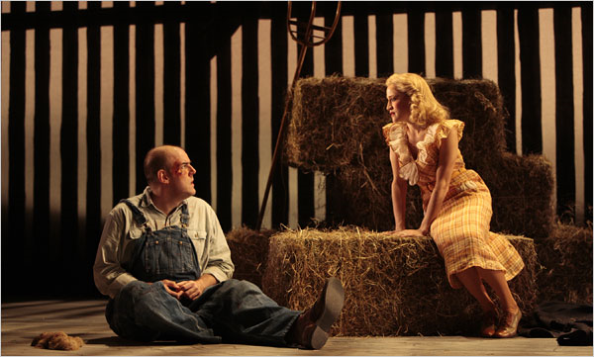

The protagonists of the three novels you have read are all “free spirits” in different ways. They do not conform to society’s expectations and have their own views of the world.
In what way are their views different from the accepted standard?
What are Esther’s, McMurphy’s and Lennie’s dreams and goals in life? What hinders them?
Benjamin Janisch Special Topic

On the Road in the United States
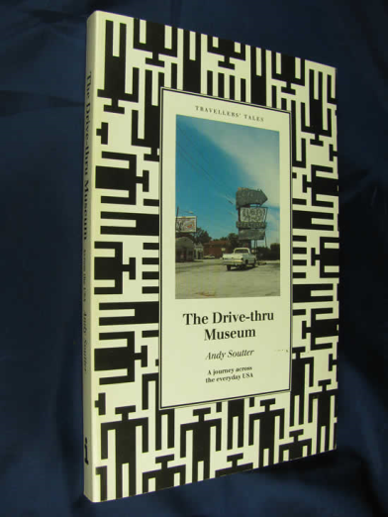
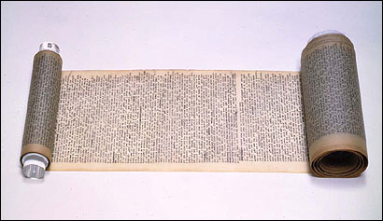

The novels and film in your project all describe extensive trips across the United States and portray American society, lifestyle and landscape. Compare and contrast the different views of America keeping in mind that they were written at different times.
Use the following quotes and explain what each of the authors/characters was looking for and what they found.
Something, someone, some spirit was pursuing all of us across the desert of life and was bound to catch us before we reached heaven. Naturally, now that I look back on it, this is only death: death will overtake us before heaven. The one thing that we yearn for in our living days, that makes us sigh and groan and undergo sweet nauseas of all kinds, is the remembrance of some lost bliss that was probably experienced in the womb and can only be reproduced (though we hate to admit it) in death.
George: You know, this used to be a helluva good country. I can't understand what's gone wrong with it.
Billy: Huh. Man, everybody got chicken, that's what happened, man. Hey, we can't even get into like, uh, second-rate hotel, I mean, a second-rate motel. You dig? They think we're gonna cut their throat or something, man. They're scared, man.

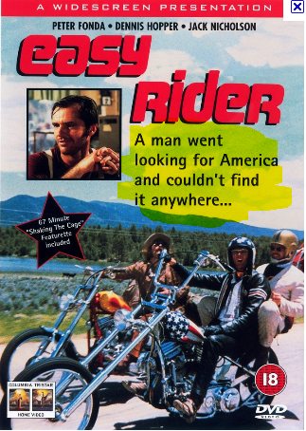

America used to be where the future happened first; but wherever we went I found a nation hooked on its past…
In everyday American landscapes, domestic trappings, and in the way people move, speak and dress, the past is invoked to an extraordinary degree, while the future is on ice.

Special Topic Daniel Toller

Kurt Vonnegut

Features > May 10, 2004

Cold Turkey

By Kurt Vonnegut
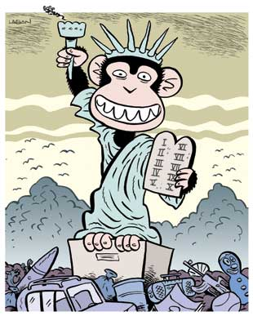
Many years ago, I was so innocent I still considered it possible that we could become the humane and reasonable America so many members of my generation used to dream of. We dreamed of such an America during the Great Depression, when there were no jobs. And then we fought and often died for that dream during the Second World War, when there was no peace.
But I know now that there is not a chance in hell of America’s becoming humane and reasonable. Because power corrupts us, and absolute power corrupts absolutely. Human beings are chimpanzees who get crazy drunk on power. By saying that our leaders are power-drunk chimpanzees, am I in danger of wrecking the morale of our soldiers fighting and dying in the Middle East? Their morale, like so many bodies, is already shot to pieces. They are being treated, as I never was, like toys a rich kid got for Christmas…

Read the above opening of a the recently published article by Kurt Vonnegut. What is he criticizing? Where can this same criticism be seen in his work?
Explain the significance of the cartoon in the context of Vonnegut’s work and give examples of Vonnegut’s recurring themes from the novels you have read.

Kathrin Bornemann

Teenage Pregnancy
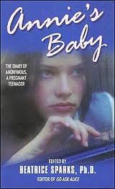
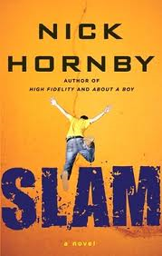

1. Compare and contrast the two books. Consider the following aspects:
- main characters’ experience and problems
- style and tone
- authors’ backgrounds and intentions

2. What role do Sam’s trips into the future play in the book Slam?
3. Twice Sam asks his mother to give him “marks out of ten” for “how he’s doing.” How many points would you give him? Why? How many points would you give Annie?
SAM | 1 | 2 | 3 | 4 | 5 | 6 | 7 | 8 | 9 | 10

ANNIE | 1 | 2 | 3 | 4 | 5 | 6 | 7 | 8 | 9 | 10

Special Topic Tanja Weinzettl

Pedophiles in Literature
Vladimir Nabokov, Lolita
A.M. Homes, The End of Alice
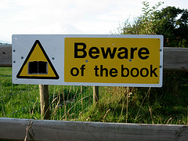

Both novels have caused scandals when they were first published and are still banned in many school districts in the United States.
What makes them dangerous? Why should they be freely available? Collect possible arguments for and against banning these books. Then make up your mind and explain your decision.

Lolita |  | The End of Alice
Should be banned… | Should be available.., | Should be banned… | Should be available…

Ulla Vardic 1. Nebentermin Special topic

Forced Love

The Collector begins as the story of Frederick but really comes to life as Miranda details her inner thoughts, schemes, and struggles – and even sympathies – on paper. The Collector becomes not the story of the collector, but of the collected.
Describe Miranda’s role and her schemes and struggles in the story.

Then compare Miranda to Alicia from The Killjoy. What do these two women have in common? In what way are they different? Draw a Venn diagram.



