Special Topic Loic Kurzweil

Ernest Hemingway
  - Death, Loss, Destruction and Defeat

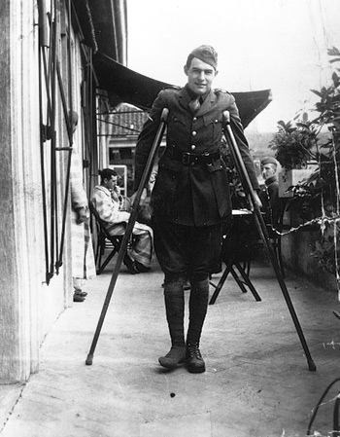

Many of the characters in Hemingway’s novels experience death, loss, destruction and defeat.
Give examples of the characters’ reactions to such experiences and explain the meaning of the quote “A man can be destroyed but not defeated.”

Is suicide an option? Is it destruction or defeat?

Special Topic Stephanie Lorber

Death Penalty
Facts and Figures
John Grisham, The Chamber
Stephen King, The Green Mile

Sister Helen Prejean, Dead Man Walking

Why do we kill
People
Who kill people
To show that
Killing people
Is wrong?

- Sum up the current situation concerning capital punishment in the US and explain some of the arguments that the supporters of the death penalty use.

- What are Sister Helen Prejean's arguments against the death penalty.

- Compare the trials of the criminals in the novels. Why were the protagonists sentenced to death? In what way are their stories similar?

- What is your personal opinion on capital punishment?

Special topic Nikolas Hansbauer

The Perfect Crime

Read the following passages by Bertold Brecht and by Joseph Wood Krutch.
What do the two writers think of crime novels?
What are the characteristic features of the crime novel according to Brecht and Krutch?
Which characteristics (or fixed elements, themes and methods) have you found in your reading?

Explain what makes John Grisham's novels bestsellers?
What makes them so appealing to the American public?

Bertold Brecht
If someone cries “The same old thing again!” when he realizes that a tenth of all murders take place in a churchyard, then he has not understood the crime novel. He might just as well cry “The same old thing again!” in the theatre when the curtain rises. The originality resides elsewhere. Indeed, the fact that one characteristic feature of the crime novel is the variation of more or less fixed elements is precisely what gives the whole genre its aesthetic quality. It is one of the properties of a cultivated brand of literature. Besides, the ignorant man’s cry of “The same old thing again!” is based on the same fallacy as the white man’s idea that all blacks look the same.

Joseph Wood Krutch
No inconsiderable part of the great literature of the world has been written within the limitations of an established tradition, and so written not because the authors lacked originality but because the acceptance of a tradition and with it of certain fixed themes and methods seems to release rather than stifle the effective working of the imagination.

extracts from: Michael Dibdin Ed., The Picador Book of Crime Writing, 1993, p. 207

Special Topic Joel Kurzweil

Jewish American Humor
  - as a Means of Coming to Terms with the Past

The list of Jewish comedians is a long one, and for centuries Jews have been known for their humor. The Talmud even says that when Rav lectured, he always started with a joke. This great sage was speaking to thousands of students on serious Torah topics – and telling jokes! Why?

Explain the role humor plays in Jewish literature and culture. Give examples from your reading.
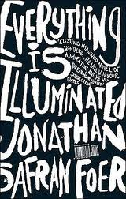
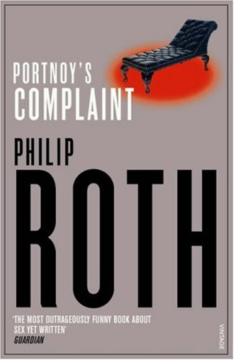
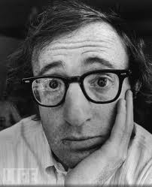
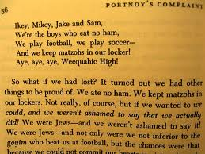



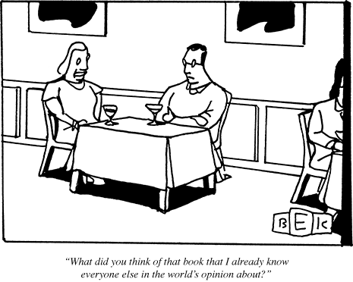

Let’s have a polite conversation!

Special Topic Fiona Widmann

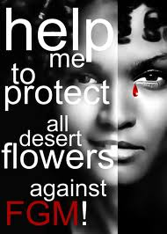
African Women’s Rights and Experiences

Waris Dirie, Desert Flower

Barbara Kingsolver, The Poisonwood Bible

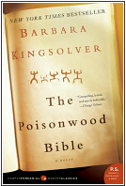
Mariama Bâ, So Long a Letter
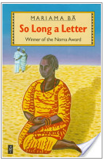



A proverb from Ghana declares that: A woman is a flower in a garden; her husband is the fence around it'."

- In what way does this proverb describe the traditional role of women in Africa?
- Give examples of cultural traditions concerning women and
- explain how the main characters in the three novels deal with these challenges and limitations.
Special Topic Dominik Maresch

The Dangers of Modern Technology


Dan Brown, Digital Fortress

Aldous Huxley, Brave New World,

Kurt Vonnegut, “The Euphio Question”

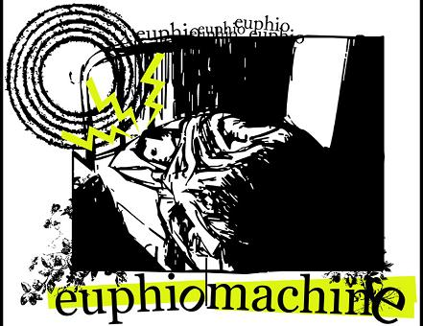








People of all ages have warned of the dangers of progress and technology.
- Briefly explain the dangers described in the literature you have read and
- discuss their significance in real life.
- Which of these dangers do you consider most threatening? Give reasons.

Special Topic Victoria Nekrepp

Split Personalities in Literature
A comparison of the double personalities in
The Strange Case of Dr. Jekyll and Mr. Hyde
The Picture of Dorian Gray
and
American Psycho
Read the definition of narcissistic personality disorder given below and examine whether Dr. Jekyll, Dorian Grey and Patrick Bateman meet any of the criteria. Give examples from the novels to back up your diagnosis. How else can their split personalities be explained?

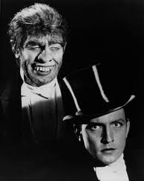
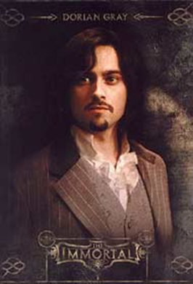


Narcissistic Personality Disorder
http://www.behavenet.com/capsules/disorders/narcissisticpd.htm
An all-pervasive pattern of grandiosity (in fantasy or behaviour), need for admiration or adulation and lack of empathy, usually beginning by early adulthood and present in various contexts. Five (or more) of the following criteria must be met:
1. Feels grandiose and self-importance (e.g., exaggerates achievements and talents to the point of lying, demands to be recognized as superior without commensurate achievements)
2. Is obsessed with fantasies of unlimited success, fame, fearsome power or omnipotence, unequalled brilliance (the cerebral narcissist), bodily beauty or sexual performance (the somatic narcissist), or ideal, everlasting, all-conquering love or passion
3. Firmly convinced that he or she is unique and, being special, can only be understood by, should only be treated by, or associate with, other special or unique, or high-status people (or institutions)
4. Requires excessive admiration, adulation, attention and affirmation - or, failing that, wishes to be feared and to be notorious (narcissistic supply)
5. Feels entitled. Expects unreasonable or special and favourable priority treatment.
6. Demands automatic and full compliance with his or her expectations Is "interpersonally exploitative", i.e., uses others to achieve his or her own ends

BANNERMAN, J.Y., Mantse-Akan Mbebusen (Ghanaian Proverbs), Accra, 1974, p.19

