Writing Test
You must write two texts altogether:
- the opinion essay in Section A
- one other text (from a choice of two) in Section B
................................................................................................................................................
Section A
You must do this task. Write 350 - 400 words. Do not copy whole phrases from the task instructions to use in your essay.
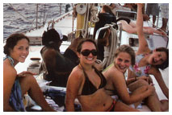
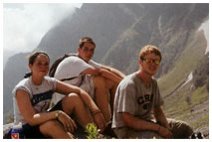

Many high-school students in Austria go together as a class on a graduation trip (“Maturareise”) after their final exams. However, it is often difficult for the class members to agree on where to go and what to do on their holiday. Is the graduation trip a tradition worth keeping? If not, why not? If so, what form should the graduation trip take and why?
Write an opinion essay in which you
- state clearly your opinion on whether a graduation trip is worth doing
- support your opinion with valid arguments and examples
- comment on the summer splash type of graduation trip

Section B
You must choose one task (1 or 2). Write 150 - 250 words.
1. Letter
The Dorking Foundation
Nominate a Candidate for the 2012 Youth Courage Award
1. ALL nominations MUST be received by 9 AM, Monday, June 1, 2011
2. Nominations received after the due date/time will NOT be considered.
3. Self-nominations are NOT accepted.
4. Nominees must be 21 or under.
The Dorking Foundation, an international humanitarian organization, is requesting nominations for its annual Youth Courage Award. Young people who have acted bravely to rescue or protect a person in danger can be nominated for the award. You decide to nominate a classmate, who recently did something very courageous.

Write a letter nominating your friend for the Youth Courage Award.

In your letter

- explain why you think the Youth Courage Award is a good idea
- describe in detail how your friend rescued or protected a person in danger
- say why you believe your friend deserves the award

2. Article
On an evening out with a group of American students visiting your school here in Austria, one of the American students was not admitted to a dance club. You are almost certain this was because of his dark skin colour, although the doorman gave a different reason.
Write an article for Megaphon.
In your article
- explain exactly what happened
- say how you feel about this incident
- suggest what the readers of Megaphon could do in response to this incident

