Daily Routines 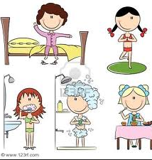

Step One: Do this on your own
- Pick one of the pictures on the teacher’s desk. Please use the picture carefully and give it back at the end of the lesson.
- Give the person a name and a life:
- Write about this person’s day. What does he/she do all day? Where does the person live? Does the person have a family, a pet? What are the person’s hobbies?

Step Two:
You are going to interview your partner in order to find out about as much as possible about his/her person.
Write down 10 questions that you are going to ask.

Step Three: Work with a partner
Interview your partner and find out as much as possible about your partner’s person.
Take notes (keywords).

Step Four:
Tell your teacher everything you have found out about your partner’s person.

