Five little monkeys sitting in a tree, 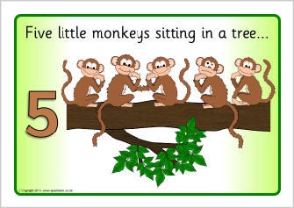

Five little monkeys swinging in a tree,
Teasing Mr. Alligator : “You can’t catch me!”
Along comes Mr. Alligator
As quiet as can be and…SNAP!
Four little monkeys swinging in a tree…
Three little monkeys swinging in a tree…
Two little monkeys swinging in a tree…
One little monkey swinging in a tree,
Teasing Mr. Alligator: “You can’t catch me!”
Along comes Mr. Alligator
As quiet as can be and….SNAP!
And away swims Mr. Alligator as full as he can be!

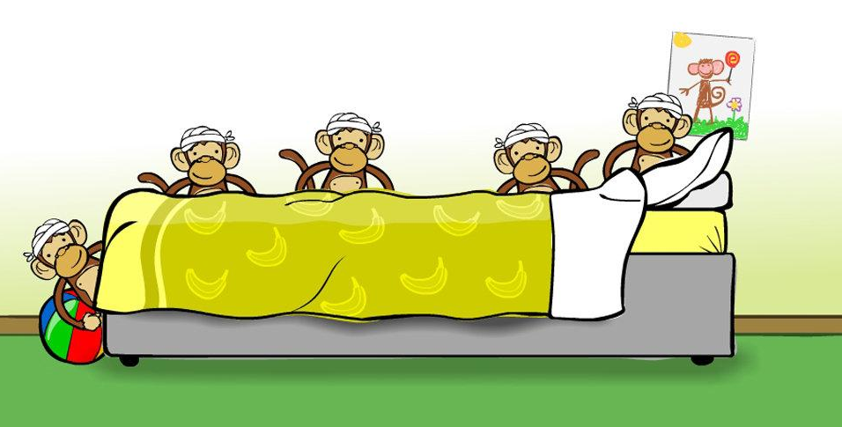

Five little monkeys
FIVE little monkeys jumping on the bed
One fell off and bumped his head;
Mother called the doctor and the doctor said:
“No more little monkeys jumping on the bed.”
FOUR little monkeys jumping on the bed
One fell off and bumped his head;
Mother called the doctor and the doctor said:
“No more little monkeys jumping on the bed.”
THREE little …..

