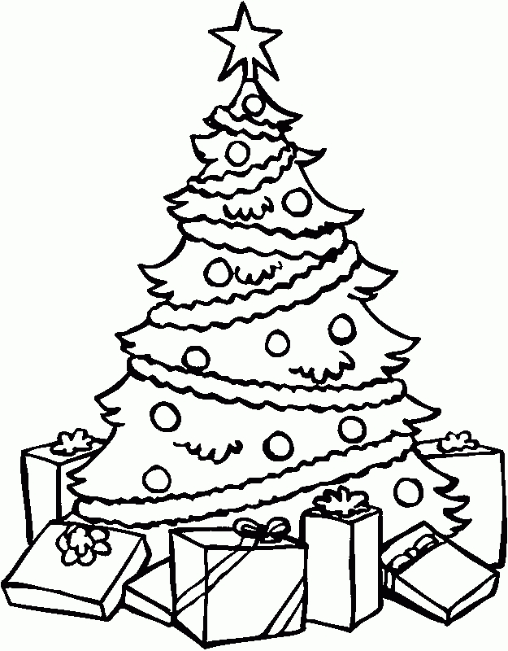
Christmas

Task | How many people | Checked
- Christmas in England | 
- Vocabulary | 
- Funny Christmas Creature
- A Letter to Santa
- Alphabet Challenge
EXTRA | If you finished early or have time in between you can get extra points here.

Christmas in England

Read the text about Christmas in England. Then get into a group of four people. One of you asks your teacher for an envelope (=Kuvert). In the envelope you will find 20 paper strips with questions or answers. Deal out the paper strips in your group. Now one by one ask your questions and see who has the right answer to them.
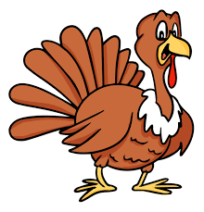
Christmas in England
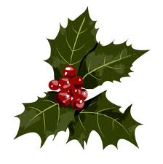

In England, families often celebrate Christmas together, so they can watch each other open their gifts and eat turkey together! Most families have a Christmas tree (or maybe even two!) in their house for Christmas. They decorate the tree and also the rest of their houses. English people use holly, ivy and mistletoe to make their homes beautiful.
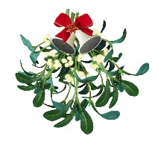

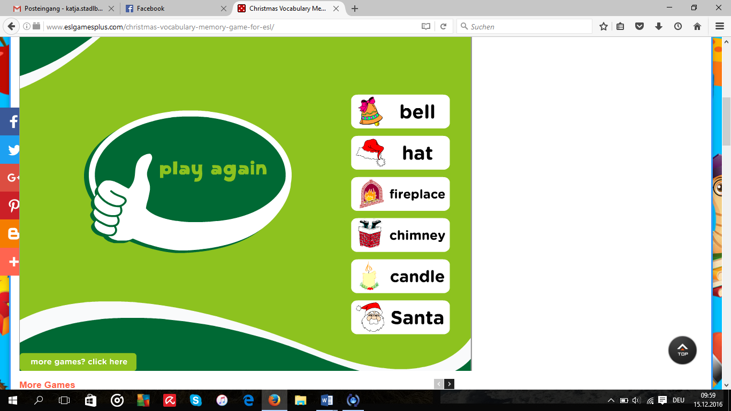
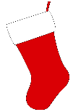
Children believe that Father Christmas or Santa Claus leaves presents in stockings or pillow-cases. These are normally hung up by the fire or by the children's beds on Christmas Eve. Santa uses the chimney to get into the houses.

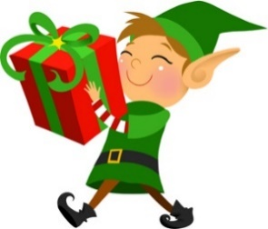
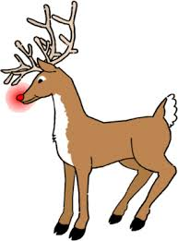
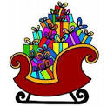
Santa uses his sleigh to carry all the presents and to travel to the houses. Flying reindeer pull the sleigh. They all love to eat carrots. Santa has nine reindeer. Their names are Rudolph, Prancer, Dancer, Donner, Blitz, Dasher, Vixen, Commet and Cupid. People all around the world know Rudolph because of his red nose. Santa’s reindeer are not his only helpers. He has many elves who help him with all the preparations for Christmas. They all live together on the North Pole.


Play the QUESTIONS and ANSWERS Game
Get an envelope from your teacher

Then answer these questions:

What are typical Christmas decorations?
_________________________________________________________________
Where does Santa Claus leave the presents?
_________________________________________________________________
What are Santa’s helpers called?
_________________________________________________________________
What form of transport does Santa use to deliver presents?

__________________________________________________________________________________

Vocabulary

Draw a line from the picture to the correct word

bell | hat | candle | chimney

 |  |  | 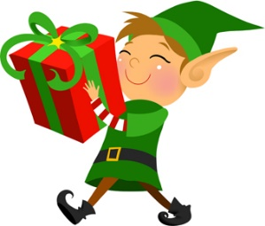
Santa | reindeer | elves | sleigh

Fill in the missing letters! If you don’t know the word, read the text about England again and look for the words.

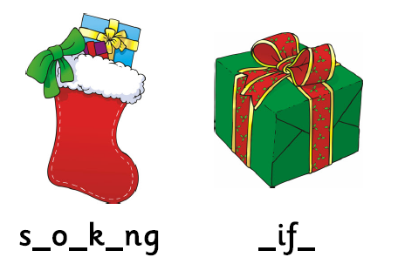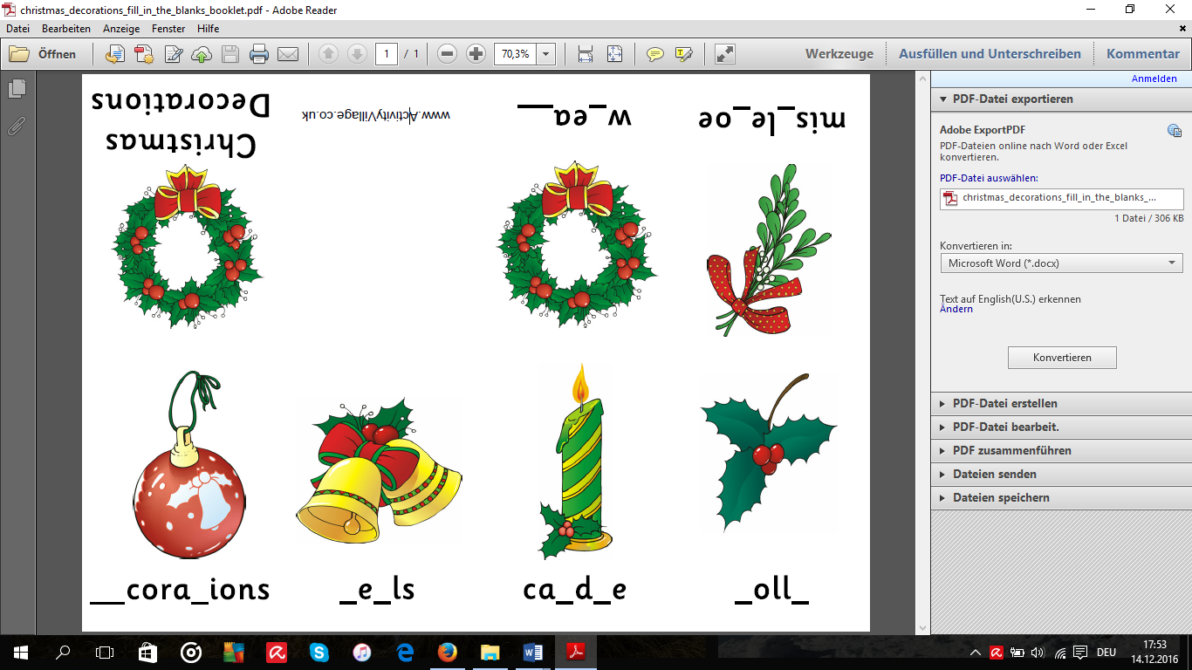

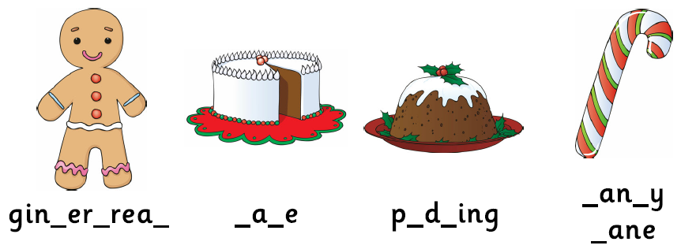

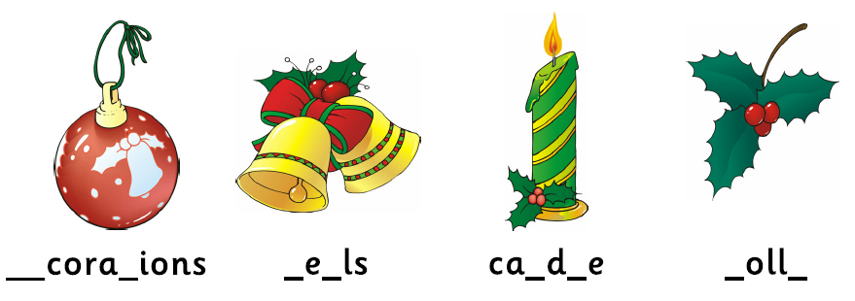

Funny Christmas Creatures

This year Santa’s reindeer are on strike! Therefore, Santa has decided to travel to Earth with a group of flying moucadogs and snabats.
Read the article of the Daily News.


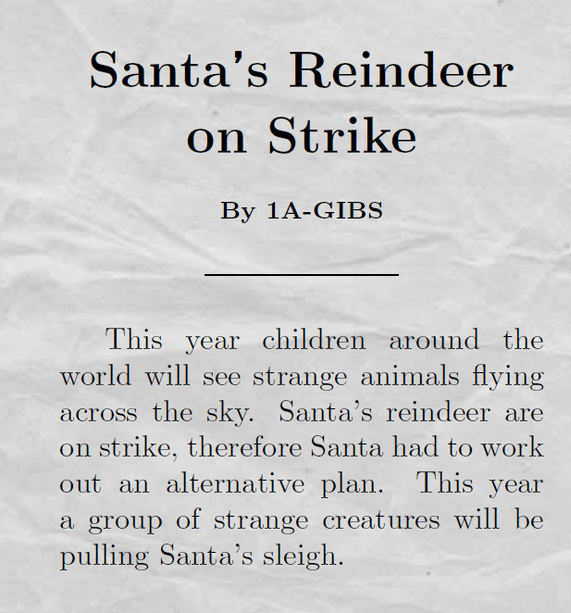
Unfortunately the rest of the article got lost. Continue the article about the flying moucadogs and snabats. Tell the readers what the flying moucadogs or snabats look like.
- Describe them in detail
- Say what is special about them and what they are good at.
The two best articles win a prize in the last lesson!

Now draw a picture of Santa’s helpers:

A Letter to Santa
Take a tablet and go to http://www.aletter4santa.com/ . There you can write your letter to Santa and get an answer. Then complete this letter:
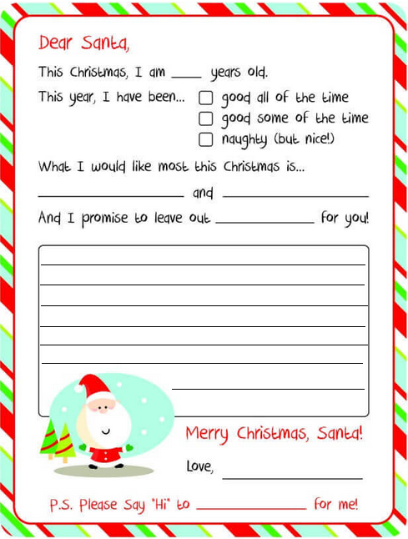
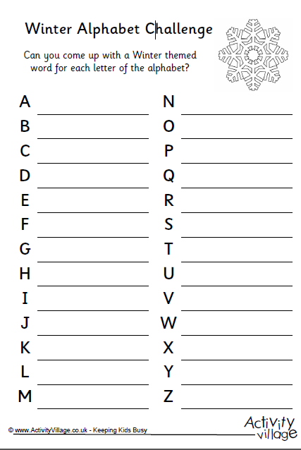
5.

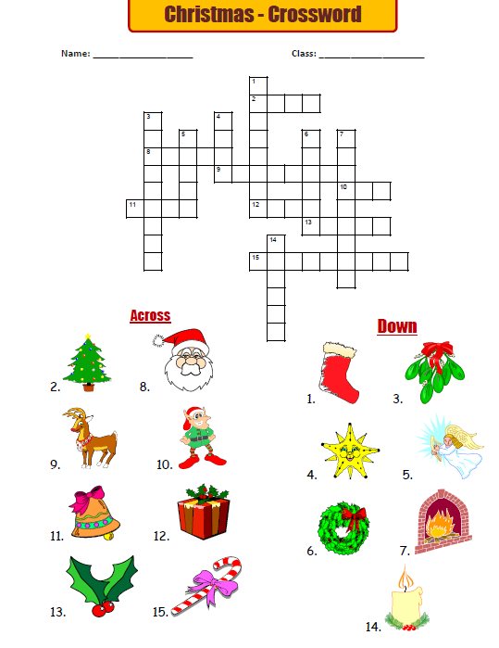
Extras - Crossword

Extras - Poems
Choose one poem and learn it by heart (=auswendig). Tell it one of your teachers.

A little Christmas tree

I’m a little Christmas tree
Glittering, glittering merrily!
A star at my head
Gifts at my feet
And on all my branches
Candy canes so sweet
(glittering = glitzern, merrily = fröhlich, gifts = presents, branches = Zweige)

Santa Claus

Santa Claus is big and fat
He wears black boots
And a bright red hat.
His nose is red
Just like a rose
And he “ho ho hos”
From his head to his toes.
(boots = Stiefel, toes = Zehen)

Extras - Christmas Word Scramble
Put the letters into the right order. Then connect the word you get to the right object.

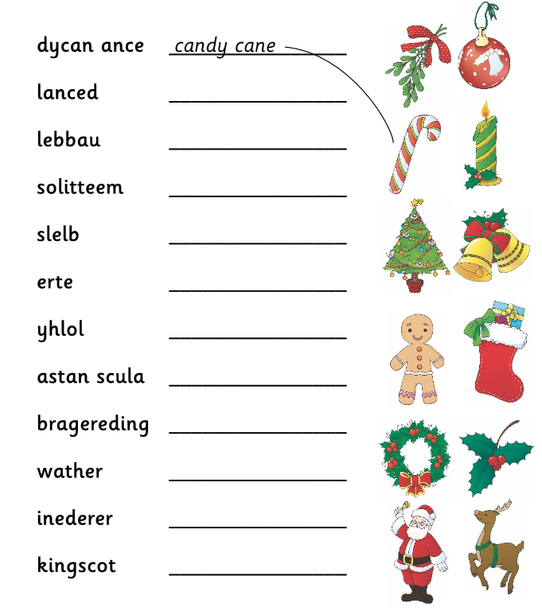

Last Lesson

Christmas Story

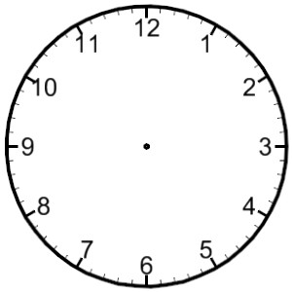

Drawing a Funny Creature

