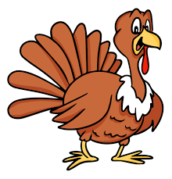
Christmas in England
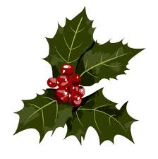

In England, families often celebrate Christmas together, so they can watch each other open their gifts and eat turkey together! Most families have a Christmas tree (or maybe even two!) in their house for Christmas. They decorate the tree and also the rest of their houses. English people use holly, ivy and mistletoe to make their homes beautiful.
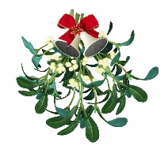

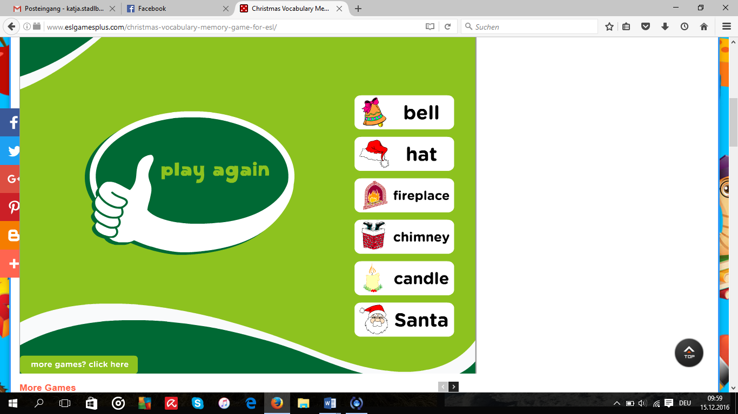

Children believe that Father Christmas or Santa Claus leaves presents in stockings or pillow-cases. These are normally hung up by the fire or by the children's beds on Christmas Eve. Santa uses the chimney to get into the houses.


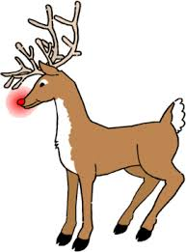
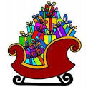
Santa uses his sleigh to carry all the presents and to travel to the houses. Flying reindeer pull the sleigh. They all love to eat carrots. Santa has nine reindeer. Their names are Rudolph, Prancer, Dancer, Donner, Blitz, Dasher, Vixen, Commet and Cupid. People all around the world know Rudolph because of his red nose. Santa’s reindeer are not his only helpers. He has many elves who help him with all the preparations for Christmas. They all live together on the North Pole.

Santa has nine reindeer. Can you name them all?
The name of Santa Claus’s reindeer are Rudolph, Prancer, Dancer, Donner, Blitz, Dasher, Vixen, Commet and Cupid.
Which meat do English people traditionally eat with Christmas dinner?
English people traditionally eat turkey with their Christmas dinner.
What are Santa’s helpers called?
Santa’s helpers are called elves.
How does Santa enter your house on Christmas Eve?
Santa enters the houses down the chimney.
What form of transport does Santa use to deliver presents?
Santa uses a sleigh to transport all the presents.
Where does Santa live?
Santa lives on the North Pole.
Santa Claus is also known as who?
Santa Claus is also called Father Christmas.
What type of vegetable do people leave by the fireplace on Christmas Eve for the reindeer?
English people leave carrots by the fireplace on Christmas Eve for the reindeer to eat.
Where does Santa Claus leave the presents?
Santa Claus usually puts the presents into a stocking. Sometimes he puts them into a pillow-case.
What are typical Christmas decorations?
Holly, ivy and mistletoe are typical Christmas decorations.

