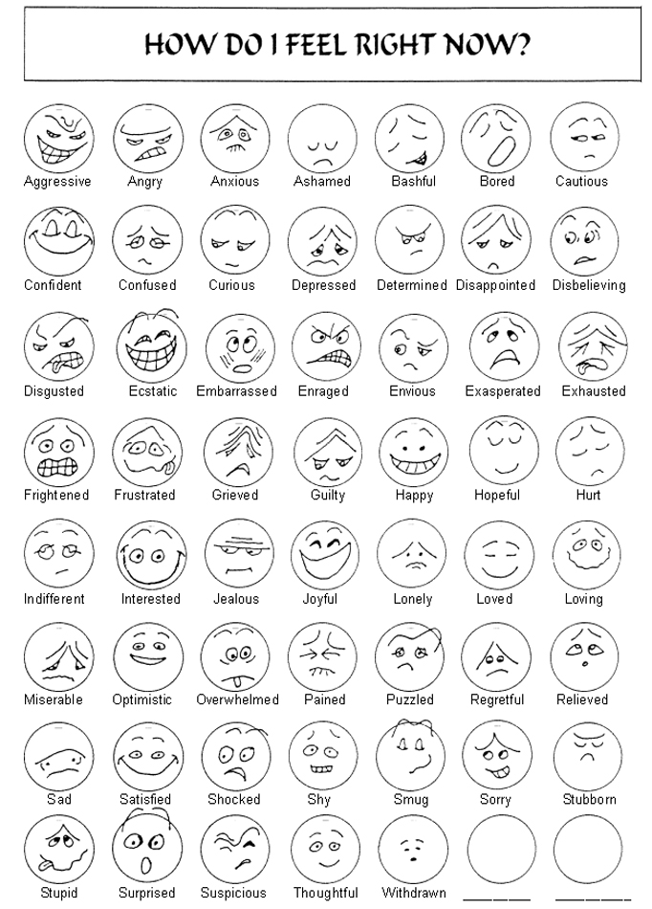

http://mymrecupera.com/dx-smiley-emotions-chart/

