Collecting Pairs: Game for 3-4 players
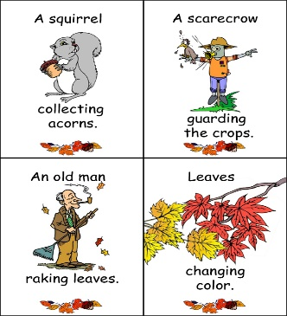
- Hand out the cards. Player 1 reads out a card.
“I need a ... boy picking apples.”
Or “Do you have leaves blowing in the wind?”

- The player who has the matching card, calls out his next wish.

Fall Cards Speed-Matching: Game for 2 players
Play this game AFTER you have played “Collecting Pairs”

- Put the picture cards (without the words) on your desk so you can see them all.

- Put all the word cards face down on a pile. (Verkehrt auf einen Stoß).

- Player 1 takes a card from the pile and reads it again and again. (Lies den Satz immer wieder so lange vor, bis dein Partner die passende Bildkarte gefunden hat.) Sonst darfst du nichts sagen.
Zähle mit wie oft du den Satz lesen kannst bis dein Partner die richtige Karte gefunden hat. Schreib die Zahl auf einen Zettel und rechne am Ende die Summe aus. Wer hat die kleinere Zahl?

- Then player 2 takes a card from the pile and reads it out...

Collecting Pairs: Game for 3-4 players
- Hand out the cards. Player 1 reads out a card.
“I need a ... boy picking apples.”
Or “Do you have leaves blowing in the wind?”

- The player who has the matching card, calls out his next wish.

Fall Cards Speed-Matching: Game for 2 players
Play this game AFTER you have played “Collecting Pairs”

- Put the picture cards (without the words) on your desk so you can see them all.

- Put all the word cards face down on a pile. (Verkehrt auf einen Stoß).

- Player 1 takes a card from the pile and reads it again and again. (Lies den Satz immer wieder so lange vor, bis dein Partner die passende Bildkarte gefunden hat.) Sonst darfst du nichts sagen.
Zähle mit wie oft du den Satz lesen kannst bis dein Partner die richtige Karte gefunden hat. Schreib die Zahl auf einen Zettel und rechne am Ende die Summe aus. Wer hat die kleinere Zahl?

- Then player 2 takes a card from the pile and reads it out...

