WTF Weds: European showers, revisited.
http://www.everywhereist.com/wtf-weds-european-showers-revisited/#more-8396
Posted on: OCT 17 2012
Tags:Bathrooms, Europe, Ireland, WTF, WTF Wednesday

Posted in: Random Musings » WTF » WTF Wednesdays

Sometimes my mother will say or do something so strange or utterly clueless, that all I can do is pull her onto my lap (for my mother is very wee and weighs nothing, and the genes that cause that are apparently recessive, damn it), gently take her face into my hands and whisper,
“You would have been eaten by wolves if it weren’t for me. Do you understand that? BY WOLVES.”
And she will dismiss me in that charming Italian way of hers, saying something like, “Oh, Geraldine, do shut up,” while sounding exactly like Arianna Huffington.
Recently, though, I realize I’ve evaluated the situation improperly. I simply thought, for years, that there was something wrong with my mother.
That’s why she calls Starburst candies by the incredibly strange name of “Opal Fruits.” Or how she refers to oatmeal as porridge. And then there’s her tendency to put ginger into random dishes like chicken soup.
No, seriously. She puts ginger in EVERYTHING.
She’ll call me when her computer breaks, or when the microwave confuses her, or when she receives a particularly aggressive piece of spam email that’s freaked her out good.
And all those times, I quietly pat her head, do what I can to help, eat her gingery chicken soup, and remind her that without me, she’d be dinner for a creature that was only slightly higher than her on the food chain.
But lately, I’ve been rethinking that. I’m starting to wonder if all the things that confuse my mother – and all the things that are confusing about my mother – are simply a result of her not exactly being from around here.
Yes, she’s lived in the U.S. for thirty odd years (sometimes very odd years), but she’s still a European at heart. I wonder if, no matter how much time you spend in another place, things still remain confusing and novel.
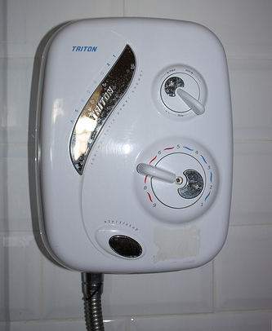
This thought hit me when I found myself confused (once again) by a European shower. We travel to Europe a handful of times a year. You’d think that by now, I’d have grown accustomed to a few things, and I have.
I have no problem drinking copious amounts of tea and gobbling up cake after cake when we’re in Ireland or England. I know that when in Italy, you don’t put cheese on any pasta with fish in it (and that, sure enough, the servers won’t even give you the option of having it).
I get that in Spain, you aren’t going to have dinner before 10pm. That’s just how it works.
But the shower I encountered in our cottage in Ireland was waaay more befuddling that all of that.
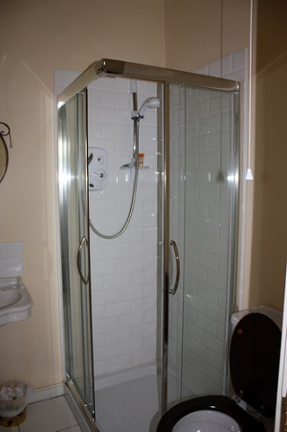
Here it is. It looks innocuous enough, right?

–
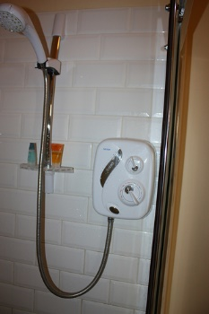
WRONG. It was positively evil. There were no knobs or handles of any kind that I could turn to get the water running. There was this little console inside, which I tried to use. At first, it seemed self explanatory.

It had dials for water temperature and water pressure, and a start/stop button! Plus, it was all in English! Surely I could figure this out, right?
I COULD NOT.
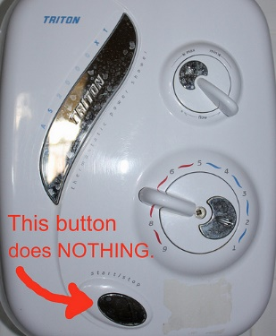
I fiddled with those dials. I pressed that start/stop button until my fingertips were red. I did every single permutation of button pressing/dial turning I could think of, until I was near weeping.
Finally, Rand wondered aloud if the cord hanging down from across the room might have anything to do with the shower. He leaned over to pull it.
“DON’T YOU DARE PULL ON THAT,” I snapped. “I am fairly sure that will call the fire department, or set off an alarm, or something.”
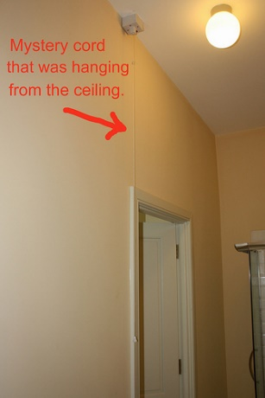
–I mean, it looked exactly like the little emergency pull-cord I’ve seen in hospitals and hotel rooms. The one you tug on that, with any luck, sends a handsome orderly or bellhop with a chiseled jaw to assist you (I’ve never pulled it. I’m speculating here).
Besides, how could that cord have anything to do with the shower? It was on the other side of the bathroom, and it looked like a fire alarm. There was even a little red light on it.
Rather than test Rand’s potentially disastrous theory, I stuck my head out of our room and screamed to our friends.
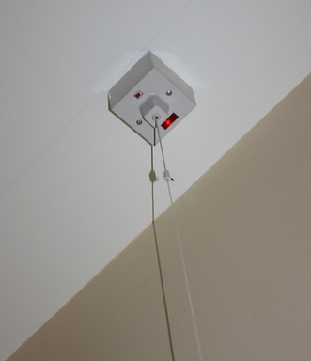
“YOU GUYS, OUR SHOWER IS BROKEN.”
“Wait, really?” someone replied. “Ours is working fine … did you pull on the cord?”
“The what?”
“The cord. Did you pull on it?”
“Well … no.” I proceeded to mumble something about fire alarms while Rand looked at me and sighed.
We pulled the cord. Water instantly started gushing through the shower head.
And I realized that maybe I owe my mother an apology.

- by OH GOD, MY WIFE IS GERMAN

Culture Shock 13: American Expat Receives Terrifying Haircut at Turkish Hairdresser in Germany
https://ohgodmywifeisgerman.com/2013/06/17/culture-shock-13-american-expat-receives-terrifying-haircut-at-turkish-hairdresser-in-germany/
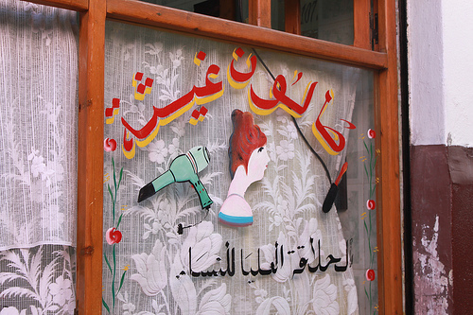
“Welcome to Turktown, my friend.” — Photo by Will Flavell (http://www.flickr.com/photos/swept14/)
As you may already know, I’ve been having some trouble getting haircuts here in Germany. I’m still learning the metric system, and the fact that a centimeter in length is nowhere near as long as an inch. Also, I speak in broken German, so when I want a ‘high fade,’ it sounds like I’m asking for a ‘lofty shrivel.’
Out of frustration, I asked my wife to write a note describing, in perfect German, the kind of haircut I wanted. This note worked wonderfully at first; I walked into my usual ‘Fast Cuts,’ handed the note over to the goth chick with the bad forearm tattoos, and received a decent version of the haircut described. Unfortunately, because it involved scissors — in addition to the usual electric razor — the price jumped from €9 euros to €22 euros. I felt this was a bit extreme, so I vowed to try a different hairdresser.
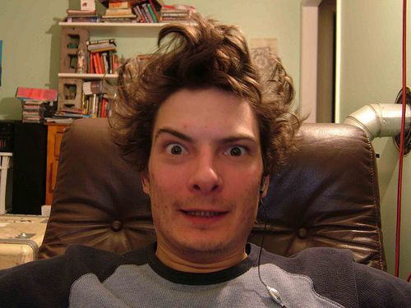
“Heeeey Joe, where you goin’ with that note from your wife of your hand?” — Photo by Todd Ordes (http://www.flickr.com/photos/toddomanbot/)
A month later, with my hair so big and puffy I looked like a member of the Jimi Hendrix Experience, I walked into a little hairdresser around the corner from our apartment. Now, this was a Turkish hairdresser, and it was full of burly Turkish men who were doing more horsing around and shit talking than actual hair cutting. You can imagine the blank stares I got when I handed my note to one of the three hairdressers. This particular gentleman chuckled, making it clear he could not read it. (To this day I am unsure if he truly was illiterate in German, or if he was just being a dick.) A young Turkish kid jumped up from the waiting area and proudly read my note aloud to the entire room. Everyone had a nice laugh about it. The hairdresser nodded his understanding, repeated “Funf miiILLLlliiimeters” to dramatic effect, and gestured for me to sit in the barber chair.
What followed was a scary clusterfuck of English, German and Turkish, if you were to translate everything directly into English:
HAIRDRESSER: “So, where you come from?” *Proceeding to attach the appropriate extension onto an electric razor and peel my scalp like a Doner kebab.*
ME: “I come from the ‘ooo-ess-ahh,’ uh, America… Portland, Oregon, correct? It is up, northwest…” *Gesturing upward and to the left with both hands in the air.*
HAIRDRESSER: *With a thick Turkish accent and a hint of mockery* “Ah, oooohkay, Mr. America.”
*Once the sides and back of my head were shaved, he attached a smaller extension and cut around my hairline. That’s when I noticed the straight razor on the counter. Close proximity to weapons any kind send me directly into fight-or-flight mode, so if someone were to menace me with one, I would either break that person’s wrist and stomp on their brain… or run screaming like a little girl in a tutu with a caterpillar on her arm.*
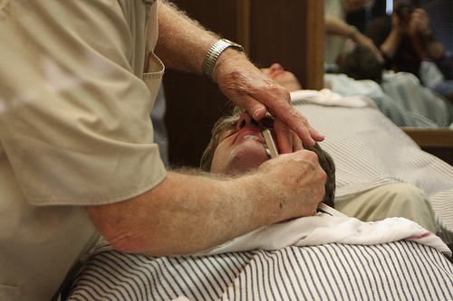
“Sir? Sir… Is this absolutely necessary?” — Photo by Chris Michaels (http://www.flickr.com/photos/chrisamichaels/)
ME: “So, uh… from where come you, formally speaking? I mean, well then, from come you where?”
HAIRDRESSER: *Gesturing to one of the other hairdressers and speaking in Turkish* “I come from him.” *Everyone started laughing for some reason.*
ME: “I don’t understand… I mean, I understand not.”
HAIRDRESSER: “Turkey.”
*That was when the hairdresser picked up the straight razor, at which point I became visibly nervous, my complexion fading from ‘Ivory Apprehension’ to ‘Eggshell Uncomfortable.’*
HAIRDRESSER: *Smiling and bringing the razor close* “Don’t move, eh?”
ME: “Ha ha… ‘kay.”
*The hairdresser proceeded to shave around the perimeter of my hairline, focusing mostly on the back of my neck. He moved the razor in quick little strokes, handling its edge with feline grace. I made the mistake of picturing how easily he could take my eye out, or how quickly he might give me a Sweeney Todd, and it was then my complexion faded from ‘Eggshell Uncomfortable’ to ‘Chartreuse Sputum.’*
HAIRDRESSER: “You for which president, George Bush or Barack Obama?”

“Choose wisely. Your life depends upon it.” — Image by DonkeyHotey (http://www.flickr.com/photos/donkeyhotey/)
ME: *Thinking frantically, Which president is least likely to have messed with Turkey? My life is on the line here, and I’ve got a 50/50 chance of survival.* “…uh, Barack Obama.”
HAIRDRESSER: *Shouting* “MOTHER FUCKER!”
ME: *Oh my God, I am going to die.* “What? I don’t know! Who do you like?” *Thinking, Did the President bomb Turkey lately? Why don’t I follow the news back home more closely? Please put the razor down, please put the razor down…*
HAIRDRESSER: *After rattling off some particularly guttural Turkish and gesturing toward the TV in the corner, I understood this man was mostly kidding, but did, in fact, prefer George Bush.* “So, it is ‘Fuck Bush’ then, eh, Mr. America?”
ME: “I… I really don’t know man.” *Now more mystified than terrified, thinking, Why in the sweet fires of hell would a Turkish man support George W. Bush?*
*The haircut concluded in merciful silence, with me in no way comforted, and the hairdresser wearing a shit-eating grin. He showed me the back of my head with a handheld mirror, I nodded my approval and we approached the cash register.*
HAIRDRESSER: “So! That will be thirty euros!”
*I paused, wallet in hand, thinking, That is way more expensive than I had anticipated, but one cannot be frugal when shopping for uncut throats.*
HAIRDRESSER: “I kid! From me to you. It is eight euros.”
ME: “Eight euros, okay.” *Thinking, That is way cheaper than I had anticipated.*
*I tipped him an extra euro (which is actually a really nice tip here in Germany), wished him a good day and shagged-ass right the hell out of there.*
“Thankyouseeyoulaterhaveaniceday!” —
When I came home, I went into the bathroom, looked in the mirror and discovered I’d received what was absolutely the best haircut I’d had in Germany thus far. Maybe it was so good because I finally had my hair cut by a man, and who better than a man to understand the subtleties of a man’s haircut? Maybe Turkish hairdressers are just really talented? I don’t know, and I shan’t question my good fortune. However, it wasn’t so long ago I would have laughed had you suggested I might someday move to Germany and switch political parties at the provocation of a knife-wielding Turk.

CHASED DOWN A MOUNTAIN BY LOCAL HMONG LADIES
http://thatbackpacker.com/2013/05/28/cat-cat-village-sapa/

I came to Sapa to go trekking; I prepared for that trek by eating mocha cake.
That should give you a glimpse into my level of fitness…
Seeing as I haven’t been on a serious hike since…oh, never…I decided I would start small by hiking down to Cat Cat Village which lies about 2 kilometres away from Sapa in the valley below. Surely, that would be enough training for the 2 day trek I was going on later that week.
I put on my brand new running shoes (the ones I’ve had for over a year but still glow white because that’s how often I use them) and we set off down the dirt path.
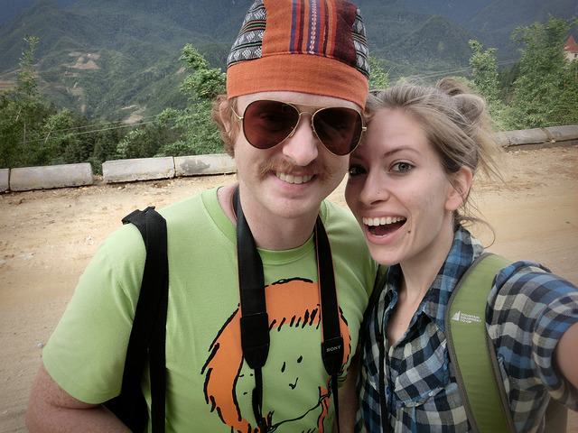
That’s when Sam and I met them – three women clad in indigo, the colour of the Hmong tribe.
“What’s your name?”
“Where you from?”
“He your boyfriend?”
I was impressed by their level of English, and we soon had a conversation underway.
“Wow, these people are so friendly!” I thought to myself. This is exactly the kind of cultural encounter every traveller hopes for – walking down a mountain en route to a rural village, water buffaloes munching away on shrubs, women from a local hill tribe joining for a walk. Why this is the kind of stuff makes the feature story on the National Geographic! Right?
If you’ve been to Sapa before you’re probably laughing at me and shaking your head at my impending demise. You know what’s coming.
Hidden agenda, you say? Impossible! I don’t fall for this kind of thing. We were talking, we were laughing, they were playing music for us. This was genuine I tell you, genuine!
Except it wasn’t.

Once we began approaching Cat Cat Village, the three women told us they would not be able to go any further because they were from Lao Chai, a village located further away.
Our time together was coming to and end and it was now time for their business pitch, which literally went like this:
“Okay, now you buy from me.”
Uh, what?
“I have bracelet, I have purse, I have bag. You buy from me.”
All three of them were looking at me with expectant eyes, each waiting for me to purchase something. I didn’t want to be the foreigner who passes through town and doesn’t give anything back to the local community, plus these women seemed nice and they had been walking with me for a while now, so in spite of having a backpack full of souvenirs and trinkets I have no use for, I gave in and purchased yet another purse.
But it didn’t end there.
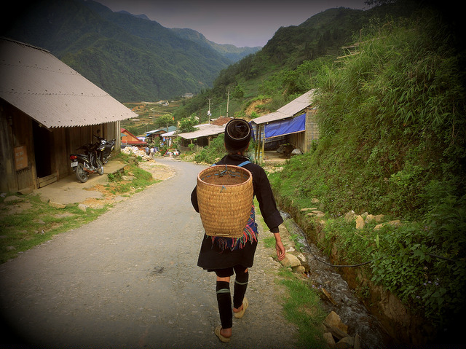
“Now you buy from heeeer. Buy from heeeeeer.”
“You buy from meeeee.”
“Yes, you buy from heeeeeeer.”
Oh oh. Despite my refusals, silver bracelets were being displayed in my face, coin purses put in my hands, this was starting to feel like the bamboo train incident, and I needed to get out of there pronto.
I declined their offers, apologized for not being able to buy from all of them, and picked up the pace hoping that would be the end of the conversation.
Except they started walking just as fast behind me. (You’ve got to admire their persistence.)
Crap! Now what? Am I supposed to run?!
How did we go from having a ‘cultural encounter’ to me galloping down the mountain with little ladies chasing after me? A funny scene to behold, yes, but where’s the part where I get invited back to their homes for a cup of tea? Isn’t that how it goes in the travel documentaries?
By now I had reached the entrance to Cat Cat Village and I was safe.

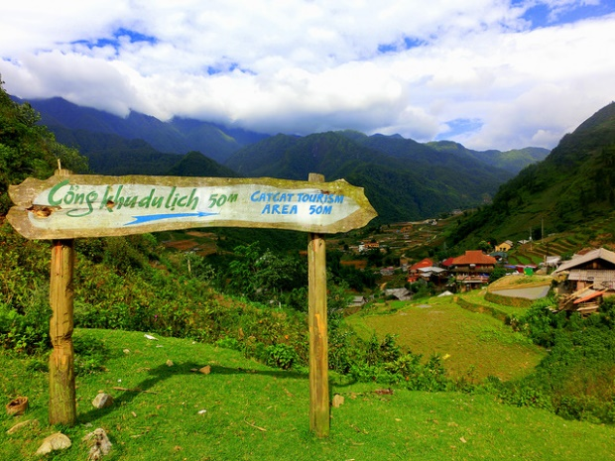
I was feeling kind of bad about the way I had handled things, but then on the hike back from Cat Cat Village to Sapa I changed my mind. As I walked back uphill on the same path I had taken down, I noticed an even larger group of local Hmong ladies were now repeating the same tactics on the group of foreigners who were slowly trickling down to the town for a visit.
I noticed the women who had chased me down only a few hours ago, and they just laughed and smiled my way.
No hard feelings – just another business day on the mountains.
P.S. There weren’t that many cats in Cat Cat Village.

Do you have a story about a ‘local encounter’?

