CONDITIONAL 1
USE: Die Möglichkeit/Kondition im if-Satz ist erfüllbar.

FORM:
if clause main clause
If + present simple will + infinitive
If I study, I will get good marks.
If it rains, I will take an umbrella.
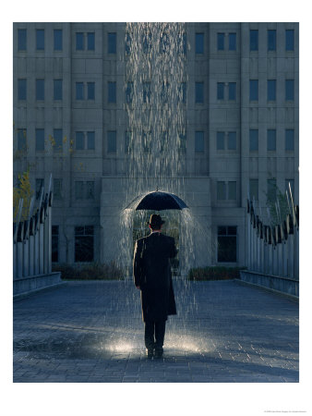
If you come to my place, I will cook for you.

CONDITIONAL 2
USE: Ich verwende den Conditional 2, wenn ich mir vorstelle, wie etwas sein könnte.
FORM:
if clause main clause
If + past simple would + infinitive
If I studied, I would get good marks.
If I were you, I’d wear more makeup.
If I had more money, I’d buy a house.
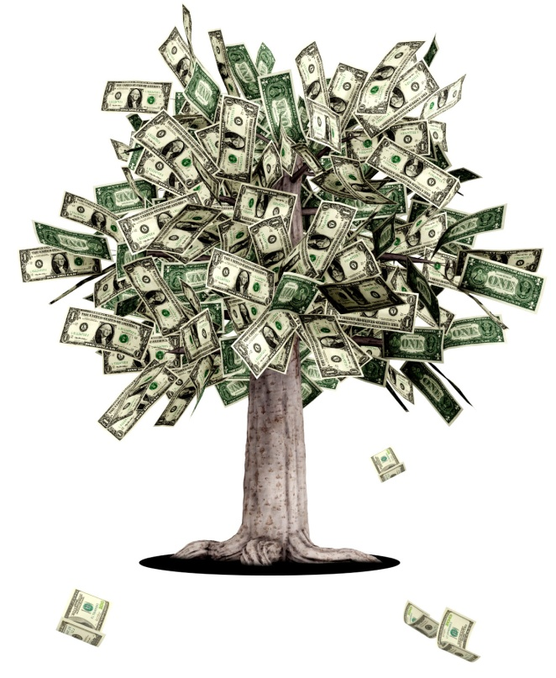

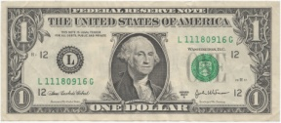
If I had a Million Dollars – Barenaked Ladies
The Barenaked Ladies are a Canadian group that has had many hits in Canada and the U.S.A.
"If I Had a Million Dollars" was their first big song. The song is very well known in Canada, especially Toronto, where the group is from.
The English grammar that is very important in this song is the 2nd Conditional. It talks about what the singer would do if he had a million dollars.


Listen to the song and fill in the missing words!

If I had a million dollars
(If I had a million dollars)
I'd buy you a ____________
(I would buy you a __________)
If I had a million dollars
(If I had a million dollars)
I'd buy you furniture for your ___________
(Maybe a nice chesterfield or an ottoman)
And if I had a million dollars
(If I had a million dollars)
Well, I'd buy you a K-Car
(A nice Reliant automobile)
If I had a million dollars I'd buy your ________
If I had a million dollars
I'd build a _______ fort in our yard
If I had million dollars
You could help, it wouldn't be that hard
If I had million dollars
Maybe we could put like a little tiny fridge in there somewhere
You know, we could just go up there and hang out
Like open the _________ and stuff
There would already be laid out ______ for us
Like little pre-wrapped sausages and things
They have pre-wrapped sausages but they don't have pre-wrapped _________
Well, can you blame 'em
Uh, yeah
If I had a million dollars
(If I had a million dollars)
Well, I'd buy you a fur ________
(But not a real fur ______ that's cruel)
And if I had a million dollars
(If I had a million dollars)
Well, I'd buy you an exotic ______
(Yep, like a llama or an emu)
And if I had a million dollars
(If I had a a million dollars)
Well, I'd buy you John Merrick's remains
(Ooh, all them crazy elephant bones)
And If I had a million dollars I'd buy your _______
If I had a million dollars
We wouldn't have to walk to the ________
If I had a million dollars
Now, we'd take a limousine 'cause it costs more
If I had a million dollars
We wouldn't have to eat Kraft Dinner
But we would eat Kraft Dinner
Of course we would, we’d just eat more
And buy really expensive ketchups with it
That’s right, all the fanciest ke... dijon ketchups!
Mmmmmm, Mmmm-Hmmm
If I had a million dollars
(If I had a million dollars)
Well, I'd buy you a green _______
(But not a real green __________, that's cruel)
And if I had a million dollars
(If I had a million dollars)
Well, I'd buy you some _________
(A Picasso or a Garfunkel)
If I had a million dollars
(If I had a million dollars)
Well, I'd buy you a ________
(Haven't you always wanted a _________)
If I had a million dollars
I’d buy your _________
If I had a million dollars, If I had a million dollars
If I had a million dollars, If I had a million dollars
If I had a million dollars
I'd be rich

Activities
- The song uses many contractions of the verb "would". Give 2 examples! (e.g. I’d buy)
______________________________________________________________________________
- What would you do if you had a million dollars? Write down 4 sentences.
_______________________________________________________________________________
_______________________________________________________________________________
_______________________________________________________________________________
_______________________________________________________________________________
- What is the difference in meaning if you say “If I have a million dollars, I will buy you hundred shoes” and “If I had a million dollars, I would buy you hundred shoes”?
_______________________________________________________________________________

