Pembroke Hill School in Austria 3.06. - 10.06. 2016

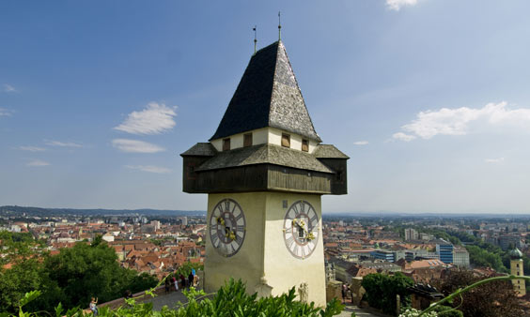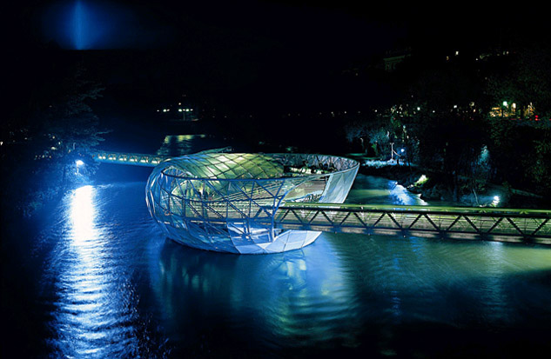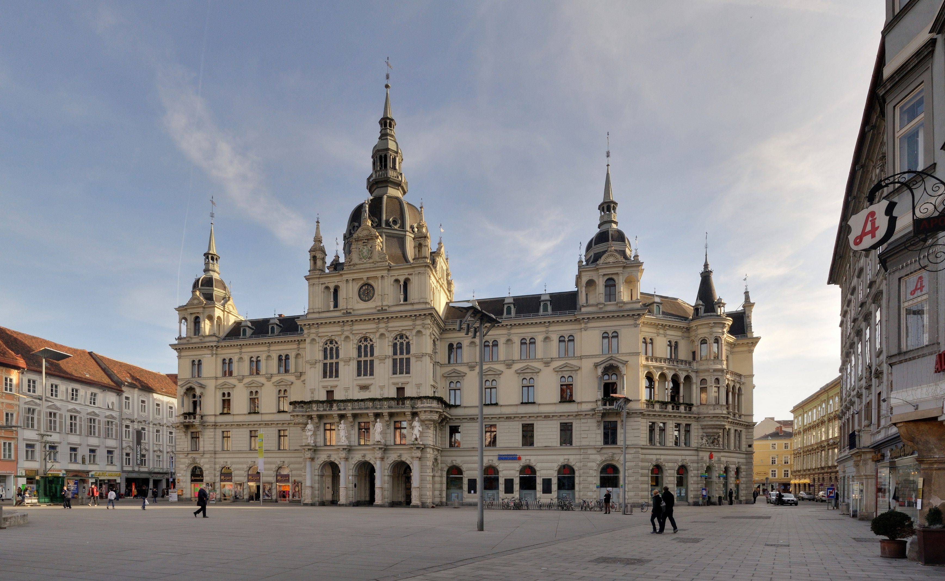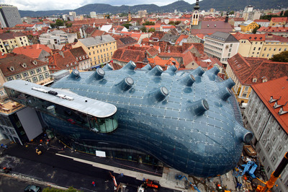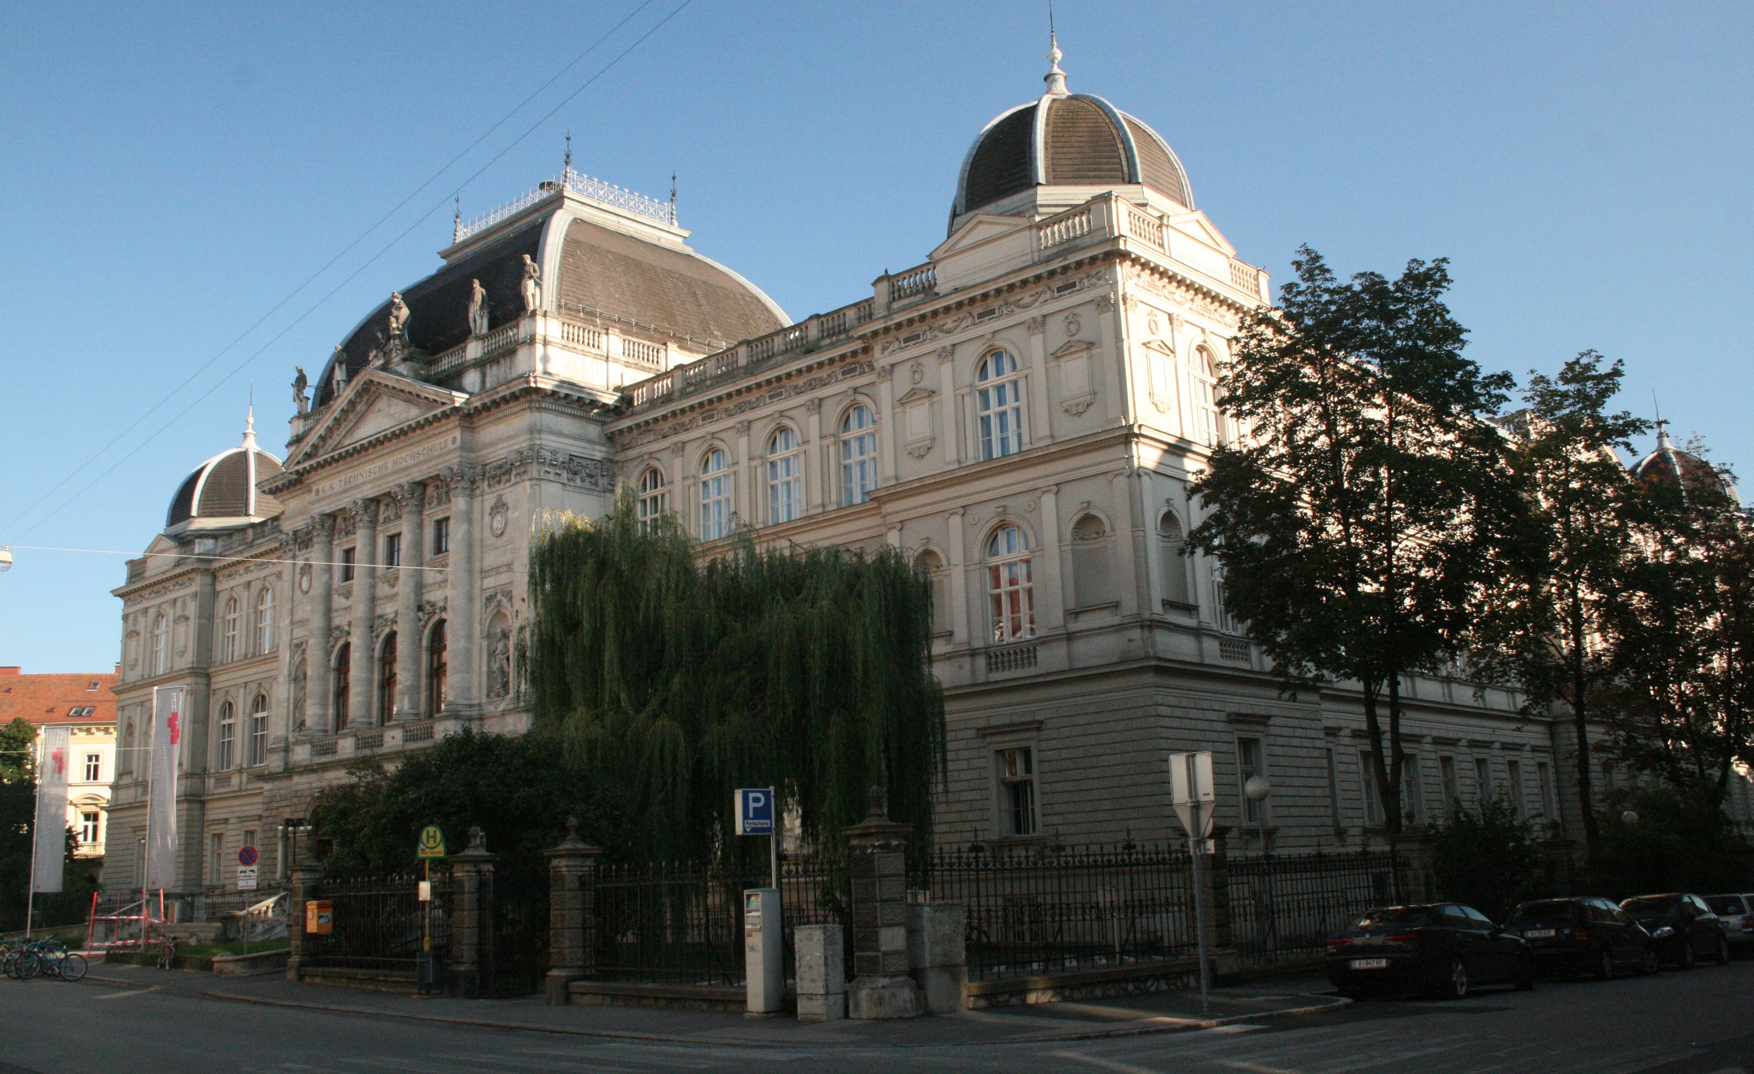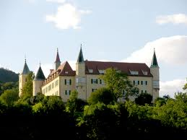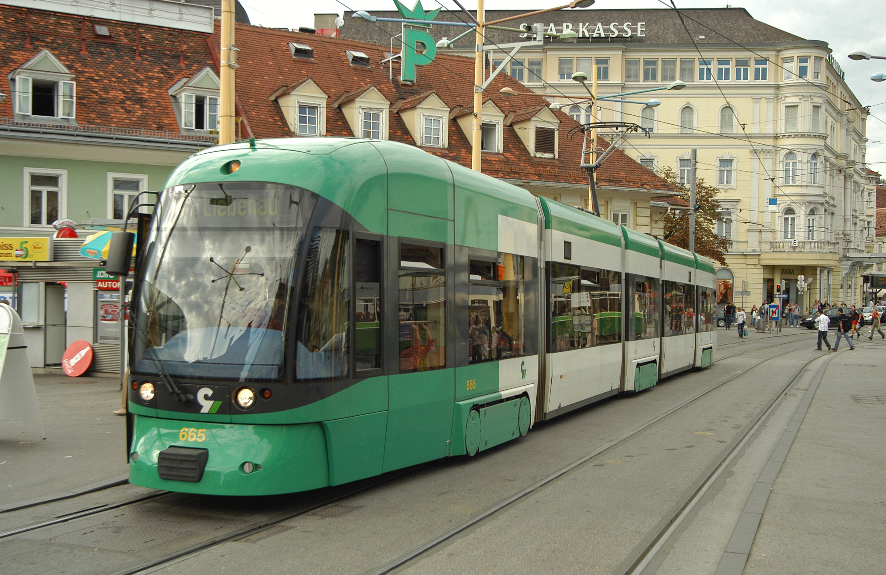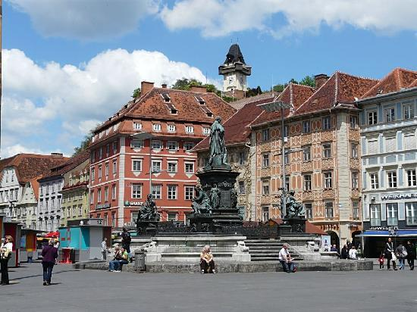

 | Vormittag/morning | Nachmittag/afternoon | Abend/evening
Fr, 3.6. |  | Approx.12.30 Ankunft in Graz  „Fernbus“ from Vienna Airport/ Schwechat | family
Sa 4.6. –  So 5.6. | Graz-Tour (guests only)  10.30 -12.00 | family | family
Mo, 6.6. | 8 am @ GIBS  - Welcome and  school tour  - shadowing  - DAF? | After period 4: Trip to Riegersburg  3.30 pm: Chocolate factory Zotter  Back approx. 6.30 pm  We ask for: small packed lunch/fruit and drink | family
Di, 7.6. | 8 am @ GIBS  - shadowing  - Zeughaus ? | 12.30 Reception Town Hall of Graz  - Zeughaus, Kunsthaus, Joanneum? | family
Mi, 8.6. | 8am @ GIBS  Per1/2 PE with 6A  Soccer/ volleyball/fistball  - Schloss Eggenberg  - packed lunch/drink | 2.30- 4.30 pm Sports /Activities  Auster: Beachvolleyball, soccer, Ultimate frisbee, swimming, ... | family
Do, 9.6. | 8 am @ GIBS  Shopping in town | 5 pm Farewell party @ Trummer’s/Stattegg | Farewell party
Fr, 10.06. | Goodbye  Pembroke Hill group leaves for Vienna  Packed lunch /drink | Vienna / PHS with Mr Kozak | Hostel in Vienna/ Saturday: flight to Dubrovnik/Croatia

